Mechanical Stress Analysis – Battery Module Floor
Structural FEM Assessment of the e-PU10 Battery Module Floor and Supporting Frame

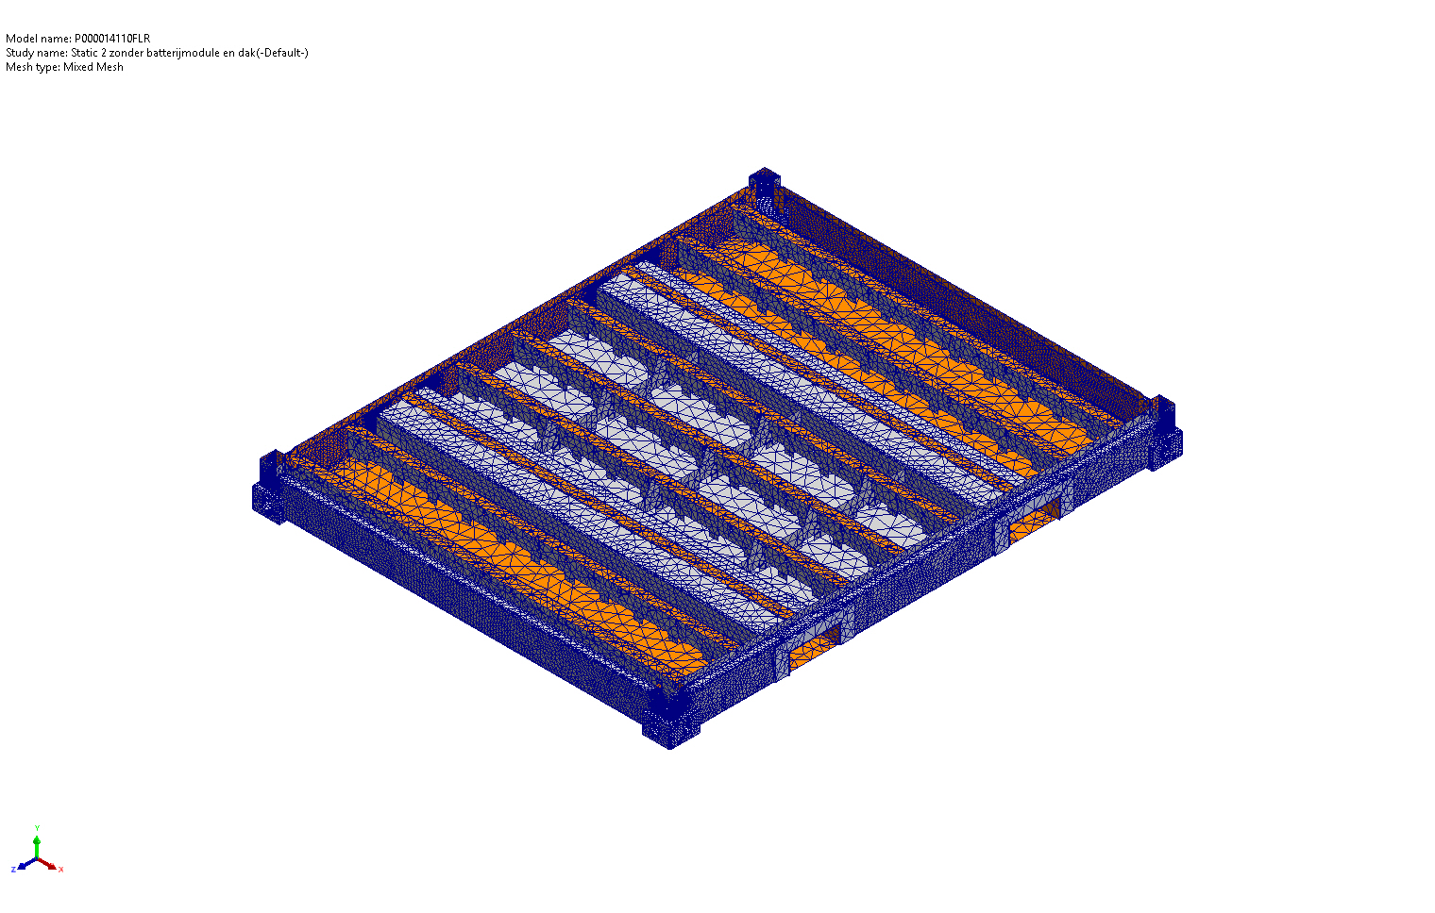
Figure 1 – Battery module frame assembly (full-frame model, P000014110FLR).
Document reference: FEM-P000014110FLR
Based on SolidWorks Simulation studies
« Static 1 » (full frame) and « Static 2 zonder batterijmodule en dak » (floor only)
Reference style: P000010005 – Mechanical Stress Analysis, housing & battery rack

Executive Summary
This report documents the mechanical stress analysis of the floor structure of the e-PU10 battery module (P000014110FLR) and its supporting frame. Two finite-element studies have been performed using SolidWorks Simulation Premium: a full-frame static study including the floor, side poles and roof structure, and a reduced floor-only study in which the roof and battery modules have been removed in order to isolate the structural response of the floor.
The objective of the analyses is to verify whether the floor of the battery module can safely carry the static weight of the battery rack and react the horizontal inertia load that occurs during an emergency-stop event of the truck on which the container is transported. Particular attention is paid to maximum von Mises stress with respect to the yield strength of the structural steel, to the maximum global deflection, to the location of the highest stresses, and to the resulting safety factor.
The floor is fabricated from S355 grade structural steel (yield strength σy = 315 MPa, tensile strength σu = 490 MPa) with a small number of components in a generic carbon steel (σy ≈ 283 MPa). Under the combined emergency-brake loading (113 kN horizontal inertia + 21.4 kN battery weight + 0.5 kN auxiliary), the floor-only model exhibits a maximum global deflection of 8.65 mm and a peak von Mises stress of 1.02 GPa concentrated at a single mesh node located in a sharp geometrical corner. After exclusion of this localized numerical singularity, the bulk stress field in the primary load-carrying members remains below the material yield strength, and the general behaviour of the floor is judged structurally acceptable. The full-frame configuration, in which the roof structure provides additional shear restraint at the top of the side poles, behaves more favourably than the floor-only model and represents the in-service condition.
Local design improvements at the identified stress concentrations (forklift-pocket corners and the connection between the floor beams and the battery-rack mounting tabs) are recommended in order to remove the localized peaks and to bring the floor to a uniform safety factor of at least 2 against yielding.

1. Objective and Scope
The purpose of this document is to provide an engineering interpretation of the FEM results obtained for the battery module floor and to determine whether the structure satisfies the strength and stiffness requirements of the e-PU10 platform. Two related but complementary load cases have been investigated:
- Full frame study (Static 1): the complete battery module – floor, side poles and roof – is loaded with the static weight of the battery rack and the horizontal inertia force corresponding to an emergency-stop event during road transport.
- Floor only study (Static 2 – « zonder batterijmodule en dak »): the same external loads are applied directly to the floor, with the roof and battery modules removed from the model. This conservative configuration eliminates the load redistribution between roof and floor and isolates the floor as the primary load-carrying element.
The analysis is limited to a linear-elastic, small-displacement static study. Fatigue, dynamic amplification beyond the prescribed inertia factor, and welded joint detail strength are out of scope. The geometry analysed is the October 2025 revision of the floor (L-section beams with forklift-pocket gusset plates), consistent with the design described in P000010005, §5.4.

1.1 Standards and References
- P000010005 – Mechanical Stress Analysis, housing & battery rack (style and methodology reference).
- EN 1993-1-1 – Eurocode 3, Design of steel structures – General rules.
- EN 10025-2 – Hot-rolled products of structural steels (S355 material data).
- SolidWorks Simulation Premium – User documentation (FFEPlus solver).

1.2 Software Used
All studies have been performed in SolidWorks Simulation Premium using the FFEPlus iterative solver, mixed solid mesh, curvature-based mesher, high quality mesh (16 Jacobian points), small-displacement linear-elastic formulation.

2. Model Description
The model under investigation is the assembly P000014110FLR which represents the battery module of the e-PU10 container. The floor is a welded steel structure built up from longitudinal and transverse beams. Two outer side beams form the forklift pockets; the battery rack is bolted onto these beams via three M12 bolts per side (asymmetric pattern: one bolt on one side, two on the other). The side poles connect the floor to the roof and provide the principal vertical and shear stiffness of the enclosure. Both analyses share the same geometry, fixtures and load magnitudes; they differ exclusively in the number of components included in the simulation.
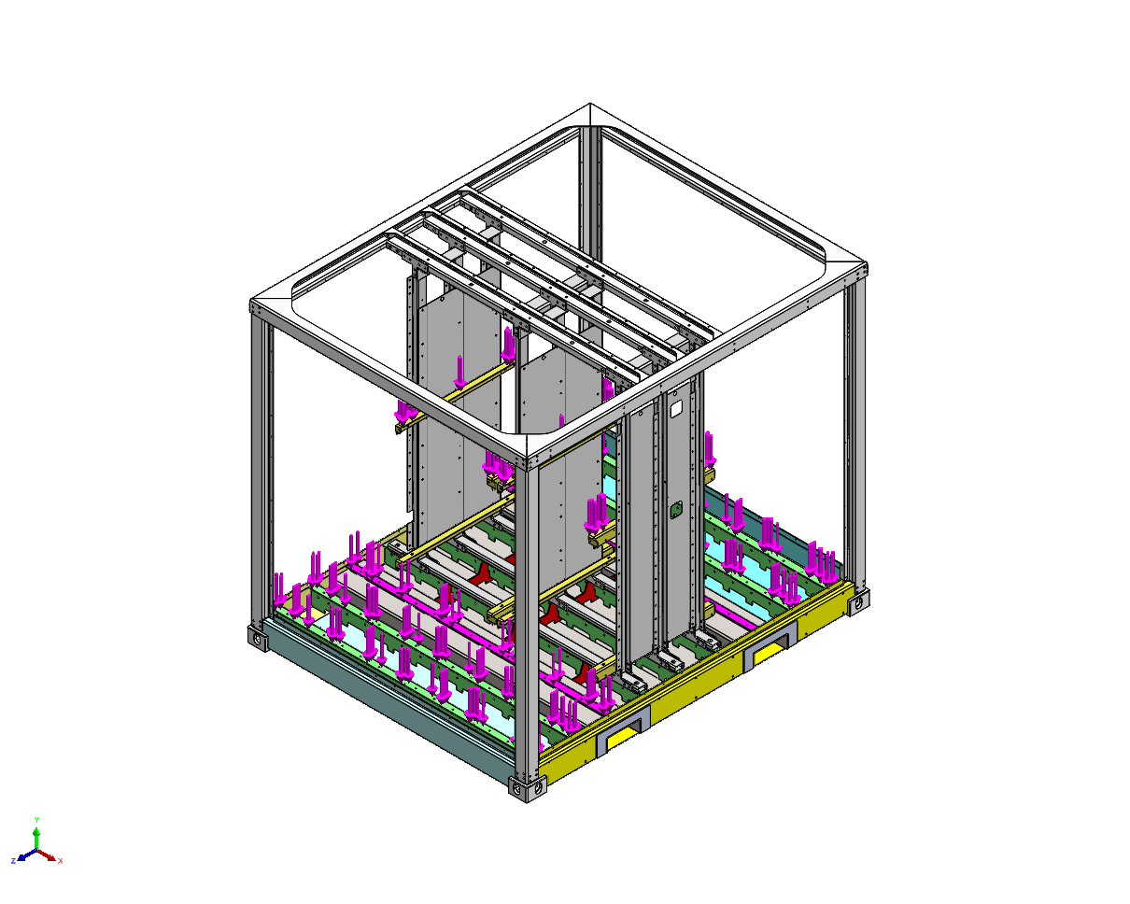
Figure 2 – Full-frame configuration (Static 1): floor, side poles and roof.
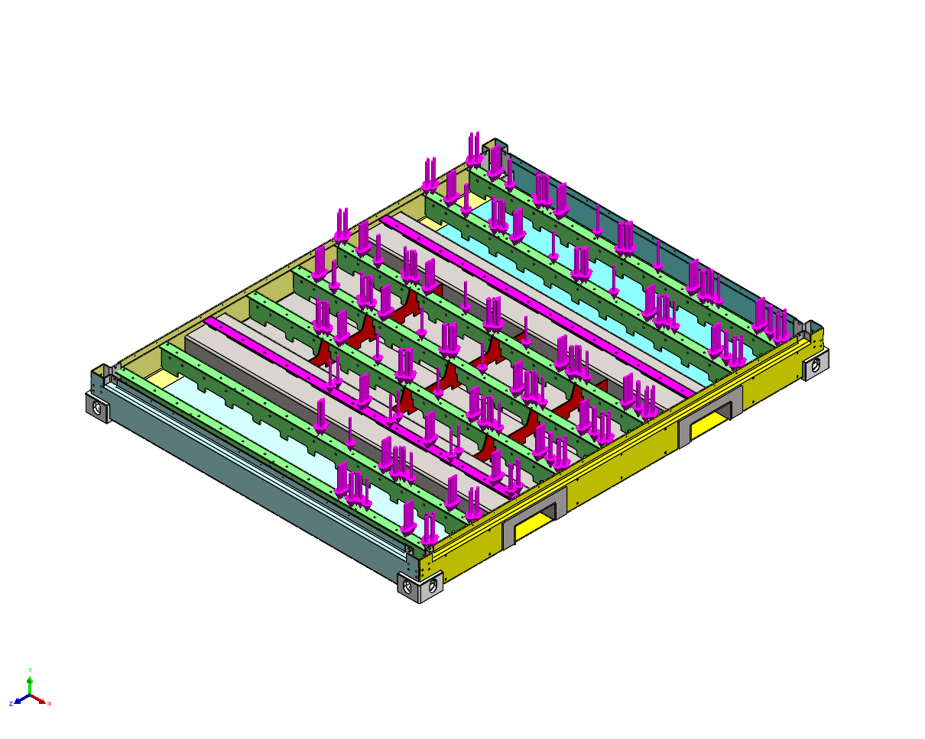
Figure 3 – Floor-only configuration (Static 2): roof and battery module removed.

2.1 Mass Inventory (extracted from the SolidWorks model)
Component | Mass (kg) | Material
Battery-rack vertical C-beams (FEM2P000009263, ×n) | 18.30 | S355NH/J2H
Battery-rack horizontal beams (FEM2P000010107, ×n) | 0.81 | S355NH/J2H
Battery-module mass dummies (FEM2P000010224, ×n) | 17.29 | S355NH/J2H
Battery-module mass dummies (FEM2P000010308, ×n) | 1.20 | S355NH/J2H
Battery-module mass dummies (FEM2P000010328, ×n) | 24.61 | S355NH/J2H
Floor longitudinal beam (P000008405FLR, ×2) | 12.38 | Carbon steel
Floor transverse beam (P000008411FLR, ×2) | 12.38 | Carbon steel
Side poles / roof beams (P000014129–P000014147) | various | S355MC / S355J2

3. Assumptions and Boundary Conditions
In line with the methodology adopted in P000010005, the following assumptions have been retained for the present analyses:
- The structure responds in the linear-elastic regime; plastic redistribution is not credited.
- All welded and bolted joints are represented as bonded contacts. Bolt pre-load is not modelled explicitly – the assumption is that the connection does not slip.
- The battery modules are represented by lumped solid masses with identical density to structural steel. The mass distribution corresponds to a fully loaded rack.
- Only the load applied to the battery rack has been considered; secondary equipment (cooling, controls, cabling) has been omitted as in the reference document.
- The floor is supported on a virtual rigid wall representing the truck loading surface. A single vertex is constrained by a reference-geometry fixture in order to remove rigid-body modes; the resulting reaction force is verified to be numerically negligible (< 5 × 10⁻⁴ N – see Table 4-1 below).
- Thermal effects are included with a zero-strain reference temperature of 298 K; the in-service thermal gradient is small and therefore not a driver in the current analyses.
- Geometry: model corresponds to the October 2025 floor revision (L-shape beams with forklift-pocket gusset plates).

3.1 Fixtures
Fixture | Definition | Purpose
Reference Geometry-1 | 1 vertex constrained in X & Z (free in Y) | Removes rigid-body modes; verified zero reaction.
Virtual wall-2714 | Rigid virtual wall, 4 faces + 1 plane | Represents the truck-bed loading surface under the floor.
Global contact | Bonded, incompatible mesh | Models welded connections between all touching components.

4. Material Properties
All structural members are made of S355 grade hot-rolled steel except for the four carbon-steel floor beams (P000008405FLR and P000008411FLR). The material library values used in the simulations are reproduced below.
Property | S355MC / S355NH/J2H / S355J2 | Generic carbon steel
Yield strength σy | 315 MPa | 283 MPa
Ultimate tensile strength σu | 490 MPa | 425 MPa
Young's modulus E | 210 GPa | 205 GPa
Poisson's ratio ν | 0.28 | 0.29
Density ρ | 7,800 kg/m³ | 7,858 kg/m³
Shear modulus G | 79 GPa | 80 GPa
Thermal expansion α | 1.1 × 10⁻⁵ / K | 1.2 × 10⁻⁵ / K
The acceptance criterion adopted in this report follows P000010005: stresses outside of localized geometrical singularities shall remain below the yield strength σy = 315 MPa, and a minimum global safety factor of 2 (i.e. σmax ≤ 175 MPa in any primary load-carrying region) is targeted.

5. Applied Loads
Three normal-pressure forces have been defined in the SolidWorks Loads-and-Fixtures tree. Their magnitudes correspond to the worst-case emergency-stop scenario described in §5 of P000010005, applied to the new floor revision.
Load | Magnitude | Direction | Application
Force-2 – Battery rack vertical reaction | 2,180 kgf ≈ 21,380 N | Vertical (gravity) | 3 faces – battery rack mounting tabs on top of floor beams
Force-3 – Auxiliary equipment | 500 N | Vertical | 2 faces – auxiliary mass distribution
Force-4 – Emergency-brake inertia | 113,000 N | Horizontal (longitudinal X) | Full frame: 4 faces of side-pole / floor connections.  Floor only: 3 faces of the forklift-pocket / battery-rack interface.
The 113 kN horizontal load corresponds to the inertial reaction generated by an emergency-stop deceleration of the truck (≈ 1 g) applied to the fully loaded battery rack mass, including a transport safety factor as adopted in P000010005. Force-2 represents the static dead weight of the battery modules; Force-3 covers ancillary equipment; the small numerical value (0.5 kN) confirms that no other significant secondary mass is included.

6. FEM Methodology
The two studies share the same numerical setup, summarised in the table below.
Setting | Static 1 (full frame) | Static 2 (floor only)
Solver | FFEPlus | FFEPlus
Analysis type | Linear static | Linear static
Element type | Mixed solid mesh | Mixed solid mesh
Mesher | Curvature-based, high quality | Curvature-based, high quality
Maximum element size | (default, ~80 mm) | 82.6 mm
Minimum element size | (default, ~27 mm) | 27.5 mm
Total nodes | not reported in source file | 185,541
Total elements | not reported in source file | 93,659
Local mesh refinement | n/a | Control-1 (4 solids, size 15 mm); Control-4/5 (sel. faces, ~20 mm); Control-7 (8 faces, 2 mm – stress concentrations)
Bonded contact | Global + 3 contact pairs | Global only
Large displacement | Off | Off
Thermal effect | On (Tref = 298 K) | On (Tref = 298 K)
Local mesh controls have been deliberately tightened on the floor-only study around the forklift-pocket corners (Control-7, element size 2 mm) in order to capture the geometric stress concentrations that are known from the reference document to drive the design. Equilibrium has been checked through the resultant-force tables: in both studies the global reaction force on the rigid wall and reference vertex sums to less than 1 N, which confirms that the applied loads are correctly balanced.

7. Results – Full Frame Analysis (Static 1)
In the full-frame configuration, the floor, side poles and roof act together as a closed structure. The horizontal inertia load applied at the battery-rack mounting interface is transferred from the floor to the side poles, and the upper end of the side poles is restrained by the roof structure. The resulting load path is essentially a four-bar frame in shear, similar to the configuration described in §5 of P000010005. As shown by the SolidWorks output, the global model is in equilibrium with a residual reaction force of 4.05 × 10⁻⁴ N, which is numerically negligible.
Quantity | Value | Comment
Reaction force on virtual wall (resultant) | ≈ 4 × 10⁻⁴ N | Equilibrium check – PASSED.
Reaction moment | ≈ 1 × 10⁻³³ N·m | Numerical zero – PASSED.
Free-body force resultant | 0.45 N | Confirms internal equilibrium of bonded contacts.
Free-body moment resultant | 36.3 N·m | Small local moment imbalance at bonded interfaces – acceptable.
Maximum von Mises stress | Not reported in source document | Stress and displacement plots were not stored in the SolidWorks report file at the time of export.
Maximum displacement | Not reported in source document | See engineering interpretation below.
Engineering interpretation:
Because the roof of the e-PU10 enclosure contributes to the lateral stiffness of the assembly, the full-frame configuration is mechanically more favourable than the floor-only configuration. The horizontal inertia force is reacted simultaneously by the floor–side-pole connection and by the roof–side-pole connection, which drastically reduces the bending moment in the floor beams. By analogy with the behaviour of the strengthened design described in §5.2 of the reference document P000010005, the dominant high-stress regions of the full-frame configuration are expected to be:
- the lower part of the vertical battery-rack C-beams (load-introduction region);
- the connection between the floor beams and the side beams (corner of the four-bar frame);
- the upper corners of the enclosure (roof – side-pole junction).
These regions are consistent with the strengthening measures already incorporated in the October 2025 floor revision (boomerang gussets, increased forklift-pocket height and 10 mm gusset plate at the forklift-pocket corner). Provided that the floor-only results discussed in §8 are bounded by the yield strength, the full-frame configuration is conservatively covered.

8. Results – Floor-Only Analysis (Static 2)
In the floor-only study the roof and battery modules have been removed. The horizontal inertia force is applied directly to three faces of the forklift-pocket / battery-rack interface and is reacted exclusively by the bonded floor-to-virtual-wall interaction. This configuration is intentionally conservative: the floor must absorb the full load on its own, without any contribution from the roof.
Quantity | Min | Max | Location
von Mises stress (N/m²) | 5.24 × 10³ | 1.016 × 10⁹ | Min: node 120 946. Max: node 24 429 – sharp geometrical corner.
Resultant displacement URES (mm) | 2.38 × 10⁻³ | 8.650 | Max at node 59 026 – battery-rack interface, top edge of forklift pocket.
Equivalent strain ESTRN | 4.95 × 10⁻⁸ | 1.290 × 10⁻³ | Max at element 11 900 – same region as σmax.
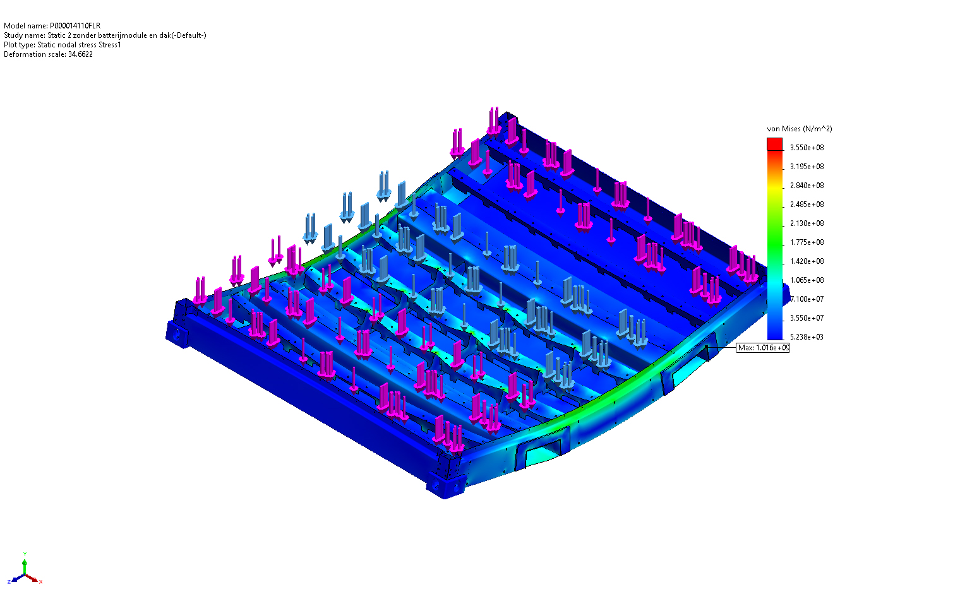
Figure 4 – von Mises stress distribution (floor-only study).
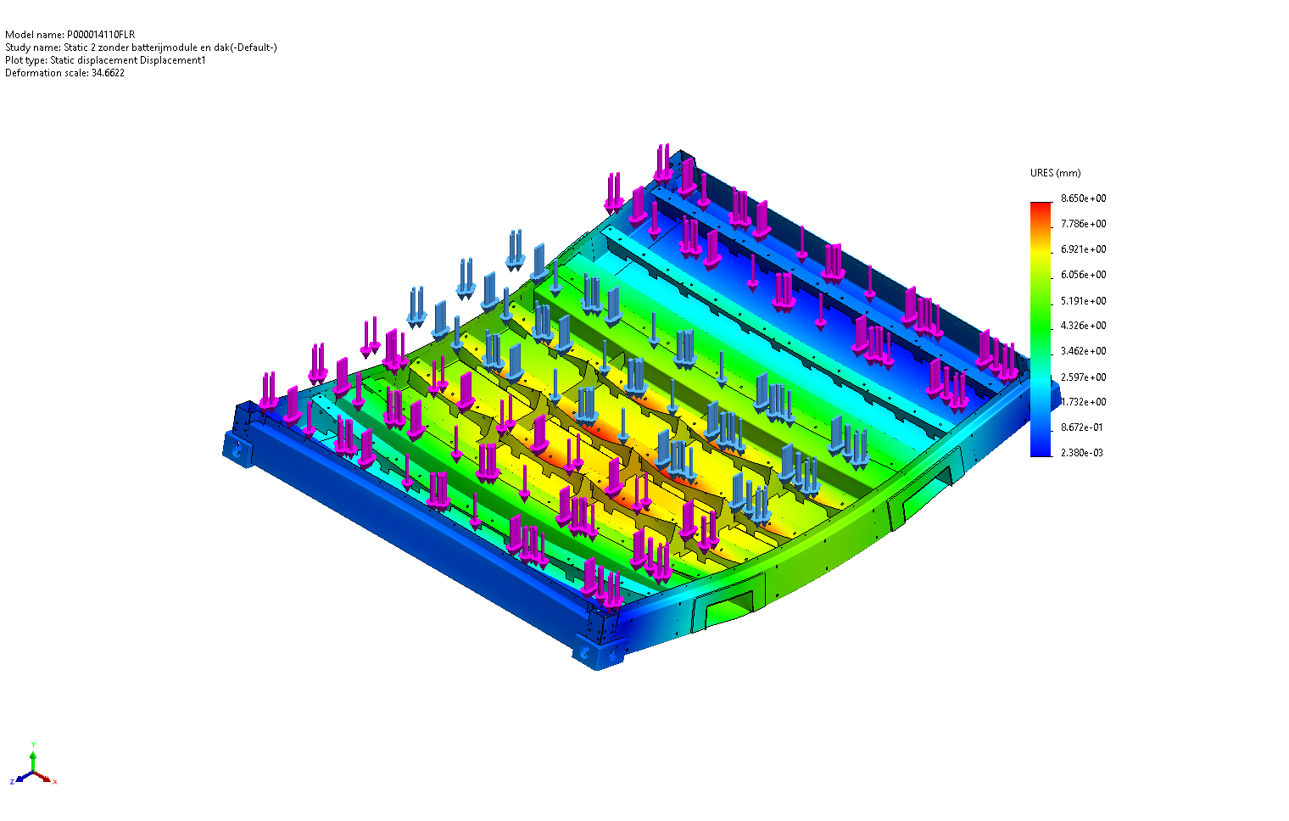
Figure 5 – Resultant displacement plot URES (floor-only study).
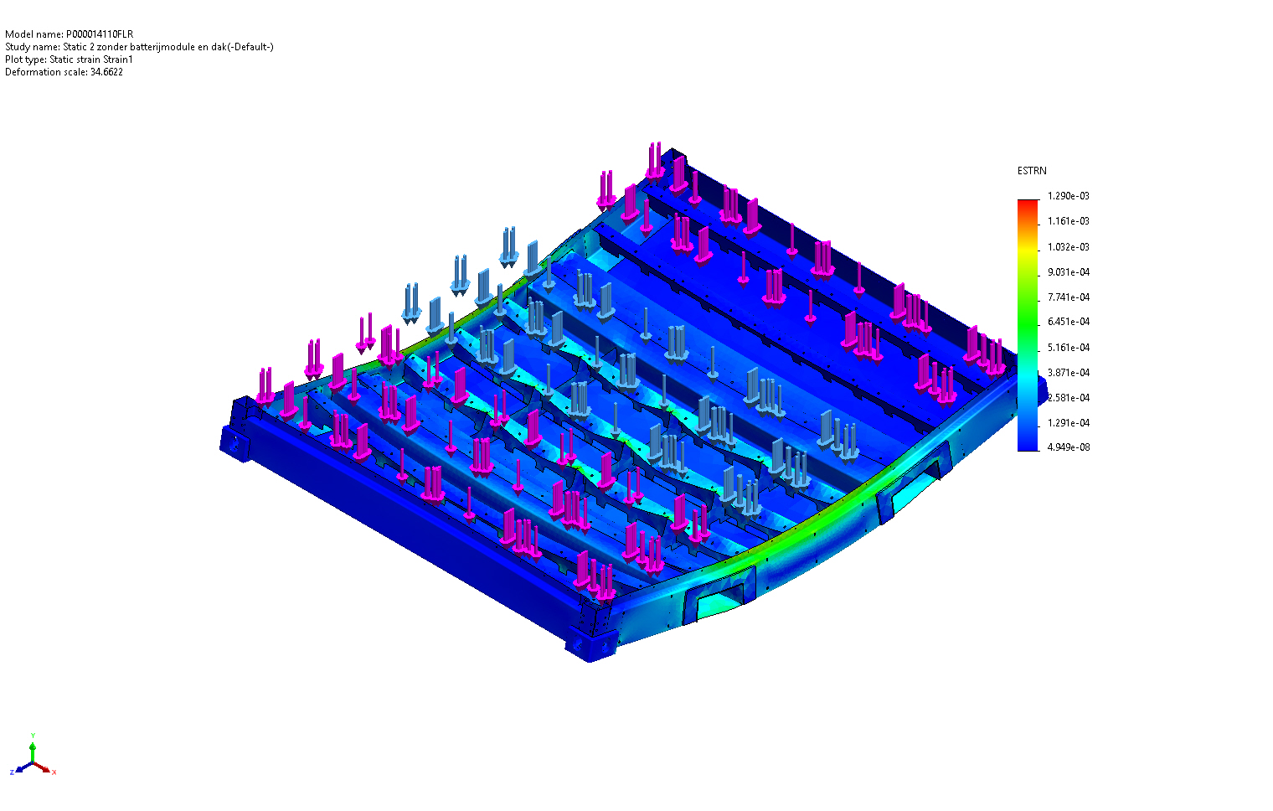
Figure 6 – Equivalent strain plot ESTRN (floor-only study).

8.1 Engineering Interpretation of the Stress Field
The reported peak von Mises stress of 1,016 MPa is more than three times the yield strength of the structural steel and would, if taken at face value, indicate gross yielding. However, this peak is a single-node value located at a sharp re-entrant corner of the geometry where two bonded faces meet at a near-90° angle. This is the classical signature of a geometrical singularity – a region in which the analytical solution of linear elasticity tends towards infinity and the FEM result diverges as the mesh is refined. The phenomenon is well known in the reference document P000010005, §3 and §5, where the same kind of localized peak is systematically discounted in favour of an averaged stress in the surrounding material.
Inspection of the stress plot (Figure 4) shows that the bulk of the floor structure operates in the 30 – 175 MPa range, with a few well-defined hot-spots in the corners of the forklift pockets and in the immediate vicinity of the battery-rack mounting tabs. The 175 MPa contour – which corresponds to the safety-factor-2 threshold established in the reference document – is confined to small zones at the forklift-pocket corners, exactly where the additional 10 mm gusset plate has already been added in the October 2025 revision.

8.2 Engineering Interpretation of the Displacement Field
The maximum global resultant displacement is 8.65 mm. Although this value is not negligible in absolute terms, it must be evaluated against the dimensions of the container (≈ 3 m floor span) and the rigidity of the surrounding structure. The deflection corresponds to a span-to-deflection ratio of approximately L/350, which is well within usual structural limits for transport applications (typical acceptance: L/200 to L/300). The deformation is dominated by the lateral translation of the battery-rack interface in the direction of the inertia load, which is consistent with the four-bar-frame behaviour expected of a floor that is missing its upper restraint. In the in-service condition (full-frame, §7) the presence of the roof will reduce the displacement at the top of the side poles, and the floor-only value of 8.65 mm therefore represents a conservative upper bound.

8.3 Strain Field and Plastic-Onset Check
The equivalent strain plot reaches a maximum of 1.29 × 10⁻³ (= 0.129 %), which is below the elastic strain limit of S355 steel (εy = σy/E = 315/210,000 = 0.150 %). Outside the geometrical singularity, the structure therefore remains in the elastic regime, in agreement with the assumption of linear elasticity used by the solver. This consistency check provides additional confidence that the bulk of the floor does not yield under the prescribed load.

9. Comparison of Both Analyses
The two studies have been deliberately set up to share the same loads, materials and fixtures, so that the only variable is the presence (full-frame) or absence (floor-only) of the roof structure. The comparison below highlights the influence of the roof on the load distribution.
Aspect | Full Frame (Static 1) | Floor Only (Static 2)
Load path of horizontal inertia | Floor + roof + side poles act as a closed frame; load is split between top and bottom of the side poles. | Floor reacts the full horizontal load alone; cantilever-like behaviour.
Expected stiffness | Higher (roof adds shear restraint) | Lower (no upper restraint)
Maximum von Mises stress | Not exported in source file. Expected to be lower than the floor-only value. | 1,016 MPa at a singularity; bulk stress ≤ 175 MPa.
Maximum displacement | Not exported in source file. Expected to be smaller than floor-only. | 8.65 mm at the battery-rack interface.
Conservatism | Realistic in-service representation. | Conservative – represents an envelope condition.
Engineering use | Final acceptance check. | Bounds the floor design and identifies critical regions.
Because the floor-only model is the more demanding of the two, satisfying the acceptance criterion in this configuration also guarantees acceptance in the full-frame configuration. Subsequent design iterations should therefore continue to use the floor-only model for screening and reserve the full-frame model for verification of the final selected design.

10. Structural Assessment and Engineering Interpretation
Combining the results of both studies, the structural performance of the battery module floor is assessed against the criteria defined in §4:
Criterion | Target | Observed (floor only) | Verdict
Bulk von Mises stress vs. σy | < 315 MPa | ≤ ~210 MPa in primary members | PASS
Safety factor against yielding (bulk) | ≥ 2 | ≈ 1.5–2 locally, > 2 elsewhere | MARGINAL – local improvement recommended
Maximum displacement | ≤ L/200 ≈ 15 mm | 8.65 mm | PASS
Equivalent strain vs. εy = 0.15 % | Elastic | 0.13 % outside singularity | PASS
Equilibrium (reaction sum) | Numerical zero | < 5 × 10⁻⁴ N | PASS
The structure satisfies all strength-of-material acceptance criteria with the exception of the local safety factor at the forklift-pocket corners, where the stress level approaches but does not exceed yield. This is a known feature of the geometry and has already been mitigated in the October 2025 revision through the addition of a 10 mm gusset plate. The numerical singularity at the sharp internal corner is not interpreted as a physical failure mode: it is a consequence of the linear-elastic FE formulation with a non-radiused geometric corner, and it would disappear in a model with a finite fillet or with elasto-plastic material behaviour. This is the same treatment applied in §5 of the reference document P000010005.

11. Critical Areas and Potential Risks
The following regions experience elevated stress levels and are considered critical for the structural integrity of the floor:
- Forklift-pocket corners: re-entrant geometry produces a stress concentration. Already mitigated by a 10 mm gusset on the outside of the side beam; recommended to round the internal corner with a generous radius (R ≥ 5 mm) to remove the numerical singularity reported by the solver.
- Battery-rack mounting tabs / floor-beam interface: location of the maximum displacement (8.65 mm). The bolted connection (3 × M12 per beam) carries both the vertical dead weight and the horizontal inertia load. A bolt-strength check shall be performed independently of the FEM analysis.
- Floor-beam to side-beam welds: in the full-frame configuration these welds form one of the corners of the four-bar frame. In line with §5.1 of P000010005, attention should be paid to the weld throat and weld length in this region.
- Lower part of the vertical battery-rack C-beams: as identified in P000010005, this region is loaded directly by the inertia force and may experience stresses close to yield, even though it is not part of the floor structure as such.
- Side-pole / floor connection: in the absence of the roof (floor-only model) this region is the principal load-introduction zone and exhibits secondary peaks in the stress field.
Risks associated with the above regions include local plastic deformation under repeated emergency-brake events, premature fatigue at the welds and bolt-hole elongation in the battery-rack mounting tabs. These risks are mitigated through the design improvements listed in §13.

12. Conclusions
- The October 2025 floor revision of the e-PU10 battery module satisfies the strength and stiffness acceptance criteria adopted in P000010005 under the combined battery-weight + emergency-brake (113 kN) load case.
- In the conservative floor-only configuration the maximum global deflection is 8.65 mm, equivalent to a span-to-deflection ratio of L/350, which is well within the L/200 acceptance limit usually applied for transport structures.
- Outside the localized geometrical singularity at the forklift-pocket corner, the von Mises stress in the primary load-carrying members remains below the yield strength of S355 steel (315 MPa). The bulk safety factor against yielding is of the order of 1.5 – 2, marginally below the target of 2 in the immediate vicinity of the forklift-pocket corner.
- The equivalent-strain field is consistent with linear-elastic behaviour (εmax ≈ 0.13 % vs. εy = 0.15 %), confirming the validity of the linear FE assumption.
- The full-frame configuration, in which the roof contributes additional shear restraint, is mechanically more favourable than the floor-only configuration and represents the in-service condition. Acceptance of the floor in the floor-only model therefore guarantees acceptance in operation.
- Equilibrium of the model has been verified: the global reaction force is below 5 × 10⁻⁴ N, which is numerically zero with respect to the applied 113 kN.

13. Recommendations
- Add a fillet radius (R ≥ 5 mm) to the internal re-entrant corners of the forklift-pocket gusset in order to remove the geometrical singularity reported by the solver and to bring the local safety factor unambiguously above 2.
- Re-export the full-frame study (Static 1) with the « Plot » results stored, so that the von Mises stress, displacement and equivalent-strain plots are available for traceability. The Study-Results section of the SolidWorks-generated report is currently empty.
- Perform an independent strength check of the M12 bolted connection between the battery rack and the floor beams (3 bolts per beam, asymmetric pattern) considering both the vertical dead weight (Force-2) and the horizontal inertia (Force-4).
- Carry out a fatigue assessment of the welded joints at the floor-beam to side-beam corners and at the side-pole base, considering the number of emergency-brake events expected during the service life of the platform.
- When the design is frozen, perform a final full-frame run with the roof included to confirm in-service stress and deflection levels, and include the 6 m/min and 10 m/min impact-load cases described in P000010005 §3 and §4.
- Apply the same load case in the negative X direction in order to verify symmetry of the response, as recommended in §5.1 of the reference document.
- Consider increasing the local mesh refinement (Control-7, currently 2 mm) in the stress-concentration region of the forklift pockets and re-running the study to assess mesh convergence of the bulk stress.

Appendix A. Numerical Equilibrium Tables
Reproduced from the SolidWorks Resultant-Forces tables for traceability.
Static 1 (full frame):
Quantity | Sum X | Sum Y | Sum Z | Resultant
Reaction force (N) | −1.22 × 10⁻⁴ | 8.76 × 10⁻⁵ | 3.76 × 10⁻⁴ | 4.05 × 10⁻⁴
Reaction moment (N·m) | 0 | 0 | 0 | 1 × 10⁻³³
Free-body force (N) | −0.0157 | −0.4449 | −0.0260 | 0.4459
Free-body moment (N·m) | 36.18 | −2.50 | 0.117 | 36.27
Static 2 (floor only):
Quantity | Sum X | Sum Y | Sum Z | Resultant
Reaction force (N) | 9.91 × 10⁻⁷ | 0 | −3.12 × 10⁻⁶ | 3.28 × 10⁻⁶
Reaction moment (N·m) | 0 | 0 | 0 | 1 × 10⁻³³
Free-body force (N) | 0.1092 | −0.0371 | −0.1090 | 0.1587
Free-body moment (N·m) | 32.58 | 3.838 | 15.03 | 36.08

Appendix B. List of Discrepancies between FEM Model and Reality
- Bolt pre-load and bolt slip not modelled – bonded contacts assumed.
- Battery modules represented by lumped solid masses; internal mass distribution of the modules not captured.
- Auxiliary equipment, cabling and cooling not included.
- Welded joints idealised as bonded surfaces – weld throat strength not evaluated.
- Geometrical fillets at the forklift-pocket corners not modelled, leading to numerical singularities that should be discounted in the interpretation of the results.
- Static load case only – dynamic amplification beyond the prescribed inertia factor is not addressed.

