Exploring Crime Clearance in Austin
Team members: Charlie Miner, Prashant Aryal
GitHub repository:
Presentation slides:

1. Introduction
When a crime is reported, understanding clearance rates and processing times is crucial for maintaining public trust. To assist the Austin Police Department (APD) and oversight staff, we analyzed 2014–2015 Austin crime reports to evaluate both overall clearance outcomes (cleared by arrest, exception, or not cleared) and the time it takes to clear cases. Separating outcome from processing time is important because a case might have a low chance of being cleared even if successful cases move quickly. Using descriptive statistics, a Welch t-test, and a Pearson correlation, we discovered that the vast majority of reported cases were not cleared. Furthermore, cases cleared by exception took significantly longer on average than those cleared by arrest. These insights provide stakeholders with a data-driven starting point for reviewing slow-moving case categories.

2. Dataset
The dataset, `austin_crime.csv`, contains 159,464 Austin crime records from 2014-2015. Each row represents one reported crime record and includes its crime type, police district, zip code, report timestamp, clearance date, and clearance status. The clearance-status field uses C for cleared by arrest, O for cleared by exception, and N for not cleared. After removing records without a valid C, O, or N status and the location information used in this project, 70,019 cases remained. Of those cases, 12,673 C/O cases had usable report and clearance dates. These fields made it possible to compare both clearance outcomes and recorded clearance time across types of crime and locations.

3. Analysis Technique
We used exploratory data analysis because our goal was to describe patterns in Austin crime clearance records rather than predict future cases. Counts and percentages were used to show the C, O, and N outcomes and to compare clearance rates by crime type and district. For C/O cases, we calculated days to recorded clearance and summarized the results with averages and standard deviations. A Welch independent-samples t-test was used to compare the average time for C cases and O cases because the two groups had different sample sizes and different variation. We also used a scatterplot and Pearson correlation to check whether zip codes with more reported crimes had different clearance rates. These methods are suitable because they show broad patterns clearly without claiming that one factor causes another.

4. Results
We began by looking at the overall clearance outcome for all valid-status cases. We then moved from that broad picture to differences by crime type, clearance method, and zip code.
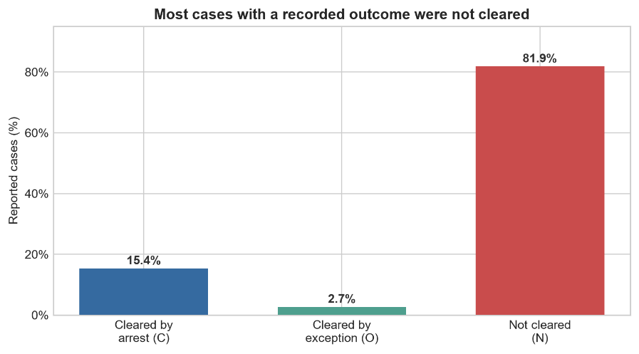
Figure 1: Clearance status of Austin crimes with a valid status.
Across the 70,019 valid-status cases, most cases were not cleared. A total of 57,346 cases, or 81.9%, were not cleared. Another 10,766 cases, or 15.4%, were cleared by arrest, and 1,907 cases, or 2.7%, were cleared by exception. This means clearance time describes a much smaller group of cases than the overall outcome analysis.
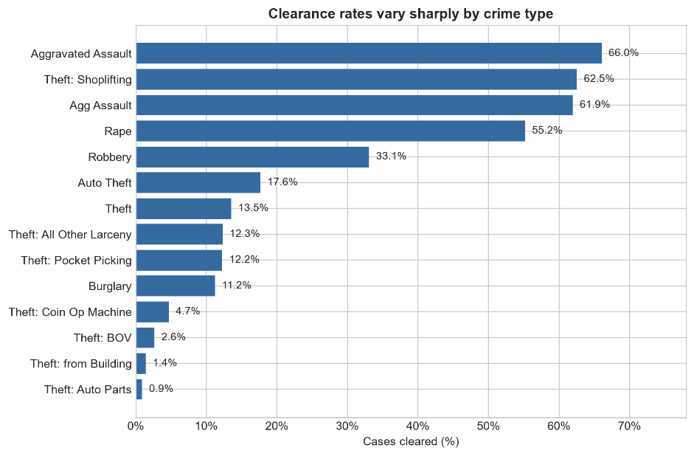
Figure 2: Clearance rate by crime type. Categories with fewer than 100 cases are excluded from the graph for readability.
Clearance rates varied sharply by crime type. Among types with at least 100 cases, auto-parts theft had a clearance rate of 0.9%, theft from a building had a rate of 1.4%, and aggravated assault had a rate of 66.0%. District rates ranged from 12.2% in District B to 22.7% in District I. These differences show where outcomes vary, but they do not explain why the differences occur or prove that police effort differs between groups.
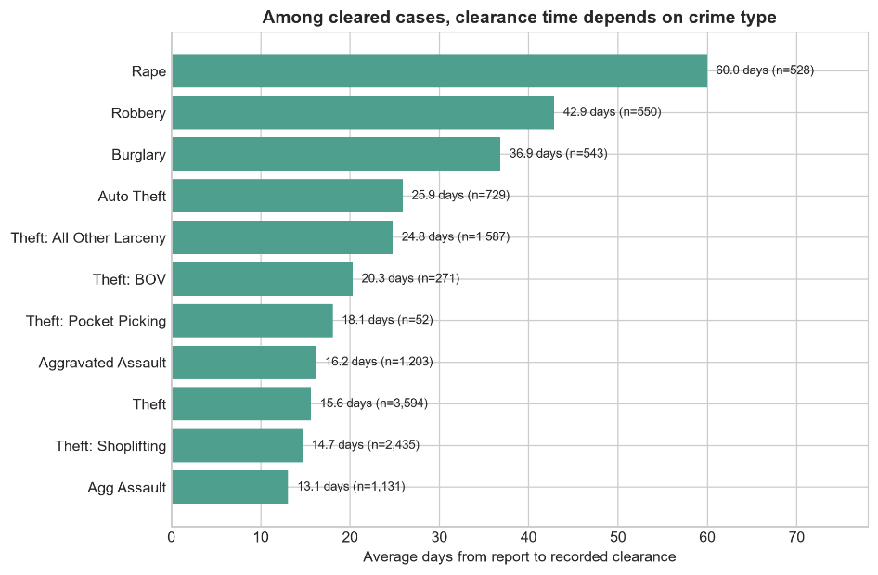
Figure 3: Average recorded clearance time by crime type among C/O cases.
Timing also varied among cleared cases. Cleared theft cases averaged 15.6 days, robbery cases averaged 42.9 days, and rape cases averaged 60.0 days. The large standard deviations mean that individual cases varied widely around these averages.
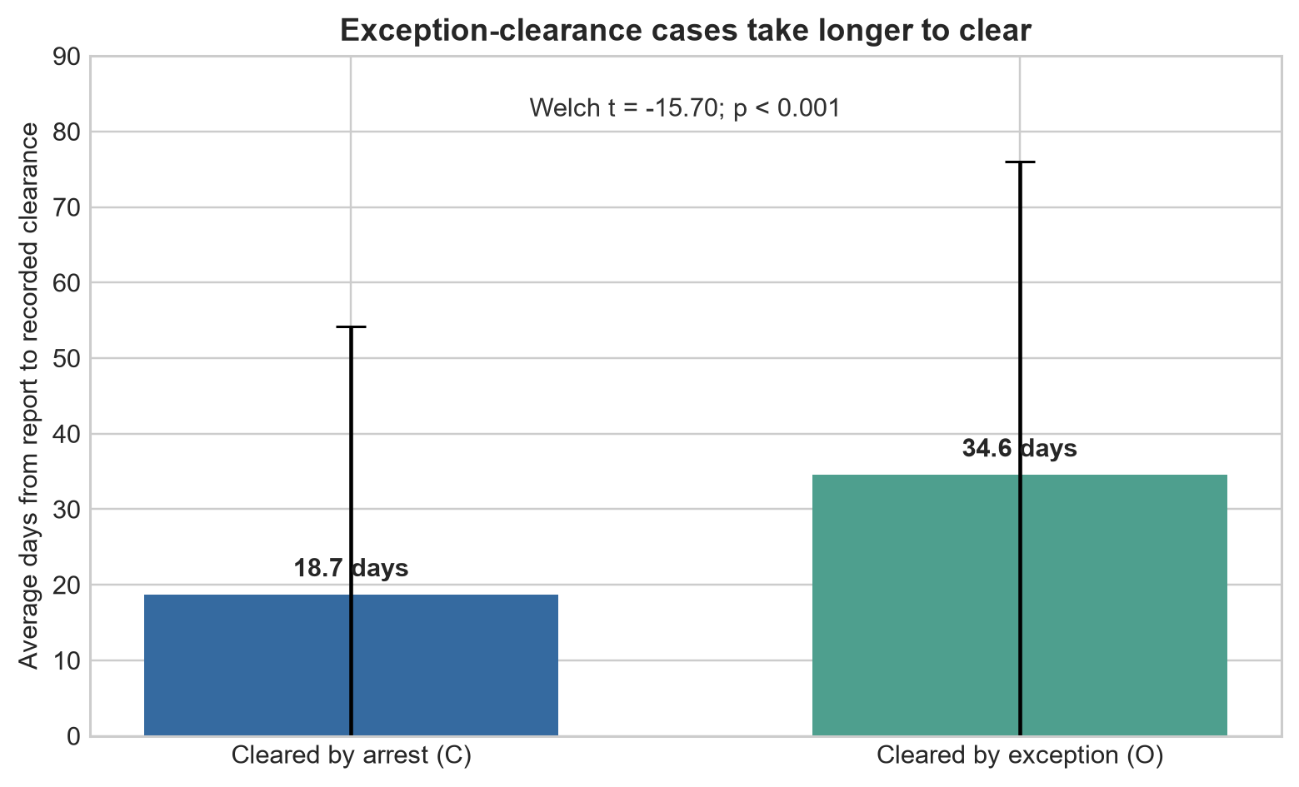
Figure 4: Clearance Method Comparison
The strongest timing difference appeared when we compared clearance methods. Cases cleared by arrest averaged 18.71 days (SD 35.45, n = 10,766), while cases cleared by exception averaged 34.56 days (SD 41.49, n = 1,907). The Welch t-test gave t = -15.698 and p = 5.76 x 10⁻⁵³. This very small p-value means the 15.85-day difference is very unlikely to be random. The test does not tell us why O cases took longer.
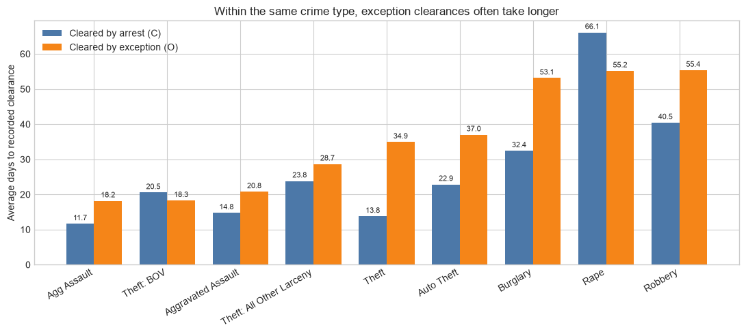
Figure 5: Average recorded clearance time for C and O cases within the same crime type.
Within the nine comparable crime types, O cases took longer in seven. For example, auto theft averaged 22.86 days for C cases and 37.00 days for O cases. Robbery had the longest average O time at 55.38 days. This means the Welch-test pattern appears in several crime types, not just one category.
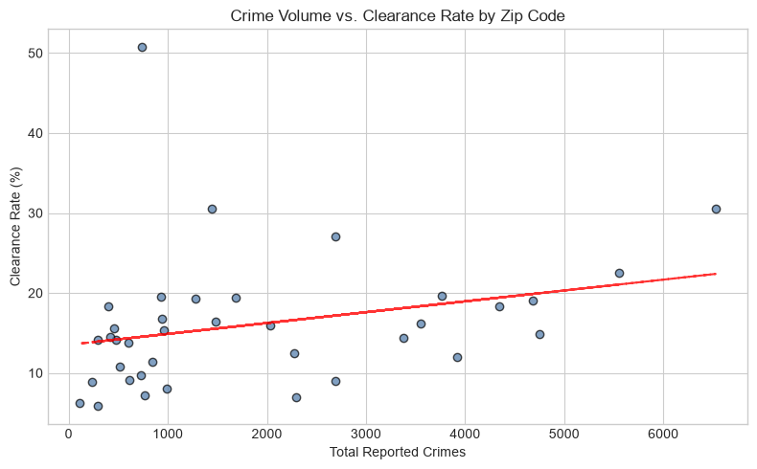
Figure 6: Crime volume versus clearance rate by zip code.
At the zip-code level, the Pearson correlation between crime volume and clearance rate was small and not statistically significant (r= 0.274, p = 0.100). Although the pattern was slightly positive, the p-value was above 0.05. We therefore cannot claim that high crime volume reliably predicts clearance rate.
Overall, the results show that clearance outcome and clearance time need to be tracked separately. Most valid-status cases were not cleared, while exception-clearance cases took longer than arrest-clearance cases. The same pattern appeared in most comparable crime types. Robbery and rape had especially long average exception-clearance times. APD can use these results to review slow O-clearance categories, but status O does not tell us why those cases took longer.

5. Technical
Using Python (pandas, matplotlib, SciPy), data preparation included normalizing status labels to C, O, and N, parsing dates, and dropping records with missing categorical values or negative report-to-clearance durations. Initially, we considered calculating delay metrics for N-status cases, but we rejected this approach because the dataset contains ambiguous dates for uncleared crimes, which would have invalidated our results. To analyze the data, a Welch t-test was chosen over a standard t-test because it effectively compares group means without assuming equal variance between the differently sized C and O groups, while a Pearson correlation suitably tested for linear relationships across zip codes. While this exploratory process successfully highlighted broad patterns, future alternative approaches could incorporate variables like case complexity or staffing levels to establish causality rather than just describing historical trends.

