# Table graph

**WRITING TASK 1**

**The table below shows the proportion of different categories of families living in poverty in Australia in 1999.**

**Summarise the information by selecting and reporting the main features, and make comparisons where relevant.**

|  |  |
| --- | --- |
| **Family type** | **Proportion of people from each**  **household type living in poverty** |
| Single aged person | 6% (54000) |
| Aged couple | 4% (48000) |
| Single, no children | 19% (359000) |
| Couple, no children | 7% (211000) |
| Sole parent | 21% (232000) |
| Couple with children | 12% (933000) |
| **All household** | **11% (1837000)** |

This table gives a breakdown of the different types of family who were living in poverty in Australia in 1999.

On average, 11% of all households, comprising almost two million people, were in this position. However, those consisting of only one parent or a single adult had almost double this proportion of poor people, with 21% and 19% respectively.

Couples generally tended to be better off, with lower poverty levels for couples without children (7%) than those with children (12%). It is noticeable that for both types of household with children, a higher than average proportion were living in poverty at this time.

Older people were generally less likely to be poor, though once again the trend favoured elderly couples (only 4%) rather than single elderly people (6%).

Overall the table suggests that households of single adults and those with children were more likely to be living in poverty than those consisting of couples.

# Line graph

**EXERCISE 1**

The graph below shows tourism statistics among Venezuelian students from 2011 to 2014. Summarize the information by selecting and reporting the main features and make comparisons where relevant.

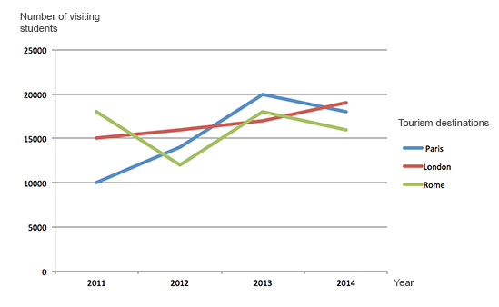

My answer, 5.0 by ChatGPT

This graph illustrates the annual number of Venezuelian students that have a tourists to Paris, London, and Rome.

Paris has the most tourists increasement from 10000 in 2011 to 20000 in 2013 while experiences a little decrease in 2014.

London has a slow but steady and monochrome increase from 15000 in 2011 to nearly 20000 in 2014.

Rome has the number very fluctuating, it has the most students in 2011, and then the least students in 2012, then increase to the level around the number in 2011, and decrease to the least in the three cities in 2014.

In 2011, Rome has the leading number and Paris has the least number. In 2012 and 2014, London has the leading number and Rome has the least number. In 2013, Paris has the leading number and London has the least number.

Model answer

The line graph illustrates the number of Venezuelan students who visited three European cities—Paris, London, and Rome—between 2011 and 2014.

Overall, Paris experienced the most significant growth in student tourists over the period, while London showed a steady upward trend. In contrast, the number of students visiting Rome fluctuated significantly.

In 2011, Rome attracted the highest number of Venezuelan students at around 18,000, whereas Paris had the fewest, with just 10,000 visitors. In 2012, Rome saw a sharp decline to about 12,000, while Paris and London both rose to around 15,000 and 16,000 respectively.

The number of students visiting Paris peaked in 2013 at 20,000 before slightly declining in 2014. London saw a consistent rise each year, reaching nearly 20,000 by 2014. Rome, after recovering in 2013, fell again to just over 16,000, making it the least popular destination in the final year.

**EXERCISE 2**

The graph below gives information from a 2008 report about consumption of energy in the USA since 1980 with projections until 2030. Summarise the information by selecting and reporting the main features and make comparisons where relevant. Write at least 150 words.

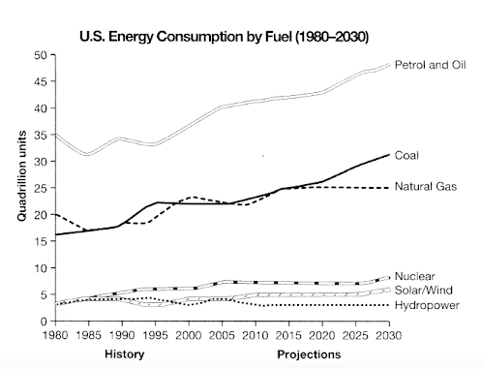

My answer, 5.5 by ChatGPT

This line graph illustrates the annual energy consumption in the USA from 1980 to 2030 in petral and oil, coal, natural gas, and clean energy including nuclear, solar and wind, hydropower.

The petrol and oil consumption is always the dominant and experienced a steady growth. This consumption nearly has it doubled from 25 quadrillion units to 50 quadrillion units in 2030. The consumption is nearly half the consumption in petrol and oil in each year.

The consumptions in coal and natural gas are very comparative before the coal begining a growing larger comsumptions than natural gas that maintains the level in 2015.

The total consumptions in nuclear, solar/wind, and hydropower are steady in these years, and they are around one-forth compared to the consumption in natural gas.

Model answer

The given line graph illustrates data from a report in 2008 regarding energy consumption in the USA since 1980 with predictions until 2030.

Overall, fossil fuels have shown increases in consumption since the start of the period, with expectations for even more reliance on these fuel sources. Cleaner energy sources have accounted for considerably less consumption with predictions for a similar trend.

Regarding fossil fuels such as coal, natural gas, petrol and oil, they have seen steady increases in energy consumption since 1980. Petrol and oil started at 35 quadrillion units in 1980, then fluctuated until 2000, at which point they rose steadily with a prediction of over 45 quadrillion units by 2030. Additionally, coal followed a similar rising trend. It is predicted that it will have surpassed 30 quadrillion units by 2030. Natural gas usage and it is set to level off at around 24 quadrillion units from 2020 onwards.

In contrast, cleaner energy fuel sources all began the period at under 5 quadrillion units and showed declines in their use, with the exception of nuclear, which climbed slightly to 6 quadrillion units in 2005 with solar/wind expecting to see slight increases. Hydropower is projected to remain relatively unchanged until 2030.

**EXERCISE 3**

The graph below gives information about changes in the birth and death rates in New Zealand between 1901 and 2101.

Summarise the information by selecting and reporting the main features, and make comparisons where relevant.

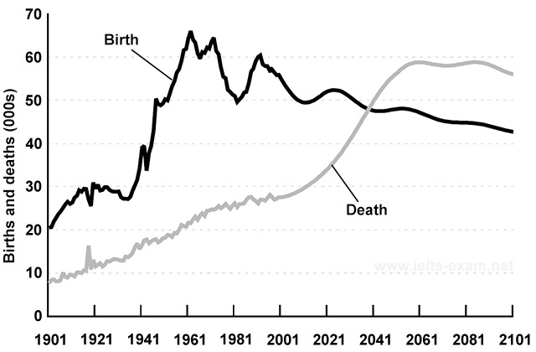

My Answer: 6.0~6.5 by ChatGPT

The graph illustrates the number regarding births and deaths in New Zealand since 1901 with predictions until 2101.

Overall, the births have shown growth since the start of the period before declining in fluctuations in 1961 with an expectation of gradually dropping. The deaths have shown monotonic increase since the beginning and are expected to maintain a constant in 2061 and further future.

At the start of the period, the birth is around 20000 and nearly twice the death. The birth peaked in 1961 at around 65000 after a sharp increase about 35000 in only 20 years, and then experienced the greatest deficit in 1981 down to 50000. The birth then reached its second peak at 60000 in 1990s.

The deaths are always less then the birth before the prediction before 2041 when they meet, and then the deaths climbed higher than the birth. The rate of death is nearly linear before 2020 and then is expected to experience a steep increase until it reaches a platform.

Model answer: 7.5~8.0 by ChatGPT

The graph shows changes in the birth and death rates in New Zealand since 1901, and forecasts trends tip until 2101.

Between 1901 and the present day, the birth rate has been consistently higher than the death rate. It stood at 20,000 at the start of this period and increased to a peak of 66,000 in 1961. Since then the rate has fluctuated between 65 and 50 thousand and it is expected to decline slowly to around 45,000 births by the end of the century.

In contrast, the death rate started below 10,000 and has increased steadily until the present time. This increase is expected to be more rapid between 2021 and 2051 when the rate will probably level off at around 60,000, before dropping slightly in 2101.

Overall, these opposing trends mean that the death rate will probably overtake the birth rate in around 2041 and the large gap between the two levels will be reversed in the later part of this century.