# VSG Basic knowledge

This paper gives a basic understanding of VSG, the voltage supporting and power supporting. But sadly it’s a Chinese version, so I write what ever I think useful here.

## VSG characteristic:

The control system of the converter is used to simulate the physical characteristics of the synchronous generator. The control system of the converter simulates the equations of motion of the rotor and the electrical equations of the stator in such a way that the oscillatory process of the output power is consistent with that of a synchronous generator.

## Basic request:

The virtual synchronous control of converters for new types of power systems must have the ability to control frequency, voltage, inertia and damping to actively support the power grid.

## synchronous generator function:



# Voltage and frequency control

## Frequency modulation: (mechanical system)



**Stator electrical equations**

## Voltage regulation: (excitation system)

The synchronous generator maintains the terminal voltage through the **excitation system**. For simplicity of control, virtual synchronous control generally simulates the machine-side voltage controller of an automatic voltage regulator (AVR). Design the virtual excitation system based on the relation between voltage and reactive power.

In real motor:



In VSG:



: Synchronous machine exciter reactive power-voltage sag coefficient.

# VSG: voltage support

**Main goal**:

Ensure that the output voltage and frequency of the converter are not affected by the output power, so that the voltage and frequency of the grid can be supported.

The system operates in **off-grid mode**, where the output power is controlled by setting the voltage amplitude and frequency.

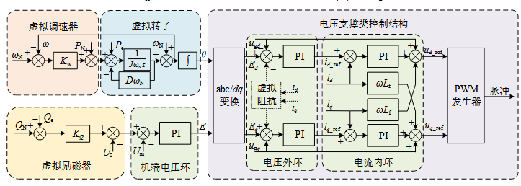

# VSG: power support

Outputs active and reactive power with a given reference value according to system scheduling requirements or the **maximum power point**. Therefore, the power support virtual synchronous control technique is equivalent to additional power control according to the system frequency and voltage deviation before the power support control structure, and actively participates in the system frequency and voltage regulation.

The system operates in **grid-connected mode**, where the output power is controlled by setting the voltage amplitude and frequency.

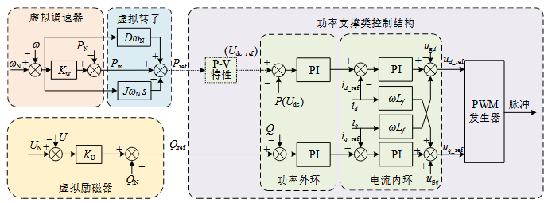

<https://ieeexplore-ieee-org.focus.lib.kth.se/document/9408354>

This paper gives a detailed explanation of every control loop. And it have different methods and functions for each loop. I think it might be helpful.

The difference between GFM and GFL, already in the slides last week

**A general control structure of GFM:**

# Outer loop-Power Synchronization Loop

## Frequency loop and angle loop:

Droop control:

: droop coefficient

钟表的特写

**Power Synchronization Control (PSC)**

钟表的特写

**Enhanced Direct Power Control (EDPC)**

手机屏幕截图

