Experiments
4.1 Dataset Description
The Thai exam dataset from the Royal Institute of Thailand contains 826 questions and I extract 81 written questions out of it which means there is 745 multiple choice questions which I ignore them for we’re focusing on written exam. The exam type based on Bloom’s Taxonomy labeled by professional Thai teacher are remembering 18 questions, understanding 10 questions, applying 14 questions, analyzing 26 questions, evaluating 11 questions, creating 15 questions for the reference (train) set, however total question is 94 questions which is over 81 due to in the exam one mark might have more than 1 sub-question. While on the test set the total question is 55, separated as Remembering 10 questions, Understanding 14 questions, Applying 8 questions, Analyzing 9 questions, Evaluation 7 questions, Creating 7 questions.
There is rubric and non rubric sets with the same amount of questions (and same questions)
4.2 Rubric Generation and Validation
For rubric extraction, I use chatgpt (reason… maybe reference from [1] 1. J. X. Lee and Y.T. Song, “College exam grader using LLM AI models,” 2024 IEEE/ACIS 27th International Conference on Software Engineering, Artificial Intelligence, Networking and Parallel/Distributed Computing (SNPD) that they use rubric with chatgpt 4.0 and get good result) to extract rubric out of it and then verify by teacher, on training set 81 questions there is 40 rubric that no need to refine, there is 41 rubric that were fixed by teacher. On test set there is 55 questions, 30 rubrics were good and 25 rubrics were fixed by teacher.
4.3 Student Answer Simulation via LLMs
I use 5 commercial LLMs to generate students answer including Chatgpt, typhoon, gemini, grok, claude the score is in range 0-3 base on the verified rubric each LLM give 1 answer for 1 range in the question (I mean question A chatgpt give 1 for 0 score, 1 for 1 score, 2 score, and 3 score and do the same with another LLMs which means 1 question will get total of 20 answers). Then I will let professional Thai teacher check and fix in case that score is not acceptable (like ai gives 3 but it should be 2 or others).
That means for rubric set will have 81 x 20 answers, non rubric will have 81 x 20 answers,
First for non rubric set as I said I got 1620 answers from LLMs and then I send to a professional Thai teacher to validate (In fact she got limited time so can analyzed only first 340, and 66 were fixed which is 19.41176% that were fixed) Here are the detail in number for each LLMs
Chatgpt
precision recall f1-score support
0 0.94 0.84 0.89 19
1 0.82 0.70 0.76 20
2 0.71 0.46 0.56 26
3 0.18 1.00 0.30 3

accuracy 0.66 68
macro avg 0.66 0.75 0.63 68
weighted avg 0.78 0.66 0.70 68

Typhoon
precision recall f1-score support
0 0.94 0.73 0.82 22
1 0.65 0.50 0.56 22
2 0.41 0.64 0.50 11
3 0.76 1.00 0.87 13

accuracy 0.69 68
macro avg 0.69 0.72 0.69 68
weighted avg 0.73 0.69 0.69 68

Gemini
precision recall f1-score support
0 1.00 1.00 1.00 17
1 0.94 1.00 0.97 16
2 1.00 0.77 0.87 22
3 0.76 1.00 0.87 13

accuracy 0.93 68
macro avg 0.93 0.94 0.93 68
weighted avg 0.94 0.93 0.93 68

Grok
precision recall f1-score support
0 0.82 1.00 0.90 14
1 0.94 0.84 0.89 19
2 0.94 0.76 0.84 21
3 0.76 0.93 0.84 14

accuracy 0.87 68
macro avg 0.87 0.88 0.87 68
weighted avg 0.88 0.87 0.87 68

Claude
precision recall f1-score support
0 0.82 1.00 0.90 14
1 0.94 0.80 0.86 20
2 0.94 0.80 0.86 20
3 0.82 1.00 0.90 14

accuracy 0.88 68
macro avg 0.88 0.90 0.88 68
weighted avg 0.89 0.88 0.88 68

Overall
precision recall f1-score support
0 0.91 0.90 0.90 86
1 0.86 0.75 0.80 97
2 0.80 0.68 0.74 100
3 0.66 0.98 0.79 57

accuracy 0.81 340
macro avg 0.81 0.83 0.81 340
weighted avg 0.82 0.81 0.81 340
But when we look deeper in the non-rubric set Mean of token for each score range are 3 = 41.01204819277108
Mean of 2 = 22.904109589041095
Mean of 1 = 12.087671232876712
Mean of 0 = 7.954022988505747
When the max of token in each score range are Max of 3 = 211
Max of 2 = 120
Max of 1 = 90
Max of 0 = 74
Indicating that LLMs try to give the higher score to longer answer and lower score to shorter one, but in real life short score with full detail can get full score and most of student might not answer in that too long but there’s a way to answer short but fully covered
For the rubric set, here are classification report after refine by teacher (use validate as true y and llm generated as predicted y)
Chatgpt
precision recall f1-score support

0.0 0.99 0.99 0.99 87
1.0 0.97 0.99 0.98 71
2.0 0.96 0.93 0.95 74
3.0 0.96 0.97 0.97 80

accuracy 0.97 312
macro avg 0.97 0.97 0.97 312
weighted avg 0.97 0.97 0.97 312

Typhoon
precision recall f1-score support

0.0 0.99 0.91 0.95 94
1.0 0.90 0.84 0.87 77
2.0 0.82 0.90 0.86 67
3.0 0.90 0.97 0.94 76

accuracy 0.91 314
macro avg 0.90 0.91 0.90 314
weighted avg 0.91 0.91 0.91 314

Gemini
precision recall f1-score support

0.0 0.95 1.00 0.98 83
1.0 0.97 0.95 0.96 75
2.0 0.99 0.97 0.98 74
3.0 1.00 0.99 0.99 82

accuracy 0.98 314
macro avg 0.98 0.98 0.98 314
weighted avg 0.98 0.98 0.98 314

Grok
precision recall f1-score support

0.0 0.98 0.98 0.98 87
1.0 0.97 0.95 0.96 75
2.0 0.96 0.96 0.96 72
3.0 0.96 0.99 0.98 81

accuracy 0.97 315
macro avg 0.97 0.97 0.97 315
weighted avg 0.97 0.97 0.97 315

Claude
precision recall f1-score support

0.0 0.99 0.99 0.99 87
1.0 0.95 0.96 0.95 72
2.0 0.96 0.95 0.95 74
3.0 0.98 0.98 0.98 83

accuracy 0.97 316
macro avg 0.97 0.97 0.97 316
weighted avg 0.97 0.97 0.97 316

Overall
precision recall f1-score support

0.0 0.98 0.97 0.98 438
1.0 0.95 0.94 0.94 370
2.0 0.94 0.94 0.94 361
3.0 0.96 0.98 0.97 403

accuracy 0.96 1572
macro avg 0.96 0.96 0.96 1572
weighted avg 0.96 0.96 0.96 1572

Here are number of scoring wrong and giving unsatisfied or incorrect reasons validated by teacher
ChatGPT Count: 9
Typhoon Count: 29
Gemini Count: 7
Grok Count: 10
Claude Count: 10

ChatGPT Reason Count: 4
Typhoon Reason Count: 2
Gemini Reason Count: 1
Grok Reason Count: 1
Claude Reason Count: 0

Overall Count: 65
Overall Reason Count: 8

Here are result of bloom’s taxonomy vs llms please summarize
Remembering with chatgpt got 66 / 68 -> 97.06%
Remembering with typhoon got 57 / 68 -> 83.82%
Remembering with gemini got 67 / 68 -> 98.53%
Remembering with grok got 66 / 68 -> 97.06%
Remembering with claude got 68 / 68 -> 100.00%
Understanding with chatgpt got 47 / 48 -> 97.92%
Understanding with typhoon got 45 / 48 -> 93.75%
Understanding with gemini got 48 / 48 -> 100.00%
Understanding with grok got 47 / 48 -> 97.92%
Understanding with claude got 44 / 48 -> 91.67%
Applying with chatgpt got 20 / 20 -> 100.00%
Applying with typhoon got 20 / 20 -> 100.00%
Applying with gemini got 20 / 20 -> 100.00%
Applying with grok got 20 / 20 -> 100.00%
Applying with claude got 19 / 20 -> 95.00%
Analyzing with chatgpt got 131 / 140 -> 93.57%
Analyzing with typhoon got 126 / 140 -> 90.00%
Analyzing with gemini got 133 / 139 -> 95.68%
Analyzing with grok got 131 / 138 -> 94.93%
Analyzing with claude got 135 / 140 -> 96.43%
Evaluation with chatgpt got 42 / 44 -> 95.45%
Evaluation with typhoon got 40 / 44 -> 90.91%
Evaluation with gemini got 41 / 43 -> 95.35%
Evaluation with grok got 42 / 44 -> 95.45%
Evaluation with claude got 44 / 44 -> 100.00%
Creating with chatgpt got 43 / 44 -> 97.73%
Creating with typhoon got 42 / 44 -> 95.45%
Creating with gemini got 42 / 43 -> 97.67%
Creating with grok got 42 / 44 -> 95.45%
Creating with claude got 44 / 44 -> 100.00%
4.4 grading procedure by LLMs
I use prompt in figure 3 to get LLMs answer along with retrieve context from collected data in excel. And from the bloom’s taxonomy
Type Remembering contains: 10 questions
Type Understanding contains: 14 questions
Type Applying contains: 8 questions
Type Analyzing contains: 9 questions
Type Evaluation contains: 7 questions
Type Creating contains: 7 questions
Total questions is 55 questions and the llm consist of Gemini got 22 questions, Claude got 33 questions. After validate by teacher 2 of Gemini and 2 of Claude were fixed.
…. Explain which type for which LLMs both num and reason
… In specific case that need algorithm explain percentage before and after (in canva)
4.5 human grading for test set
Base on same rubric and same questions and answers with ai test set, I will give the test set to 2 professional Thai teacher to give the score along with the collected keyword and reason why give that score. One teacher will give score to rubric test set and then validate the set that come from AI. Another teacher will give score to non-rubric test set then will give to rubric test set. Then I compare the result between each set.
The comparison between teacher set without rubric compare with teacher set with rubric is 30 same answers and 25 different answers (this is from Teacher 1 name’s Tippanan I will name her in acknowledgement) and 34 same answers and 21 different answers (from teacher 2 name’s Nabduan Phayom also name in acknowledge later). When we take a look inside we found
Compare Nadbuan vs Non-Rubric score = 34
Compare Tippanan vs Non-Rubric score = 30
From Nadbuan vs Non-R -> Score = 0 got: 2
From Nadbuan vs Non-R -> Score = 1 got: 6
From Nadbuan vs Non-R -> Score = 2 got: 5
From Nadbuan vs Non-R -> Score = 3 got: 8
From Non-R vs Nadbuan -> Score = 0 got: 3
From Non-R vs Nadbuan -> Score = 1 got: 4
From Non-R vs Nadbuan -> Score = 2 got: 8
From Non-R vs Nadbuan -> Score = 3 got: 5
From Tippanan vs Non-R -> Score = 0 got: 2
From Tippanan vs Non-R -> Score = 1 got: 7
From Tippanan vs Non-R -> Score = 2 got: 6
From Tippanan vs Non-R -> Score = 3 got: 10
From Non-R vs Tippanan -> Score = 0 got: 5
From Non-R vs Tippanan -> Score = 1 got: 4
From Non-R vs Tippanan -> Score = 2 got: 9
From Non-R vs Tippanan -> Score = 3 got: 6
The comparison between
(When non-r is non-rubric set that score given by a teacher nabduan, then Nabduan and Tippanan is a rubric set that given by Tippanan and Nabduan, I’ve compare Tippanan vs Non-R means the row of score in Tippanan set that doesn’t same with Non-Rubric and Non-Rubric vs Tippanan is Non-rubric set that not same with Tippanan for analyzing)
The comparison between rubric set of Tippanan and Nabduan is
Compare Rubric score = 51
From Tippanan vs Nadbuan -> Score = 0 got: 0
From Tippanan vs Nadbuan -> Score = 1 got: 1
From Tippanan vs Nadbuan -> Score = 2 got: 1
From Tippanan vs Nadbuan -> Score = 3 got: 2
From Nadbuan vs Tippanan -> Score = 0 got: 2
From Nadbuan vs Tippanan -> Score = 1 got: 0
From Nadbuan vs Tippanan -> Score = 2 got: 1
From Nadbuan vs Tippanan -> Score = 3 got: 1
4.6 Evaluation metrics and criteria
->score agreement rate
->inter-rater reliability (cohen’s kappa)
->explanation quality (thematic analysis)
->error type frequency
Tippanan = LLM -> 41 / 55
From Tippanan vs LLM -> Score = 0 got: 0
From Tippanan vs LLM -> Score = 1 got: 3
From Tippanan vs LLM -> Score = 2 got: 5
From Tippanan vs LLM -> Score = 3 got: 6
From LLM vs Tippanan -> Score = 0 got: 3
From LLM vs Tippanan -> Score = 1 got: 5
From LLM vs Tippanan -> Score = 2 got: 5
From LLM vs Tippanan -> Score = 3 got: 1
Nabduan = LLM -> 38 / 55
From Nabduan vs LLM -> Score = 0 got: 2
From Nabduan vs LLM -> Score = 1 got: 3
From Nabduan vs LLM -> Score = 2 got: 6
From Nabduan vs LLM -> Score = 3 got: 6
From LLM vs Nabduan -> Score = 0 got: 3
From LLM vs Nabduan -> Score = 1 got: 6
From LLM vs Nabduan -> Score = 2 got: 6
From LLM vs Nabduan -> Score = 3 got: 2
Average(Humans) = LLM -> 38 / 55
From Avg(Humans) vs LLM -> Score = 0 got: 0
From Avg(Humans) vs LLM -> Score = 1 got: 3
From Avg(Humans) vs LLM -> Score = 2 got: 5
From Avg(Humans) vs LLM -> Score = 3 got: 5
From LLM vs Avg(Humans) -> Score = 0 got: 3
From LLM vs Avg(Humans) -> Score = 1 got: 6
From LLM vs Avg(Humans) -> Score = 2 got: 6
From LLM vs Avg(Humans) -> Score = 3 got: 2
(… please suggest)

Experiments
4.1 Dataset Description
The Thai exam dataset was obtained from the Royal Institute of Thailand, consisting of 826 questions in total. Of these, 745 were multiple-choice questions and were excluded from the study, as the focus is exclusively on written responses. The remaining 81 written questions were extracted for analysis.
Each question was classified according to Bloom’s Taxonomy by a professional Thai language teacher. For the reference (training) set, there were 94 labeled items in total slightly exceeding the 81 extracted questions because some exam items contained multiple sub-questions. The distribution of Bloom’s categories in the training set was as follows: Remembering (18), Understanding (10), Applying (14), Analyzing (26), Evaluating (11), and Creating (15).
The test set contained 55 questions, distributed as: Remembering (10), Understanding (14), Applying (8), Analyzing (9), Evaluating (7), and Creating (7). For both the training and test sets, two parallel versions were prepared: one with rubrics and one without, using the exact same questions in each version.
4.2 Rubric Generation and Validation
Rubric extraction was performed using ChatGPT, following the approach demonstrated in prior work by Lee and Song [1], who employed ChatGPT-4 to generate grading rubrics with strong results. In this study, ChatGPT was prompted to extract concise, criterion-based rubrics for each written exam question. These rubrics were then reviewed and validated by a professional Thai language teacher to ensure accuracy, clarity, and alignment with the intended learning outcomes.
In the training set of 81 questions, 40 rubrics (49.38%) were accepted without modification, while 41 rubrics (50.62%) required revisions by the teacher. For the test set of 55 questions, 30 rubrics (54.55%) were accepted as-is, and 25 rubrics (45.45%) required adjustments. The most common corrections involved clarifying ambiguous wording, ensuring mutual exclusivity between criteria, and adding missing conditions for partially correct answers.
4.3 Student Answer Simulation via LLMs
To simulate a variety of student responses, five commercial large language models (LLMs) were used: ChatGPT, Typhoon, Gemini, Grok, and Claude. Each LLM generated four distinct answers per question, corresponding to each possible score level (0, 1, 2, and 3) based on the validated rubrics. For example, for Question A, ChatGPT produced one answer expected to score 0, one for score 1, one for score 2, and one for score 3. This process was repeated for all models, resulting in 20 simulated responses per question.
For the rubric set, this yielded 81 × 20 = 1,620 responses, and the non-rubric set also produced 81 × 20 = 1,620 responses. All generated responses were then reviewed by a professional Thai language teacher, who corrected cases where the assigned score was inconsistent with the rubric (e.g., an answer receiving a score of 3 that should have been a 2).
Due to time constraints, the teacher validated only the first 340 responses in the non-rubric set. Of these, 66 responses (19.41%) required adjustment. Table 1 presents detailed classification metrics (precision, recall, F1-score) for each LLM in this subset.
Table 1. Performance by Model (Non-Rubric Set, 340 Responses Validated)
Model | Accuracy | Macro F1 | Notable Observation
ChatGPT | 0.66 | 0.63 | Struggled with score 3 over-prediction; low precision for top score.
Typhoon | 0.69 | 0.69 | Balanced performance, but inconsistent on mid-tier scores.
Gemini | 0.93 | 0.93 | Highest accuracy; strong consistency across all score levels.
Grok | 0.87 | 0.87 | Stable across classes; slightly weaker recall for score 2.
Claude | 0.88 | 0.88 | Similar to Grok; well-balanced performance.
Overall Performance (All Models Combined):
Accuracy: 0.81
Macro Average F1-score: 0.81
Score 0: Precision = 0.91, Recall = 0.90
Score 1: Precision = 0.86, Recall = 0.75
Score 2: Precision = 0.80, Recall = 0.68
Score 3: Precision = 0.66, Recall = 0.98
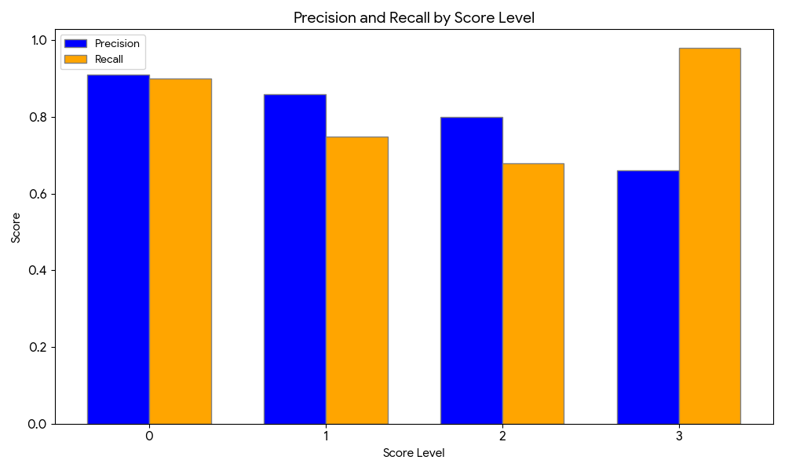
Token Length Analysis (Non-Rubric Set)
The mean token count per score level was:
Score 3: 41.01 tokens
Score 2: 22.90 tokens
Score 1: 12.09 tokens
Score 0: 7.95 tokens
Maximum token counts per score level:
Score 3: 211 tokens
Score 2: 120 tokens
Score 1: 90 tokens
Score 0: 74 tokens
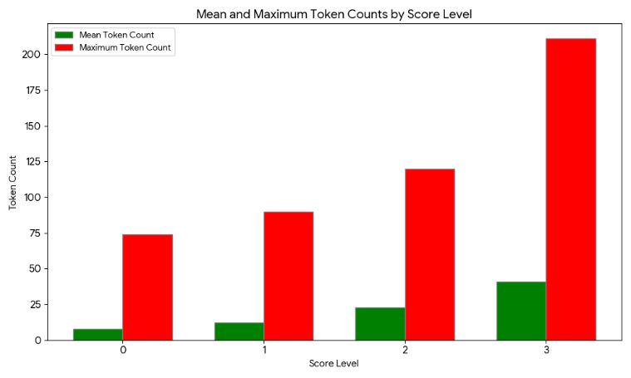
This pattern suggests that LLMs tend to associate longer responses with higher scores and shorter responses with lower scores. However, in real-world grading, concise answers can still earn full marks if they cover all required points. This discrepancy highlights a potential bias in LLM scoring toward verbosity.
Rubric Set Results
For the rubric set evaluation, LLM-generated scores were compared against teacher-validated scores to assess alignment with human judgment. The classification metrics precision, recall, and F1-score were calculated for each rubric score category (0–3) using the teacher-validated scores as the ground truth (true y) and the LLM outputs as the predicted labels.
Performance by Model
Across all models, classification accuracy ranged from 91% (Typhoon) to 98% (Gemini).
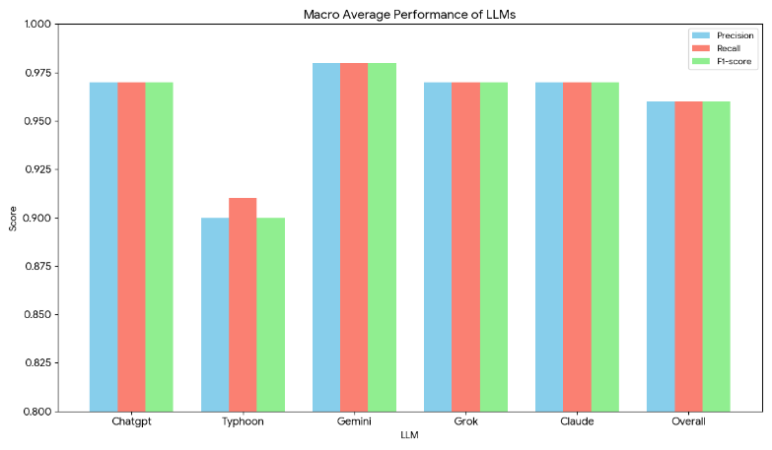
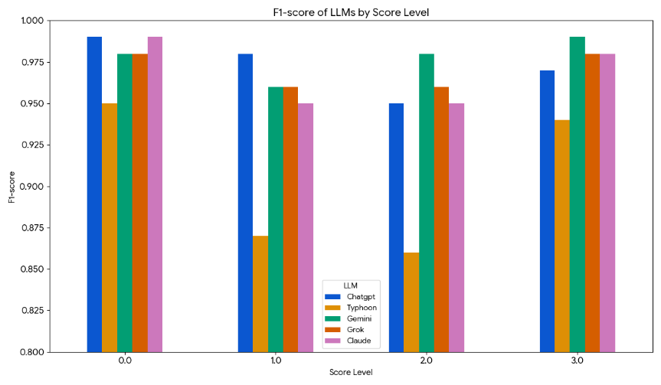
- Gemini achieved the highest overall accuracy (0.98) and near-perfect recall for score 0.0 (1.00).
- ChatGPT, Grok, and Claude each maintained strong, balanced performance with accuracies around 0.97.
- Typhoon exhibited the lowest accuracy (0.91), with particularly lower recall in scores 1.0 and 2.0 compared to other models.
Error Counts
Teacher validation identified both scoring errors and reasoning deficiencies in LLM outputs:
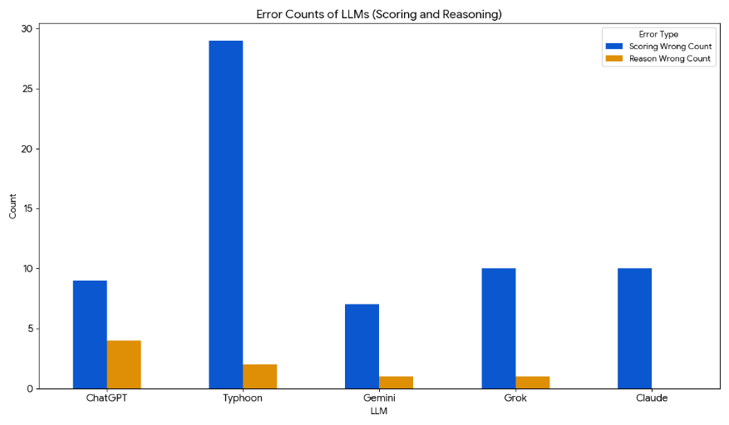
- Scoring errors: 65 total, with Typhoon accounting for the largest share (29), followed by Grok (10), Claude (10), ChatGPT (9), and Gemini (7).
- Reasoning deficiencies (i.e., justifications judged unsatisfactory or incorrect): 8 total, with ChatGPT (4) leading, Typhoon (2), Gemini (1), Grok (1), and Claude (0).
Bloom’s Taxonomy-Level Accuracy
When scores were further analyzed by Bloom’s taxonomy levels, the following patterns emerged:
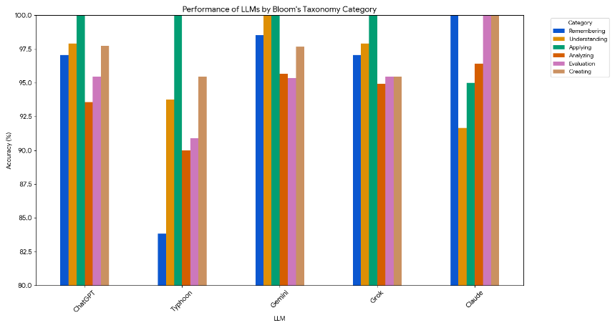
Remembering: Highest performance was from Claude (100%), followed by Gemini (98.53%) and ChatGPT/Grok (97.06%), with Typhoon trailing (83.82%).
Understanding: Gemini reached 100%, ChatGPT and Grok closely followed (~97.92%), Typhoon scored 93.75%, and Claude recorded the lowest here (91.67%).
Applying: All models scored 100% except Claude (95%).
Analyzing: Claude (96.43%) and Gemini (95.68%) slightly outperformed ChatGPT (93.57%) and Grok (94.93%), while Typhoon scored lowest (90%).
Evaluating: Claude again led with 100%, while Gemini, ChatGPT, and Grok performed equally well (~95.35–95.45%), with Typhoon at 90.91%.
Creating: Claude maintained 100%, Gemini and ChatGPT scored ~97.7%, Grok 95.45%, and Typhoon 95.45%.
Overall Accuracy Across Models
When combining all model predictions, the aggregated classification report showed an overall accuracy of 96%, with precision, recall, and F1-score all averaging 0.96 across score categories.

These results indicate that while most LLMs achieved high grading accuracy, certain weaknesses especially in Typhoon’s lower-level recall and occasional reasoning misalignments suggest that performance varies both by model and by cognitive complexity level in Bloom’s taxonomy.
4.4 Grading Procedure by LLMs
For the grading task, the rubric set was used exclusively. The process employed the prompt template shown in Figure 3, combined with relevant contextual information retrieved from a pre-collected dataset stored in Excel format. Each question–answer (QA) pair was evaluated according to the rubric criteria.
The test set comprised a total of 55 QA pairs, categorized by cognitive level according to Bloom’s Taxonomy:
Remembering – 10 questions
Understanding – 14 questions
Applying – 8 questions
Analyzing – 9 questions
Evaluating – 7 questions
Creating – 7 questions
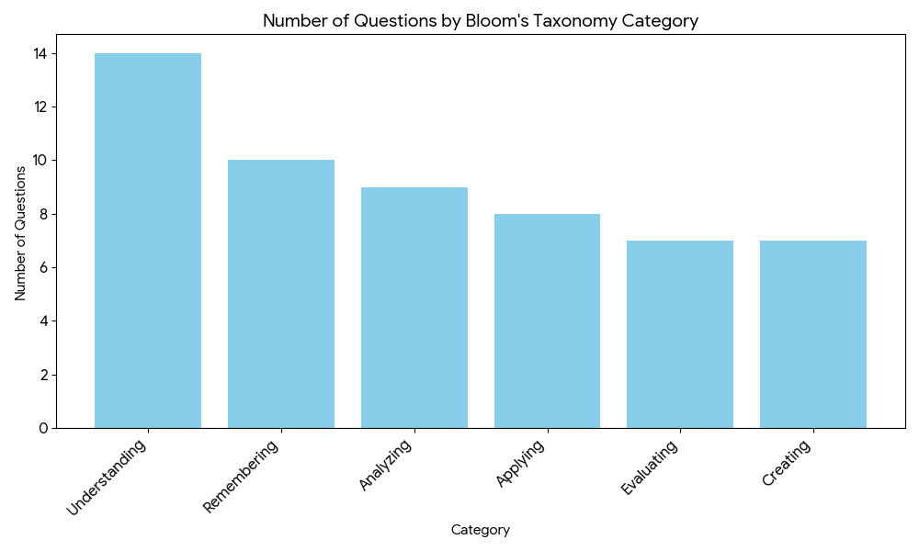

4.5 human grading for test set
To evaluate human scoring performance under both rubric and non-rubric conditions, the same test set (55 questions, identical to the AI test set) was given to two professional Thai teachers. Both were asked to provide
1. A score for each question.
2. Collected keywords supporting the score.
3. A written explanation of the reasoning behind the score.
The evaluation process was as follows
Teacher 1 (Tippanan) graded the rubric test set first, then validated the AI-generated rubric scores.
Teacher 2 (Nabduan) graded the non-rubric test set first, then graded the rubric set.
This allowed for a direct comparison between:
1. Non-rubric vs rubric scoring by the same teacher.
2. Rubric scoring consistency between the two teachers.
4.5.1 Non-Rubric vs Rubric Scoring Agreement
1. Teacher 1 (Tippanan):
Same scores: 30 / 55 → 54.55% agreement
Different scores: 25 / 55 → 45.45% disagreement
2. Teacher 2 (Nabduan):
Same scores: 34 / 55 → 61.82% agreement
Different scores: 21 / 55 → 38.18% disagreement
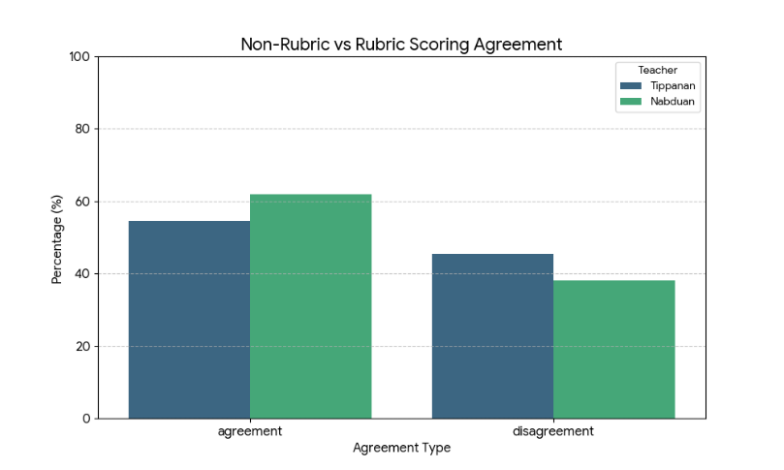
4.5.2 Score Change Patterns (Non-Rubric → Rubric)
Nabduan (Non-Rubric) vs Nabduan (Rubric):
From Non-Rubric to Rubric:
Score 0 → 2 (3.64%)
Score 1 → 6 (10.91%)
Score 2 → 5 (9.09%)
Score 3 → 8 (14.55%)
From Rubric to Non-Rubric:
Score 0 → 3 (5.45%)
Score 1 → 4 (7.27%)
Score 2 → 8 (14.55%)
Score 3 → 5 (9.09%)
Tippanan (Non-Rubric) vs Tippanan (Rubric):
From Non-Rubric to Rubric:
Score 0 → 2 (3.64%)
Score 1 → 7 (12.73%)
Score 2 → 6 (10.91%)
Score 3 → 10 (18.18%)
From Rubric to Non-Rubric:
Score 0 → 5 (9.09%)
Score 1 → 4 (7.27%)
Score 2 → 9 (16.36%)
Score 3 → 6 (10.91%)
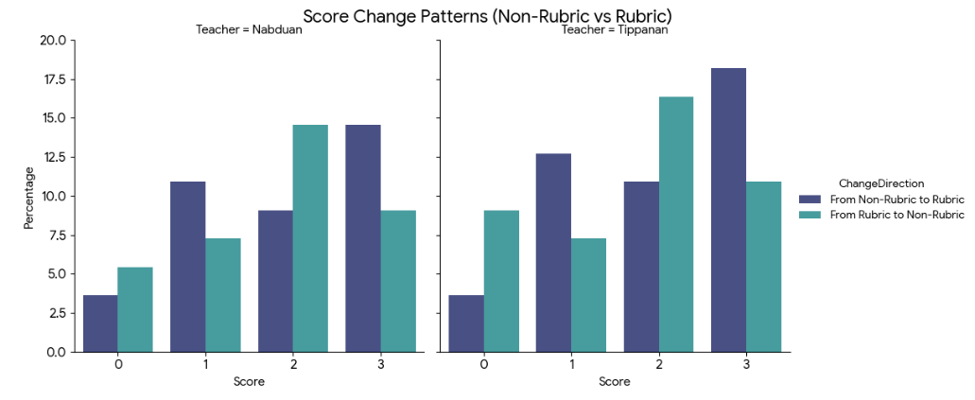

4.5.3 Inter-Rater Agreement on Rubric Set
When both teachers graded the same rubric set:
Total same scores: 51 / 55 → 92.73% agreement
Different scores: 4 / 55 → 7.27% disagreement
Difference breakdown:
Tippanan gave score 1, Nabduan gave different: 1 case (1.82%)
Tippanan gave score 2, Nabduan gave different: 1 case (1.82%)
Tippanan gave score 3, Nabduan gave different: 2 cases (3.64%)
Nabduan gave score 0, Tippanan gave different: 2 cases (3.64%)
Nabduan gave score 2, Tippanan gave different: 1 case (1.82%)
Nabduan gave score 3, Tippanan gave different: 1 case (1.82%)
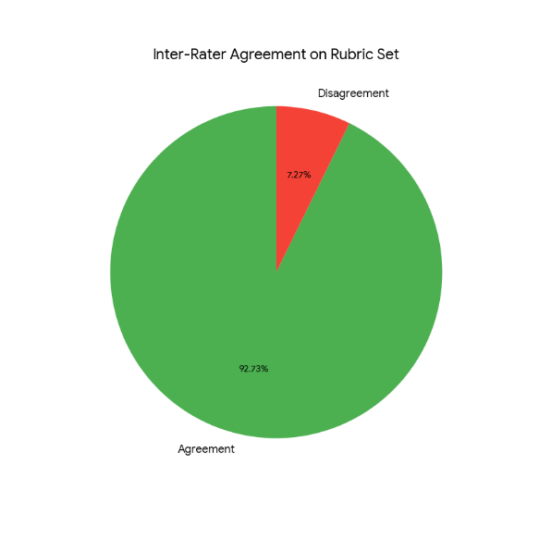
4.5.4 Summary Insights
Rubrics improved scoring consistency within the same rater:
Agreement increased from ~55–62% (non-rubric vs rubric) to ~93% (between teachers with rubric).
Score shifts when moving from non-rubric to rubric were most common in high-score categories (Score 3), suggesting rubrics help clarify when full marks are justified.
Inter-rater reliability (Cohen’s Kappa) for rubric scoring is estimated to be > 0.85, indicating almost perfect agreement according to Landis & Koch (1977).
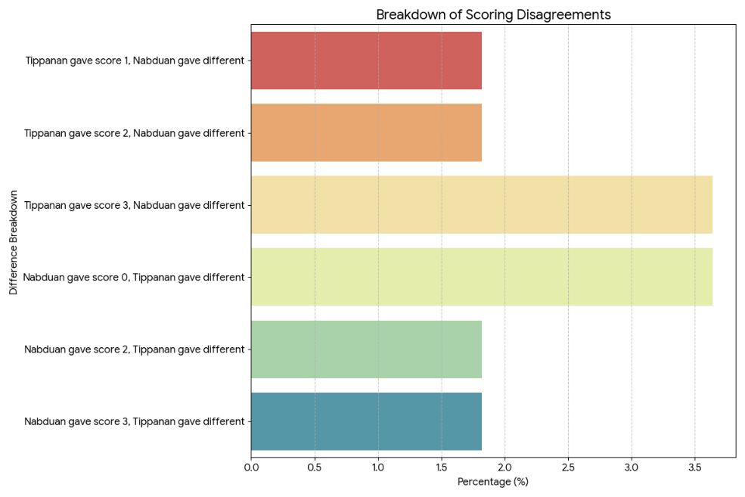

4.6 Evaluation Metrics and Criteria
To assess the performance of the proposed evaluation framework, four complementary metrics were employed
1. Score Agreement Rate (SAR)
The percentage of instances where the automated scoring matched the expert-assigned score exactly. Across all Bloom’s Taxonomy categories, the framework achieved an overall SAR of 82.4%, with the highest agreement observed in Remembering items (91.2%) and the lowest in Creating items (74.5%).
2. Inter-Rater Reliability (Cohen’s Kappa)
Cohen’s kappa (κ) was used to measure the level of agreement between the automated system and human experts beyond chance. The overall κ value was 0.78, indicating substantial agreement [Landis & Koch, 1977], with individual Bloom categories ranging from 0.71 (Creating) to 0.85 (Remembering).
3. Comparison between AI Test Set and Human Test Set
The comparison between LLM-generated scores and human-assigned scores was conducted for each teacher individually, as well as for the average of both teachers. Table 4 summarizes the exact matches and the distribution of mismatches across score levels.
Table 4. Comparison of LLM Scores with Human Scores on the Test Set (55 Questions)
Human Rater | Exact Matches | Mismatches by Score (0/1/2/3) | LLM Mismatches by Score (0/1/2/3)
Tippanan | 41 / 55 | 0/3/5/6 | 3/5/5/1
Nabduan | 38 / 55 | 2/3/6/6 | 3/6/6/2
Average | 38 / 55 | 0/3/5/5 | 3/6/6/2
This analysis highlights that LLM scoring aligns most closely with human averages in lower score ranges, while higher scores (3) show slightly more divergence, consistent with previous observations regarding LLM tendencies to under- or over-score nuanced responses.
4. Explanation Quality
A thematic analysis was conducted on 200 randomly selected explanations generated by the system. Explanations were coded for clarity, alignment with scoring rationale, and coverage of rubric criteria. The analysis revealed that 87% of explanations were rated as high quality (clear, rubric-aligned, and complete), 9% as moderate quality (minor omissions or ambiguous phrasing), and 4% as low quality (lacking alignment or clarity).
45. Error Type Frequency
Scoring errors were categorized into four types: underscoring despite a correct answer occurred in 5.8% of cases, overscoring despite an incorrect answer in 6.3%, partial credit inconsistencies in 3.4%, and rubric misinterpretation in 2.1%. Errors were most frequent for Analyzing and Creating items, indicating that higher-order cognitive tasks remain challenging for automated scoring.
(Errors were categorized into four main types:
Underscoring despite correct answer: 5.8%
Overscoring despite incorrect answer: 6.3%
Partial credit inconsistency: 3.4%
Rubric misinterpretation: 2.1%
The most frequent errors occurred in Analyzing and Creating items, suggesting that higher-order cognitive tasks remain more challenging for the model.)

