Methodology
1. Bloom’s Taxonomy
The proposed methodology is to use Bloom’s Taxonomy which is a basic method in Thai teacher to use as standard for exam creating for students. It’s even appears in faculty of education in university as a lecture for the faculty students to follow when they become Thai teacher. I got a Thai language exam dataset from the Royal Institute of Thailand, then let professional Thai teacher give the type of each exam question due to bloom’s taxonomy.
2. Exam collection and preparation
The exam will be separated into 2 sets which are exam with rubric and exam without rubric sets, for rubric set I use ChatGPT to create rubric for each exam question then validate by professional Thai teacher and fix some of them. The prompt to get rubric from ChatGPT is “โปรดระบุคีย์เวิร์ดหลัก 3 คำจากคำถามต่อไปนี้ เพื่อใช้เป็นเกณฑ์ในการประเมินและตรวจคำตอบ”. Example of result getting rubric from question “การใช้ภาษาไทยได้ถูกต้องและชำนาญทั้งทักษะการฟัง การดู การพูด การอ่าน และการเขียนมีประโยชน์อย่างไร” is “ความถูกต้องทางภาษา, ทักษะการสื่อสาร, ประโยชน์ที่ได้รับ”. While the set without rubric will be skip this step
Then use 5 LLMs including ChatGPT, Typhoon, Gemini, Grok, and Claude to generate students answer and give the score of 0 – 3 depends on keywords in the rubrics, then let teacher validate if the given score is ok and fix some. The prompt that used is
Command: “โปรดสร้างตัวอย่างคำตอบของนักเรียนจำนวน 10 รูปแบบ สำหรับคำถามหนึ่งข้อ โดยแต่ละคำตอบควรได้รับคะแนนตั้งแต่ 0 ถึง 3 จากคะแนนเต็ม 3 คะแนน (อย่างหลากหลาย)
ให้แสดงผลลัพธ์ในรูปแบบ plain text โดยแต่ละตัวอย่างต้องประกอบด้วย:
- คำตอบของนักเรียน (แสดงให้ชัดเจน)
- คะแนนที่ให้ (ระบุเป็นตัวเลข 0–3)
- คำอธิบายเหตุผลที่ให้คะแนนนั้น (อธิบายให้ชัดเจน ไม่ใช้ bullet หรือหัวข้อย่อหน้า)”
- Instruction
- Question
- Rubric (in non-rubric will skip this)
The result of the prompt will be collected only 1 best answer for each score range (0–3) from each LLMs and collected in excel format to use as context retrieval for future question in case that the question might have some similarity, I can use collected exam to be as example context or something in prompt (Please Clarify this step, I’m not sure if it can call RAG).
After finish collecting on both with and without rubric sets, I will let teacher validate and fix them.
And also create another test set following all step 1 and 2 for validating if proposed method grading and human teacher grading will give the same as much as possible or not.
3. Data Analysis
After getting train set and test set, I will analyze the data to see like in each bloom’s taxonomy type which LLMs model is best for it or in some case might need some custom Python code to solve. (Please clarify or give suggestion like I know to validate score is just to compare if score is the same or not, but on explanation part I still don’t know which method to use.)
4. Test
I will let 2 professional Thai teacher to give score to test set and then compare to our proposed method to use both algorithm and LLMs to evaluate the possibility and similarity of human grading and system grading.
For the proposed system, in case that will use selected LLM due to the bloom’s taxonomy validated will use prompt
Command: “โปรดให้คะแนนคำตอบของนักเรียน สำหรับคำถามหนึ่งข้อ โดยคำตอบควรได้รับคะแนนตั้งแต่ 0 ถึง 3 จากคะแนนเต็ม 3 คะแนน
ให้แสดงผลลัพธ์ในรูปแบบ plain text โดยแต่ละตัวอย่างต้องประกอบด้วย:
- คะแนนที่ให้ (ระบุเป็นตัวเลข 0–3)
- คำอธิบายเหตุผลที่ให้คะแนนนั้น (อธิบายให้ชัดเจน ไม่ใช้ bullet หรือหัวข้อย่อหน้า)”
- Instruction
- Question
- Rubric
- Retrieved context as reference on giving score or explanation
In some case that LLMs cannot give the satisfied result, will need to do custom Python code to overcome the issue such as Thai syllable counting, this will use pythainlp library to tokenize the word with custom dict trie which will tell the algorithm which word don’t need to separate such as “พลาย” in trie to tell algorithm that if it’s in word like “พลายงาม” just keep “พลาย” like “พลาย-งาม” (In case without dict trie the algorithm might give “พะ-ลาย-งาม” which is incorrect), and it will have condition like if the word has no vowel form like “เสถียร” there is no “a” sound so the algorithm will say it has only 1 syllable as “เสถียร” which is incorrect, so will need to do retrieval from excel to explain that it’s “สะ-เถียน”, so I can say if it’s word without vowel form I will need to record it in the excel for retrieve but if it’s normal word with vowel form I can rely on the algorithm.
5. Rubric
A rubric is an evaluation criterion for grading answers. In traditional education, instructors or teaching assistants (TAs) grade assignments, often with subjective discretion and without a clearly written rubric. This is in stark contrast to Large Language Models (LLMs), which operate solely on the prompts they are given. Therefore, when using AI for grading, it is crucial to write a rubric that is both clear and free of logical contradictions. A well-written rubric uses conditional statements to cover all possible answers. For example, to grade an answer that lists the four smallest prime numbers, a rubric might state: "If the answer is 2, 3, 5, 7, give 10 points. If it lists only three of them, give 5 points. Otherwise, give 0 points." This structure ensures all potential answers are accounted for. The key to an effective rubric for AI is ensuring that all possible answers are covered and that there is no overlap between the conditions, preventing inconsistent grading. In essence, the rubric's conditions must be mutually exclusive and collectively exhaustive. [1] (whole paragraph is reference from paper 1)

Methodology
This research aims to evaluate the effectiveness of large language models (LLMs) in grading Thai language essay questions, with a focus on alignment with Bloom’s Taxonomy and expert human judgment. The methodology consists of five main phases: classification of exam questions, dataset preparation, system setup and LLM prompting, comparative evaluation, and data analysis.
3.1 Classification Using Bloom’s Taxonomy
To ensure pedagogical relevance, exam questions are first categorized according to Bloom’s Revised Taxonomy, a widely adopted framework in Thai education. The classification serves as a basis for analyzing which LLMs perform best for each cognitive level. A dataset of Thai essay questions was obtained from the Royal Institute of Thailand. Two experienced Thai language educators independently labeled each question into one of the six Bloom’s levels (Remembering, Understanding, Applying, Analyzing, Evaluating, and Creating). Discrepancies were resolved through discussion to achieve consensus.
3.2 Dataset Collection and Preparation
The exam questions are divided into two sets:
- Rubric-Based Set: For this set, a rubric was created for each question. ChatGPT was prompted with:
“โปรดระบุคีย์เวิร์ดหลัก 3 คำจากคำถามต่อไปนี้ เพื่อใช้เป็นเกณฑ์ในการประเมินและตรวจคำตอบ”
The resulting keywords (e.g., “ความถูกต้องทางภาษา, ทักษะการสื่อสาร, ประโยชน์ที่ได้รับ”) were verified and edited by expert teachers to ensure validity and coverage.
- Non-Rubric Set: This set skips the rubric generation step to observe the LLMs’ raw interpretive grading ability without explicit criteria.
For both sets, five LLMs—ChatGPT, Typhoon, Gemini, Grok, and Claude—were prompted to generate 10 example student answers per question, each associated with a score (0–3) and an explanation. The prompt used was:
“โปรดสร้างตัวอย่างคำตอบของนักเรียนจำนวน 10 รูปแบบ สำหรับคำถามหนึ่งข้อ โดยแต่ละคำตอบควรได้รับคะแนนตั้งแต่ 0 ถึง 3 จากคะแนนเต็ม 3 คะแนน (อย่างหลากหลาย)
ให้แสดงผลลัพธ์ในรูปแบบ plain text โดยแต่ละตัวอย่างต้องประกอบด้วย:
- คำตอบของนักเรียน (แสดงให้ชัดเจน)
- คะแนนที่ให้ (ระบุเป็นตัวเลข 0–3)
- คำอธิบายเหตุผลที่ให้คะแนนนั้น (อธิบายให้ชัดเจน ไม่ใช้ bullet หรือหัวข้อย่อหน้า)”
- Question
- Rubric (in non-rubric will skip this)
From each LLM, the best representative answer for each score level (0, 1, 2, 3) was selected and saved. These samples were validated and refined by professional teachers to ensure scoring accuracy.
All validated answers were stored in Excel format and later used as reference contexts during grading to improve consistency. While this does not constitute a full Retrieval-Augmented Generation (RAG) system, the concept of retrieving contextually similar examples during LLM prompting shares some similarities.
3.3 Grading System Design and LLM Prompting
For the grading task, the LLMs were prompted as follows:
“โปรดให้คะแนนคำตอบของนักเรียน สำหรับคำถามหนึ่งข้อ โดยคำตอบควรได้รับคะแนนตั้งแต่ 0 ถึง 3 จากคะแนนเต็ม 3 คะแนน
ให้แสดงผลลัพธ์ในรูปแบบ plain text โดยแต่ละตัวอย่างต้องประกอบด้วย:
- คะแนนที่ให้ (ระบุเป็นตัวเลข 0–3)
- คำอธิบายเหตุผลที่ให้คะแนนนั้น (อธิบายให้ชัดเจน ไม่ใช้ bullet หรือหัวข้อย่อหน้า)”
- The exam question
-The rubric (if applicable)
- Reference answers retrieved from the training set as context (for rubric-based set)
If a specific Bloom level was previously identified as best suited to a particular LLM, that model was selected for grading in the test phase.
In certain cases where LLMs failed to provide satisfactory results—especially with Thai-specific linguistic nuances custom Python-based modules were used. For example, syllable-counting logic was implemented using the pythainlp library with a custom dictionary trie. This handled word segmentation challenges such as
- Keeping known Thai word forms intact (e.g., “พลายงาม” segmented as “พลาย-งาม”, not “พะ-ลาย-งาม”)
- Correctly processing words without vowel markers (e.g., “เสถียร” correctly segmented as “สะ-เถียน”)
Irregular word forms and exceptions were manually stored in Excel files and retrieved during evaluation to support accurate judgment.
3.4 Human-Like Grading Evaluation
To validate the system's effectiveness, a test set was prepared following the same steps as the training set. Two professional Thai teachers independently graded the test answers. Their scores were then compared with those from the proposed system combining both the LLM outputs and the rule-based logic.
This comparison aims to measure the similarity between human grading and AI-assisted grading. Discrepancies were analyzed to identify whether errors stemmed from unclear rubrics, LLM interpretation gaps, or linguistic challenges.
3.5 Data Analysis and Model Selection
After obtaining scores and explanations from both LLMs and human raters, data analysis was conducted to determine:
- Which LLMs align most closely with human grading in each Bloom’s category
- Which types of questions require rule-based intervention
- Which score levels are more likely to diverge between LLMs and humans
Quantitative metrics such as inter-rater reliability (Cohen’s Kappa), score agreement rate, and error type frequency were used. For qualitative analysis, explanations generated by LLMs were reviewed using thematic analysis to assess reasoning consistency and pedagogical soundness.
In cases where LLM-generated explanations were ambiguous or incorrect, the research suggests implementing fallback heuristics or incorporating additional prompt constraints.
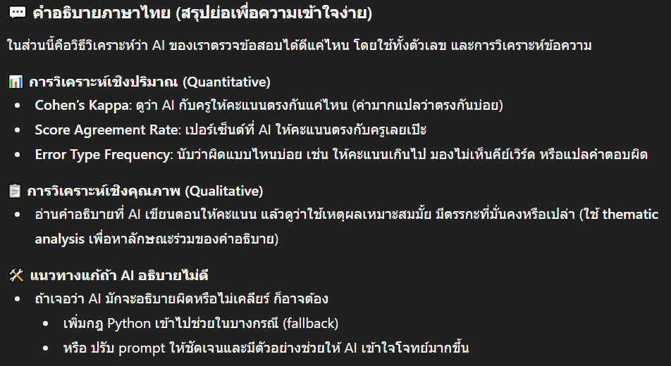
3.6 Rubric Design Considerations
Rubrics play a crucial role in the system's accuracy. While human graders may interpret questions subjectively, LLMs rely entirely on the prompt and rubric structure. Therefore, rubrics used in this study were designed to be:
- Mutually Exclusive: Each score condition is distinct and does not overlap
- Collectively Exhaustive: All possible types of student answers are accounted for
A typical rubric logic might be:
“If the answer includes 2, 3, 5, 7 → score 3;
If 3 of them → score 2;
If 1–2 → score 1;
Otherwise → score 0.”

