IP Tile – Jesús Esparza

## Overview

This tile was designed by the student Jesús Esparza as part of a custom microcontroller (uC) implementation. The design represents a minimalist yet functional 8-bit microcontroller, tailored for didactic and experimental purposes. It features a reduced instruction set composed of 16 essential operations, enabling memory access, I/O handling, control flow, and arithmetic/logic execution.

The internal architecture is structured around a simplified two-state finite state machine (FSM), which transitions between:

* FETCH – retrieves the instruction from program memory and decodes.
* EXECUTE – performs the operation.

**Instruction Set**

The instruction format uses a 16-bit word, segmented into an opcode and three additional fields (registers or immediate values, depending on the operation). The complete instruction set is summarized below:

|  |  |  |  |  |  |
| --- | --- | --- | --- | --- | --- |
| INSTRUCTION | DATA[15:0] | | | | DESCRIPTION |
| OPCODE | BYTE 2 | BYTE 1 | BYTE 0 |
| NOP | 0x0 | x | x | x | Does nothing. Typically used for delay or alignment. |
| LOAD | 0x1 | reg_dst | ram_addr_src | | Loads a value from memory (ram_addr_src) into reg_dst |
| STORE | 0x2 | reg_src | ram_addr_dst | | Stores the contents of reg_src into memory at ram_addr_dst. |
| JMP | 0x3 | pc_dst | | | Unconditionally jumps to program counter address pc_dst |
| BEQ | 0x4 | pc_dst | | | Jumps to pc_dst if the last comparison (CMP) was equal. |
| BC | 0x5 | pc_dst | | | Jumps to pc_dst if a carry-out occurred in the last add (ADD). |
| IN | 0x6 | reg_dst | data_in* | | In bootstrap mode data_in storages in reg_dst, if it is not bootstrap mode reads data from input port and stores it in reg_dst, and data_in don’t care (xx). |
| OUT | 0x7 | reg_src | x | out_port | Sends the contents of reg_src to an output port (PORT0 or PORT1). |
| ADD | 0x8 | reg_dst | reg_a | reg_b | Adds reg_a and reg_b; stores the result in reg_dst. Sets the carry flag. |
| SUB | 0x9 | reg_dst | reg_a | reg_b | Subtracts reg_b from reg_a; result is stored in reg_dst. |
| AND | 0xA | reg_dst | reg_a | reg_b | Performs bitwise AND on reg_a and reg_b; stores the result in reg_dst. |
| OR | 0xB | reg_dst | reg_a | reg_b | Performs bitwise OR on reg_a and reg_b; stores the result in reg_dst. |
| NOT | 0xC | reg_dst | reg_a | x | Bitwise NOT on reg_a; result is stored in reg_dst. |
| CMP | 0xD | x | reg_a | reg_b | Compares reg_a and reg_b; updates equality flag but stores no result. |
| SHR | 0xE | reg_dst | reg_a | reg_b | Right shifts reg_a by reg_b bits; result stored in reg_dst. |
| SHL | 0xF | reg_dst | reg_a | reg_b | Left shifts reg_a by reg_b bits; result stored in reg_dst. |

**Memory Mapping**

The microcontroller implements a memory map to support dual-phase operation:

* Bootstrapping mode (addresses 0x000 to 0x1FF): This region is writable using the IN instruction and can be used to pre-load register values or instructions during the initialization phase.
* Execution mode (addresses 0x200 and above):  
  This region is dedicated to program execution. The control unit fetches and decodes instructions from this area once the system exits bootstrap mode.

**Microarchitecture**

The microcontroller consists of the following main components:

* Program Counter (PC): Generates instruction addresses, supports jumps and branches.
* ALU (Arithmetic Logic Unit): Supports 8-bit operations including addition, subtraction, logic gates, shifts, and comparisons.
* SRAM (Registers Bank): Allows read/write access to 256x8-bit memory block using dedicated control signals (write_en, saddr, data_in/out).
* GPIO: Facilitates communication with the outside world via in_gpio and out_gpio.
* Control Unit (CU): A finite-state machine that orchestrates instruction sequencing and data routing.

## Usage Guide

**Folder Structure Requirement**

Make sure you execute the script from inside the 'equipo_16' directory, where the following files are present:

* csr.py
* tests.py
* interface.py
* programs.py

**Usage**

Example command to run the default multiplication program:

*python tests.py --test mul --cycles 1000 --inputs 9 5*

**Command-Line Arguments**

|  |  |  |  |
| --- | --- | --- | --- |
| Argument | Type | Default | Description |
| --test | str | "mul" | Name of the test program to execute. Must match a keyword defined in programs.py. |
| --cycles | int | 1000 | Number of cycles the test will run. Controls duration. |
| --verbose | flag | False | Enables detailed output for debugging. |
| --inputs | int list | [9, 4] | List of integer inputs for the test program. |

**Important Note**

Before running any test, press the lower-right push button on the FPGA board to reset the system. This ensures proper synchronization over the UART interface.

**Case 1**

Inputs: 9, 5 → Result: 9 x 5 = 45 → Binary: 0b101101

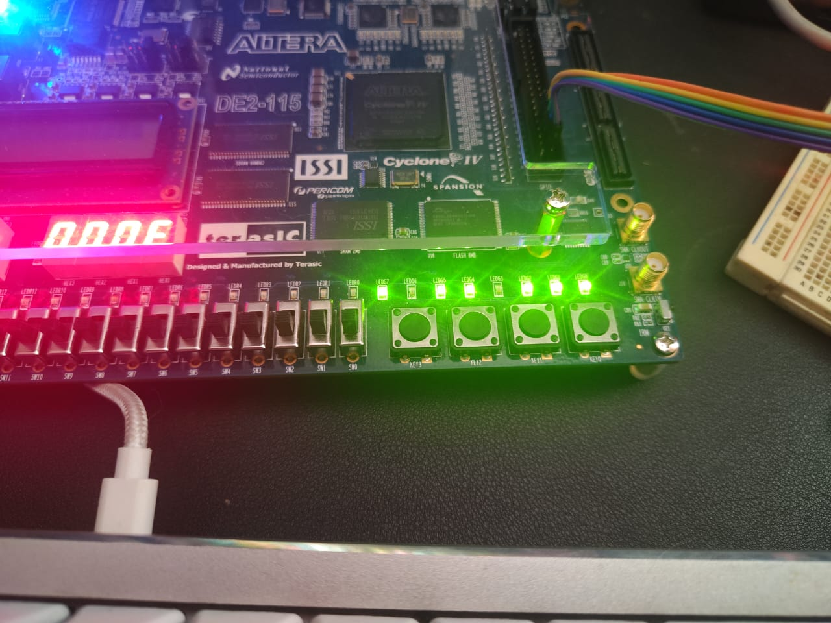

**

Inputs: 7, 6 → Result: 7 x 6 = 42 → Binary: 0b101010

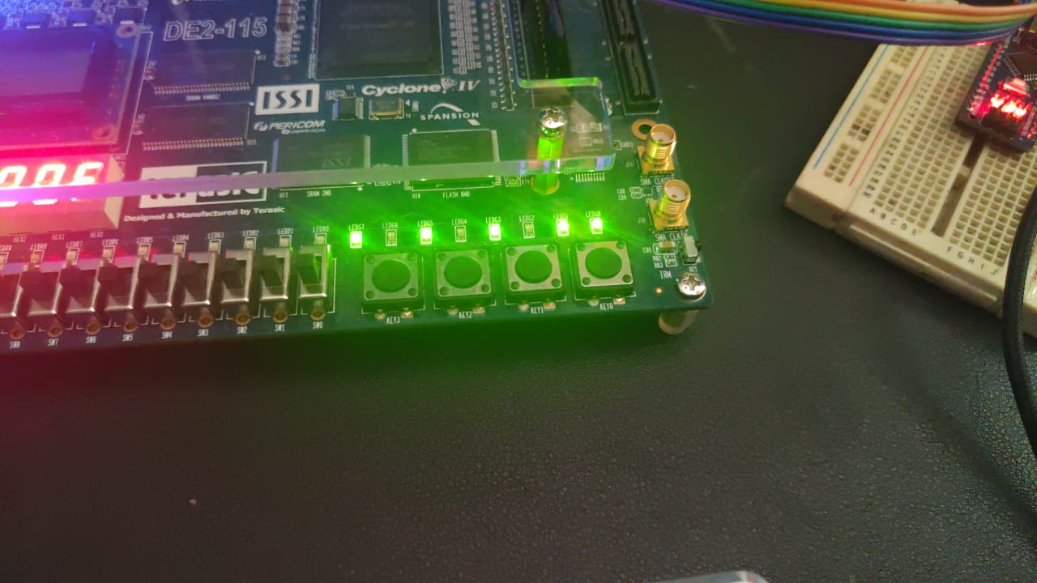

**Custom Programs**

By default, only the 'mul' program is defined in programs.py. To create and run additional tests:

* Add a new keyword in programs.py and define the instruction sequence.
* Run: python tests.py --test <your_keyword> --cycles 1000

**Purpose of the "mul" Program**

The 'mul' test program demonstrates how multiplication can be implemented using only 9 out of the 16 available instructions in the ISA: LOAD, STORE, IN, OUT, ADD, SUB, JMP, BEQ, and NOP. It showcases the uC’s capability to execute non-trivial logic using minimal instruction resources. The next picture show the program.

