u22519042&u21456552 COS 214 PRAC 3

Task 1:

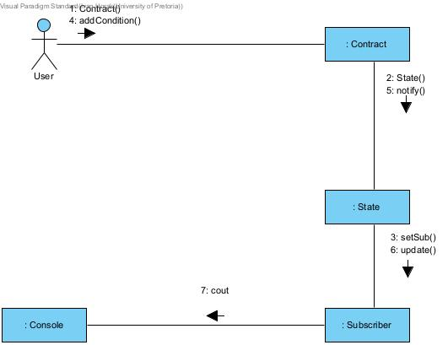

Task 2: