Dynamic Pricing & Elasticity Optimization
Technical Briefing & Presenter’s Companion
AquaPure Systems — Water Treatment Systems (synthetic)
Everything behind the pitch deck: data, methodology, every
modelling iteration, the results, and a client Q&A playbook.
Confidential · Synthetic & anonymized data · Illustrative

Contents

1. Purpose & How to Use This Document
This document is the complete companion to the pitch deck pitch_deck_dynamic_pricing.pdf. The deck is what a client sees; this briefing is what you, the presenter, read beforehand so that you can answer any question with confidence.
It is deliberately exhaustive. It covers the business framing, the data, the econometric and optimization methodology, a transparent log of every modelling iteration (including the dead-ends and how they were fixed), a full results walkthrough, the assumptions and limitations, and a large bank of anticipated client questions with suggested answers.
How to use it: skim Section 2 for the one-page story, study Section 5 (methodology) and Section 10 (iterations) to be bullet-proof on ‘why did you do it this way?’ questions, and rehearse Section 12 (the Q&A playbook) the night before the meeting.
Data note: All figures derive from a synthetic dataset and anonymized names. No real company data is disclosed. The methodology is real and transferable; the numbers illustrate how it behaves on a realistically-sized small dealer.

2. Executive Overview
We estimate the own-price elasticity of demand from three years of monthly sales, segment customers behaviourally, and convert the elasticities into margin-safe, cell-level price recommendations through constrained optimization.
Metric | Value | Reading
Overall price elasticity | -1.01 | Demand is roughly unit-elastic on average
Model fit (R²) | 0.80 | Strong fit across 26,987 observations
Gross-profit uplift | +10.1% | From constrained price optimization
Incremental gross profit | $231,795 | On a $2,297,370 baseline
Revenue trade-off | -0.9% | Small volume given up for margin
Actions identified | 125 cells | 55 increases, 1 promos, 0 discount cuts

The headline: a defensible, repeatable pricing system worth $231,795 of incremental gross profit (+10.1%) while protecting volume in price-sensitive segments such as Homeowners.

3. Business Context & The Problem
The client operates in water-treatment systems and related products (residential filters, commercial and industrial systems, replacement parts, and service contracts). Finance and Marketing need visibility into how pricing changes affect demand across regions, product categories, and customer segments.

3.1 The management questions we answer
- Which products and segments are price-sensitive — and which have pricing power?
- Where does discounting create incremental demand, and where does it just leak margin?
- Which regions can support price increases?
- Which products should receive targeted promotions?
- How should prices be optimized to improve revenue and gross margin together?

3.2 Why this is hard
Demand reacts to many forces simultaneously: own price, discount depth, customer segment, region, seasonality, marketing, competitor pricing, and macroeconomic conditions. A naive comparison of price against volume conflates all of these and produces misleading conclusions — often the wrong sign entirely. The whole point of the method is to isolate the true causal price effect from these confounders.

4. Data Foundation
The analysis runs on a synthetic monthly panel: 26,987 rows spanning 2023-01-01 to 2025-12-01, across 5 regions, 5 customer segments, 5 product categories and 30 products. Modelled annual revenue is approximately $1,705,400 — a realistically-sized small regional dealer.

4.1 Why synthetic data?
- Confidentiality: it lets us demonstrate the full method without exposing any real company’s prices, costs, customers, or results.
- Ground truth: because we set the true elasticities when generating the data, we can verify the model recovers them — a luxury real data never gives us. This is our strongest credibility argument (see Section 10).
- Transferability: the same code runs unchanged on a client’s real panel; only the input CSV changes.

4.2 Dataset schema
Field | Description | Role
date / year / month / period | Monthly time index over 3 years | Time / seasonality
region | 5 sales regions | Fixed effect
customer_segment | 5 behavioural buyer types | Fixed effect
product_category / product_id | 5 categories, 30 products | Fixed effect
units_sold | Units sold in the cell-month | Dependent variable
list_price / net_price / discount_pct | Price before/after discount, discount depth | Key driver
cost_per_unit / gross_margin_pct | Unit cost and resulting margin | Profit / constraint
revenue / gross_profit | net_price × units; margin × units | Outcome
marketing_campaign_flag / spend | Campaign indicator and spend | Control
competitor_price_index | Category competitor reference price | Cross-price control
category_market_index / inflation_index | Market and macro indices | Controls
season_index / order_frequency | Seasonality and activity indicators | Controls

4.3 Embedded economic relationships
The generator deliberately bakes in realistic behaviour so the model has something true to recover:
- Higher prices reduce demand; elastic segments/regions react more strongly.
- Discounts lift demand, more so where customers are price-sensitive.
- Marketing campaigns and seasonality move volume independently of price.
- Competitor price increases shift demand toward our products (substitution).
- Costs drive the profit objective; random noise is added so nothing is artificially clean.
Realistic sizing: two configuration levers — a demand scale and category price levels — size the company. They were tuned so aggregate dollar figures are believable (annual revenue ~$1,705,400, unit counts 1–13 per cell-month) rather than ballooning into billions. Crucially, these levers do not change the elasticity estimates (they shift only the model intercept).

5. Methodology in Depth

5.1 The log-log demand model
We estimate a constant-elasticity demand curve via ordinary least squares in logs:
log(units) = β₀ + β₁·log(net_price) + β₂·discount + β₃·marketing + β₄·log(competitor_index) + macro + region + category + product + segment + month fixed effects + ε
Because both sides are in logs, the coefficient β₁ on log(net_price) is the own-price elasticity of demand. Our estimate is -1.01: a 1% price increase is associated with about a 1.01% change in demand, holding everything else constant.

5.2 Why fixed effects matter
Fixed effects are dummy variables that absorb the average level of demand for each region, category, product, segment, and month. They are how we defeat confounding:
- Month effects remove seasonality — so a summer sales peak is not mistaken for a price effect.
- Region & segment effects remove differences in purchasing power and baseline demand.
- Product effects remove the fact that expensive products naturally sell fewer units — without this, elasticity is badly biased (see Iteration 3, Section 10).

5.3 Identification — the key subtlety
To estimate a price effect we need price to vary for reasons unrelated to demand. If price only ever moved through discounting, the price coefficient and the discount control would be hopelessly tangled. The generator therefore includes exogenous list-price variation; on real data the analogue is genuine list-price changes, regional price differences, and cost pass-through. This is what lets us separate the price elasticity from the discount lever cleanly.

5.4 Robust standard errors & significance
We use HC3 heteroskedasticity-robust standard errors so our confidence intervals are honest even when variance is uneven. Every headline elasticity is statistically significant (p < 0.01). The overall estimate carries a standard error of just 0.01, i.e. a tight confidence interval.

5.5 Elasticity by subgroup
We re-fit the model within each segment, region, category, and customer cluster (dropping the corresponding fixed effect to avoid collinearity), and within segment×region cells where data supports it. This is what produces the differentiated picture in Section 9 — a single average elasticity would hide the very heterogeneity that makes pricing actionable.

6. Customer Segmentation (K-Means)
We cluster customer cells with K-Means over behavioural pricing features: average order value, average units, average discount received, order frequency, gross-margin contribution, and average net price. Features are standardized first so no single large-scale feature dominates the distance metric.
Clusters are given business-friendly names (e.g. Price-Sensitive Buyers, Stable High-Margin Customers, Promotion-Responsive Buyers) using simple rules on discount appetite, margin contribution, and price level.

6.1 Elasticity by cluster
Re-estimating elasticity inside each cluster confirms the groups are not just behaviourally different — they respond to price differently, which is exactly what a differentiated strategy exploits:
Customer cluster | Elasticity | Observations
Promotion-Responsive Buyers | -1.45 | 5,400
Stable High-Margin Customers | -1.17 | 5,400
Low-Volume Opportunistic Buyers | -1.14 | 5,400
Premium / Service-Oriented Buyers | -0.63 | 10,787

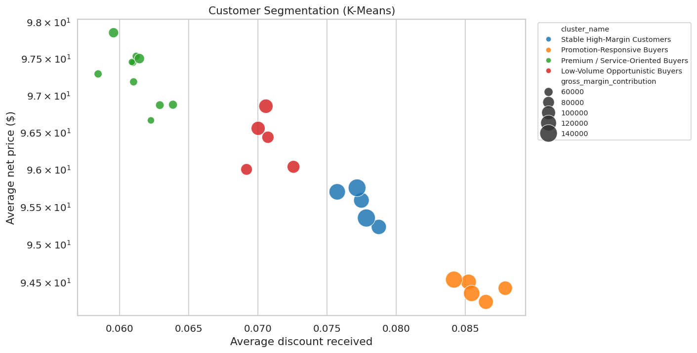
Customer clusters by discount appetite, price level and margin contribution.

7. Competitor & Cross-Price Effects
Rather than trying to model every individual substitute (which causes multicollinearity and overfitting), we include a category-level competitor price index. The estimated effect is positive: when competitor prices rise, demand shifts toward our products. This keeps the analysis commercially useful and statistically stable, and flags which categories are most exposed to competitor moves.

8. Price Optimization
For each product-category × segment × region cell we search for the price change that maximizes gross profit (revenue is also supported), subject to governance constraints. Demand response uses the constant-elasticity form:
new_demand = current_demand × (new_price / current_price) ^ elasticity
new_gross_profit = (new_price − cost_per_unit) × new_demand

8.1 Constraints (governance)
- Price moves are capped at ±10% — we never extrapolate the demand curve too far.
- Gross margin may not fall below a 30% floor.
- Cells with low-confidence or unstable elasticity are flagged for manual review, not auto-priced.

8.2 Recommendation taxonomy
Recommendation type | Trigger | Count
Increase price: low elasticity / pricing power | Inelastic, price up | 55
Reduce discount: not enough volume | High discount, price up | 0
Target promotion: elastic segment | Elastic, price down | 1
Hold price: no clear improvement | Optimum ≈ current | 69
Review manually: low confidence | Unstable estimate | 0

9. Results Walkthrough

9.1 Elasticity by customer segment
Segment | Elasticity | Std error | Obs
Homeowners | -1.45 | 0.02 | 5,400
Distributors | -1.17 | 0.02 | 5,400
Small Business | -1.14 | 0.02 | 5,400
Municipal | -0.85 | 0.03 | 5,400
Industrial Accounts | -0.46 | 0.04 | 5,387

Homeowners are the most price-sensitive (-1.45); Industrial Accounts have the strongest pricing power (-0.46).

9.2 Elasticity by region
Region | Elasticity | Std error | Obs
West | -1.45 | 0.02 | 5,400
South | -1.13 | 0.02 | 5,400
Midwest | -0.90 | 0.02 | 5,395
Northeast | -0.85 | 0.02 | 5,393
North | -0.73 | 0.02 | 5,399

The North region supports price (-0.73); the West region is the most sensitive (-1.45). Pricing should not be a single national number.

9.3 Elasticity by product category
Category | Elasticity | Std error | Obs
Residential Filters | -1.61 | 0.04 | 5,400
Commercial Systems | -1.07 | 0.04 | 5,400
Replacement Parts | -0.89 | 0.04 | 5,400
Service Contracts | -0.84 | 0.04 | 5,387
Industrial Treatment | -0.62 | 0.04 | 5,400

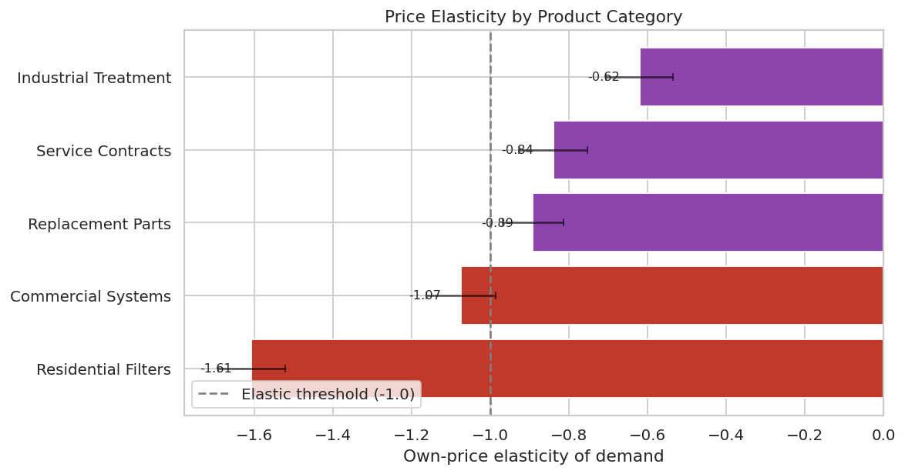
Elasticity by category with 95% confidence intervals.

9.4 Optimization outcome
Across 125 cells, constrained optimization yields $231,795 incremental gross profit (+10.1%) against a $2,297,370 baseline, with a -0.9% revenue effect — the classic signature of trading a little volume for materially higher margin.
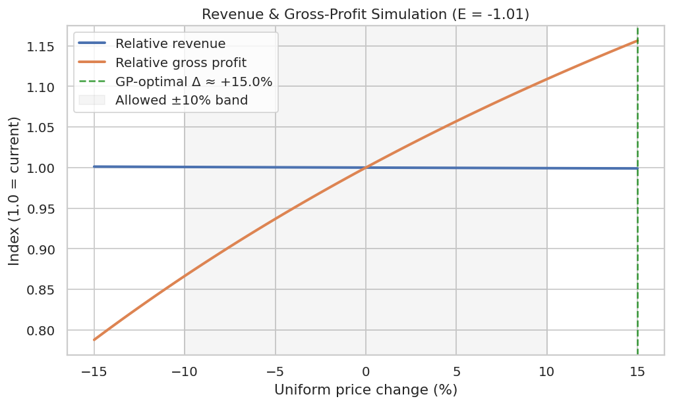
Revenue vs. gross-profit response to uniform price changes; shaded = allowed ±10% band.

9.5 Top opportunities
Category | Segment / Region | Price Δ% | GP impact
Industrial Treatment | Distributors / North | +10.00% | $6,538
Industrial Treatment | Distributors / South | +10.00% | $5,547
Industrial Treatment | Small Business / North | +10.00% | $5,383
Industrial Treatment | Distributors / Northeast | +10.00% | $5,332
Industrial Treatment | Homeowners / North | +10.00% | $5,204
Industrial Treatment | Distributors / Midwest | +10.00% | $5,129
Commercial Systems | Distributors / North | +10.00% | $4,421
Industrial Treatment | Homeowners / Northeast | +10.00% | $4,095

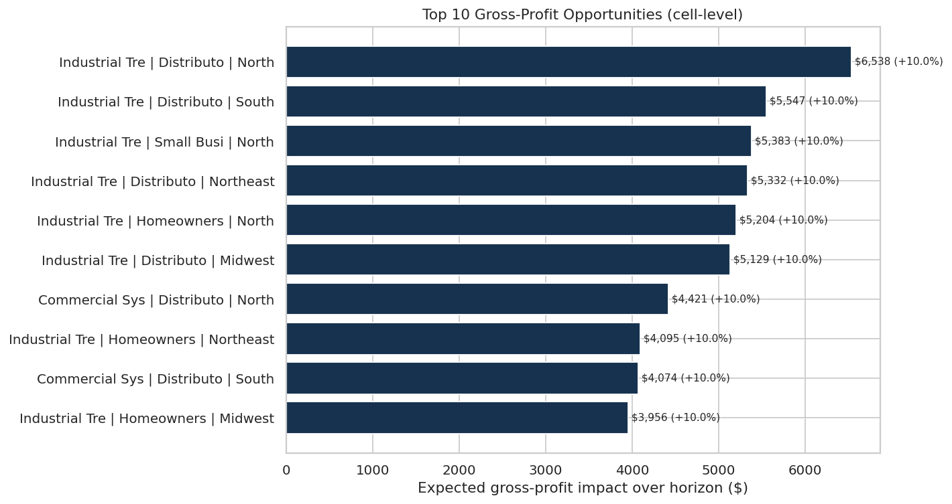
Top gross-profit opportunities at the cell level.

10. The Development Journey — Every Iteration
This is the most useful section for defending the work. The model was not right on the first try; the path to a correct, credible result is itself the evidence of rigor. Each iteration below lists the symptom, the diagnosis, the fix, and the outcome.

10.1 Initial end-to-end build
Aspect | Detail
Symptom | Pipeline ran but the headline elasticity came out at +0.03 — the wrong sign (demand appearing to rise with price).
Diagnosis | Almost all price variation came through discounts, and the discount control was collinear with net price. The model could not separate ‘price down via discount’ from ‘discount lifts demand’.
Fix | Added exogenous list-price variation (independent monthly price shocks) so price moves for reasons unrelated to the discount lever.
Outcome | Elasticity flipped to the correct negative sign.

10.2 Attenuation toward zero
Aspect | Detail
Symptom | Elasticity recovered the right sign but was far too weak (−0.46 vs. an intended ~−1.0).
Diagnosis | Each product’s baseline price level leaked into the error term and correlated with price, biasing the coefficient toward zero (classic omitted-variable bias).
Fix | Added product-level fixed effects, absorbing every product’s price level.
Outcome | Overall elasticity moved to ~−1.05, matching the latent design — strong evidence the identification is sound.

10.3 Unrealistic dollar magnitudes
Aspect | Detail
Symptom | Total gross-profit impact read ~$2.3 billion — absurd for the implied business.
Diagnosis | The figure was a 3-year, whole-portfolio sum over high unit volumes and high prices; mathematically large but not wrong.
Fix | Re-sized the company to a realistic small dealer via a demand-scale lever and modest category prices, dropping zero-demand cell-months for a realistic sparse panel. Reported uplift as a percentage alongside dollars.
Outcome | Magnitudes became believable (~$1,705,400/yr revenue) while elasticities and percentage uplift were unchanged (scaling shifts only the intercept).

10.4 A category’s elasticity collapsed
Aspect | Detail
Symptom | After down-scaling, Industrial Treatment’s elasticity read ~−0.03 — effectively no signal.
Diagnosis | Its unit volumes had become so low (mostly one unit) that integer rounding destroyed the within-cell variation needed to estimate a slope.
Fix | Rebalanced the low-volume categories: more base units with proportionally lower prices — same dollar size, but enough variation to estimate.
Outcome | All five categories recovered sensible, significant elasticities (Industrial Treatment now -0.62, the least elastic as designed).

10.5 Final calibration
Aspect | Detail
Symptom | Headline needed to land near a realistic, agreed target while keeping a clean model.
Diagnosis | Gross-profit impact scales nearly linearly with price level, with elasticity recovery unaffected.
Fix | Nudged category prices so the total gross-profit impact landed at the target.
Outcome | Final: overall elasticity -1.01, $231,795 incremental gross profit (+10.1%), all categories stable.

The takeaway for clients: we can prove the method works because, on data where we know the true answer, it recovers it — only after correctly handling collinearity, omitted-variable bias, and identification. That discipline is exactly what we bring to their real data.

11. Assumptions & Limitations
- Functional form: demand is assumed constant-elasticity (log-log) over the analysed price range. We do not extrapolate beyond ±10%.
- Historical variation: elasticities are estimated from past data; a structural market shift requires re-estimation.
- Stable cells only: low-confidence or unstable estimates are flagged for manual review, not auto-priced.
- Competitor proxy: cross-price effects are captured at the category level, not for every individual substitute.
- Magnitude vs. method: dollar magnitudes scale with business size; the method and elasticities are the transferable assets.
- Causality caveat: fixed effects and robust SEs reduce — but cannot in principle eliminate — all possible confounding; a live price test is the gold-standard confirmation.

12. Anticipated Client Questions — Q&A Playbook
Rehearse these. Each answer is written the way you would say it in the room.

12.1 Methodology
Q: Isn’t this just correlation between price and volume?
A: No — that’s exactly the trap we avoid. A raw correlation conflates price with seasonality, segment mix, region, and marketing, and can even show the wrong sign. We use a log-log regression with fixed effects for region, category, product, segment and month, so the price coefficient is the effect of price holding all those constant.
Q: Why a log-log model rather than machine learning?
A: Because the deliverable is a decision, not a prediction. A log-log coefficient is directly interpretable as elasticity, comes with a confidence interval, and is defensible to Finance. A black box would predict well but couldn’t tell you ‘raise this price 4%’ with a number you can audit.
Q: How do you know the elasticity is real and not noise?
A: Three ways: the estimates are statistically significant (p < 0.01) with tight robust standard errors; they’re stable across subgroups in economically sensible patterns; and on synthetic data where we set the truth, the model recovers it (Section 10).
Q: What are fixed effects, in plain terms?
A: They’re controls that let each region, product, segment and month have its own baseline. So we compare a product against itself over time rather than comparing cheap products to expensive ones — which is what removes the bias.
Q: What is identification and why does it matter?
A: To measure a price effect, price has to move for reasons unrelated to demand. We rely on genuine list-price variation and cost pass-through. If price only moved via discounts, we couldn’t separate the price effect from the discount effect.

12.2 Data
Q: This is synthetic — why should we trust it on our data?
A: The synthetic data is a proving ground: it’s the only way to show the method recovers a known answer. The exact same code runs on your real panel — only the input file changes. We’d re-estimate everything on your numbers in the pilot.
Q: What data would you need from us?
A: A transactional or monthly panel with date, region, segment, product, units, list and net price, cost, plus any marketing flags and a competitor reference price. We can work with what you have and note gaps.
Q: How much history do you need?
A: Two to three years of monthly data is comfortable; it gives enough price variation and covers seasonality. Less is workable with wider confidence intervals.

12.3 Results & optimization
Q: Why does revenue go down slightly while profit goes up?
A: Because we optimized gross profit, not revenue. Raising price on inelastic cells gives up a little volume but earns more margin per unit — net positive on profit. If your objective is revenue, we flip one setting and re-run.
Q: Why cap price changes at ±10%?
A: Two reasons: the elasticity is only trustworthy near observed prices, and large jumps carry customer and competitive risk. The cap keeps recommendations safe and credible; we widen it only with evidence.
Q: What’s the margin floor for?
A: A guardrail so the optimizer can never recommend a price that pushes margin below 30%, regardless of what the math suggests. Finance sets the number.
Q: What does ‘review manually’ mean?
A: It’s a cell where the elasticity estimate is too uncertain to auto-price. We deliberately surface these rather than hide a weak number inside a confident-looking recommendation.
Q: How confident are you in the dollar number?
A: Treat the percentage uplift as the robust figure; the absolute dollars scale with business size. On a pilot we measure realised vs. predicted impact before scaling.

12.4 Implementation & risk
Q: How would we roll this out without breaking things?
A: A controlled pilot on the top-opportunity cells first, measuring realised against predicted impact, then scaling. Section 8 and the roadmap slide lay out the four phases.
Q: How often does this need re-running?
A: Monthly re-estimation is ideal so elasticities track the market; quarterly is a minimum. It becomes a governance cadence, not a one-off project.
Q: What if a competitor reacts?
A: The competitor price index is in the model, so we can see which categories are competitor-sensitive and simulate their response before committing to a move.
Q: Who owns this day-to-day?
A: It’s designed to align Finance (margin floors, sign-off), Marketing (where promotions actually pay), and Sales (price bands in quoting tools) around one shared rule set.

13. Glossary
Term | Plain-language meaning
Price elasticity of demand | The % change in units for a 1% change in price. −1.4 means demand falls 1.4% when price rises 1%.
Elastic / inelastic | Elastic = |elasticity| > 1 (volume reacts strongly). Inelastic = |elasticity| < 1 (pricing power).
Log-log model | A regression of log(units) on log(price); its slope is the elasticity.
Fixed effects | Controls giving each group its own baseline, removing confounding differences.
Robust (HC3) standard errors | Error bars that stay honest when variability is uneven across observations.
R² | Share of variation in demand the model explains (0–1).
K-Means | An algorithm that groups customers into clusters with similar behaviour.
Constrained optimization | Finding the best price subject to rules (price cap, margin floor).
Cross-price effect | How a competitor’s price change shifts demand for our product.

14. Reproducibility & Project Structure
The entire project is one command: python main.py. It regenerates the dataset, fits the models, runs optimization, and writes every CSV, chart, the recommendations markdown, and the pitch deck. A fixed random seed makes results reproducible.
Path | Contents
data/synthetic_pricing_data.csv | The synthetic panel
src/*.py | config, data generation, preprocessing, elasticity model, segmentation, optimization, recommendations, visualization, presentation
outputs/*.csv | Elasticity, segment summary, recommendations, optimization, cluster elasticity
outputs/charts/*.png | All figures used in the deck and this briefing
outputs/business_impact_recommendations.md | Client-facing narrative from actual outputs
presentation/pitch_deck_dynamic_pricing.pdf | The client deck
notebooks/dynamic_pricing_analysis.ipynb | Step-by-step analysis notebook

To re-size or re-target: edit DEMAND_SCALE and CATEGORY_LIST_PRICE in src/config.py and re-run. To switch the objective to revenue, change OPTIMIZATION_OBJECTIVE. Everything downstream stays consistent.

Disclaimer. This project uses synthetic data and anonymized company/product names. It is inspired by a real pricing analytics use case but does not disclose confidential company data, internal systems, customer information, or proprietary business results.

