МИНИСТЕРСТВО НАУКИ И ВЫСШЕГО ОБРАЗОВАНИЯ РОССИЙСКОЙ ФЕДЕРАЦИИ
ФЕДЕРАЛЬНОЕ ГОСУДАРСТВЕННОЕ БЮДЖЕТНОЕ ОБРАЗОВАТЕЛЬНОЕ УЧРЕЖДЕНИЕ ВЫСШЕГО ОБРАЗОВАНИЯ
«БЕЛГОРОДСКИЙ ГОСУДАРСТВЕННЫЙ ТЕХНОЛОГИЧЕСКИЙ УНИВЕРСИТЕТ им. В. Г. ШУХОВА» (БГТУ им. В.Г. Шухова)

Кафедра программного обеспечения вычислительной техники и автоматизированных систем

Лабораторная работа №4
по дисциплине: «Исследование операций»
Вариант 23

Выполнил: ст. группы ПВ-211
Чувилко Илья Романович

Проверил:
Куртова Лилиана Николаевна
Вирченко Юрий Петрович

Белгород 2023 г.
Тема: Закрытая транспортная задача
Вариант: 23
Цель работы: изучить математическую модель транспортной задачи, овладеть методами решения этой задачи
Ход работы:
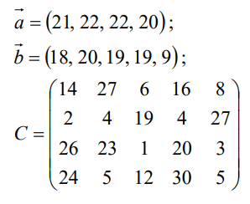

1. Изучить содержательную и математическую постановки закрытой транспортной задачи, методы нахождения первого опорного решения ее системы ограничений. Изучить понятие цикла пересчета в матрице перевозок. Овладеть распределительным методом и методом потенциалов, а также их алгоритмами.
2. Составить и отладить программы решения транспортной задачи распределительным методом и методом потенциалов.
Написанная библиотека:
#include "transport.h"
#include <utility>
TransportTable::TransportTable(Matrix costMatrix, vector<float> stock,
vector<float> requests) {
this->costMatrix = costMatrix;
this->stock = std::move(stock);
this->requests = std::move(requests);
planTable = vector < vector < PlanTableElement >> ();
for (int row = 0; row < costMatrix.getRows(); row++) {
planTable.emplace_back(costMatrix.getColumns());
for (int column = 0; column < costMatrix.getColumns(); column++) {
planTable[row][column].isBasic = false;
planTable[row][column].value = 0;
}
}
}
void TransportTable::fillTransportTableMinValue() {
for (int row = 0; row < planTable.size(); row++) {
for (int column = 0; column < planTable[0].size(); column++) {
planTable[row][column].isBasic = true;
}
}
vector<float> stockTmp = stock;
vector<float> requestsTmp = requests;
bool isFull = false;
while (!isFull) {
Position minValuePosition = findMinValuePosition();
if (fcmp(requestsTmp[minValuePosition.column],
stockTmp[minValuePosition.row])) {
planTable[minValuePosition.row][minValuePosition.column].value =
requestsTmp[minValuePosition.column];
requestsTmp[minValuePosition.column] = 0;
stockTmp[minValuePosition.row] = 0;
for (int row = 0; row < planTable.size(); row++) {
if (row != minValuePosition.row &&
planTable[row][minValuePosition.column].value == 0) {
planTable[row][minValuePosition.column].isBasic = false;
}
}
for (int column = 0; column < planTable.size(); column++) {
if (column != minValuePosition.column &&
planTable[minValuePosition.row][column].value == 0) {
planTable[minValuePosition.row][column].isBasic = false;
}
}
} else if (requestsTmp[minValuePosition.column] <
stockTmp[minValuePosition.row]) {
planTable[minValuePosition.row][minValuePosition.column].value =
requestsTmp[minValuePosition.column];
stockTmp[minValuePosition.row] -= requestsTmp[minValuePosition.column];
requestsTmp[minValuePosition.column] = 0;
for (int row = 0; row < planTable.size(); row++) {
if (row != minValuePosition.row &&
planTable[row][minValuePosition.column].value == 0) {
planTable[row][minValuePosition.column].isBasic = false;
}
}
} else {
planTable[minValuePosition.row][minValuePosition.column].value =
stockTmp[minValuePosition.row];
requestsTmp[minValuePosition.column] -= stockTmp[minValuePosition.row];
stockTmp[minValuePosition.row] = 0;
for (int column = 0; column < planTable.size(); column++) {
if (column != minValuePosition.column &&
planTable[minValuePosition.row][column].value
== 0) {
planTable[minValuePosition.row][column].isBasic = false;
}
}
}
isFull = checkIfTableIsFull();
}
}
bool TransportTable::checkIfTableIsFull() {
for (int row = 0; row < planTable.size(); row++) {
for (int column = 0; column < planTable[0].size(); column++) {
if (planTable[row][column].isBasic &&
fcmp(planTable[row][column].value, 0))
return false;
}
}
return true;
}
Position TransportTable::findMinValuePosition() {
Position minValuePosition(0, 0);
float minValue = INT32_MAX;
for (int row = 0; row < planTable.size(); row++) {
for (int column = 0; column < planTable[0].size(); column++) {
if (planTable[row][column].isBasic &&
fcmp(planTable[row][column].value, 0)
&& costMatrix.getData(row, column) < minValue) {
minValuePosition = Position(row, column);
minValue = costMatrix.getData(row, column);
}
}
}
return minValuePosition;
}
float TransportTable::countCycleGamma(Sequence cycle) {
float sum = 0;
for (int i = 0; i < cycle.positions.size() - 1; i++) {
float nextValue = costMatrix.getData(cycle.positions[i].row,
cycle.positions[i].column);
if (i % 2 == 0) {
sum += nextValue;
} else {
sum -= nextValue;
}
}
return sum;
}
Sequence TransportTable::findCycle(Position start) {
Sequence sequence;
sequence.positions.push_back(start);
return _findCycle(sequence, Direction::Any);
}
Sequence TransportTable::_findCycle(Sequence sequence, Direction direction) {
if (sequence.checkIfCycle()) {
return sequence;
} else {
Position currentPosition = sequence.getPosition(-1);
if (direction == Direction::Vertical || direction == Direction::Any) {
//Проход вверх
while (currentPosition.row >= 0) {
bool isCurrentPositionInSequence =
sequence.checkIfPositionInSequence(currentPosition);
if (getPlanTableElement(currentPosition).isBasic &&
!isCurrentPositionInSequence ||
sequence.positions.size() > 2 && currentPosition ==
sequence.positions[0]) {
Sequence newSequence = sequence;
newSequence.positions.push_back(currentPosition);
Sequence resultSequence = _findCycle(newSequence,
Direction::Horizontal);
if (!resultSequence.isEmpty()) {
return resultSequence;
}
}
currentPosition.row--;
}
//Проход вниз
currentPosition = sequence.getPosition(-1);
while (currentPosition.row <= planTable.size() - 1) {
bool isCurrentPositionInSequence =
sequence.checkIfPositionInSequence(currentPosition);
if (getPlanTableElement(currentPosition).isBasic &&
!isCurrentPositionInSequence ||
sequence.positions.size() > 2 && currentPosition ==
sequence.positions[0]) {
Sequence newSequence = sequence;
newSequence.positions.push_back(currentPosition);
Sequence resultSequence = _findCycle(newSequence,
Direction::Horizontal);
if (!resultSequence.isEmpty()) {
return resultSequence;
}
}
currentPosition.row++;
}
}
if (direction == Direction::Horizontal || direction == Direction::Any) {
//Проход влево
currentPosition = sequence.getPosition(-1);
while (currentPosition.column >= 0) {
bool isCurrentPositionInSequence =
sequence.checkIfPositionInSequence(currentPosition);
if (getPlanTableElement(currentPosition).isBasic &&
!isCurrentPositionInSequence ||
sequence.positions.size() > 2 && currentPosition ==
sequence.positions[0]) {
Sequence newSequence = sequence;
newSequence.positions.push_back(currentPosition);
Sequence resultSequence = _findCycle(newSequence,
Direction::Vertical);
if (!resultSequence.isEmpty()) {
return resultSequence;
}
}
currentPosition.column--;
}
//Проход вправо
currentPosition = sequence.getPosition(-1);
while (currentPosition.column <= planTable[0].size() - 1) {
currentPosition.column++;
bool isCurrentPositionInSequence =
sequence.checkIfPositionInSequence(currentPosition);
if (getPlanTableElement(currentPosition).isBasic &&
!isCurrentPositionInSequence ||
sequence.positions.size() > 2 && currentPosition ==
sequence.positions[0]) {
Sequence newSequence = sequence;
newSequence.positions.push_back(currentPosition);
Sequence resultSequence = _findCycle(newSequence,
Direction::Vertical);
if (!resultSequence.isEmpty()) {
return resultSequence;
}
}
}
}
return {};
}
}
PlanTableElement TransportTable::getPlanTableElement(Position position) {
return planTable[position.row][position.column];
}
void TransportTable::makeShiftByCycle(Sequence cycle, float value) {
for (int i = 0; i < cycle.positions.size() - 1; i++) {
Position currentPosition = cycle.getPosition(i);
if (i % 2 == 0) {
planTable[currentPosition.row][currentPosition.column].value += value;
} else {
planTable[currentPosition.row][currentPosition.column].value -= value;
}
}
}
bool Sequence::checkIfCycle() {
for (int i = 0; i < positions.size() - 1; i++) {
if (positions[i].row != positions[i + 1].row &&
positions[i].column != positions[i + 1].column) {
return false;
}
}
return positions.size() > 1 && positions[0] == positions[positions.size() - 1];
}
void Sequence::addPosition(Position position) {
positions.push_back(position);
}
Position Sequence::getPosition(int index) {
if (index >= 0)
return positions[index];
else {
return positions[positions.size() + index];
}
}
bool Sequence::isEmpty() {
return positions.empty();
}
bool Sequence::checkIfPositionInSequence(Position target) {
for (int i = 0; i < positions.size(); i++) {
if (positions[i] == target)
return true;
}
return false;
}
bool Position::operator==(Position other) {
return this->row == other.row && this->column == other.column;
}

Реализация распределительного метода:
void TransportTable::solveByDistributiveMethod() {
fillTransportTableMinValue();
bool foundSolution = false;
while (!foundSolution) {
float minGamma = INT32_MAX;
Sequence cycleWithMinValue;
for (int i = 0; i < planTable.size(); i++) {
for (int j = 0; j < planTable[0].size(); j++) {
std::cout << planTable[i][j].value << " ";
}
std::cout << "\n";
}
std::cout << "\n";
for (int row = 0; row < planTable.size(); row++) {
for (int column = 0; column < planTable[0].size(); column++) {
if (!planTable[row][column].isBasic) {
Sequence currentCycle = findCycle({row, column});
float cycleGamma = countCycleGamma(currentCycle);
if (cycleGamma < minGamma) {
minGamma = cycleGamma;
cycleWithMinValue = currentCycle;
}
}
}
}
if (minGamma < 0 && !fcmp(minGamma, 0)) {
float minAmongNegative = INT32_MAX;
Position positionOfMinAmongNegative{-1, -1};
for (int i = 1; i < cycleWithMinValue.positions.size() - 1; i += 2) {
float currentValueWithNegativePosition =
getPlanTableElement(cycleWithMinValue.getPosition(i)).value;
if (currentValueWithNegativePosition < minAmongNegative) {
minAmongNegative = currentValueWithNegativePosition;
positionOfMinAmongNegative = cycleWithMinValue.getPosition(i);
}
}
makeShiftByCycle(cycleWithMinValue, minAmongNegative);
planTable[positionOfMinAmongNegative.row][positionOfMinAmongNegative.column].isBasic = false;
planTable[cycleWithMinValue.getPosition(0).row][cycleWithMinValue.getPosition(0).column].isBasic = true;
} else {
foundSolution = true;
}
}
}
void TransportTable::fillPotentialsColumn(vector<Potential> &rows,
vector<Potential> &columns, int column) {
for (int row = 0; row < rows.size(); row++) {
if (planTable[row][column].isBasic && !rows[row].isSet) {
rows[row].value = costMatrix.getData(row, column) -
columns[column].value;
rows[row].isSet = true;
fillPotentialsRow(rows, columns, row);
}
}
}
void TransportTable::fillPotentialsRow(vector<Potential> &rows, vector<Potential>
&columns, int row) {
for (int column = 0; column < columns.size(); column++) {
if (planTable[row][column].isBasic && !columns[column].isSet) {
columns[column].value = costMatrix.getData(row, column) -
rows[row].value;
columns[column].isSet = true;
fillPotentialsColumn(rows, columns, column);
}
}
}

содержимое файла main.cpp:
#include <iostream>
#include "libs/matrix/matrix.h"
#include "libs/transport/transport.h"
int main() {
Matrix costMatrix;
costMatrix.inputMatrix(4, 5, {
{14, 27, 6, 16, 8},
{2, 4, 19, 4, 27},
{26, 23, 1, 20, 3},
{24, 5, 12, 30, 5}
});
vector<float> stock{21, 22, 22, 20};
vector<float> requests{18, 20, 19, 19, 9};
TransportTable transportTable(costMatrix, stock, requests);
transportTable.solveByDistributiveMethod();
for (int i = 0; i < transportTable.planTable.size(); i++) {
for (int j = 0; j < transportTable.planTable[0].size(); j++) {
std::cout << transportTable.planTable[i][j].value << " ";
}
std::cout << "\n";
}
}

Результат работы программы:
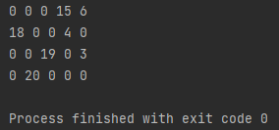

Реализация метода потенциалов:
void TransportTable::solveByPotentialMethod() {
fillTransportTableMinValue();
bool foundSolution = false;
while (!foundSolution) {
vector<Potential> stockPotentials(stock.size());
vector<Potential> requestPotentials(requests.size());
for (auto potential: stockPotentials) {
potential.isSet = false;
}
for (auto potential: requestPotentials) {
potential.isSet = false;
}
requestPotentials[0].value = 0;
requestPotentials[0].isSet = true;
fillPotentialsColumn(stockPotentials, requestPotentials, 0);
float minPotentialValue = INT32_MAX;
Position minPotentialPosition{-1, -1};
for (int row = 0; row < costMatrix.getRows(); row++) {
for (int column = 0; column < costMatrix.getColumns(); column++) {
float currentPotential = costMatrix.getData(row, column) -
(stockPotentials[row].value +
requestPotentials[column].value);
if (currentPotential < minPotentialValue) {
minPotentialValue = currentPotential;
minPotentialPosition = Position {row, column};
}
}
}
if (minPotentialValue < 0 && !fcmp(minPotentialValue, 0)) {
Sequence cycleWithMinValue = findCycle(minPotentialPosition);
float minAmongNegative = INT32_MAX;
Position positionOfMinAmongNegative{-1, -1};
for (int i = 1; i < cycleWithMinValue.positions.size() - 1; i += 2) {
float currentValueWithNegativePosition =
getPlanTableElement(cycleWithMinValue.getPosition(i)).value;
if (currentValueWithNegativePosition < minAmongNegative) {
minAmongNegative = currentValueWithNegativePosition;
positionOfMinAmongNegative = cycleWithMinValue.getPosition(i);
}
}
makeShiftByCycle(cycleWithMinValue, minAmongNegative);
planTable[positionOfMinAmongNegative.row][positionOfMinAmongNegative.column].isBasic = false;
planTable[cycleWithMinValue.getPosition(0).row][cycleWithMinValue.getPosition(0).column].isBasic = true;
} else {
foundSolution = true;
}
}
}

содержимое файла main.cpp:
#include <iostream>
#include "libs/matrix/matrix.h"
#include "libs/transport/transport.h"
int main() {
Matrix costMatrix;
costMatrix.inputMatrix(4, 5, {
{14, 27, 6, 16, 8},
{2, 4, 19, 4, 27},
{26, 23, 1, 20, 3},
{24, 5, 12, 30, 5}
});
vector<float> stock{21, 22, 22, 20};
vector<float> requests{18, 20, 19, 19, 9};
TransportTable transportTable(costMatrix, stock, requests);
transportTable.solveByPotentialMethod();
for (int i = 0; i < transportTable.planTable.size(); i++) {
for (int j = 0; j < transportTable.planTable[0].size(); j++) {
std::cout << transportTable.planTable[i][j].value << " ";
}
std::cout << "\n";
}
}

Результат работы программы:

3. Для подготовки тестовых данных решить вручную одну из следующих ниже задач.
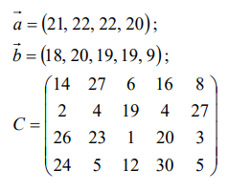

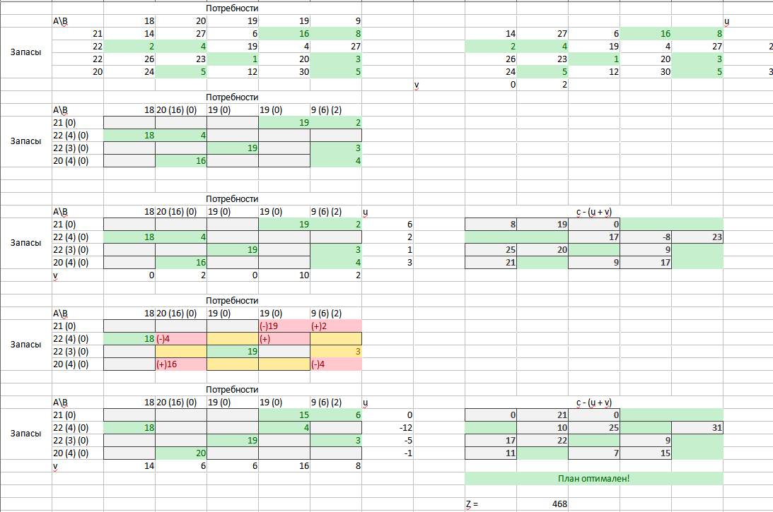

Вывод: в ходе лабораторной работы мы изучили методы решения закрытой транспортной задачи; реализовали заполнение исходной таблицы методом наименьшей стоимости, решение задачи методом потенциалов и распределительным методом

