**1.**

My choice of agent is coyote. The logic that it fits into the simulation is that coyotes eat deer, and thus directly impacts deer number and indirectly impacts grain height. If coyotes are too few and the season is favorable, deer population increases fast (by 30%). If deer number more than doubles the coyote number, coyote population also increases. Meanwhile, if coyote population is larger than the deer’s, deer number drop by 1. Specific quantity interaction is as follows:

In GrainDeer()

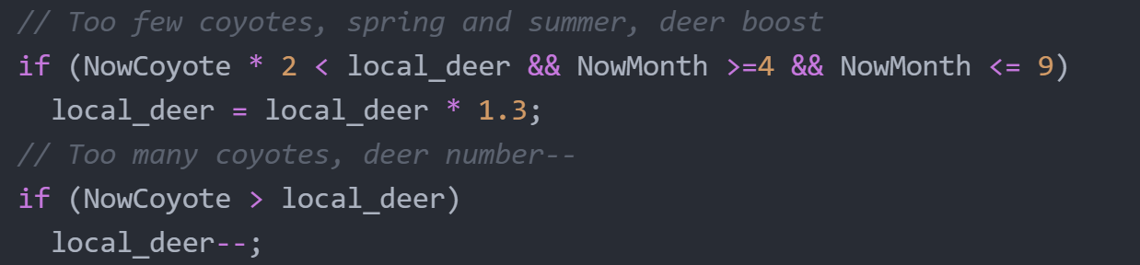

In coyoteBoost()

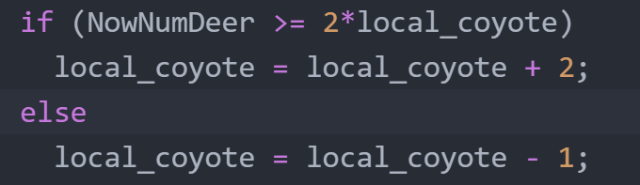

**2.**

|  |  |  |  |  |  |
| --- | --- | --- | --- | --- | --- |
| Time | Temperature(Celsius) | Precipitation(cm) | Coyote | Deer | Height(cm) |
| Jan-20 | -17.78 | 0 | 0 | 1 | 0 |
| Feb-20 | 2.15 | 31.6 | 2 | 0 | 15.62 |
| Mar-20 | 16.4 | 28.51 | 1 | 0 | 15.84 |
| Apr-20 | 21.36 | 33.87 | 0 | 0 | 15.84 |
| May-20 | 22.61 | 33.63 | 2 | 1 | 15.84 |
| Jun-20 | 28.2 | 20.04 | 1 | 1 | 13.3 |
| Jul-20 | 23.52 | 14.44 | 0 | 2 | 10.76 |
| Aug-20 | 20.56 | 5.33 | 2 | 3 | 5.68 |
| Sep-20 | 18.92 | 0.8 | 1 | 2 | 0 |
| Oct-20 | 15.85 | 1.53 | 3 | 1 | 0 |
| Nov-20 | 5.02 | 11.72 | 2 | 0 | 14.38 |
| Dec-20 | 8.81 | 10.29 | 1 | 0 | 23.03 |
| Jan-21 | 8.4 | 19.23 | 0 | 0 | 36 |
| Feb-21 | 12.84 | 33.11 | 2 | 1 | 38.13 |
| Mar-21 | 11.17 | 37.36 | 1 | 1 | 39.81 |
| Apr-21 | 23.2 | 36.16 | 0 | 2 | 37.27 |
| May-21 | 27.99 | 32.24 | 2 | 3 | 32.19 |
| Jun-21 | 26.79 | 26.53 | 1 | 4 | 24.57 |
| Jul-21 | 21.39 | 9.55 | 3 | 6 | 14.41 |
| Aug-21 | 27.79 | 7.1 | 5 | 5 | 0 |
| Sep-21 | 19.53 | 0 | 4 | 4 | 0 |
| Oct-21 | 17.16 | 3.76 | 3 | 3 | 0 |
| Nov-21 | 9.13 | 8.21 | 2 | 2 | 0 |
| Dec-21 | 6.27 | 18.75 | 1 | 1 | 14.08 |
| Jan-22 | 6.17 | 19.37 | 0 | 2 | 31.16 |
| Feb-22 | 10.46 | 31.08 | 2 | 3 | 32.82 |
| Mar-22 | 17.86 | 36.56 | 1 | 4 | 25.26 |
| Apr-22 | 21.36 | 33.12 | 3 | 5 | 15.1 |
| May-22 | 23.19 | 30.37 | 2 | 6 | 2.4 |
| Jun-22 | 25.69 | 26.26 | 4 | 6 | 0 |
| Jul-22 | 25 | 11.05 | 3 | 5 | 0 |
| Aug-22 | 28.73 | 6.8 | 2 | 4 | 0 |
| Sep-22 | 15.68 | 0 | 4 | 3 | 0 |
| Oct-22 | 10.78 | 4.03 | 3 | 1 | 0 |
| Nov-22 | 6.89 | 11.79 | 2 | 0 | 11.6 |
| Dec-22 | 2.99 | 13.85 | 1 | 0 | 28.95 |
| Jan-23 | 3.75 | 21.85 | 0 | 0 | 51.03 |
| Feb-23 | 2.26 | 30.35 | 2 | 1 | 69.88 |
| Mar-23 | 14.74 | 33.92 | 1 | 1 | 68 |
| Apr-23 | 19.27 | 32.18 | 0 | 2 | 65.48 |
| May-23 | 24.56 | 28.16 | 2 | 3 | 60.4 |
| Jun-23 | 28.44 | 19.53 | 1 | 4 | 52.78 |
| Jul-23 | 27.49 | 18.2 | 3 | 6 | 42.62 |
| Aug-23 | 22.77 | 10.77 | 5 | 7 | 27.38 |
| Sep-23 | 18.77 | 6.73 | 4 | 8 | 9.61 |
| Oct-23 | 12.54 | 0 | 6 | 7 | 0 |
| Nov-23 | 5.6 | 10 | 5 | 6 | 0 |
| Dec-23 | 10.25 | 12.9 | 4 | 5 | 0 |
| Jan-24 | 6.97 | 18.63 | 3 | 4 | 4.61 |
| Feb-24 | 10.09 | 27.76 | 2 | 3 | 2.51 |
| Mar-24 | 11.51 | 32.57 | 1 | 2 | 0 |
| Apr-24 | 22.75 | 33.03 | 3 | 1 | 0 |
| May-24 | 20.5 | 28.98 | 2 | 0 | 0 |
| Jun-24 | 23.32 | 24.6 | 1 | 0 | 0 |
| Jul-24 | 29.11 | 16.06 | 0 | 0 | 0 |
| Aug-24 | 26.24 | 3 | 2 | 1 | 0 |
| Sep-24 | 21.31 | 4.51 | 1 | 1 | 0 |
| Oct-24 | 15.3 | 2.67 | 0 | 0 | 0 |
| Nov-24 | 6.49 | 7.28 | 2 | 0 | 12.01 |
| Dec-24 | 4.22 | 16.61 | 1 | 0 | 32.25 |
| Jan-25 | 0.6 | 26.44 | 0 | 0 | 46.38 |
| Feb-25 | 2.97 | 29.26 | 2 | 1 | 67.19 |
| Mar-25 | 9.66 | 12.93 | 1 | 1 | 73.34 |
| Apr-25 | 17.11 | 13.64 | 0 | 2 | 70.92 |
| May-25 | 20.7 | 12.28 | 2 | 3 | 65.84 |
| Jun-25 | 27.02 | 9.37 | 1 | 4 | 58.22 |
| Jul-25 | 30.95 | 7.08 | 3 | 6 | 48.06 |
| Aug-25 | 27.35 | 1.17 | 5 | 7 | 32.82 |
| Sep-25 | 23.91 | 0 | 4 | 8 | 15.04 |
| Oct-25 | 10.54 | 1.28 | 6 | 7 | 0 |
| Nov-25 | 9.54 | 2.57 | 5 | 6 | 0 |
| Dec-25 | 3.08 | 6.31 | 4 | 5 | 3.54 |

**3.**

**4.**

**Pattern of graph without coyote and reason:**

Temperature and precipitation fluctuates as time goes on. We can observe generally that as temperature and precipitation go up, grain height goes up thereafter. This is followed by an increase of deer population. As deer consume more grain, and temperature and precipitation drop, grain height decreases, followed by a drop in deer population. As the simulation continues and temperature and precipitation gradually increase, the cycle goes on.

The graph has such pattern as we made the temperature and precipitation follow cosine and sine wave patterns with some randomness. We also made grain height dependent on temperature, precipitation and deer population. If temperature and precipitation are close ideal, grain grows exponentially faster. The quantity of deer and grain interacts. As grain grow and can carry more deer, deer population goes up. As deer consumes more grain, grain height goes down. This is the logic built in the simulation.

**Simulation with coyote, effect and evidence:**

Effect: Coyotes prey on deer, so it adds another check on deer population, making deer population peak less dominant. Deer number increases less dramatically, so grain has a better chance of growing higher.

Evidence: The two dark blue grain height peaks are in the 70’s range on the first graph. By contrast, the grain height in the second graph without coyote simulation only goes to 60’s ballpark and never reaches 70.