# 1 3D REPRESENTATION OF AUDIO SIGNALS-APPLICATION IN RAGA DETECTION AND CORRECTION

## Introduction

Signal is a pattern of variations that carry information. In order to study a signal, it has to be represented in some form. All the signals in the real world are analog signals which are continuous in nature. In our project we are mainly dealing with the voice and acoustic signals (sound or music).

Time domain refers to the analysis of mathematical functions or signals with respect to time. In the time domain, the signal or a function's value is known for all real numbers, for the case of continuous time signals or at various separate instants in the case of discrete time. An oscilloscope is a tool commonly used to visualize real-world signals in the time domain. A time-domain graph shows how a signal changes with time.

The frequency domain refers to the analysis of mathematical functions or signals with respect to frequency, rather than time. Put simply, a time-domain graph shows how a signal changes over time, whereas a frequency-domain graph shows how much of the signal lies within each given frequency band over a range of frequencies. A frequency-domain representation can also include information on the phase shift that must be applied to each sinusoid in order to be able to recombine the frequency components to recover the original signal.

A given function or signal can be converted between time and frequency domains with a pair of mathematical operators called transforms. An example is the Fourier Transform, which converts a time function into a sum or integral of sine waves of different frequencies, each of which represents a frequency component. The "spectrum" of frequency components is the frequency-domain representation of the signal. The Inverse Fourier Transform converts the frequency-domain function back to the time-domain function. A spectrum analyser is a tool commonly used to visualize electronic signals in the frequency domain.

For the time-domain analysis of signals, it has to be sampled at at least the sampling frequency which is based on Nyquist sampling theorem. The maximum frequency of the voice signals is about 4KHz, so it has to be sampled at at least 8KHz to get detectable samples. The sounds generated from the musical instruments can have frequencies upto 15KHz, and thus the standard sampling frequency is 44.1KHz which is quite high. And the high sampling frequency in time-domain results in high computational complexity and cost. Time domain analysis of signals involves mathematical systems governed by linear differential equations which are complex.

One of the main reasons for using a frequency-domain representation of a problem is to simplify the mathematical analysis. For mathematical systems governed by linear differential equations, a very important class of systems with many real-world applications, converting the description of the system from the time domain to a frequency domain converts the differential equations to algebraic equations, which are much easier to solve.

The motivation for this project is because neither time-domain nor frequency domain analysis were sufficient enough to analyze signals with time-varying frequency content. To overcome this difficulty and to analyze the nonstationary signals effectively, techniques which could give joint time and frequency information were needed. This gave birth to the TF transformations. So we tend towards three dimensional representation of signals for their analysis. In three dimensional representation of signals we can represent the signal in frequency domain along with time domain. The three dimensions hence being - Frequency, Time, and Amplitude (or Intensity).

## 

## 1.2 Motivation

Humans classify audio signals all the time without conscious eﬀort. Recognizing a voice on the telephone, telling the diﬀerence between a telephone ring and a doorbell ring, these are tasks that we don’t consider very difficult. Problems do arise when the different sounds arise simultaneously. If we knew the general systems that can identify different audio, we might be able to better diagnose and treat auditory ailments.

Extraction of features from the audio signal is a very important part in analyzing and finding relations between different things. The data provided of audio cannot be understood by the models directly, so to convert them into an understandable format feature extraction is used. It is a process that explains most of the data but in an understandable way. Feature extraction is required for classification, prediction and recommendation algorithms.

In the real world scenario, we cannot distinguish between the sounds generated by more than one instrument simultaneously using the approach of two dimensional representation of signal. Consider a scenario where in sounds generated from guitar, drums and singer simultaneously. If we analyse this signal in time-domain we can see them as a single signal of amplitude variations over time, overlapped on each other. The frequency content of the signal cannot be obtained using time-domain approach. Introduction of Fourier theory addressed this issue by enabling the analysis of signals in the frequency domain. However, Fourier technique provides only the global frequency content of a signal and not the time occurrences of those frequencies. Hence neither time-domain nor frequency domain analysis were sufficient enough to analyse signals with time-varying frequency content. To overcome this difficulty and to analyse the nonstationary signals effectively, we look into techniques which could give joint time and frequency information.

## 

## 1.3 Problem Statement

In the two dimensional analysis of the signal, if we consider the time-domain analysis we cannot obtain the frequency content of the signal and if we consider the frequency-domain analysis we cannot get the time of occurrences of the frequencies. So there is a need to develop an algorithm which can represent a signal in three dimensions (Time, Frequency and Amplitude) for real world applications. Some of the algorithms which are already being developed to solve such problems are based on machine learning concept. Such algorithms require a lot of datasets for training the model and they also require a lot of resources for processing. These factors reduces the computational speed and makes the algorithm much complex.

We are hence focussing on developing an algorithm based on the mathematical modelling of the signals instead of trained datasets as in machine learning algorithms to represent the signal in three dimensions using the concept of short time fourier transform. The algorithm has to be developed in such a way that it uses minimum number of samples to compute fourier transform and yet provide an efficient frequency spectrum for analysis with least error.

## 1.4 Objectives

Objectives of our project are classified are as follows:

1. Compare various algorithms which use short time fourier transform and commit to an algorithm which gives the faster results and at the same not have significant errors.
2. Develop an algorithm to compute the fourier transform using the least number of samples possible to obtain the detectable three dimensional waveform.
3. Representation and classification of sound signals based on these three dimensional representations.
4. Use the mathematical results thus obtained in an acoustic application in which we build melodic(Raga based) databases and develop a UI for interaction.

## 

## 1.5 Project outcome and Mode of demonstration

Our project consists of only software components. Initially, for the mode of demonstration the mathematical analysis of the signals is done by simulating the graph of three dimensional representation of audio signal. Once the three-dimensional representation is completed, we will develop an algorithm for the various real-world applications, and a UI for the interaction with the user. Testing of the algorithm can be done using the UI by providing various audio signals as the input.

## 1.6 Application

As mentioned in the objectives, we will try to demonstrate the use of the three dimensional approach of representing audio signals for an acoustic application.

Other than that, there are many more applications where the three dimensional approach of representing audio signals could be used, such as –

1. Character recognition: Direct correlation of an input signal with a database produces many errors. It fails under the conditions where a frequency mismatch occurs between the input audio and the audio in the database, which has a very high possibility of occurrence. This technique could be used to create 3D matrix based database samples, and any input signal can then be conditioned to fit into the same 3D window as that of the database and then compared to obtain optimal results.
2. Voice recognition: Each person’s voice will have unique three dimensional waveform(signature). Voice recognition can again be performed by the same method of comparing the processed sample (normalised and shifted) with the standard database samples.
3. Auto-Tune: Auto tuned waveforms in music shift abruptly from one frequency to the other unlike the smooth transition of a natural voice, autotune thus uses a principle of levelizing audio to standard levels using suitable threshold. The three dimensional representation can be used to easily differentiate the processed and unprocessed signals visually and computationally.

# 2 LITERATURE SURVEY

## 2.1 Previous Research

As a part of literature survey, a number of IEEE papers and journals were referred and part of those of which have been used in our implementation have been mentioned, below table also describes in detail about the part of the papers that has been adapted in the implementation of the project.

The frequency analysis of time-dependent signal can be obtained by using various methods. Paper “The wavelet transform, time-frequency localization and signal analysis” by I. Daubechies [1] explains two different procedures for effecting a frequency analysis of a time-dependent signal locally in time. The first procedure is the short-time or windowed Fourier transform and the second is the wavelet transform, in which high-frequency components are studied with sharper time resolution than low-frequency components. The similarities and the differences between these two methods are discussed in this paper. For both schemes a detailed study is made of the reconstruction method and its stability as a function of the chosen time-frequency density. Finally, the notion of time-frequency localization is made precise, within this framework, by two localization theorems.

# The Short-Time [Fourier Transform](https://www.sciencedirect.com/topics/biochemistry-genetics-and-molecular-biology/fourier-transform) (STFT) is widely used to convert signals from the time domain into a time–frequency representation. In our project we need to compare various algorithms which implements short time fourier transform. Paper “Audio Signal Classification: History and Current techniques” by David Gerard [2] explains about the drawbacks of using two-dimensional representation of signals and how three dimensional representation of the signals can be achieved. This paper also explains about the various machine learning algorithms which are being used to implement the concept of short time fourier transforms.

The short time fourier transform technique can be implemented using adaptive window method. Paper “STFT With Adaptive Window Width Based on the Chirp Rate” by [Soo-Chang Pei](https://www.semanticscholar.org/author/Soo-Chang-Pei/144782814) and [Shih-Gu Huang](https://www.semanticscholar.org/author/Shih-Gu-Huang/3089528) [3] explains about an adaptive time-frequency representation(TFR) technique. An adaptive time-frequency representation (TFR) with higher energy concentration usually requires higher complexity. In this paper low-complexity adaptive shirt time Fourier transform(ASTFT) based on the chirp rate has been proposed. To enhance the performance, this method is substantially modified in this paper: i) because the wavelet transform used for the instantaneous frequency(IF) estimation is not signal dependent, a low-complexity ASTFT based on a novel concentration measure is addressed; ii)In order to increase robustness to IF estimation error, the principal component analysis(PCA) replaces the difference operator for calculating the chirp rate; and iii) a more robust Guassian kernel with time-frequency-varying window width is proposed. But such techniques requires evaluation of local signal characteristics there by reducing the computational speed.

Another method of implementing short time fourier transform is by using multi resolution technique. Paper “Multi-resolution Short-time Fourier Transform Implementation of Directional Audio Coding” by Tapani Pihlajamaki [4] proposes such multi resolution techniques. It was found that the use of multiple resolutions increases the quality of sound. Bin based processing, however, did not increase subjective quality. Also, new decorrelation methods did not produce any enhancement compared to the previously established methods. Also, these results were achieved with a great cost in calculation needs and use of alternative methods are recommended in this paper.

There are many limitations regarding time–frequency resolution. Paper “Short-Time Fourier Transform with the Window Size Fixed in the Frequency Domain (STFT-FD): Implementation” by [Carlos Mateo](https://www.sciencedirect.com/science/article/pii/S2352711017300638#!)[5] explains a set of MATLAB functions to compute a transform, which uses the basic concept of the Short-Time Fourier Transform, but fixes the window size in the frequency domain instead of in the time domain. This approach is simpler than similar existing methods, such as adaptive STFT or multi-resolution STFT, and in particular it requires neither the filters of multi-resolution techniques, nor the evaluation of the local signal characteristics of adaptive techniques.

The short time fourier transform is applicable only for non-varying signals. In the paper “**Fast-varying AM–FM components extraction based on an adaptive STFT” by** Xie H, Lin J, Lei Y and Liao Y [6], a new method is proposed for fast-varying AM–FM components extraction. There are two prominent characteristics in this method. Firstly, a new evaluation method for the instantaneous bandwidth is established, which is based on the instantaneous slope of the time-frequency curve with respect to the AM–FM component. Secondly, a new adaptive STFT algorithm is established, which adjusts the window width by adapting to the instantaneous bandwidth at each frequency position. In order to extract multiple AM–FM components from a signal, the width of the reconstruction area is required to be determined efficiently to avoid the interference caused by adjacent components. In this paper it was observed that the proposed method has good performance for fast-varying AM–FM components extraction from noisy signals.

Rolling-element bearings can be found on almost all rotating machines and their failure is one of the major causes of machine breakdown. These concepts are not at all related to our project but the paper “A comparative study of short time fourier transform and Continuous Wavelet Transform for bearing condition monitoring” by Liu H, Li L and Ma J [7] provides a review on joint time-frequency domain analysis. Since in the real machine monitoring environment, the monitored signal, such as from vibration measurement, can be transient events with abrupt changes in the waveform, traditional analyses conducted solely in either the time or frequency domain are not always capable of revealing the occurrence of bearing faults. An approach is to utilise joint time-frequency domain methods such as the Continuous Wavelet Transform (CWT) or the Short-Time Fourier Transform (STFT). The transformed signals were represented as colour-coded images which might contain unique characteristic features relating to the various types of bearing faults. Simulated signals were used in this study to compare the performance between STFT and CWT for signal classification. In this case, classification was basically pattern recognition of the image. The similarity between images was quantified using the correlation matching method. Results showed that CWT was more effective than STFT and its superiority was further affirmed by tests conducted on real bearing vibration signals.

Basic algorithm which we will be using for implementation is Fast Fourier Transform (FFT). So the background knowledge about fourier transform is required. Paper “A Generalized Mixed-Radix Algorithm for Memory Based FFT Processors “ by Chen-Fong Hsiao, Yuan Chen[8] explains about various FFT algorithms and how it can be applied. The paper also explains about the optimisation of the algorithm to obtain high throughput.

One of the technique of optimising the algorithm is by reducing the number of computations which is carried out during the implementation. The paper *“*Computational Frameworks for the Fast Fourier Transform” by Van Loan and Charles[9] explains about the computational frameworks that can be used for the Fast Fourier Transform. Our idea of using Fourier transform for the implementation instead of any machine learning algorithm is to reduce the number of computations carried out.

In a audio signal, note detection is very much essential for the computation. The paper “Real-time estimation of fundamental frequency and harmonics for active shunt power filters in aircraft electrical systems” by Lavopa E, Zanchetta P, Sumner M and Cupertino F [10] explains the algorithm for the real-time implementation of discrete Fourier Transform and accurate estimation of fundamental frequency.

For the detection of harmonics in a audio signals mathematical knowledge behind it is essential. The paper “A precise and adaptive algorithm for interharmonics measurement based on iterative DFT” by Zhang Q, Liu H., Chen H, Li Q and Zhang Z [11] explains the precise and adaptive algorithm for harmonic detection based on iterative DFT. This paper also explains the practical formulas to calculate harmonics and inter-harmonics.

For the accurate identification of frequency of the signals, some algorithm has to be implemented to remove the various distortions present in it. The paper “New spectrum leakage correction algorithm for frequency estimation of power system signals” by Radil T, Ramos PM and Serra AC [12] explains the algorithm for the estimation of the frequency of single-tone signals. The algorithm works in the frequency domain and is based on best fitting a theoretical spectrum of a single-tone signal that is windowed using a rectangular window on the spectrum of the sampled signal. The influence of noise and harmonic and inter-harmonic distortions on the proposed algorithm was investigated and is reported in this paper. This paper also provides the comparison of various frequency estimation algorithms.

There are several machine learning algorithms like HMM which is used for the estimation of fundamental frequency of the signal. The paper “Fundamental frequency estimation of musical signals using a two-way mismatch procedure“ by Robert C. Maher[13] explains one such HMM algorithm. From this paper it was found that lot of training of the model is required to determine the evolution of the signal.

Very little work has been done in the area of Raga identification of Indian music and in particular Carnatic music. Paper “Hindustani raga representation and identification: A transition probability based approach” by Pandey et al [14] explains raga identification using HMM algorithm. They have constructed a HMM for these two Hindustani Ragas, in which they have defined a probabilistic automata based on the notes, to help in the process of Raga identification. The authors have achieved an accuracy of 87% for these two Ragas. The drawback of this system is the various constraints that are used by the system in terms of the fundamental frequency and monophonic music.

# If we consider to take our implementation to real time scenario some pre-calculation is necessary. The paper “Real-time FFT with Precalculation” by Yena WF, Shingchern DY and Changc YC [15] explains the pre-calculation process for real time FFT.This paper also explains how real time fft algorithm simultaneously constructs and computes the butterfly modules while incoming data is collected.

## 2.2 Summary of the Literature Review

Literature survey describes various methods of obtaining frequency analysis of time-dependent signals and the need of three dimensional representation of signals. Papers based on short time fourier transforms and wavelet transform have been studied. From this study, the advantages and disadvantages of using such methods was understood. The algorithms which were implemented in the papers gives the accurate results only when non-varying spectral signal is considered and many samples are considered for the computation. Most of the above mentioned papers referred for the project have implemented machine learning algorithms which requires a lot of data sets for training the model. Our idea is to develop an algorithm using the concept of short time fourier transform which reduces the complexity and computational time. Our main aim is compute fourier transforms as fast as possible considering least possible samples at a time so that detectable output is obtained. And this algorithm is used to solve real world applications.

# 3 REQUIREMENT

## 3.1 Block Diagram

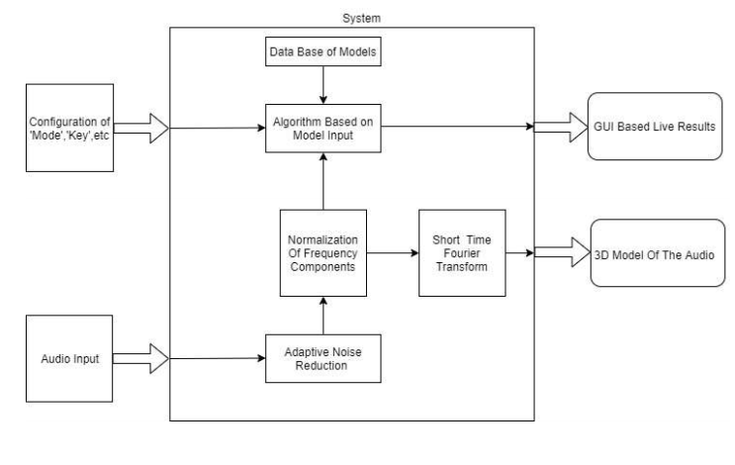

# Figure 1 : Block Diagram of the system

# The proposed block diagram for the system is as shown in the figure 1. The system block is an application with which the user interacts. The application supports a user interface to set parameters like the 'mode' of working, 'key' for the basis of the correction, etc. The voice/audio input is given through a mic to the system. The system consists of a signal conditioning algorithm for the audio input. The frequency components in the audio are then normalized into a predefined window. The normalization helps in minimizing the cost for the comparison of the ragas using the database. STFT of the conditioned signals provides a 3D model of the audio. The GUI provides the corresponding output results to the user based on the mode in which the application is being used.

## 

## 3.2 Flow Chart

## The flow chart helps us to easily understand the work flow of our implementation. The flow chart of the system is represented by the figure 2.

## 

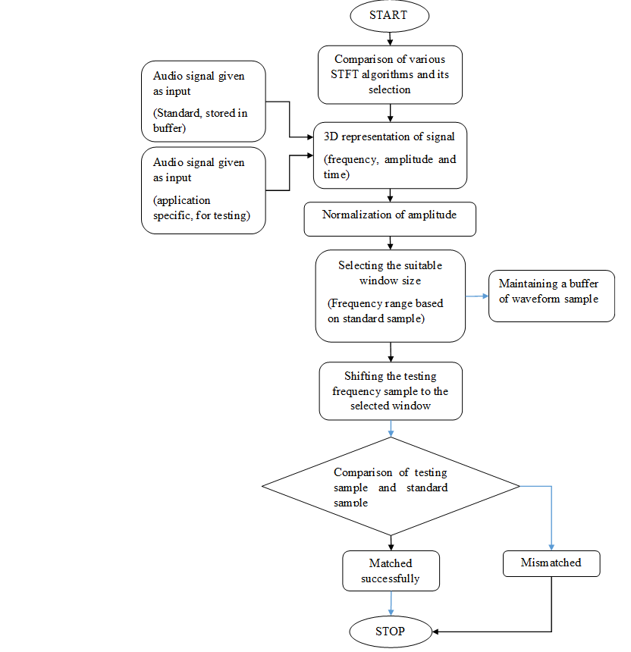

## Figure 2: Flow chart

## 3.3 Software Requirements:

### 1 MATLAB:

MATLAB is a [multi-paradigm](https://en.wikipedia.org/wiki/Multi-paradigm_programming_language) [numerical computing](https://en.wikipedia.org/wiki/Numerical_analysis) environment and [proprietary programming language](https://en.wikipedia.org/wiki/Proprietary_programming_language) developed by [MathWorks](https://en.wikipedia.org/wiki/MathWorks" \o "MathWorks).MATLAB allows [matrix](https://en.wikipedia.org/wiki/Matrix_(mathematics)) manipulations, plotting of [functions](https://en.wikipedia.org/wiki/Function_(mathematics)) and data, implementation of [algorithms](https://en.wikipedia.org/wiki/Algorithm), creation of [user interfaces](https://en.wikipedia.org/wiki/User_interface), and interfacing with programs written in other languages, including [C](https://en.wikipedia.org/wiki/C_(programming_language)), [C++](https://en.wikipedia.org/wiki/C%2B%2B), [C#](https://en.wikipedia.org/wiki/C_Sharp_(programming_language)), [Java](https://en.wikipedia.org/wiki/Java_(programming_language)), [Fortran](https://en.wikipedia.org/wiki/Fortran) and [Python](https://en.wikipedia.org/wiki/Python_(programming_language)). Although MATLAB is intended primarily for numerical computing, an optional toolbox uses the [MuPAD](https://en.wikipedia.org/wiki/MuPAD" \o "MuPAD) [symbolic engine](https://en.wikipedia.org/wiki/Computer_algebra_system), allowing access to [symbolic computing](https://en.wikipedia.org/wiki/Symbolic_computing) abilities. An additional package, [Simulink](https://en.wikipedia.org/wiki/Simulink), adds graphical multi-domain simulation and [model-based design](https://en.wikipedia.org/wiki/Model-based_design) for [dynamic](https://en.wikipedia.org/wiki/Dynamical_system) and [embedded systems](https://en.wikipedia.org/wiki/Embedded_system).

### 2 Python:

Python is an [interpreted](https://en.wikipedia.org/wiki/Interpreted_language), [general-purpose](https://en.wikipedia.org/wiki/General-purpose_programming_language) [programming language](https://en.wikipedia.org/wiki/Programming_language). Python's design philosophy emphasizes [code readability](https://en.wikipedia.org/wiki/Code_readability) with its notable use of [significant whitespace](https://en.wikipedia.org/wiki/Off-side_rule). Its language constructs and [object-oriented](https://en.wikipedia.org/wiki/Object-oriented_programming) approach aim to help programmers write clear, logical code for small and large-scale projects. Python is [dynamically typed](https://en.wikipedia.org/wiki/Dynamic_programming_language) and [garbage-collected](https://en.wikipedia.org/wiki/Garbage_collection_(computer_science)). It supports multiple [programming paradigms](https://en.wikipedia.org/wiki/Programming_paradigm), including [procedural](https://en.wikipedia.org/wiki/Procedural_programming), object-oriented, and [functional programming](https://en.wikipedia.org/wiki/Functional_programming). Python is often described as a "batteries included" language due to its comprehensive [standard library](https://en.wikipedia.org/wiki/Standard_library). Python was conceived in the late 1980s as a successor to the [ABC language](https://en.wikipedia.org/wiki/ABC_(programming_language)).

Python [interpreters](https://en.wikipedia.org/wiki/Interpreter_(computing)) are available for many [operating systems](https://en.wikipedia.org/wiki/Operating_system). A global community of programmers develops and maintains [CPython](https://en.wikipedia.org/wiki/CPython" \o "CPython), an [open source](https://en.wikipedia.org/wiki/Open-source_software) [reference implementation](https://en.wikipedia.org/wiki/Reference_implementation). A [non-profit organization](https://en.wikipedia.org/wiki/Nonprofit_organization), the [Python Software Foundation](https://en.wikipedia.org/wiki/Python_Software_Foundation), manages and directs resources for Python and CPython development.

## 3.4 Methodology

In our project, we will be using Short Time Fourier transform as a basic technique for the development of our algorithm. The Fourier transform provides information about how much of each frequency is present in a signal. If the spectral content of the signal does not change much over time, then this works quite well, but if the signal changes over time, for example in a song where different notes are played one after another, the Fourier transform will not be able to distinguish between the different notes and the Fourier representation will show information about all of the notes together. The short-time Fourier transform (STFT) is an attempt to fix the lack of time resolution in the classic Fourier transform. The input data is broken into many small sequential pieces, called frames or windows, and the Fourier transform is applied to each of these frames in succession. What is produced is a time-dependent representation, showing the changes in the harmonic spectrum as the signal progresses. The above concept can be implemented as follow:

1. There are various algorithms which implements short time Fourier transform. So we will compare between various algorithms and choose the best one whichever gives the fastest results with least error to perform fourier transform and obtain frequency response of audio signal at that instant.
2. We will convert the frequency response obtained in the form of three dimensional array with time, frequency and amplitude(intensity) as its axis.
3. Since amplitude of signals varies, we will be normalising the three dimensional wave along the amplitude considering suitable normalising window.
4. We will choose suitable frequency range based on the application. Then we will shift the frequency sample to the chosen frequency range for comparison.
5. We will develop the algorithm for various real world application. Based on the application we will compare the shifted frequency samples with the standard samples which will be stored in the buffer.

## 3.5 Novelty of proposed work

The proposed system is completely a new method of implementing audio signal related application. In the already existing algorithm of obtaining three dimensional representation of audio signal generates accurate results only when large number of samples are considered for the computation and is applicable only for non-varying spectral signals. In this system, real world application related to music or audio signals are implemented using machine learning algorithms which requires lot of data sets for training the model and lot of other resources.

In the proposed system, we will develop an algorithm to compute Fourier transform considering least number of samples at a time for computation. This algorithm will be applicable for varying as well as non-varying spectral signals. In this system, we will be implementing such application using the concept Fourier transform and various mathematical models. This system is faster, lighter (uses less number of resources) and less complex when compared to existing system.

# 4 PLANNING AND FEASIBILITY OF WORK

## 4.1 Feasibility Analysis

## In our project we do not make use of any machine learning algorithms, so the number of computations will be much lesser in the proposed system. The accurate results are obtained with lesser number of datasets when compared to machine learning algorithms where in lot of additional data sets are required for training the model. The developed application is user friendly and also consists of correction model which detects the error in ideal and detected raga’s if it is not present in the database.

## 4.2 Anticipated Bottleneck

## Mathematical modelling issue - Frequency domain representation of the audio should be done for each instant and hence the number of samples required for the Fourier Transform must be minimized. But on minimizing the number of samples, the accuracy in distinguishing the frequencies reduces.

## Raga detection algorithm - Since the classical music is based on a relative pitch scale of seven musical notes, the identification of the position of Shadja (Sa) is the major bottleneck for the initial stage of the algorithm development.

## Identification of similar ragas - Similar ragas generate a similar spectrum with close-lying frequency components. The model must have the resolution more than that of these half steps to properly differentiate the ragas.

## Real-time results - The algorithm developed must be optimized enough to produce real-time results. Hence the algorithm must be lightweight implying that the codes to be written must be optimal.

## 4.3 Pert Chart

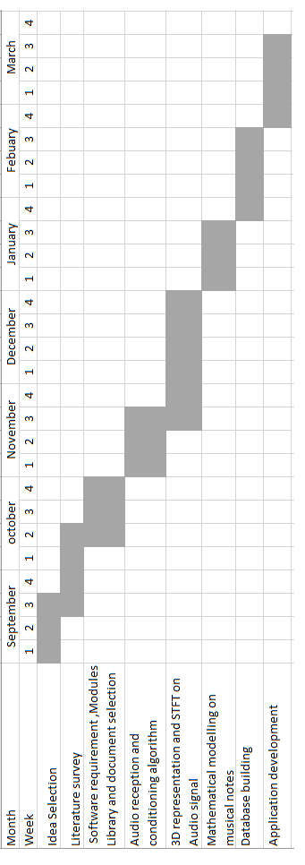

## Figure 3: Pert Chart

# References

1. I.Daubechies , “The wavelet transform, time-frequency localization and signal analysis”,2008.
2. David Gerard, “Audio Signal Classification: History and Current techniques”,2003.
3. [Soo-Chang Pei](https://www.semanticscholar.org/author/Soo-Chang-Pei/144782814), [Shih-Gu Huang](https://www.semanticscholar.org/author/Shih-Gu-Huang/3089528), “STFT With Adaptive Window Width Based on the Chirp Rate”,2017.
4. Tapani Pihlajamaki , “Multi-resolution Short-time Fourier Transform Implementation of Directional Audio Coding”,2009.
5. [Carlos Mateo](https://www.sciencedirect.com/science/article/pii/S2352711017300638#!) ,“Short-Time Fourier Transform with the Window Size Fixed in the Frequency Domain (STFT-FD):Implementation” ,2018.
6. Xie H, Lin J, Lei Y,Liao Y ,“**Fast-varying AM–FM components extraction based on an adaptive STFT”,2017.**
7. Liu H, Li L, Ma J, “A comparative study of short time fourier transform and Continuous Wavelet Transform for bearing condition monitoring”,2003.
8. Chen-Fong Hsiao, Yuan Chen, “A Generalized Mixed-Radix Algorithm for Memory Based FFT Processors”,2010.
9. Van Loan, Charles, “Computational Frameworks for the Fast Fourier Transform”,2003.
10. Lavopa E, Zanchetta P, Sumner M, Cupertino F, “Real-time estimation of fundamental frequency and harmonics for active shunt power filters in aircraft electrical systems”, 2009.
11. Zhang Q, Liu H., Chen H, Li Q, Zhang Z, “A precise and adaptive algorithm for interharmonics measurement based on iterative DFT”,2008.
12. Radil T, Ramos PM, Serra AC, “New spectrum leakage correction algorithm for frequency estimation of power system signals”, 2009.
13. Robert C. Maher, Fundamental frequency estimation of musical signals using a two-way mismatch procedure,1993.
14. Pandey et al, “Hindustani raga representation and identification: A transition probability based approach”,2003.
15. Yena WF, Shingchern DY, Changc YC, “Real-time FFT with Pre-calculation”,2009.