Figure 1 (System Overview / End-to-End Pipeline):
Design an end-to-end HISR system overview diagram with two planes: Data Plane (sketch update) and Control Plane (learning + inference). In the Data Plane, show streaming updates to fixed-size counters ye using multiple hash rows/views. In the Control Plane, show periodic snapshots and bucketization into logical buckets b of length L, extracting bucket-local observations y_{e,b}​ and bucket-local operators A_{e,b} (sparse edge list / bipartite incidence). Then show the model pipeline: bipartite-graph encoder Φθ\Phi_\thetaΦθ​ producing (zc,zv)(z_c, z_v)(zc​,zv​), hierarchical decoder producing leaf-level x^e,b\hat{x}_{e,b}x^e,b​, and an optional refinement loop with KKK iterations. Highlight constraints as callouts: “no change to data-plane update path”, “bucket-wise interface for scalability”, and “multi-environment training across (τ,s,π)(\tau,s,\pi)(τ,s,π)”. Use a clean block-diagram style with arrows, consistent icons for counters/graphs/trees, and print-ready vector graphics.
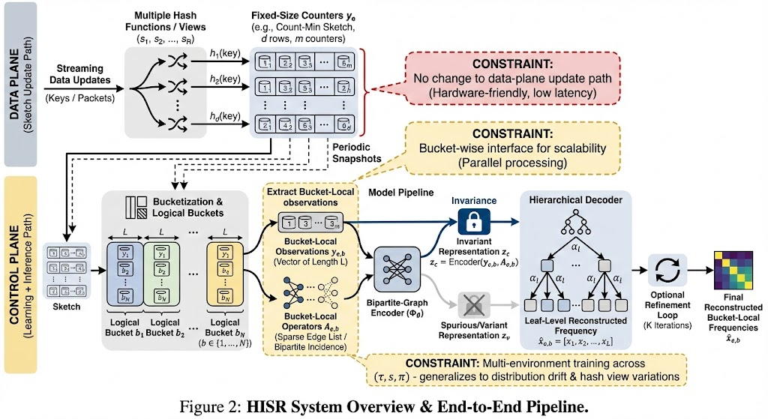

Figure 2: The Detailed Network Architecture (GNN + Split Tree)
Type: Model Architecture Diagram
Purpose: To detail the specific neural network components defined in the Method section (Section 3).
Prompt:
Design a detailed neural network architecture diagram for the HISR model. The flow moves from left to right:
- Input Layer - Local Bipartite Graph: Show the input not as a vector, but as a bipartite graph. On the left, a column of Key Nodes ($U$); on the right, a column of Counter Nodes ($V$). Draw connecting lines representing hash mappings. Label inputs to Counter Nodes as $[y, \text{row\_id}, \text{deg}]$.
- Encoder - Invariant GNN: Illustrate $T$ layers of Message Passing. Use curved arrows to show information flowing from Counter-to-Key (C2K) and Key-to-Counter (K2C). The output should converge into a central vector labeled $\mathbf{Z}_c$ (Invariant Feature).
- Decoder - Mass-Conserving Split Tree: Visualize a binary tree structure of depth $H$.
  - Root: Shows $\mathbf{Z}_c$ predicting the total mass $\hat{M}$.
  - Split Node: Zoom in on a single node to show the mechanism: It takes the parent mass and predicts a split ratio $\alpha$ (via Sigmoid), resulting in $\hat{M} \cdot \alpha$ (Left Child) and $\hat{M} \cdot (1-\alpha)$ (Right Child). Label this "Conservation Constraint".
- Refinement Module: At the leaf nodes, show a small block labeled "ResNet Refinement" that adds a residual term $\eta$ to produce the final $\hat{\mathbf{x}}$.
Style: Technical network diagram. Use boxes for operations (MLP, GRU, Softplus) and arrows for tensors. Similar style to standard Transformer or GNN architecture diagrams in NeurIPS/ICLR papers.
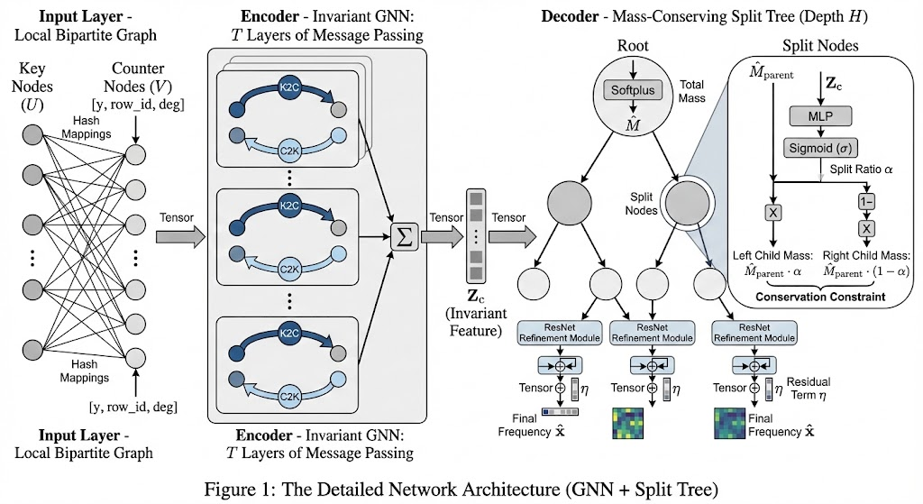

Figure 3: Multi-Environment Invariant Learning Strategy
Type: Mechanism/Process Diagram
Purpose: To explain how the model learns without ground truth labels using IRM and Multi-view consistency.
Prompt:
Create a schematic diagram illustrating the "Self-Supervised Invariant Learning Strategy". Center the diagram around the HISR Model.
Top Section (Multi-View Consistency): Show two different "Hash Views" (Row $r_1$ and Row $r_2$) from the same Logical Bucket. Feed both into the model and show a bidirectional arrow minimizing the difference between their outputs: $||\hat{\mathbf{x}}_{r1} - \hat{\mathbf{x}}_{r2}||^2$. Label this "View Consistency".
Bottom Section (IRM & Adversarial):
IRM Penalty: Depict multiple environments ($e_1, e_2$) entering the model. Show a gradient symbol $\nabla$ and a visual representation of "Minimizing Gradient Variance" across these environments.
Adversarial Branch: Show the Variant Representation ($z_v$) and Invariant Representation ($z_c$). Connect $z_c$ to a "Discriminator ($D_{adv}$)" that tries to predict the Environment ID ($e$). Add a "crossed-out" or "block" icon to signify that the Encoder maximizes entropy (prevents $z_c$ from leaking environment info).
Output Constraint: Show the final output $\hat{\mathbf{x}}$ being projected back via Matrix $\mathbf{A}$ to match the input Counter $\mathbf{y}$ (Measurement Consistency).
Style: Schematic, utilizing icons for mathematical concepts (e.g., scales for balancing, diverging arrows for variance). Color-coded loss functions.
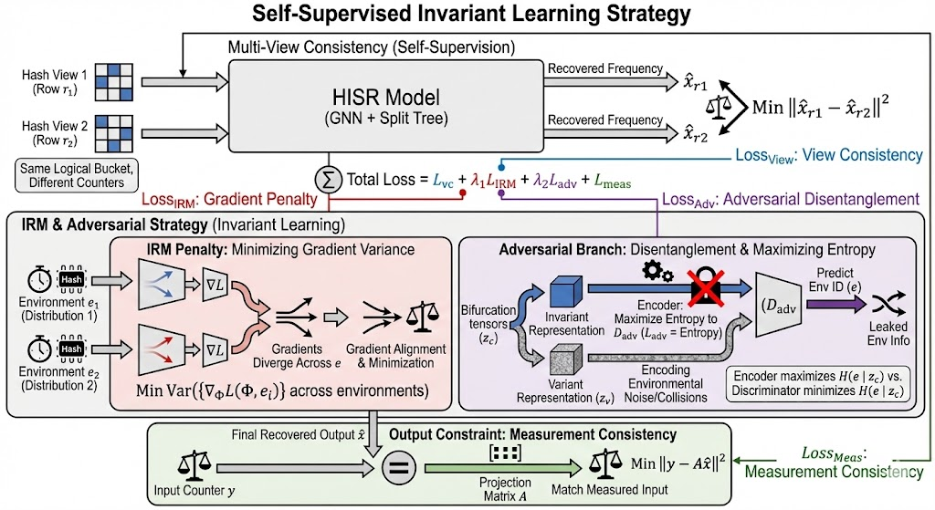

Figure 4 (Objective / Multi-Environment Invariance):
Draw an objective schematic that decomposes the HISR training loss into components. Show per-environment self-supervision: measurement consistency \|A_{e,b}\hat{x}_{e,b}-y_{e,b}\| and sparsity regularization. Then show multi-environment invariance mechanisms: an IRM-style penalty across environments e∈Ee\in\mathcal{E} (depict multiple environment branches converging into a shared predictor), plus a multi-hash (multi-view) consistency term aligning predictions across different hash views s under the same (\tau,\pi). Optionally include an adversarial “environment classifier” block that tries to predict e from z_c​, with a gradient reversal arrow to indicate de-environmentalization. Use a clear “loss components” legend and arrows showing which representations each term operates on. Recommended style: clean academic vector flowchart; emphasize readability with minimal colors and strong contrast.
