The Network AudioSource allows for easy and fast synchronisation of AudioSources across the network using Unity‘s NetworkMessages. It synchronises from and to both clients and servers.

It additionally supports the features FadeIn and FadeOut, which allows for linear fading of a currently played AudioClip.

Prerequisites
- Every AudioClip must have a unique name.
- A connection must have been established using Unity‘s NetworkManager.

Setting it up

- Set the message identifier NetworkAudioSourceMessageIdentifier in NetworkAudioSource.cs to a short value that you are not using for other messages.
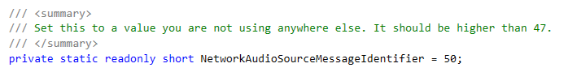

Syncing an AudioSource

- Add an AudioSource to your game object
- Add the script NetworkAudioSource to your game object
- A NetworkIdentity should be added automatically
- Drag the AudioSource to the field Networked Audio Source
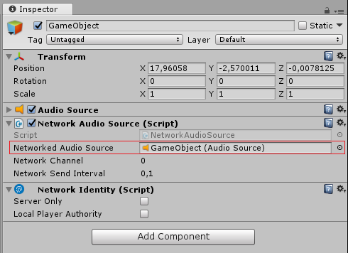
- Instead of accessing the AudioSource via GetComponent<AudioSource>, access it using GetComponent<NetworkAudioSource>(). Calls will be synchronised across the network.

Supported properties
Clip | The default AudioClip to play.
DopplerLevel | Sets the Doppler scale for this AudioSource.
IgnoreListenerPause | Allows AudioSource to play even though AudioListener.pause is set to true. This is useful for the menu element sounds or background music in pause menus.
IgnoreListenerVolume | This makes the audio source not take into account the volume of the audio listener.
IsPlaying | Is the clip playing right now (Read Only)?
Loop | Is the audio clip looping?
Pitch | The pitch of the audio source.
Time | Playback position in seconds.
TimeSamples | Playback position in PCM samples.
Volume | The volume of the audio source (0.0 to 1.0).

Supported functions
Pause | Pauses playing the clip.
Play | Plays the clip with an optional certain delay.
PlayDelayed | Plays the clip with a delay specified in seconds. Users are advised to use this function instead of the old Play(delay) function that took a delay specified in samples relative to a reference rate of 44.1 kHz as an argument.
PlayOneShot | Plays an AudioClip, and scales the AudioSource volume by volumeScale.
PlayScheduled | Plays the clip at a specific time on the absolute time-line that AudioSettings.dspTime reads from.
Stop | Stops playing the clip.
UnPause | Unpause the paused playback of this AudioSource.
FadeIn | Fades the AudioSource from the current volume to a specified target volume given a specified time.
FadeOut | Fades out the AudioSource given a specified time.
PlayAndLoop | Plays and loops a clip.
LoopRandomClips | Selects a random clip based on provided clips and plays it. Repeats this process endlessly stopped.
StopLoopRandomClips | Stops the looping of random clips.
AddLinkedSource | Adds a source with a corresponding damping factor that is linked to this audioSource, eg if AudioSource A is linked to AudioSource B with a damping factor 0.5f, if A plays a clip at volume 1f, B automatically is told to play the same clip at volume 0.5f.

Contact

If you notice any bugs or need a currently unsupported property or function urgently, feel free to send me a tweet to @Chykary or write an email to chikari@t-online.de

