Star Topology Network Documentation
This document explains the network topology used in the provided diagram. The network is designed using a Star Topology, which is commonly used in home and small office networks.

Topology Type: Star Topology
In a star topology, all devices are connected to a central networking device. In this network, the modem acts as the central device. All communication between end devices passes through the modem, which also provides internet access and assigns IP addresses to connected devices.

Network Topology Diagram
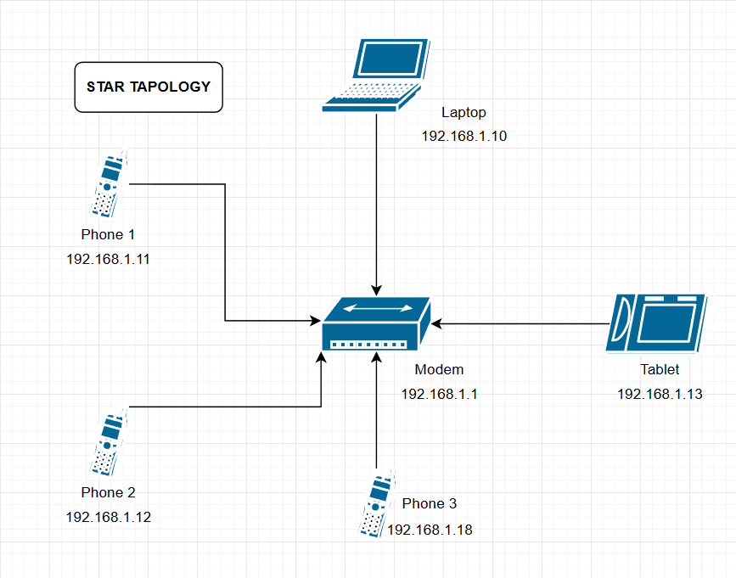

a

Device Information Table
Device Name | Device Type | IP Address | Connection Type | Connected To
Modem | Modem/Router | 192.168.1.1 | ISP / Wi-Fi | ISP
Laptop | Laptop | 192.168.1.10 | Wi-Fi | Modem
Phone 1 | Smartphone | 192.168.1.11 | Wi-Fi | Modem
Phone 2 | Smartphone | 192.168.1.12 | Wi-Fi | Modem
Phone 3 | Smartphone | 192.168.1.18 | Wi-Fi | Modem
Tablet | Tablet | 192.168.1.13 | Wi-Fi | Modem

Conclusion
This star topology network is efficient, easy to manage, and suitable for home use. If one end device fails, it does not affect the rest of the network. The modem serves as the central point, ensuring stable connectivity and centralized network control.

