Transcript Certificate of Graduation

No.
Date: / /2024
الباركود
الصورة
Full Name: AEMAN MOHAMMED TRKEE
Place and Date of Birth: BAGHDAD - 1/1/1993
College: Physical Education and Sport Sciences
Department: None
Certificate: B.Sc.
Grade: Middle
Student's rank: (77ᵗʰ) of (79) graduates
Rate: 62.633
Rate(written): Sixty Two and Six hundred Thirty Three Thousandths
Note: More information is on the back of the paper.

Gender: Male
Nationality: Iraqi
Admission year: 2016-2017
Date of Graduation: 01/01/2027
Type of Study: Morning
Attempt: 1ˢᵗ
Year of Graduation: 2020-2021
Rate of the 1st Graduate: 86.297

Below is the official transcript of the subjects and marks achieved during the years of study
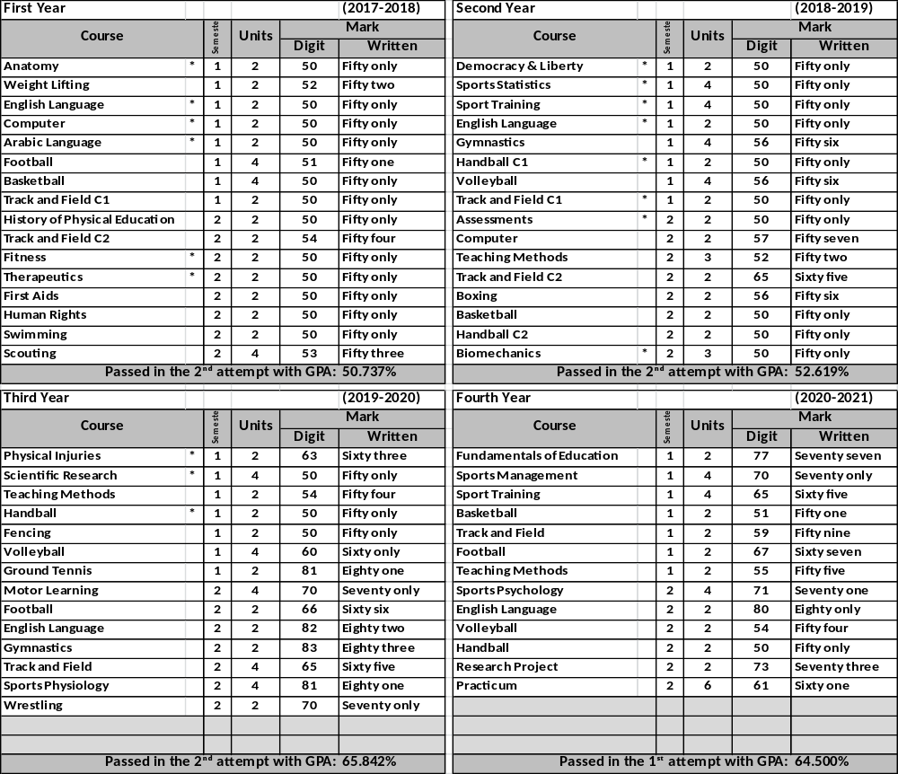

Notes related to the student:
- Number and date order of graduation: .3088/14 in 8/11/2021
- Failed years: 2005-2006, 2005-2006
- Deferred years: 2005-2006, 2005-2006
- No-fail academic year: 2005-2006, 2005-2006
- Termination years and the order for recommencing
the study:1994-1995, ./1999 in 11/11/2022

General Notes:
- Average Weight: (90-100%)-Excellent, (80-89%)-Very Good,
(70-79%)- Good, (60-69%)- Middle, (50-59%)-Pass.
- Pass Mark: 50%.
- Language of Instruction: Arabic
- The sign (*)means that the students passed in the 2nd attempt
- This document is free from erasures and alterations.

Prof. Dr. Labeeb Zouyan Moseekh
Dean
Dr. Marwan Abdulhamed Yousif
Registrar
Prof. Dr. Waleed Khalid Humadi
Dean Asst. for Student’s Affair

Hayder Dhameer Abed
Document Officer

