أدوات التصميم

Full Name: fdgdfgdgdgffdgdg dfgdfgd
Place and Date of Birth: Baghdad - 2/10/1988
College: Physical Education and Sport Sciences
Department: None
Certificate: B.Sc.
Rate: 62.633
Rate(written): Sixty Two and Six hundred Thirty Three Thousandths
Grade: Very Good
Student's rank: (73ʳᵈ) of (81) graduates
Note: More information is on the back of the paper.

Gender: Male
Nationality: Iraqi
Admission year: 2019-2020
Date of Graduation: 01/01/2027
Type of Study: Morning
Attempt: 1ˢᵗ
Year of Graduation: 2022-2023
Rate of the 1st Graduate: 86.297
Rate(written): Eighty Six and Two hundred Ninety Seven Thousandths

Notes related to the student:
- Number and date order of graduation: .2801/14 in 10/10/2023
- Failed years: None
- Deferred years: None
- No-fail academic year: None
- Termination years and the order for recommencing the study:None

- Admission year: 2019-2020

He/she : He
Rate: 62.633% Sixty One and One hundred Fifty Thousandths
Order No.: .2801/14 in 10/10/2023
Date: / /2024

Text النموذج الاول

This is to certify that (RAAD MOAGHHGD ALI) (Iraqi Nationality), whose photo is affixed aside, has been awarded the B.Sc. Degree. in Physical Education and Sport Science (Morning Studies) in the academic year (2001-2002) with an average (61.150%) (Sixty One and One hundred Fifty Thousandths) corresponding to (Middle) evaluation, the 1ˢᵗ Attempt, according to the Order No.5333 in 10/07/2002. He has ranked the (1ˢᵗ) out of (11) graduates. Below are the courses undertaken and the marks gained by the student during his study period at this college.

Transcript Certificate of Graduation

No.
Date: / /2024
الباركود
الصورة

Full Name: AEMAN MOHAMMED TRKEE
Place and Date of Birth: BAGHDAD - 1/1/1993
College: Physical Education and Sport Sciences
Department: None
Certificate: B.Sc.
Rate: 62.633
Grade: Middle
Student's rank: (77ᵗʰ) of (79) graduates
Note: More information is on the back of the paper.

Gender: Male
Nationality: Iraqi
Admission year: 2016-2017
Date of Graduation: 01/01/2027
Type of Study: Morning
Rate of the 1st Graduate: 87.186
Attempt: 1ˢᵗ
Year of Graduation: 2020-2021

Below is the official transcript of the subjects and marks achieved during the years of study
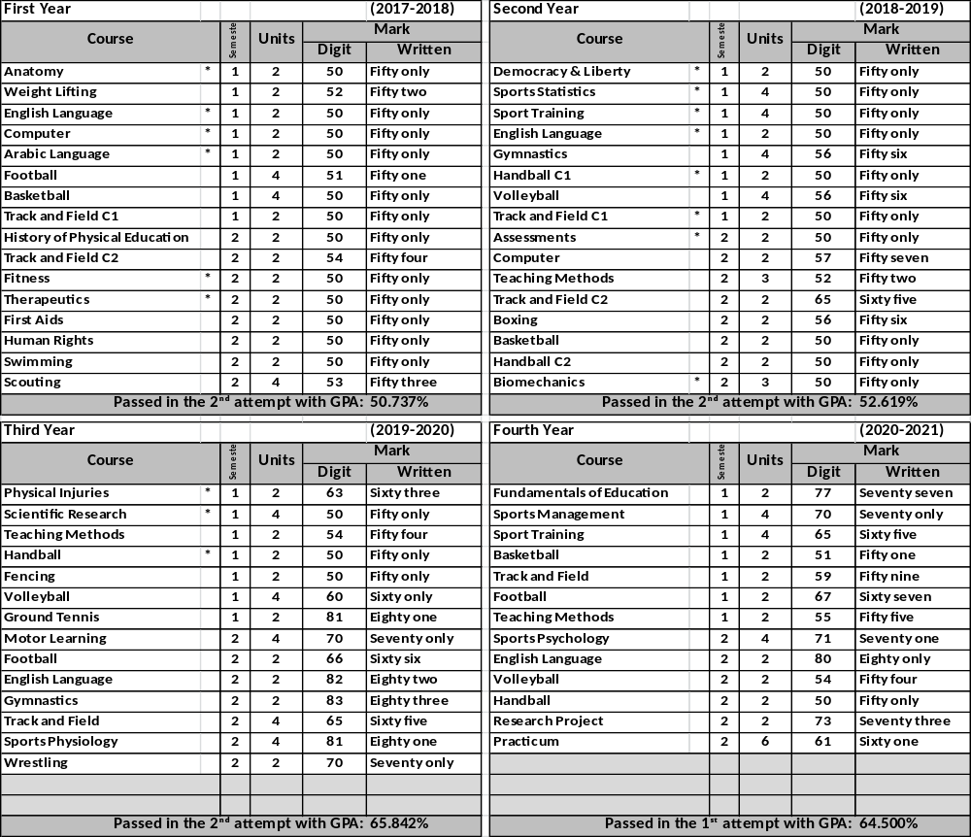

Notes related to the student:
- Number and date order of graduation: .3088/14 in 8/11/2021
- Failed years: 2005-2006, 2005-2006
- Deferred years: 2005-2006, 2005-2006
- No-fail academic year: 2005-2006, 2005-2006
- Termination years and the order for recommencing the study:1994-1995, ./1999 in 11/11/2022

General Notes:
- Average Weight: (90-100%)-Excellent, (80-89%)-Very Good,
(70-79%)- Good, (60-69%)- Middle, (50-59%)-Pass.
- Pass Mark: 50%.
- Language of Instruction: Arabic
- The sign (*)means that the students passed in the 2nd attempt

Prof. Dr. Labeeb Zouyan Moseekh
Dean
Dr. Marwan Abdulhamed Yousif
Registrar
Prof. Dr. Waleed Khalid Humadi
Dean Asst. for Student’s Affair

