Transcript Certificate of Graduation

No.
Date: / /2024
الباركود
الصورة
Full Name: ORAS QASM MOHAMMED
Place and Date of Birth: BAGHDAD - 1/1/1979
College: Physical Education and Sport Sciences
Department: None
Certificate: B.Sc.
Grade: Middle
Student's rank: (1ˢᵗ) of (11) graduates
Rate: 69.12
Rate(written): Sixty Nine and Twelve Percent
Note: More information is on the back of the paper.

Gender: Male
Nationality: Iraqi
Admission year: 1998-1999
Date of Graduation: 01/01/2027
Type of Study: Morning
Attempt: 1ˢᵗ
Year of Graduation: 2001-2002
Rate of the 1st Graduate: 82.97

Below is the official transcript of the subjects and marks achieved during the years of study
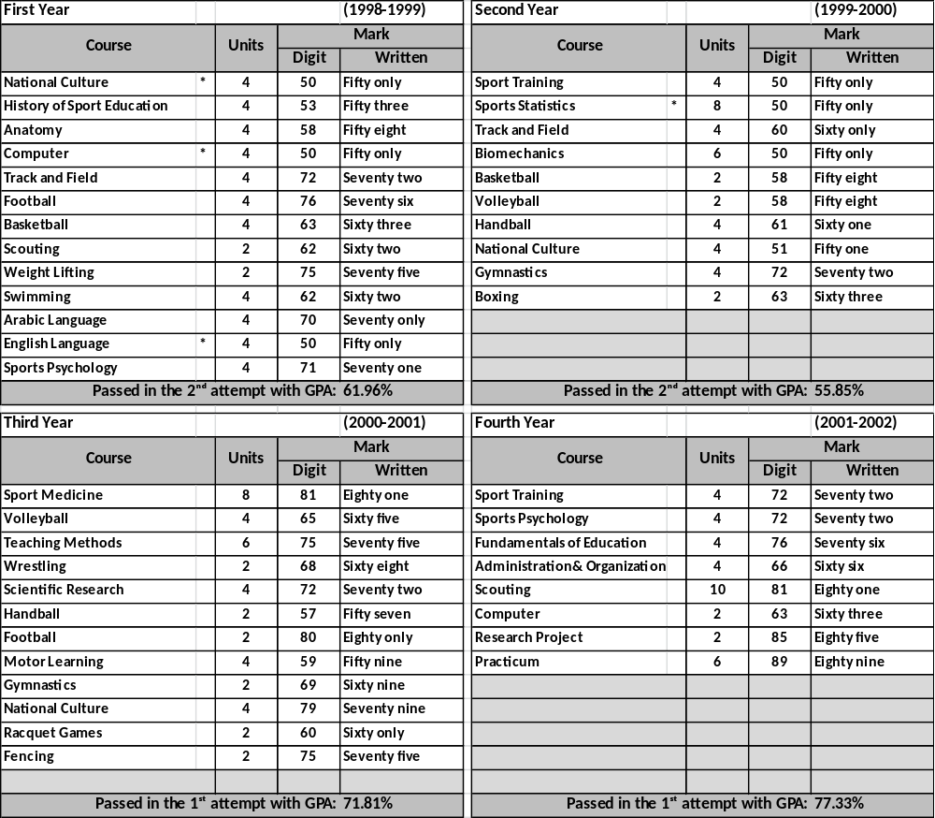

Notes related to the student:
- Number and date order of graduation: 5333 in 10/7/2002
- Failed years: 2000-2001, 2000-2001
- Deferred years: 2000-2001, 2000-2001
- No-fail academic year: 2000-2001, 2000-2001
- Termination years and the order for recommencing
the study:1995-1996, ./1999 in 12/12/2000

General Notes:
- Average Weight: (90-100%)-Excellent, (80-89%)-Very Good,
(70-79%)- Good, (60-69%)- Middle, (50-59%)-Pass.
- Pass Mark: 50%.
- Language of Instruction: Arabic
- The sign (*)means that the students passed in the 2nd attempt
- This document is free from erasures and alterations.

Prof. Dr. Labeeb Zouyan Moseekh
Dean
Dr. Marwan Abdulhamed Yousif
Registrar
Prof. Dr. Waleed Khalid Humadi
Dean Asst. for Student’s Affair

Hayder Dhameer Abed
Document Officer

