أدوات التصميم

Full Name: ORAS QASM MOHAMMED
Place and Date of Birth: Baghdad - 2/10/1988
College: Physical Education and Sport Sciences
Department: None
Certificate: B.Sc.
Rate: 55.69
Rate(written): Fifty Five and Sixty Nine Percent
Grade: Very Good
Student's rank: (1ˢᵗ) of (11) graduates
Note: More information is on the back of the paper.

Gender: Male
Nationality: Iraqi
Admission year: 2018-2019
Date of Graduation: 01/01/2027
Type of Study: Morning
Rate of the 1st Graduate: 55.69
Rate(written): Fifty Five and Sixty Nine Percent
Attempt: 1ˢᵗ
Year of Graduation: 2001-2002

Notes related to the student:
- Number and date order of graduation: 5333 in 10/7/2002
- Failed years: None
- Deferred years: None
- No-fail academic year: None
- Termination years and the order for recommencing the study:None

- Admission year: 2018-2019

He/she : He
Rate: 55.69% Fifty Five and Sixty Nine Percent
Order No.: 5333 in 10/07/2002
Date: / /2024

Text النموذج الاول

This is to certify that (RAAD MOAGHHGD ALI) (Iraqi Nationality), whose photo is affixed aside, has been awarded the B.Sc. Degree. in Physical Education and Sport Science (Morning Studies) in the academic year (2001-2002) with an average (69.84%) (Sixty Nine and Eighty Four Percent) corresponding to (Middle) evaluation, the 1ˢᵗ Attempt, according to the Order No.5333 in 10/07/2002. He has ranked the (1ˢᵗ) out of (11) graduates. Below are the courses undertaken and the marks gained by the student during his study period at this college.

Transcript Certificate of Graduation

No.
Date: / /2024
الباركود
الصورة

Full Name: ORAS QASM MOHAMMED
Place and Date of Birth: BAGHDAD - 10/12/1979
College: Physical Education and Sport Sciences
Department: None
Certificate: B.Sc.
Rate: 55.69
Grade: Middle
Student's rank: (1ˢᵗ) of (11) graduates
Note: More information is on the back of the paper.

Gender: Male
Nationality: Iraqi
Admission year: 2018-2019
Date of Graduation: 01/01/2027
Type of Study: Morning
Rate of the 1st Graduate: 69.84
Attempt: 1ˢᵗ
Year of Graduation: 2001-2002

Below is the official transcript of the subjects and marks achieved during the years of study
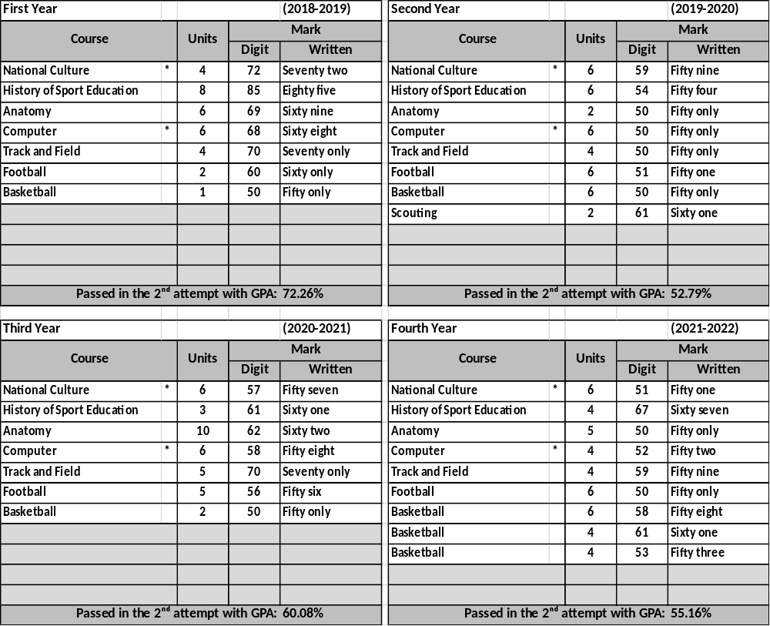

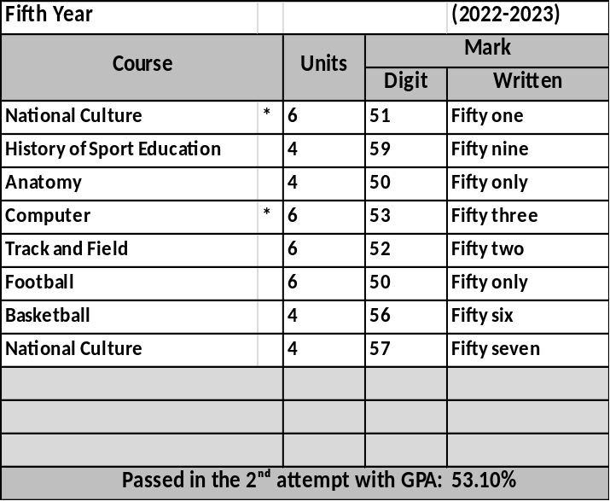
Notes related to the student:
- Number and date order of graduation: 5333 in 10/7/2002
- Failed years: 2003-2004, 2003-2004
- Deferred years: 2003-2004, 2003-2004
- No-fail academic year: 2003-2004, 2003-2004
- Termination years and the order for recommencing the study:1994-1995, ./1588 in 11/12/202211/12/2022

General Notes:
- Average Weight: (90-100%)-Excellent, (80-89%)-Very Good,
(70-79%)- Good, (60-69%)- Middle, (50-59%)-Pass.
- Pass Mark: 50%.
- Language of Instruction: Arabic
- The sign (*)means that the students passed in the 2nd attempt

Prof. Dr. Labeeb Zouyan Moseekh
Dean
Dr. Marwan Abdulhamed Yousif
Registrar
Prof. Dr. Waleed Khalid Humadi
Dean Asst. for Student’s Affair

