OFFICIAL TRANSCRIPT
الباركود
الصورة
This is to certify that (AEMAN MOHAMMED TRKEE) (Iraqi Nationality), whose photo is affixed aside, has been awarded the B.Sc. Degree. in Physical Education and Sport Sciences (Morning Studies) in the academic year (2020-2021) with an average (61.150%) (Sixty One and One hundred Fifty Thousandths) corresponding to (Middle) evaluation, the 1ˢᵗ Attempt, according to the Order No..3088/14 in 08/11/2021. He has ranked the (77ᵗʰ) out of (79) graduates. Below are the courses undertaken and the marks gained by the student during his study period at this college.

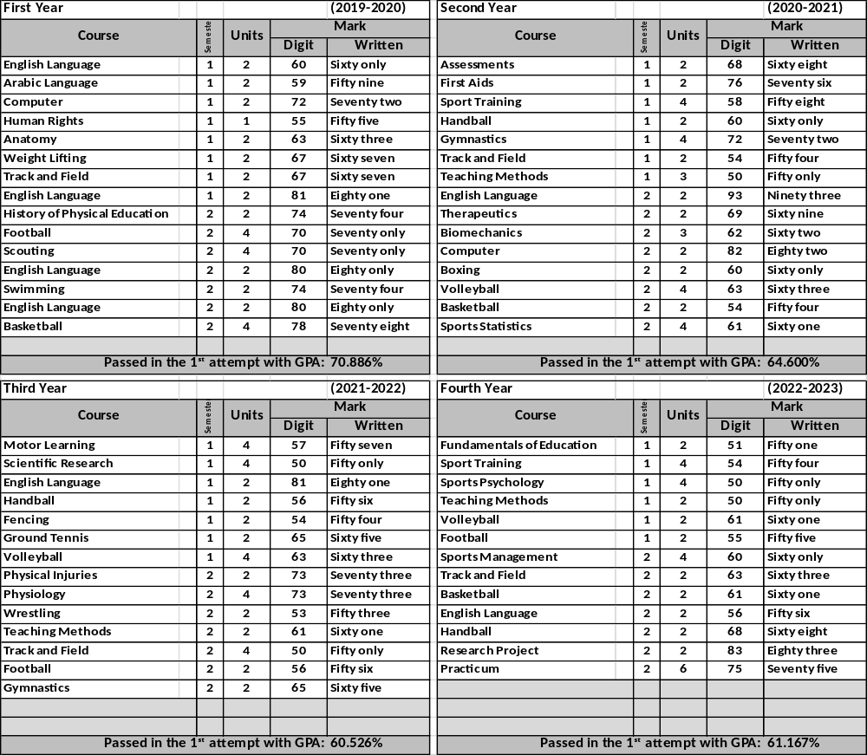

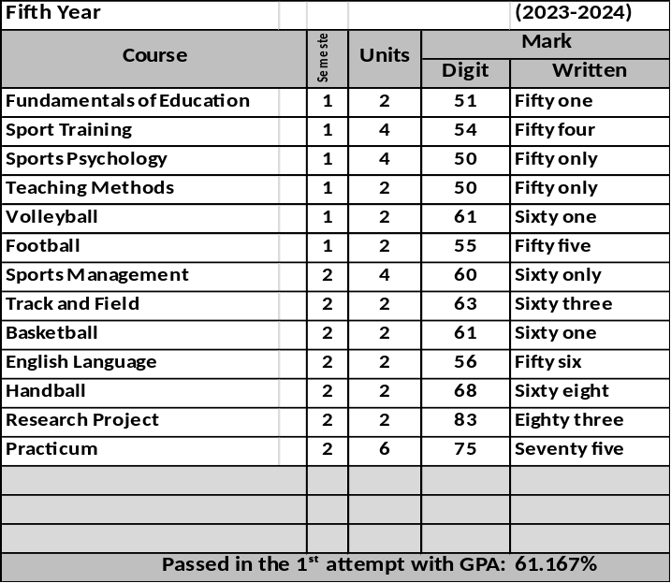
Notes related to the student:
- Average of the first rank student: 87.186%
- Admission year: 2019-2020
- Failed years: 2013-2014, 2013-2014
- Deferred years: 2014-2015, 2014-2015
- No-fail academic year: 2011-2012, 2011-2012
- Termination years and the order for recommencing
the study:1995-1996, ./1444 in 11/10/2012

General Notes:
- Average Weight: (90-100%)-Excellent, (80-89%)-Very Good,
(70-79%)- Good, (60-69%)- Middle, (50-59%)-Pass.
- Pass Mark: 50%.
- Language of Instruction: Arabic
- The sign (*)means that the students passed in the 2nd attempt
- This document is free from erasures and alterations.

Prof. Dr. Labeeb Zouyan Moseekh
Dean
Dr. Marwan Abdulhamed Yousif
Registrar
Prof. Dr. Waleed Khalid Humadi
Dean Asst. for Student’s Affair

Hayder Dhameer Abed
Document Officer

