Transcript Certificate of Graduation

No.
Date: / /2024
الباركود
الصورة

Full Name: AEMAN MOHAMMED TRKEE
Place and Date of Birth: ANBAR - 1/1/1993
College: Physical Education and Sport Sciences
Department: None
Certificate: B.Sc.
Rate: 62.633
Grade: Middle
Student's rank: (77ᵗʰ) out of (79)
Note: More information is on the back of the paper.

Gender: Male
Nationality: Iraqi
Admission year: 2019-2020
Date of Graduation: 01/01/2027
Type of Study: Morning
Rate of the 1st Graduate: 87.186
Attempt: 1ˢᵗ
Year of Graduation: 2020-2021

Below is the official transcript of the subjects and marks achieved during the years of study
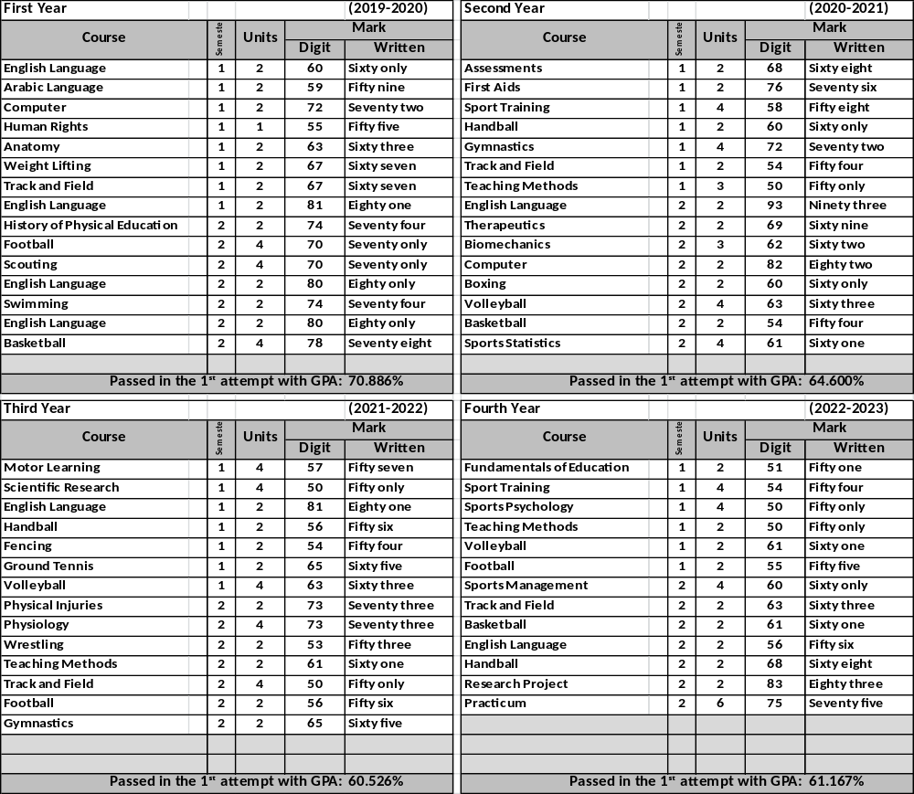

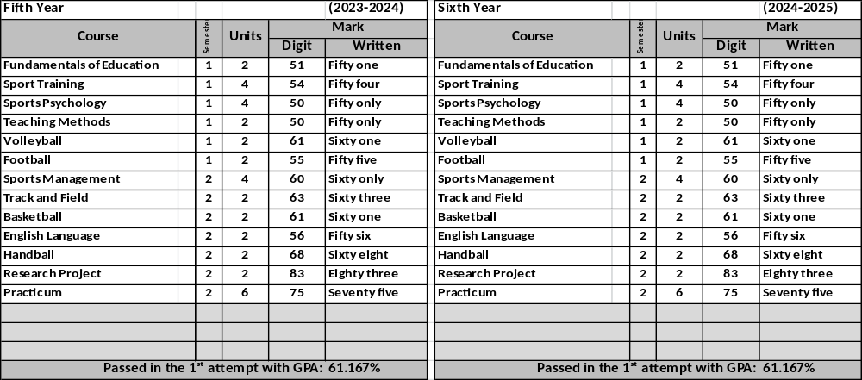
Notes related to the student:
- Number and date order of graduation: .3088/14 in 8/11/2021
- Failed years: 2222-2222, 2222-2222
- Deferred years: 3333-3333, 3333-3333
- No-fail academic year: 1111-1111, 1111-1111
- Termination years and the order for recommencing
the study:1990-1991, ./1111 in 19/12/2005

General Notes:
- Average Weight: (90-100%)-Excellent, (80-89%)-Very Good,
(70-79%)- Good, (60-69%)- Middle, (50-59%)-Pass.
- Pass Mark: 50%.
- Language of Instruction: Arabic
- The sign (*)means that the students passed in the 2nd attempt
- This document is free from erasures and alterations.

Prof. Dr. Labeeb Zouyan Moseekh
Dean
Dr. Marwan Abdulhamed Yousif
Registrar
Prof. Dr. Waleed Khalid Humadi
Dean Asst. for Student’s Affair

Hayder Dhameer Abed
Document Officer

