**Lidar Classification in New Orleans, LA**

This code is originally developed by Sean Woznicki. https://www.gvsu.edu/wri/woznicki/

Modified and Implemented by Ci Song, Oct 2022.

Instructed by Derek Van Berkel

**Data Source:**

Lidar data (2017): U.S. Geological Survey, 2017 USGS Lidar: Upper Delta Plain, LA, [NOAA: Data Access Viewer](https://coast.noaa.gov/dataviewer/#/lidar/search/-10060183.040725186,3474215.8096178314,-9998116.173757622,3524664.2482860475/details/8564)

NAIP data (11/2021 - 01/2022), [EarthExplorer (usgs.gov)](https://earthexplorer.usgs.gov/" \t "_blank)

Road centerline (2016), [Road Centerline | Road Centerline | City of New Orleans Open Data Portal (arcgis.com)](https://portal-nolagis.opendata.arcgis.com/datasets/NOLAGIS::road-centerline/explore)

**Code**

library(rgdal)

library(raster)

library(caret)

library(sp)

library(ggplot2)

library(RStoolbox)

library(klaR)

library(dplyr)

library(sf)

set.seed(22587)

int <- raster("NOLA\_intensity\_5m.tif")

hag <- raster("NOLA\_HAG\_5m\_0906.tif")

ndvi <- raster("NOLA\_NDVI\_0725.tif")

imp <- raster("NOLA\_IMP\_0906.tif")

naip <- brick("NOLA\_RGBIR\_0725.tif")

img <- addLayer(naip, ndvi, int, hag, imp)

names(img) <- c(paste0("B",1:8,coll="")) #R,G,B,NIR,NDVI,Intensity,HAG,Impervious (binary)

poly <- rgdal::readOGR("TrainingPolygon1010.shp")

test <- spsample(poly, n = 25000, type = "stratified")

test.lulc.df <- extract(poly, test, df = TRUE)

test.img.df <- extract(img, test, df=TRUE)

drops <- c("Shape\_Leng","Shape\_Area")

test.lulc.df2 <- test.lulc.df[, !(names(test.lulc.df) %in% drops)]

names(test.lulc.df2) <- c("ID", "LULC")

test.lulc.df2$LULC <- as.integer(test.lulc.df2$LULC)

df.train <- merge(test.lulc.df2, test.img.df, by="ID")

df.train$LULC <- as.factor(df.train$LULC)

df.train %>%

group\_by(LULC) %>%

summarise(no\_rows = length(LULC))

df.train <- na.omit(df.train)

split = 0.7

trainIndex <- createDataPartition(df.train$LULC, p=split, list=FALSE)

data\_train <- df.train[ trainIndex,]

data\_test <- df.train[-trainIndex,]

rf.train <- train(LULC~B1+B2+B3+B4+B5+B6+B7+B8, method='rf', data=data\_train)

x\_test <- data\_test[,3:10] # B1~B8

y\_test <- data\_test[,2] # LULC

predictions <- predict(rf.train,x\_test)

confusionMatrix(predictions, y\_test)

importance <- varImp(rf.train)

classify <- predict(img,rf.train)

classify.save <- writeRaster(classify,filename="NOLA\_Classified\_2017\_221010.tif", format="GTiff", overwrite=TRUE)

**Results**

**Confusion Matrix**

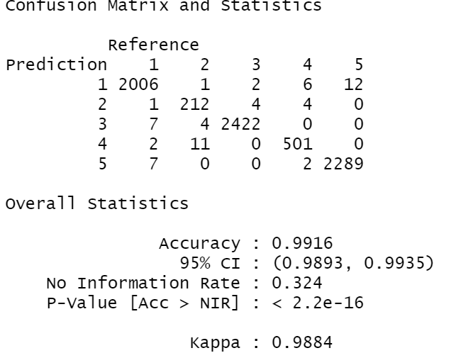

**Statistics** **by Class**

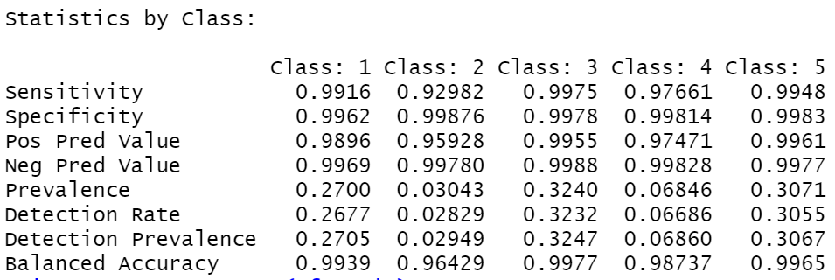

Legend: 1 impervious; 2 grass; 3 forest; 4 soil; 5 water.

**Importance Plot**

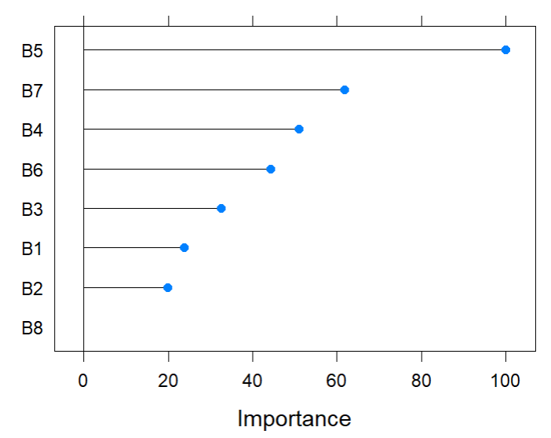

B1~B8: R, G, B, NIR, NDVI, Intensity, HAG, Impervious

Charles Song

[songsc@umich.edu](mailto:songsc@umich.edu)

12/05/2022

