# Introduction to GIS concepts

* + Definition of GIS.

Geographic Information System (GIS) is a technology that captures, stores, analyzes, and visualizes spatial and geographic data, allowing users to explore relationships, patterns, and trends on Earth’s surface to support decision-making across various fields. GIS can at times become abstract to fit the definitions below:

GIS as a Science and Art:

Geographic Information System (GIS) is both a science and an art focused on understanding spatial and geographic patterns. It involves the study of spatial relationships, geographical phenomena, and the creative interpretation of spatial data to analyze how physical and social processes interact across space. This scientific and artistic approach in GIS enables the visualization, analysis, and interpretation of complex spatial information to support insight into environmental, societal, and cultural patterns.

GIS as Technology (Hardware and Software):

Geographic Information System (GIS) is a technological system composed of hardware and software used for capturing, storing, analyzing, and displaying geographic data. The hardware consists of computers, servers, GPS devices, and other tools that facilitate data collection and processing. The software includes specialized GIS applications that enable users to manage spatial databases, perform complex spatial analyses, and create detailed maps. This technology allows for efficient data handling, visualization, and geographic analysis, supporting a range of applications across industries.

Importance and applications of GIS.

GIS is essential because it provides a unique perspective on data through the lens of location, making it possible to identify patterns, relationships, and trends that are difficult to see otherwise. This spatial perspective enhances decision-making in various fields, promotes efficient resource allocation, and aids in planning and managing the environment, infrastructure, and public services. GIS enables better communication through visualizations, supports problem-solving with data-driven insights, and fosters collaboration across disciplines by providing a common framework.

**Applications of GIS:**

1. **Urban Planning and Development**: GIS is used to analyze land use, assess zoning compliance, design transportation networks, and monitor urban growth to make informed development plans.
2. **Environmental Management**: GIS helps track and manage natural resources, assess environmental impacts, monitor wildlife habitats, and plan conservation efforts, aiding in sustainable environmental practices.
3. **Disaster Management**: GIS is crucial in risk assessment, emergency response, and recovery by mapping hazard zones, predicting disaster impact, and coordinating rescue operations.
4. **Public Health**: GIS enables the mapping and analysis of disease outbreaks, healthcare accessibility, and health resource allocation, allowing for better responses to public health challenges.
5. **Agriculture**: In agriculture, GIS supports precision farming by analyzing soil conditions, weather patterns, and crop health, leading to optimized resource use and increased yields.
6. **Transportation and Logistics**: GIS assists in route planning, traffic management, and infrastructure maintenance, improving efficiency and reducing costs in logistics and transportation.
7. **Natural Resource Management**: GIS supports the exploration and management of resources such as minerals, oil, gas, and water by mapping resource locations and analyzing geological data.
8. **Real Estate and Market Analysis**: GIS provides insights into property values, market demographics, and spatial trends, benefiting real estate development and retail site selection.
9. **Utilities Management**: GIS is used by utility companies to manage infrastructure such as water, gas, and electric networks, helping to optimize maintenance and manage assets.
10. **Education and Research**: GIS is widely used in academia and research for spatial analysis, enabling scientists to conduct studies in fields like ecology, geography, sociology, and archaeology.

Key components of GIS.

The key components of GIS are essential elements that work together to collect, store, analyze, and visualize geographic data effectively. These components include:

1. **Hardware**:  
   The physical technology that runs GIS software, such as computers, servers, GPS devices, and mobile devices. Hardware facilitates data processing, storage, and output in various formats, including maps, reports, and digital displays.
2. **Software**:  
   GIS software provides the tools needed for data entry, analysis, visualization, and management. Examples include ArcGIS, QGIS, and Google Earth. Software is responsible for data processing, mapping, spatial analysis, and creating user interfaces for interaction with spatial data.
3. **Data**:  
   The core of any GIS, data includes geographic (spatial) and attribute (non-spatial) information. Spatial data describes the location and shape of features (such as points, lines, and polygons), while attribute data provides descriptive information about those features (such as population or land use). Data sources can be diverse, including satellite imagery, GPS data, surveys, and existing databases.
4. **People**:  
   Users and professionals who operate GIS systems, analyze data, and apply the information in real-world scenarios. GIS professionals include GIS analysts, cartographers, data scientists, and decision-makers who interpret and utilize spatial data to solve problems and make decisions.
5. **Methods**:  
   The procedures, techniques, and workflows used to collect, process, analyze, and interpret spatial data within a GIS. These methodologies ensure that GIS analyses are conducted accurately, consistently, and efficiently, which is vital for obtaining reliable results.
6. **Networks and Infrastructure**:  
   The connectivity tools and resources, such as internet networks, cloud platforms, and data-sharing protocols, that allow GIS data to be shared, accessed remotely, and integrated with other systems. This infrastructure supports collaboration, data distribution, and cloud-based processing in modern GIS applications.

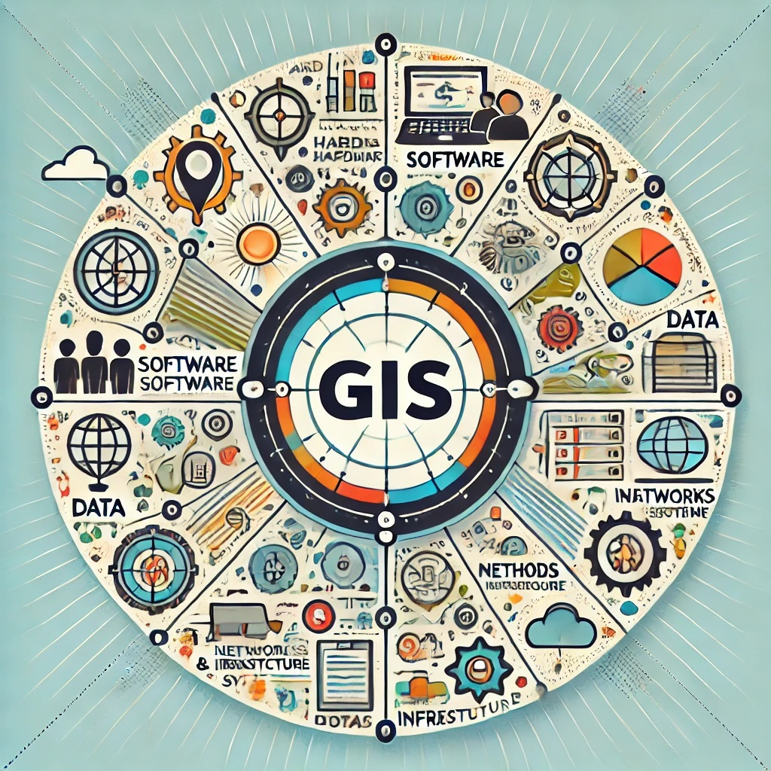

Spatial data types: vector and raster.

In GIS, spatial data is primarily categorized into two types: **vector** and **raster** data. Each has unique characteristics and is suited to different types of spatial analysis and visualization.

**1. Vector Data**

* **Description**: Vector data represents geographic features using points, lines, and polygons. Each feature is defined by its coordinates, making it precise and suitable for representing discrete objects with clear boundaries.
* **Components**:
  + **Points**: Represent discrete locations, like a city or a landmark.
  + **Lines**: Represent linear features, like roads or rivers.
  + **Polygons**: Represent areas, such as land parcels, lakes, or political boundaries.
* **Applications**: Ideal for mapping features with exact boundaries, like property lines, road networks, and administrative areas.

**2. Raster Data**

* **Description**: Raster data represents geographic information as a grid of cells or pixels, each with a value. This type is typically used for continuous data like elevation, temperature, or satellite imagery.
* **Components**:
  + **Pixels (Cells)**: Each pixel has a specific value, such as a color or a numerical value, representing the attribute at that location.
  + **Resolution**: Refers to the size of each cell, affecting the level of detail in the image. Higher resolution means more detail.
* **Applications**: Well-suited for representing continuous phenomena like rainfall, land cover, and elevation.

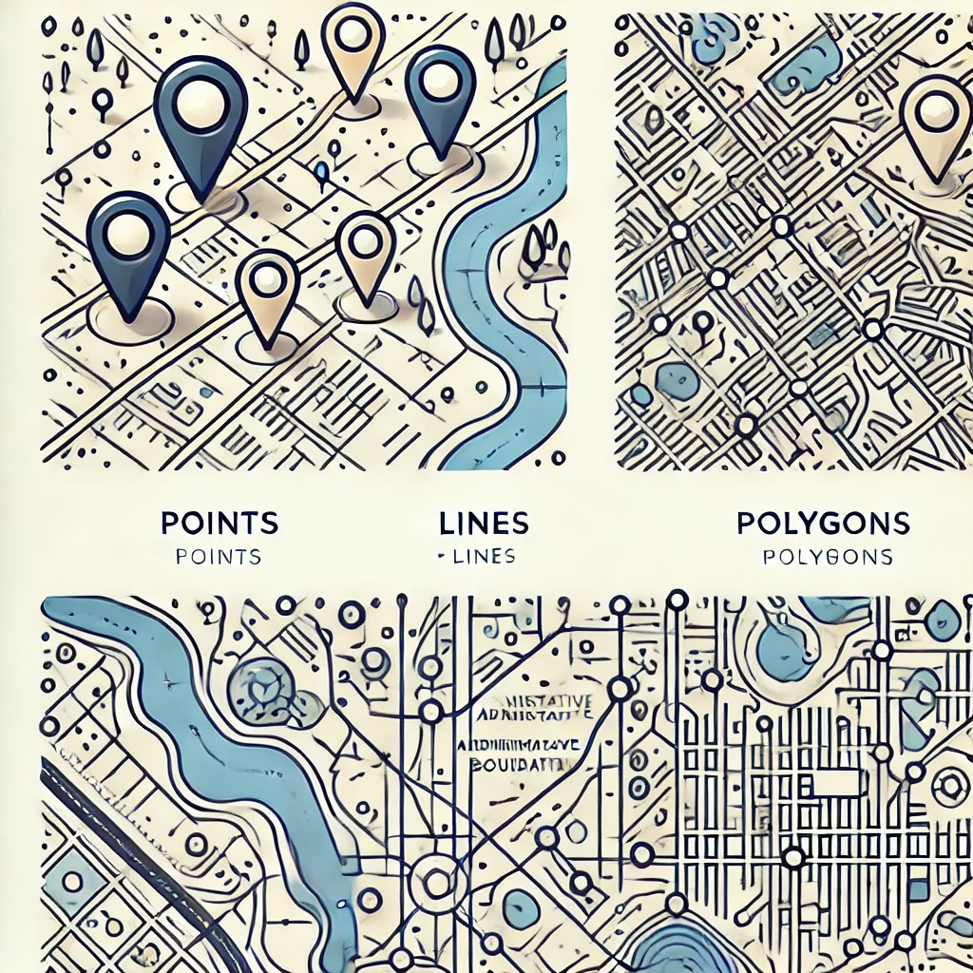

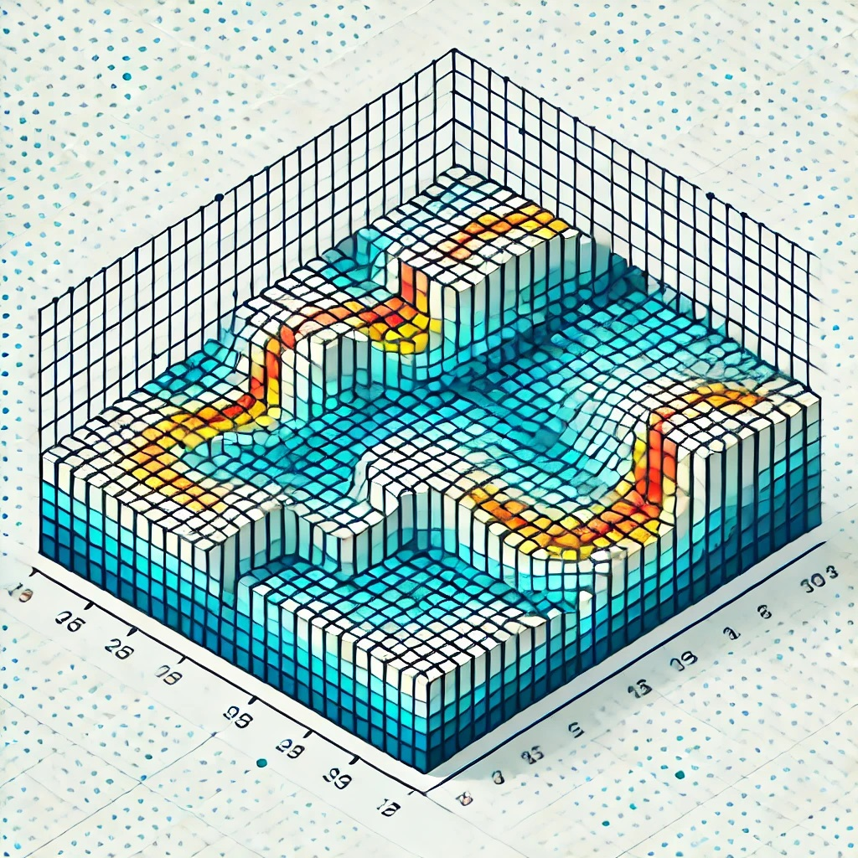

Overview of geospatial technology trends.

# Getting started with QGIS:

* + Overview of QGIS and its capabilities.

QGIS (Quantum Geographic Information System) is a free, open-source Geographic Information System (GIS) software that allows users to create, analyze, and visualize spatial data. It is widely used by GIS professionals, researchers, and organizations for mapping and spatial analysis due to its flexibility, extensive capabilities, and community support.

**Key Features and Capabilities of QGIS**

**1. Data Management**

* **Support for Multiple Data Formats**: Handles raster, vector, and tabular data from various sources, including shapefiles, GeoJSON, KML, CSV, PostGIS, and more.
* **Data Import and Export**: Facilitates seamless data exchange between QGIS and other software, enabling compatibility with industry standards.
* **Database Integration**: Supports spatial databases like PostgreSQL/PostGIS, SpatiaLite, Oracle Spatial, and others.

**2. Mapping and Visualization**

* **Cartographic Design**: Create professional-quality maps with custom symbology, labels, and layouts.
* **Layer Styling**: Apply advanced styling options like heatmaps, graduated symbols, and rule-based rendering.
* **3D Visualization**: Visualize spatial data in 3D to better understand elevation, terrain, and other spatial relationships.

**3. Spatial Analysis**

* **Geoprocessing Tools**: Perform operations like buffering, intersecting, clipping, and union on spatial datasets.
* **Raster Analysis**: Tools for slope, aspect, reclassification, and other raster-based analyses.
* **Network Analysis**: Solve problems related to routing, service areas, and shortest paths.

**4. Plugins and Extensibility**

* **Plugin Repository**: Access a wide range of plugins developed by the QGIS community for tasks like geocoding, topology checks, and advanced analysis.
* **Custom Plugins**: Create custom plugins using Python to extend QGIS functionalities.

**5. Integration with Other Software**

* **GRASS GIS and SAGA GIS**: Direct integration for advanced spatial analysis.
* **Python Console**: Perform scripting and automation tasks using Python, including PyQGIS library for customization.
* **Web Mapping**: Export projects to web-compatible formats using tools like QGIS2Web and LizMap.

**6. User-Friendly Interface**

* **Drag-and-Drop Functionality**: Simplifies data handling and layer management.
* **Customizable Toolbar and Panels**: Tailor the interface to suit specific workflows.
* **Dynamic Data Visualization**: Real-time updates for layers linked to external data sources.

**7. Project Sharing and Collaboration**

* **Project Files**: Save and share QGIS project files (.qgz or .qgs) with other users.
* **Coordinate System Support**: Full support for a wide range of coordinate reference systems, ensuring accurate spatial representation.

**8. Community Support and Documentation**

* **Active Community**: A global network of users and developers provides continuous updates and technical support.
* **Extensive Documentation**: Comprehensive user manuals, tutorials, and forums are available to assist beginners and advanced users alike.

**Benefits of QGIS**

* **Cost-Efficiency**: Open-source and free to use for individuals, businesses, and governments.
* **Cross-Platform Compatibility**: Runs on Windows, macOS, Linux, and other platforms.
* **Scalability**: Suitable for simple mapping projects as well as complex spatial analyses.
* **Customizability**: Flexible enough to meet specific project requirements through plugins and scripting.

Installing and configuring QGIS.

Installing and configuring QGIS involves downloading the software, installing it on your system, and setting up the environment for optimal use. Follow these steps to get started with QGIS:

**1. Downloading QGIS**

* **Official Website**: Visit the official QGIS website at <https://qgis.org>.
* **Choose Version**:
  + **Long-Term Release (LTR)**: Stable and recommended for production use.
  + **Latest Release**: Includes the newest features but may have minor bugs.
* **Select OS**: Choose the appropriate installer for your operating system (Windows, macOS, Linux).

**2. Installing QGIS**

**For Windows**

1. Download the QGIS installer (.exe file) from the official website.
2. Run the installer and follow the on-screen instructions:
   * Choose the installation type (default is typically fine).
   * Select the destination folder.
   * Install optional packages like GRASS GIS and SAGA GIS for advanced analysis.
3. Complete the installation process.

**3. Initial Configuration**

**Launch QGIS**

* Open QGIS from your applications or start menu.
* Choose the default or custom project template (if applicable).

**Set Up the Interface**

* **Panels and Toolbars**: Customize the interface by enabling or disabling panels and toolbars from the "View" menu.
* **Themes**: Select a light or dark theme under Settings > Options > General > UI Theme.

**Configure Plugins**

* Go to Plugins > Manage and Install Plugins.
* Search for and install essential plugins like:
  + **QGIS2Web**: For web mapping.
  + **OpenLayers Plugin**: To access basemaps.
  + **QuickOSM**: For OpenStreetMap data.
  + **Processing Tools**: GRASS GIS and SAGA GIS integration.

**Set Up Coordinate Systems**

* Go to Settings > Options > CRS.
* Set the default Coordinate Reference System (CRS) for new projects (e.g., WGS 84 or a local CRS).
* Enable on-the-fly CRS transformation for seamless data integration.

Understanding the QGIS interface (toolbars, menus, panels).

The QGIS interface is user-friendly and customizable, designed to provide access to a wide range of tools for mapping and spatial analysis. Here’s an overview of its key components:

* + 1. **Main Components of the Interface**

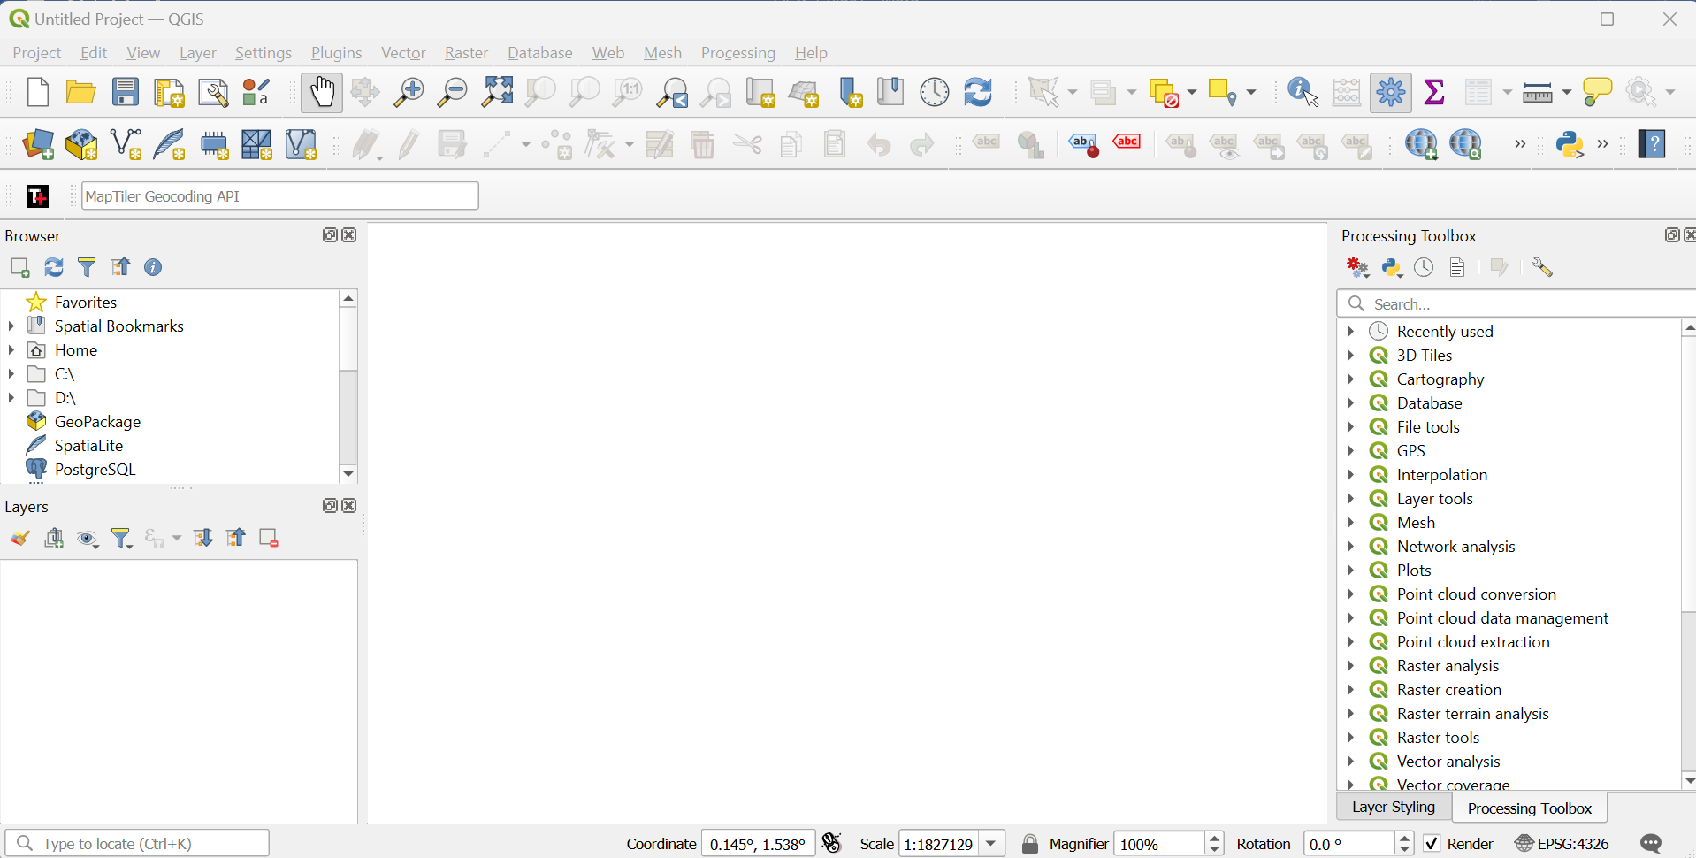

**A. Menu Bar**

* Located at the top of the interface.
* Provides access to all QGIS functions organized under different menus (e.g., File, Edit, View, Layer, Settings, Plugins, Help).



* Key menus include:
  + **Project**: Create, open, save, and manage QGIS projects.
  + **Layer**: Add, remove, and manage vector and raster layers.
  + **View**: Control the visibility of toolbars, panels, and the map canvas.
  + **Processing**: Access advanced geospatial analysis tools.

**B. Toolbars**



* Below the menu bar, toolbars provide quick access to frequently used tools.
* Common toolbars:
  + **Project Toolbar**: Create, open, save, and manage projects.
  + **Navigation Toolbar**: Zoom in/out, pan, or navigate through the map.
  + **Layer Toolbar**: Add vector, raster, and database layers.
  + **Advanced Digitizing Toolbar**: Edit and manipulate vector features.
  + **Attributes Toolbar**: Edit and query attribute data.
  + **Plugins Toolbar**: Manage and access installed plugins.
* Toolbars are customizable: Right-click in the toolbar area to add or remove toolbars.

**C. Panels**

* Panels provide detailed controls and information for working with layers, data, and tools.

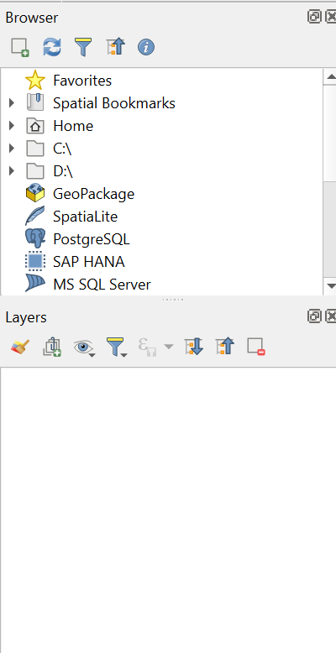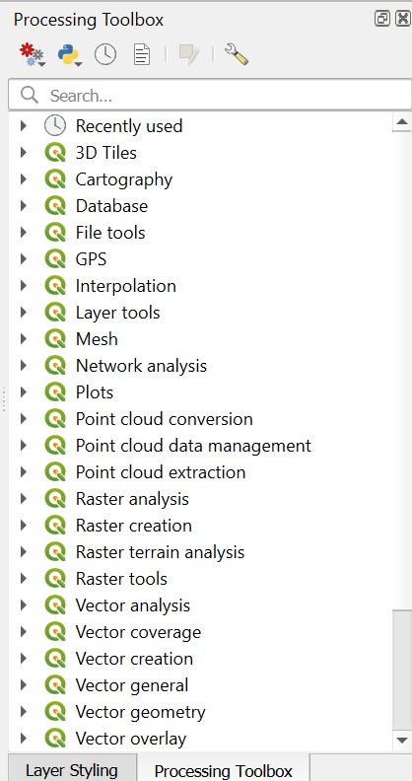

* Common panels:
  + **Layers Panel**: Displays all the layers in the project. Layers can be reordered, styled, or toggled on/off.
  + **Browser Panel**: Allows navigation through file systems and databases to add data to the project.
  + **Log Panel**: Shows log messages for debugging and tracking processing activities.
  + **Processing Toolbox**: Provides access to all analysis tools and algorithms.
  + **Attributes Table Panel**: Displays attribute data for a selected layer.

**D. Map Canvas**

* The central workspace where spatial data is visualized and interacted with.
* Features:
  + Zoom and pan to navigate the map.
  + On-the-fly rendering of layers based on coordinate reference systems.
  + Interactive map selection and querying tools.

**E. Status Bar**

* Located at the bottom of the interface.
* Provides real-time information about the map, including:
  + Coordinate reference system (CRS).
  + Current cursor coordinates.
  + Map scale.
  + Zoom level.



**2. Navigating the Interface**

**Customizing the Interface**

* Panels and toolbars can be rearranged, docked, or undocked to suit your workflow.
* Use View > Toolbars or View > Panels to enable or disable elements.

**Exploring Layers Panel**

* Layers are displayed in a hierarchical structure.
* Functions:
  + Right-click a layer for options like styling, attribute table access, or exporting.
  + Drag layers to reorder them in the map canvas.

**Using the Browser Panel**

* Browse for spatial data (shapefiles, raster images, databases, or web services) and drag it directly into the Map Canvas.

**3. Key Toolbars and Their Functions**

**Project Toolbar**

* **New Project**: Start a new QGIS project.
* **Save/Save As**: Save the current project.
* **Open Project**: Open an existing project file.

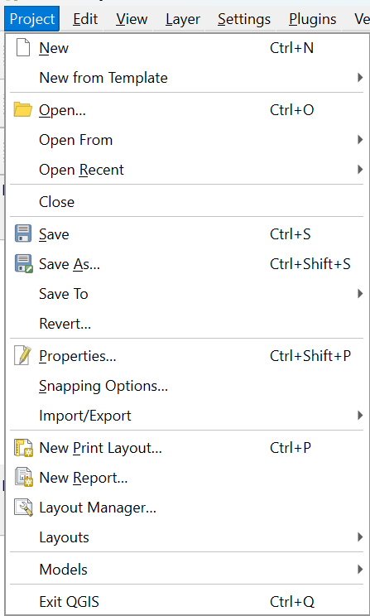

**Navigation Toolbar**

* **Zoom In/Out**: Adjust the map view.
* **Pan Map**: Move around the map without altering the zoom.
* **Zoom to Layer/Selection/Extent**: Quickly adjust the map view to specific features.

**Layer Toolbar**

* **Add Vector Layer**: Load vector data (e.g., shapefiles, GeoJSON).
* **Add Raster Layer**: Load raster data (e.g., satellite imagery).
* **Manage Layers**: Duplicate, group, or remove layers. 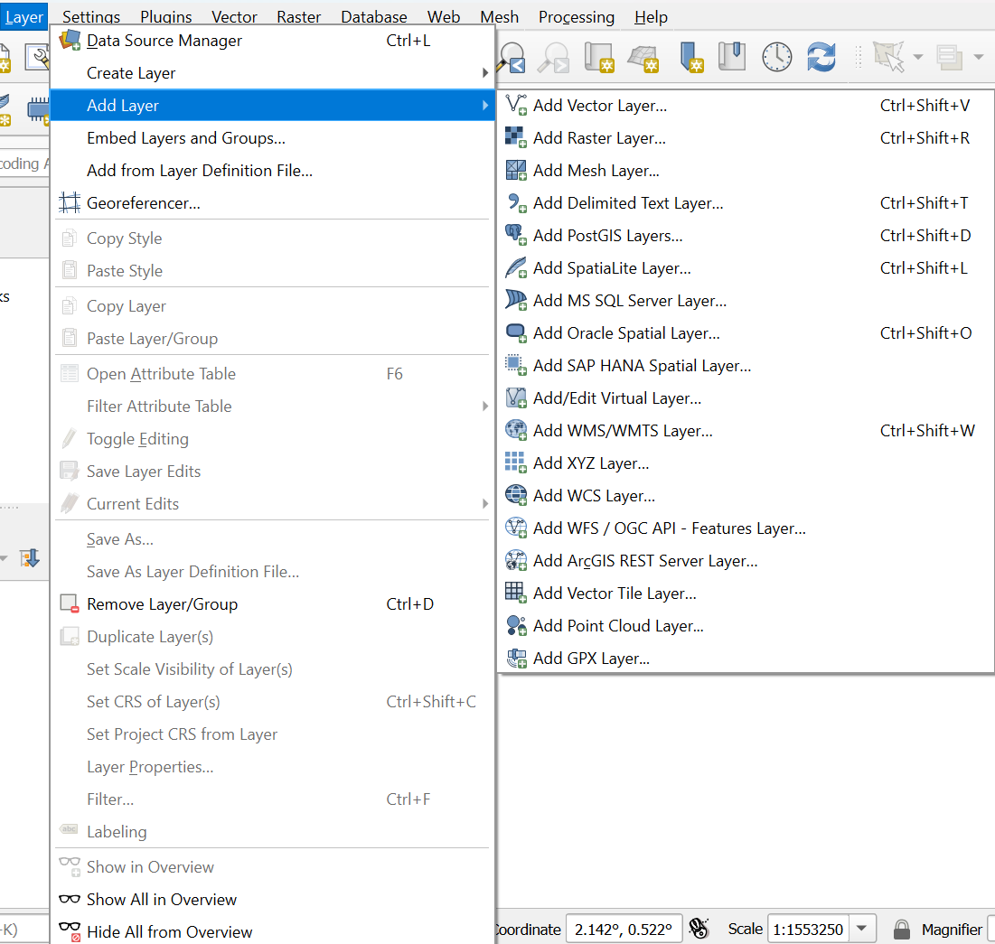

**Digitizing Toolbar**

* **Edit Features**: Modify existing vector features.
* **Add Features**: Digitize new points, lines, or polygons.
* **Snap Settings**: Ensure accurate feature alignment.

**4. Workflow Example**

1. Open QGIS and enable the **Browser** and **Layers** panels from View > Panels.
2. Use the **Layer Toolbar** to load a shapefile or raster dataset.
3. Adjust the layer symbology by right-clicking the layer in the **Layers Panel** and selecting Properties > Symbology.
4. Use the **Navigation Toolbar** to zoom and pan within the map.
5. Open the **Attributes Table Panel** to inspect and edit attribute data for a layer.

**5. Tips for Beginners**

* **Familiarize with Toolbars**: Start with navigation and layer management toolbars.
* **Experiment with Panels**: Layers and Browser panels are critical for managing data.
* **Customize the Layout**: Tailor the interface to your needs for a more efficient workflow.

Managing projects, layers, and symbology.

**Managing Projects, Layers, and Symbology in QGIS**

QGIS provides powerful tools for managing GIS projects, organizing layers, and customizing symbology to create meaningful and visually appealing maps.

**1. Managing Projects**

Projects in QGIS are containers for spatial data, map layouts, and settings. The project file saves the arrangement of layers, symbology, and other configurations.

**Creating and Saving a Project**

* **New Project**: Go to Project > New or click the **New Project** icon on the toolbar.
* **Save Project**: Save the current project as a .qgz file using Project > Save or Project > Save As.
  + .qgz files store the project, symbology, and settings.
* **Open Existing Project**: Use Project > Open to load an existing project.

**Project Settings**

* **Coordinate Reference System (CRS)**: Set the project’s CRS under Project > Properties > CRS. For global data, use WGS 84.
* **Project Environment**: Configure default layer styles, rendering settings, and snapping options in Project > Properties.

**Organizing Projects**

* Use logical file structures for data and project files.
* Store related datasets in a single directory for easier management. 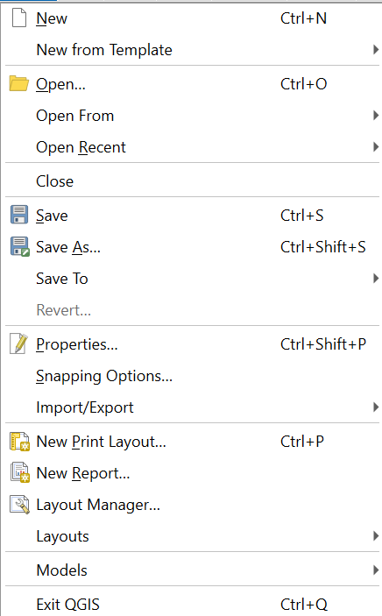

**2. Managing Layers**

Layers represent spatial data and can be vector (points, lines, polygons) or raster (gridded data like images or elevation).

**Adding Layers**

* **Vector Data**: Add shapefiles, GeoJSON, or database tables using *Layer > Add Layer > Add Vector Layer.*
* **Raster Data**: Load images or DEMs using *Layer > Add Layer > Add Raster Layer.*
* **Drag-and-Drop**: Import layers directly from the **Browser Panel**.

**Organizing Layers**

* **Reordering**: Drag layers in the **Layers Panel** to change their order.
* **Grouping**: Right-click the panel and select Add Group to create layer groups for better organization.
* **Renaming Layers**: Right-click a layer and choose Rename.

**Layer Properties**

* Access properties by right-clicking the layer and selecting Properties. Key tabs include:
  + **Information**: Metadata about the layer.
  + **Symbology**: Customize the layer's appearance.
  + **Source**: Data source details.
  + **Fields**: Manage attribute fields.
  + **Joins**: Add table joins. 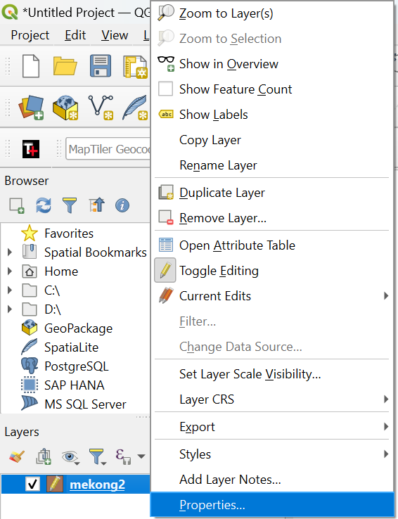

**3. Symbology (Layer Styling)**

Symbology defines how spatial features are visually represented in the map. QGIS offers versatile styling options.

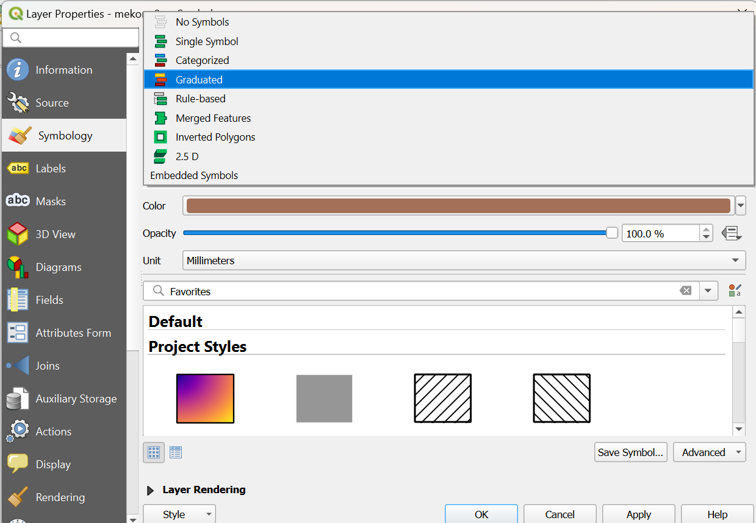

**Accessing Symbology Settings**

* Right-click a *layer > Properties > Symbology*.
* Alternatively, use the **Layer Styling Panel** for real-time updates.

**Vector Layer Symbology**

* **Single Symbol**: Apply one symbol to all features (e.g., uniform point markers or polygon fills).
* **Categorized**: Style features based on attribute values (e.g., land use types).
  + Select an attribute, choose a color ramp, and click Classify.
* **Graduated**: Style features based on numerical ranges (e.g., population density).
  + Select an attribute, define intervals, and choose a color ramp.
* **Rule-Based**: Apply complex rules for styling (e.g., roads with speed limits above 50 km/h in red).

**Raster Layer Symbology**

* **Singleband Gray**: Display raster data as grayscale.
* **Singleband Pseudocolor**: Use a color ramp to represent continuous data (e.g., elevation).
* **Hillshade**: Apply hillshading for terrain visualization.
* Customize raster symbology in Properties > Symbology to adjust transparency, color ramps, and classifications.

**Customizing Symbols**

* Use the **Symbol Selector** to modify symbol size, color, shape, and outline.
* Save and load symbol styles to maintain consistency across projects.

**Labels**

* Add labels to layers in Properties > Labels.
* Customize font, placement, and formatting to improve readability.

**4. Advanced Layer Management**

**Data Joins**

* Combine attribute tables from multiple datasets using Properties > Joins.
* Useful for linking external data to spatial layers.

**Layer Styling Panel**

* Use the **Layer Styling Panel** for interactive style adjustments without opening properties dialogs.
* Access this panel from *View > Panels > Layer Styling*.

**Topological Editing**

* Enable topological editing under Settings > Snapping Options to ensure features align correctly during digitization.

**Layer Export**

* Export layers in different formats using Layer > Export > Save Features As.
* Choose options like shapefile, GeoJSON, or KML formats.

**5. Tips for Effective Management**

* **Use Meaningful Layer Names**: Rename layers descriptively to make projects easier to understand.
* **Group Layers**: Organize layers into logical groups for large projects.
* **Symbology Templates**: Save commonly used styles as templates to reuse in other projects.
* **Backup Projects**: Save copies of project files and data in case of accidental changes or loss.

# Working with spatial data:

Importing and exporting geospatial data (Shapefiles, GeoJSON, CSV).

QGIS supports various geospatial data formats, including Shapefiles, GeoJSON, and CSV. Here’s a guide to importing and exporting these formats.

1. **Importing Spatial Data**

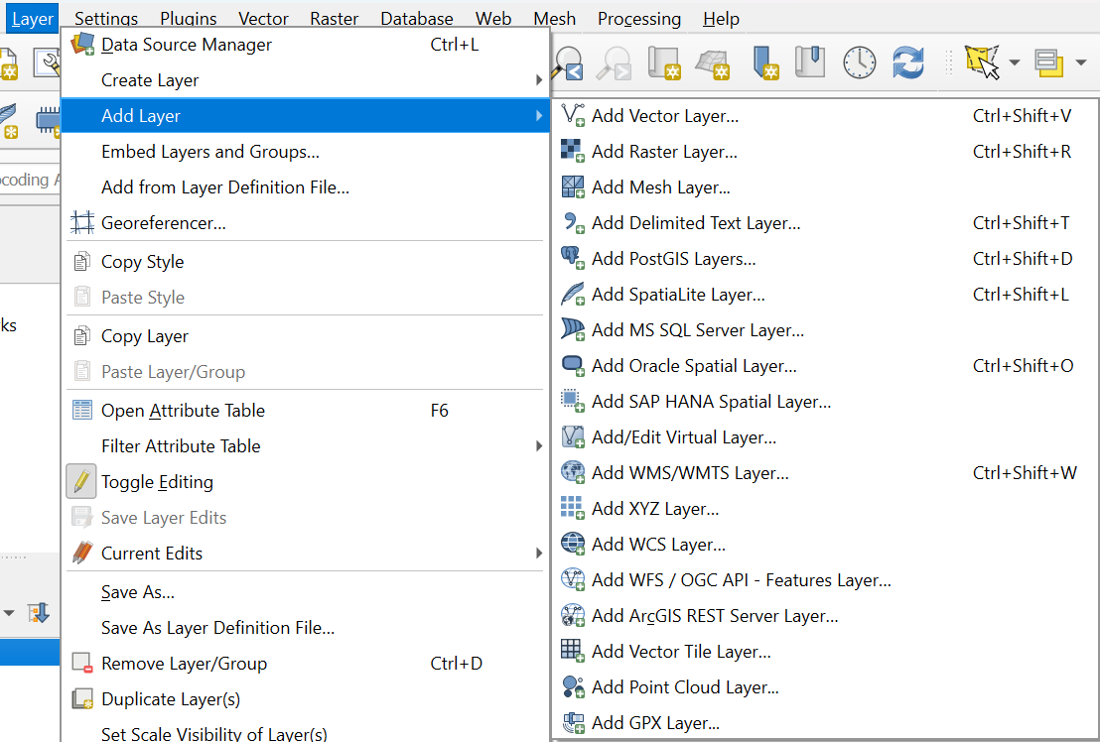

**A. Shapefiles**

* **What is a Shapefile?**: A common geospatial vector data format consisting of multiple files (.shp, .shx, .dbf, etc.).
* **Steps to Import**:
  1. Go to Layer > Add Layer > Add Vector Layer.
  2. Click Browse and locate the .shp file.
  3. Select the file and click Open.
  4. The layer will appear in the **Layers Panel** and **Map Canvas**.
* **Drag-and-Drop**: Alternatively, drag the .shp file into the QGIS interface.

**B. GeoJSON**

* **What is GeoJSON?**: A JSON-based format for encoding geographic features.
* **Steps to Import**:
  1. Go to Layer > Add Layer > Add Vector Layer.
  2. Click Browse and locate the .geojson file.
  3. Select the file and click Open.
  4. The GeoJSON file is loaded as a vector layer in QGIS.
* **Drag-and-Drop**: GeoJSON files can also be dragged directly into QGIS.

**C. CSV (Comma-Separated Values)**

* **What is a CSV?**: A tabular data format that may include geographic coordinates (e.g., latitude and longitude).
* **Steps to Import**:
  1. Go to Layer > Add Layer > Add Delimited Text Layer.
  2. Browse and select the .csv file.
  3. Configure settings:
     + Set **X Field** (longitude) and **Y Field** (latitude).
     + Choose the CRS (e.g., WGS 84 - EPSG:4326 for geographic coordinates).
  4. Click Add to load the CSV data as a spatial layer.

1. **Exporting Spatial Data**

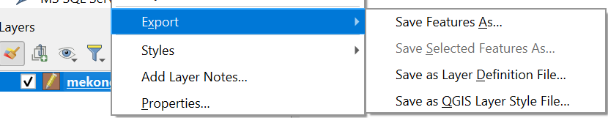

**A. Exporting as Shapefile**

* **Steps**:
  1. Right-click the layer in the **Layers Panel**.
  2. Select Export > Save Features As.
  3. Set the format to ESRI Shapefile.
  4. Choose the output file location and CRS.
  5. Click OK to export.

**B. Exporting as GeoJSON**

* **Steps**:
  1. Right-click the layer in the **Layers Panel**.
  2. Select Export > Save Features As.
  3. Set the format to GeoJSON.
  4. Specify the file location and CRS.
  5. Click OK to save.

**C. Exporting as CSV**

* **Steps**:
  1. Right-click the layer in the **Layers Panel**.
  2. Select Export > Save Features As.
  3. Set the format to CSV.
  4. Choose whether to include geometry (e.g., as WKT or coordinate fields).
  5. Specify the file location and CRS.
  6. Click OK to export.

**3. Tips for Importing and Exporting**

**Coordinate Reference Systems (CRS)**

* Always ensure that the CRS of the imported data matches the project CRS to avoid misaligned layers.
* Reproject layers if necessary using Layer > Export > Save Features As and select a different CRS.

**Data Quality Checks**

* For CSV files, verify that the latitude and longitude fields are numeric and contain valid values.
* Use Layer > Open Attribute Table to inspect data before exporting. To open the attribute table of a selected layer on the go just press F6.

**File Management**

* For shapefiles, ensure all associated files (.shp, .shx, .dbf, etc.) remain together when moving or copying the data.
* Name exported files descriptively to avoid confusion.

**Common Import/Export Errors**

* **Missing Fields**: Ensure attribute names in CSV files don’t have special characters or spaces.
* **CRS Mismatch**: Always check CRS settings for accurate data alignment.

**4. Practical Use Cases**

* **Importing Shapefiles**: Use to load preprocessed spatial data for analysis or visualization.
* **Exporting GeoJSON**: Ideal for sharing data with web mapping applications or developers.
* **Importing CSV**: Useful for adding spatial data from spreadsheets or databases with geographic coordinates.

Coordinate systems and projections.

In GIS, understanding coordinate systems and projections is critical for accurately representing spatial data on the Earth's surface. Here's an overview of the concepts and their significance:

**1. Coordinate Systems**

A coordinate system is a reference framework that uses coordinates to define the locations of features on a two- or three-dimensional surface.

**Types of Coordinate Systems**

1. **Geographic Coordinate System (GCS)**:
   * Represents locations on a spherical surface (Earth).
   * Uses latitude and longitude measured in degrees.
   * Example: WGS 84 (World Geodetic System 1984).
   * Common Uses: Global datasets, navigation, and mapping.
2. **Projected Coordinate System (PCS)**:
   * Projects the Earth's curved surface onto a flat plane.
   * Units are typically in meters or feet.
   * Example: UTM (Universal Transverse Mercator), State Plane.
   * Common Uses: Local and regional mapping for accurate distance and area measurements.

**2. Projections**

A projection is a mathematical transformation that converts the Earth's curved surface (3D) into a flat, 2D map. Each projection introduces some distortion in shape, area, distance, or direction.

**Types of Projections**

1. **Conformal Projections**:
   * Preserve shape.
   * Example: Mercator projection.
   * Common Uses: Navigation.
2. **Equal-Area Projections**:
   * Preserve area.
   * Example: Albers Equal-Area, Mollweide.
   * Common Uses: Thematic mapping (e.g., population density).
3. **Equidistant Projections**:
   * Preserve distances along certain lines.
   * Example: Equidistant Cylindrical.
   * Common Uses: Measuring distances from a central point.
4. **Azimuthal Projections**:
   * Preserve direction from a central point.
   * Example: Lambert Azimuthal Equal-Area.
   * Common Uses: Polar maps, aviation.

**3. Choosing the Right Projection**

The choice of projection depends on:

* **Purpose**: Navigation, thematic mapping, distance measurement.
* **Region of Interest**:
  + Large-scale maps (local): Use UTM or State Plane.
  + Small-scale maps (global): Use Robinson or Winkel Tripel.
* **Feature Importance**: Minimize distortion in the most critical aspect (shape, area, or distance).

**4. Coordinate Reference Systems (CRS)**

A CRS defines how spatial data is projected and tied to locations on the Earth.

**Components of CRS:**

1. **Datum**:
   * A model of the Earth used for measuring positions.
   * Example: WGS 84 (global), NAD 83 (North America).
2. **Projection**:
   * Defines how the Earth’s surface is flattened for mapping.
3. **Units**:
   * Specifies the measurement units (e.g., meters, feet, degrees).

**Common CRS Examples:**

* **WGS 84 (EPSG:4326)**:
  + A global geographic coordinate system.
  + Units: Degrees.
  + Common for GPS and global datasets.
* **UTM (Universal Transverse Mercator)**:
  + A projected system dividing the world into zones.
  + Units: Meters.
  + Common for regional mapping.

**5. Working with CRS in QGIS**

1. **Setting the CRS**:
   * Go to Project > Properties > CRS to set the project CRS.
   * Recommended CRS for global data: WGS 84.
   * For local data, choose a CRS suitable for the region.
2. **Reprojecting Layers**:
   * Right-click a layer in the **Layers Panel** > Export > Save Features As.
   * Select the desired CRS for reprojection.
   * Alternatively search for the reproject tool in the processing toolbox, select layer(s) to transform and set destination CRS.
3. **On-the-Fly CRS Transformation**:
   * Enable this in QGIS (Settings > Options > CRS) to align layers with different CRS.
4. **Checking CRS**:
   * Right-click a layer > Properties > Source to view or modify its CRS.

**6. Practical Considerations**

* Always verify the CRS of your data before analysis.
* Align the CRS of all layers in a project to avoid misaligned maps.
* Use metadata to track the original CRS of datasets.

**7. Common Challenges**

* **CRS Mismatch**: Layers appear misaligned due to different CRS settings.
  + Solution: Reproject layers or enable on-the-fly CRS transformation.
* **Datum Shifts**: Small positional differences due to different datums.
  + Solution: Use consistent datums across datasets.

Basic data management (attribute tables, editing features).

Efficient data management is a critical skill in GIS. This involves working with **attribute tables** (which store descriptive information about spatial data) and **editing features** (modifying spatial and non-spatial data). Here’s how to manage these elements in QGIS:

**1. Attribute Tables**

The **attribute table** is a tabular representation of non-spatial data associated with each feature in a spatial layer.

**Opening an Attribute Table**

* Right-click the layer in the **Layers Panel** > Open Attribute Table.
* Alternatively, select the layer and click the **Open Attribute Table** icon in the toolbar.

**Structure of the Attribute Table**

* **Rows**: Represent individual features (points, lines, polygons).
* **Columns (Fields)**: Contain attribute information (e.g., name, area, population).
* **Feature IDs**: Unique identifiers for each feature.

**Managing Attributes**

1. **Sorting**: Click a column header to sort features by that attribute.
2. **Filtering**:
   * Use the **Filter ** option in the attribute table to display specific features.
   * Example: Filter all features where population > 1000.
3. **Field Calculator**:
   * Use the Field Calculator (Open Field Calculator icon)  to compute new attribute values.
   * Example: Calculate area in square kilometers: area($geometry) / 1000000.

**Editing Attributes**

1. Enable editing mode: Click the **Toggle Editing ** button in the attribute table.
2. Modify values directly in the table.
3. Save edits by clicking the **Save Layer Edits** button. 

**2. Editing Features**

Editing features involves modifying the geometry (shape) or attributes of spatial data.

**A. Enabling Editing Mode**

* Right-click the layer in the **Layers Panel** > Toggle Editing. 
* Once enabled, tools for adding, deleting, and modifying features become available.

**B. Editing Tools**

1. **Adding Features**:
   * Select the **Add Feature** tool from the toolbar.
   * Click on the map to draw the geometry (e.g., a point, line, or polygon).
   * Enter attribute data in the pop-up dialog.
2. **Modifying Features**:
   * **Move Features**: Use the **Move Feature** tool to reposition features.
   * **Vertex Editing**:
     + Select the **Vertex Tool** to move, add, or delete vertices in lines or polygons.
     + Useful for refining boundaries or shapes.
3. **Deleting Features**:
   * Select the **Delete Selected Feature(s)** tool.
   * Click on the feature or select multiple features and press **Delete**.
4. **Splitting and Merging Features**:
   * **Split Features**: Use the **Split Features** tool to divide a polygon or line into multiple parts.
   * **Merge Features**: Select multiple features > Right-click > Merge Selected Features.
5. **Snapping Options**:
   * Enable snapping under Settings > Snapping Options.
   * Helps ensure new features align with existing ones (e.g., road intersections).

**3. Adding and Managing Fields**

**Adding New Fields:**

1. Open the attribute table and enable editing mode.
2. Click the **New Field** button.
3. Specify:
   * Field name.
   * Data type (e.g., integer, text, decimal).
   * Length and precision (for numeric fields).
4. Click OK to add the field.

**Deleting Fields:**

1. Enable editing mode.
2. Click the **Delete Field** button.
3. Select the field(s) to delete and confirm.

**4. Practical Use Cases**

**Analyzing Data**

* Use filters and sorting to find patterns in the data.
* Example: Highlight schools with student populations exceeding a specific threshold.

**Digitizing Data**

* Digitize new features (e.g., roads, buildings) and add attribute information.
* Example: Add building footprints with attributes like address and occupancy type.

**Data Cleanup**

* Fix missing or incorrect attribute data.
* Edit geometry to correct digitizing errors (e.g., overlapping polygons or misaligned features).

**5. Tips for Effective Data Management**

1. **Backup Data**:
   * Always create backups before editing to avoid data loss.
2. **Use Editing Mode Carefully**:
   * Only enable editing mode when necessary.
   * Save edits frequently to avoid losing changes.
3. **Validate Data**:
   * Use the **Topology Checker** plugin to identify geometry errors like overlaps or gaps.
4. **Maintain Attribute Consistency**:
   * Standardize attribute data formats (e.g., consistent naming conventions).

Layer symbology

Layer symbology in QGIS allows you to visually represent spatial data in meaningful ways. Depending on the type of analysis or visualization you need, QGIS provides several symbology options: **Single Symbol**, **Categorized**, **Graduated**, **Rule-Based**, and **Clusters**. Here’s an overview of each:

**1. Single Symbol**

* **Description**: All features in the layer are represented using the same symbol.
* **Use Cases**:
  + General-purpose maps where individual feature distinctions are unnecessary.
  + Background layers or outlines for context.
* **How to Apply**:
  + Right-click the layer in the **Layers Panel** > Properties > Symbology.
  + Select Single Symbol in the dropdown menu.
  + Customize symbol properties (e.g., color, size, outline) using the **Symbol Selector**.
* **Example**: Displaying all rivers in a single color.

**2. Categorized**

* **Description**: Features are styled based on unique values in a selected attribute field.
* **Use Cases**:
  + Representing categorical data such as land use types, administrative boundaries, or road classifications.
* **How to Apply**:
  + Right-click the *layer > Properties > Symbology*.
  + Select Categorized.
  + Choose an attribute field (e.g., land_use or type).
  + Click Classify to generate categories.
  + Assign colors or styles to each category.
* **Example**: Displaying different land use types like residential, commercial, and industrial areas.

**3. Graduated**

* **Description**: Features are styled based on a numerical attribute field, divided into ranges or classes.
* **Use Cases**:
  + Representing continuous data like population density, elevation, or rainfall.
* **How to Apply**:
  + Right-click the *layer > Properties > Symbology*.
  + Select Graduated.
  + Choose a numeric attribute field (e.g., population or elevation).
  + Select a **classification method** (e.g., Equal Interval, Natural Breaks).
  + Choose a color ramp for the visualization.
  + Adjust class intervals as needed.
* **Example**: Displaying population density with darker colors for higher values.

**4. Rule-Based**

* **Description**: Apply custom rules to style features based on logical expressions.
* **Use Cases**:
  + Complex visualizations where multiple conditions must be represented.
  + Combining styling for attributes and geometry.
* **How to Apply**:
  + Right-click the layer > Properties > Symbology.
  + Select Rule-Based.
  + Click the **Add Rule** button.
  + Define rules using expressions (e.g., type = 'highway' AND lanes > 4).
  + Assign styles to each rule.
* **Example**: Highlighting major roads with more than 4 lanes in red and minor roads in gray.

**5. Clusters**

* **Description**: Groups nearby points into clusters, useful for visualizing dense datasets.
* **Use Cases**:
  + Representing large point datasets like accident locations, wildlife sightings, or population distribution.
* **How to Apply**:
  + Right-click the layer > Properties > Symbology.
  + Select Cluster.
  + Adjust cluster settings:
    - **Distance**: Controls the proximity required for points to cluster.
    - **Symbol Size and Color**: Customize the cluster appearance.
  + Apply additional scaling or labels for cluster counts.
* **Example**: Displaying clusters of wildlife sightings, with larger clusters representing higher densities.

**6. Tips for Effective Symbology**

* **Use Meaningful Colors**:
  + Use intuitive color schemes (e.g., blue for water, green for forests).
  + Avoid overloading maps with too many colors.
* **Add Labels**:
  + Enable labels to improve feature identification (Properties > Labels).
* **Layer Transparency**:
  + Adjust transparency to avoid obscuring underlying layers (Properties > Symbology > Transparency).
* **Save Styles**:
  + Save frequently used styles as templates for reuse in other projects (Right-click Layer > Styles > Save Style).

**Example Workflow**

1. Import a dataset (e.g., roads shapefile).
2. Use **Categorized Symbology** to style roads by type (highways, streets).
3. Add **Graduated Symbology** for population density in a different layer.
4. Highlight specific features using **Rule-Based Symbology** (e.g., major highways).
5. Visualize point data (e.g., accident reports) using **Clusters**.

Layer labelling

Labeling is an essential aspect of map design, used to identify and describe features in a spatial dataset. QGIS provides powerful tools to customize label placement, visibility, and styling.

**1. Enabling Labels**

* Right-click the layer in *the* ***Layers Panel*** *> Properties > Labels*.
* Select Single Labels or Rule-Based Labels.
* Choose the attribute field to use for the label (e.g., name, population).

**2. Label Placement**

Label placement ensures labels do not overlap and are positioned appropriately relative to features.

**Options for Placement**

* Go to *Properties > Labels > Placement*.
* Options vary depending on feature geometry:
  + **Points**: Place labels above, below, left, right, or at the center of points.
  + **Lines**: Align labels parallel to lines, curved along the feature, or placed at specific intervals.
  + **Polygons**: Place labels inside polygons, offset from edges, or centered.

**Custom Placement Settings**

* **Offset**: Adjust the distance of the label from the feature.
* **Anchor Points**: Define specific anchor points for the label relative to the feature.
* **Priority**: Set priorities for labels to ensure critical labels are placed first.

**3. Scale-Dependent Labels**

Scale-dependent labeling ensures labels appear only at appropriate zoom levels, avoiding clutter at smaller scales.

**How to Set Scale-Dependent Labels**

1. Go to *Properties > Labels > Rendering*.
2. Check **Show labels only in this scale range**.
3. Set the minimum and maximum scale values:
   * **Minimum Scale**: Labels disappear when zoomed out beyond this scale.
   * **Maximum Scale**: Labels disappear when zoomed in beyond this scale.
4. Apply and test the settings by zooming in and out.

**4. Masking Labels**

Masking helps labels stand out by creating a background or border that obscures underlying features or other labels.

**How to Add a Mask**

1. Go to *Properties > Labels > Buffer.*
2. Enable **Draw text buffer**.
3. Customize the mask:
   * **Buffer Size**: Adjust the thickness of the mask.
   * **Color**: Choose a background color (e.g., white or black).
   * **Transparency**: Adjust opacity for the buffer.
4. Apply the settings to make the labels more readable.

**5. Buffering Labels**

A buffer adds space around a label to make it more legible and visually distinct.

**How to Add a Label Buffer**

1. Go to *Properties > Labels > Buffer.*
2. Enable the **Buffer** option.
3. Configure buffer settings:
   * **Buffer Size**: Set the distance around the label text (measured in map units or points).
   * **Join Style**: Choose rounded or mitered corners for the buffer.
   * **Opacity**: Adjust transparency for subtle effects.
4. Preview the changes on the map.

**6. Advanced Label Styling**

**Label Formatting**

* Go to *Properties > Labels > Text*.
* Customize font, size, color, and alignment.
* Add bold or italics for emphasis.

**Label Priority**

* Go to *Properties > Labels > Placement > Priority.*
* Assign priorities to ensure important features are labeled first.

**Data-Defined Overrides**

* Use expressions to dynamically control label properties (e.g., font size based on population).
* Example: Set label color based on a value: CASE WHEN population > 1000 THEN 'red' ELSE 'blue' END.

**7. Practical Applications**

1. **Point Data**: Label cities with names, and place labels offset from points to avoid overlap.
2. **Line Data**: Label rivers with names aligned along the curves of the rivers.
3. **Polygon Data**: Label administrative boundaries with region names, centered within polygons.
4. **Custom Designs**:
   * Use buffers for labels over imagery to ensure readability.
   * Apply scale-dependent labeling for dense datasets like roads or buildings.

**8. Tips for Effective Labeling**

* **Avoid Clutter**: Use scale-dependent rendering to minimize label overlap.
* **Consistency**: Use uniform fonts and colors for similar features across layers.
* **Hierarchy**: Use size and boldness to prioritize important labels.

Spatial data queries

Spatial data queries allow you to filter or select specific features in a dataset based on their attributes, location, or relationships with other features. Here’s an overview of the most common query methods in QGIS: **Select by Expression**, **Select by Location**, and **Select by Value**.

**1. Select by Expression**

This method uses expressions to query features based on attribute data or calculated values.

**Steps to Perform Select by Expression**

1. Open the layer's **Attribute Table** (Right-click the layer > Open Attribute Table).
2. Click the **Select Features by Expression** icon  in the toolbar.
3. Build your query in the **Expression Builder**.

**Common Query Examples**

* **Equality and Comparison**:
  + Select features where a field equals a specific value:  
    field_name = 'value'
  + Select features with values greater than a threshold:  
    population > 1000
* **String Matching**:
  + Select features where a field contains part of a string:  
    name LIKE '%Park%'
* **Logical Operators**:
  + Combine conditions with AND/OR:  
    land_use = 'Residential' AND population > 5000
* **Geometry Functions**:
  + Select features based on spatial properties:  
    area($geometry) > 5000 (select polygons larger than 5000 units).

**Tips:**

* Use the **Function List** to explore available expressions.
* Click **Test** to preview the selection.

**2. Select by Location**

This method selects features based on their spatial relationship with features in another layer.

**Steps to Perform Select by Location**

1. Go to *Vector > Research Tools > Select by Location*.
2. Configure the query:
   * **Input Layer**: The layer whose features you want to select.
   * **Predicate**: Define the spatial relationship (e.g., Intersects, Within, Touches).
   * **Overlay Layer**: The layer used as the reference for the spatial query.
3. Click **Run** to perform the selection.

**Common Spatial Relationships**

* **Intersects**: Select features that touch or overlap the reference layer.
* **Within**: Select features entirely within the reference layer.
* **Contains**: Select features that completely contain the reference layer.
* **Touches**: Select features that share a boundary with the reference layer.

**Example Use Cases**

* Select all buildings (input layer) within a flood zone (overlay layer).
* Select roads that intersect with a specific administrative boundary.

**3. Select by Value**

This method is the simplest and is used to select features based on specific attribute values.

**Steps to Perform Select by Value**

1. Open the layer's **Attribute Table**.
2. Click the **Select Features by Value** button in the toolbar.
3. Configure the query:
   * Choose the **Field** to query.
   * Select the **Operator** (e.g., Equals, Contains).
   * Enter the **Value** to match.
4. Click **OK** to select matching features.

**Example Use Cases**

* Select all features where land_use = 'Commercial'.
* Select features where the population_density is greater than 1000.

**4. Combining Query Methods**

QGIS allows you to combine multiple selection methods for more complex queries:

* Use **Select by Expression** to filter by attributes.
* Apply **Select by Location** on the filtered results to further refine the selection.

**5. Exporting Selected Features**

* Once features are selected, you can export them as a new layer:
  1. Right-click the layer > Export > Save Selected Features As.
  2. Choose a format (e.g., Shapefile, GeoJSON) and save the file.

**6. Tips for Effective Queries**

* **Validate Queries**: Test expressions and location queries before applying them to ensure correctness.
* **Combine Attributes and Location**: Use both attribute and spatial queries to refine results.
* **Save Selection**: Use Vector > Research Tools > Save Selected Features to save results for reuse.

# Geospatial Analysis

* + Vector analysis (Geoprocessing)
    1. Buffer

Buffering is a key geoprocessing technique used in geospatial analysis. It creates a zone around a feature at a specified distance. This zone can represent areas of influence, proximity, or impact.

**What is a Buffer?**

A **buffer** is a polygon or area created around a point, line, or polygon feature to represent a zone within a specified distance.

* **Point Buffer**: Creates circular areas around points (e.g., a 500m zone around schools).
* **Line Buffer**: Creates a band around linear features (e.g., a 1km buffer around roads).
* **Polygon Buffer**: Creates an expanded area around polygons (e.g., a protected zone around parks).

**Applications of Buffering**

* **Environmental Planning**: Identifying areas affected by pollution or natural disasters.
* **Urban Planning**: Defining zones around utilities or infrastructure (e.g., power lines, roads).
* **Proximity Analysis**: Determining access to services like schools, hospitals, or public transit.
* **Wildlife Conservation**: Delineating buffer zones around habitats to prevent human interference.

**How to Create a Buffer in QGIS**

**Steps to Perform Buffering**

1. **Open the Buffer Tool**:
   * Go to *Vector > Geoprocessing Tools > Buffer.*
   * Alternatively, use the **Processing Toolbox** (Buffer).
2. **Configure Buffer Parameters**:
   * **Input Layer**: Select the layer you want to buffer.
   * **Distance**: Specify the buffer distance (in the same units as the layer's CRS).
     + Example: 500 meters.
   * **Segments**: Define the number of segments to smooth curved edges. Higher values produce smoother buffers.
   * **Dissolve Option**:
     + **Enabled**: Combines overlapping buffer zones into one.
     + **Disabled**: Keeps individual buffer zones separate.

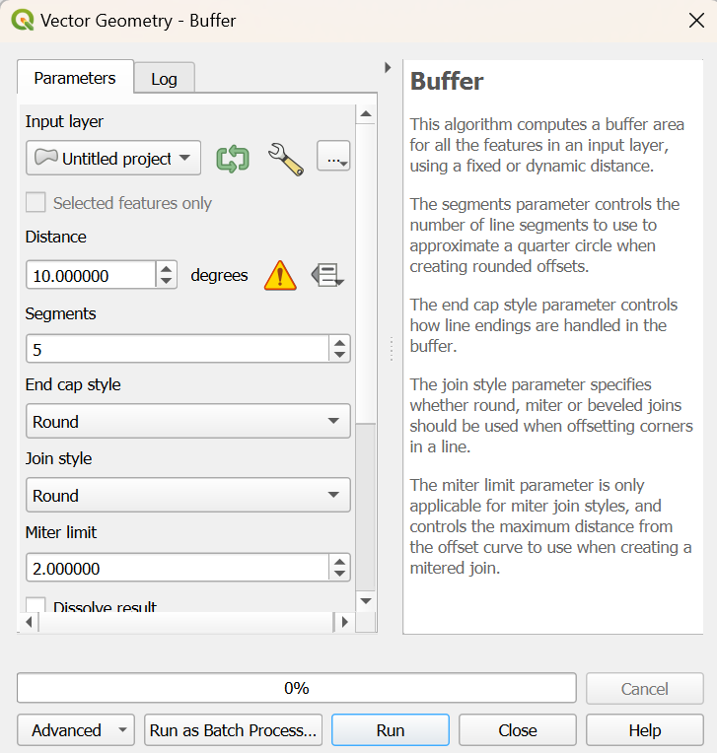

1. **Run the Tool**:
   * Click **Run** to generate the buffer layer.
   * The new buffer layer will be added to the **Layers Panel**.
     1. Clip

**Clipping** is a geoprocessing operation used to extract portions of a dataset that fall within the boundaries of another dataset. It is commonly used to focus on specific areas of interest by "cutting" layers to a desired boundary.

**What is Clipping?**

Clipping is the process of trimming one layer (input layer) to the extent of another layer (clip layer). The result is a new layer that contains only the features or portions of features from the input layer that intersect the clip layer.

**Applications of Clipping**

* **Focus Area Analysis**: Extract features within a specific region (e.g., cities within a state boundary).
* **Environmental Studies**: Isolate data within ecological zones or watersheds.
* **Map Production**: Reduce the size of large datasets to fit specific areas of interest.

**How to Perform Clipping in QGIS**

**Steps to Clip a Layer**

1. **Open the Clip Tool**:
   * Go to Vector > Geoprocessing Tools > Clip.
   * Alternatively, use the **Processing Toolbox** (Clip).
2. **Configure Clip Parameters**:
   * **Input Layer**: Select the layer you want to clip (e.g., land cover data).
   * **Clip Layer**: Select the boundary layer used to "clip" the input layer (e.g., administrative boundaries).
   * **Output Layer**: Specify a name and location for the clipped layer (if not saving as temporary).

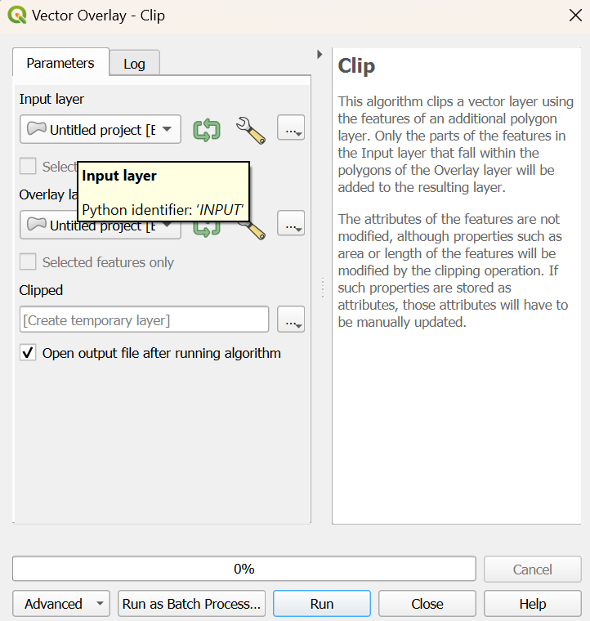

1. **Run the Tool**:
   * Click **Run** to execute the clip operation.
   * The clipped layer will appear in the **Layers Panel**.
     1. Dissolve

**Dissolve** is a geoprocessing operation used to merge adjacent features in a vector layer based on a common attribute or without any attribute distinction. It simplifies datasets by combining features and removing internal boundaries.

**What is Dissolve?**

Dissolve combines features in a vector layer into a single feature or multiple grouped features by aggregating their geometries and attributes. It eliminates unnecessary boundaries within or between features.

**Applications of Dissolve**

* **Simplify Data**: Combine multiple administrative boundaries (e.g., states into a country).
* **Group Features**: Aggregate regions with a common attribute (e.g., same land use type).
* **Area Calculations**: Create contiguous zones for accurate area measurement.
* **Preprocessing for Analysis**: Simplify datasets before further geospatial operations like buffering.

**How to Perform Dissolve in QGIS**

**Steps to Dissolve Features**

1. **Open the Dissolve Tool**:
   * Go to Vector > Geoprocessing Tools > Dissolve.
   * Alternatively, use the **Processing Toolbox** (Dissolve).
2. **Configure Dissolve Parameters**:
   * **Input Layer**: Select the layer to dissolve.
   * **Dissolve Field(s)**:
     + Choose one or more fields to group features by common attribute values.
     + Leave blank to dissolve all features into a single feature.
   * **Output Layer**: Specify the name and location of the output layer (optional).

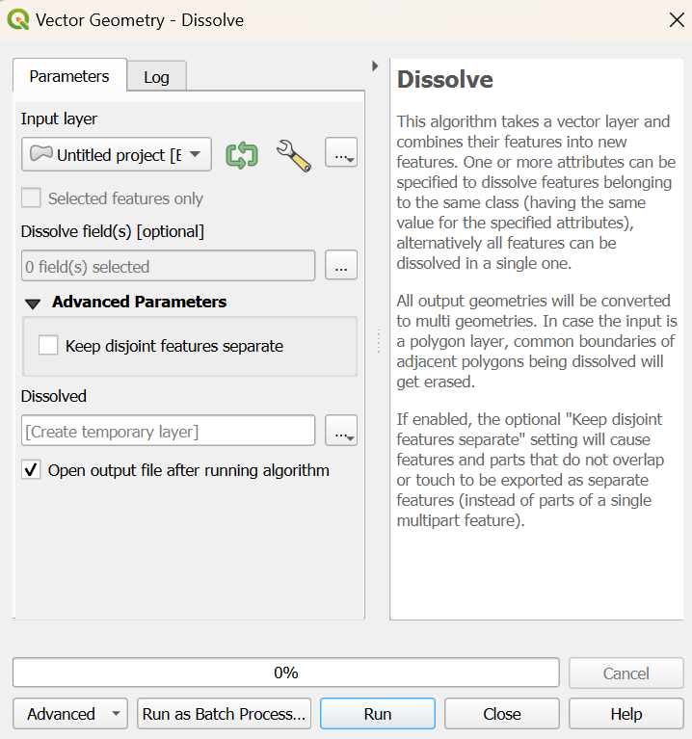

1. **Run the Tool**:
   * Click **Run** to perform the dissolve operation.
   * The dissolved layer will be added to the **Layers Panel**.
     1. Difference

The **Difference** tool removes the intersecting areas of one layer (input layer) using another layer (overlay layer) as a "cookie cutter." The result is a new layer containing only the non-overlapping portions of the input layer.

**Applications of Difference**

* **Map Exclusion Areas**: Identify areas that fall outside of a restricted or protected zone.
* **Environmental Studies**: Remove developed areas from natural habitat layers.
* **Planning and Development**: Identify land available for development by subtracting existing infrastructure.

**How to Perform Difference in QGIS**

**Steps to Use the Difference Tool**

1. **Open the Difference Tool**:
   * Go to Vector > Geoprocessing Tools > Difference.
   * Alternatively, use the **Processing Toolbox** (Difference).
2. **Configure Difference Parameters**:
   * **Input Layer**: Select the layer from which you want to subtract.
   * **Overlay Layer**: Select the layer to use as the subtraction or "cutting" layer.
   * **Output Layer**: Specify the name and location of the resulting layer (if not saving as temporary).

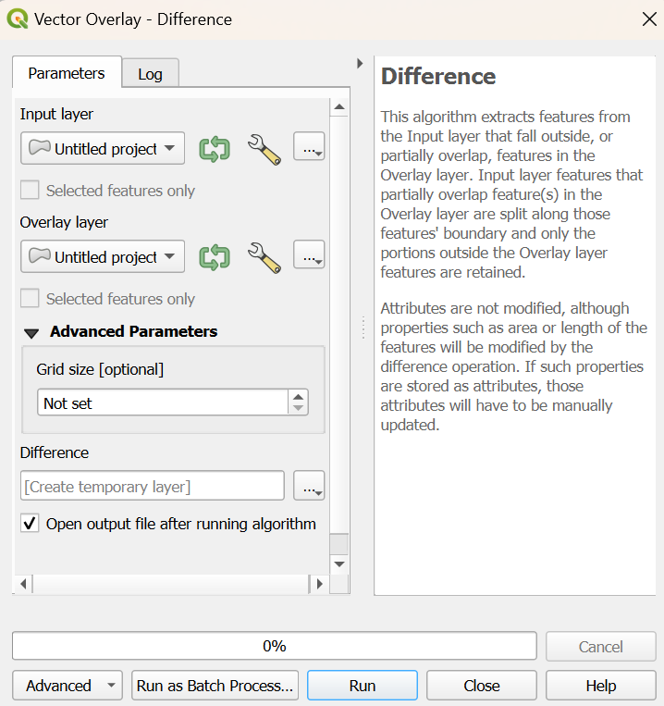

1. **Run the Tool**:
   * Click **Run** to execute the operation.
   * The resulting layer will appear in the **Layers Panel**.

**Raster analysis**

Raster calculator

The **Raster Calculator** in QGIS is a powerful tool used for mathematical and logical operations on raster datasets. It enables the creation of new raster layers by performing calculations on existing raster data.

**What is the Raster Calculator?**

The Raster Calculator allows you to:

* Perform mathematical operations (e.g., addition, subtraction, multiplication) on raster layers.
* Create derived datasets such as slope, aspect, normalized indices, or suitability maps.
* Apply logical conditions to extract or classify specific data values.

**Applications of the Raster Calculator**

* **Environmental Analysis**: Calculate vegetation indices (e.g., NDVI).
* **Hydrology**: Create flow accumulation maps or threshold areas for water runoff.
* **Land Use Classification**: Reclassify raster values into new categories.
* **Suitability Analysis**: Combine multiple rasters using weighted formulas.

**How to Use the Raster Calculator in QGIS**

**Steps to Open and Use the Raster Calculator**

1. **Open the Raster Calculator**:
   * Go to Raster > Raster Calculator.
   * Alternatively, find it in the **Processing Toolbox** (Raster Calculator).
2. **Set Input Layers**:
   * Select the raster layers you want to include in the calculation. These should be loaded into the **Layers Panel**.
3. **Build the Expression**:
   * Use the provided fields and operators to create a mathematical or logical expression.
   * Example expressions:
     + **Simple Arithmetic**: Combine layers using basic math.  
       layer1@1 + layer2@1
     + **Normalized Difference**: Calculate indices like NDVI:  
       (NIR - RED) / (NIR + RED)
     + **Conditional Statement**: Classify or extract values.  
       ("layer1@1" > 100) * 1 + ("layer1@1" <= 100) * 0

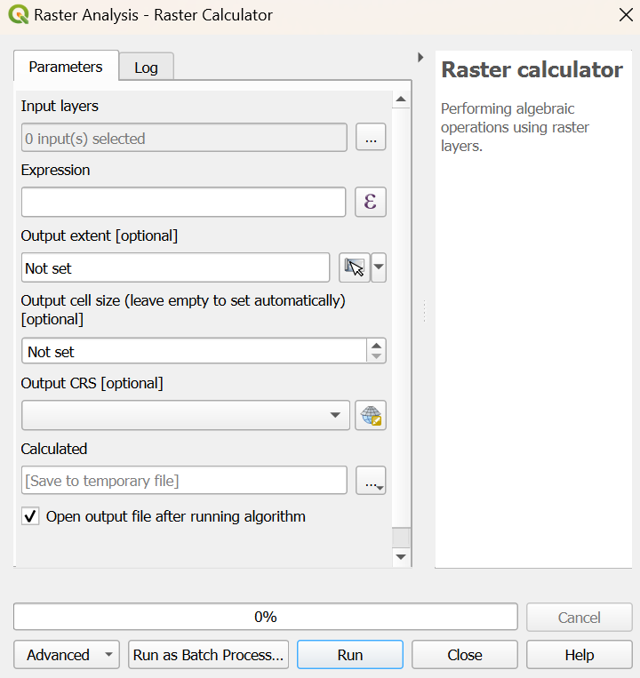

1. **Set Output Parameters**:
   * Specify the name and location of the output raster layer.
   * Choose the output CRS (default is the CRS of the input layers).
2. **Run the Calculation**:
   * Click **OK** to generate the output raster layer.

**Common Raster Calculator Operations**

**A. Arithmetic Operations**

* Add, subtract, multiply, or divide raster layers:
  + layer1@1 + layer2@1 (Sum of two rasters).
  + layer1@1 * 2 (Scale a raster by a factor of 2).

**B. Conditional Statements**

* Use logical operators to classify or extract specific values:
  + ("layer1@1" > 100) * 1 (Output 1 where values > 100, else 0).
  + ("layer1@1" >= 50 AND "layer1@1" <= 100) * 1 (Output 1 for values between 50 and 100).

**C. Index Calculations**

* Example: **NDVI** (Normalized Difference Vegetation Index):
  + ("NIR@1" - "RED@1") / ("NIR@1" + "RED@1").

**D. Reclassification**

* Reassign values to new classes:
  + (layer1@1 >= 0 AND layer1@1 < 50) * 1 + (layer1@1 >= 50 AND layer1@1 < 100) * 2.

**E. Mathematical Functions**

* Use trigonometric, logarithmic, or power functions:
  + sin(layer1@1) (Sine of raster values).
  + log(layer1@1) (Natural logarithm of raster values).

**5. Example Workflows**

**Workflow 1: Extract High Elevations**

1. Input Layer: DEM (Digital Elevation Model).
2. Expression:  
   ("DEM@1" > 2000) * 1
3. Output: A raster where cells above 2000m elevation are assigned 1, others 0.

**Workflow 2: Vegetation Index**

1. Input Layers: NIR (Near Infrared), RED (Red Band).
2. Expression:  
   (NIR@1 - RED@1) / (NIR@1 + RED@1)
3. Output: A raster of NDVI values for vegetation analysis.

**Workflow 3: Weighted Suitability Analysis**

1. Input Layers: Slope, Land Use, Proximity to Water.
2. Expression:  
   (0.4 * "Slope@1") + (0.3 * "LandUse@1") + (0.3 * "Proximity@1")
3. Output: A suitability map based on weighted criteria.
   * 1. Masking

**Masking** is a raster analysis technique used to isolate or extract specific parts of a raster dataset by applying a mask layer. This process helps focus on areas of interest while ignoring irrelevant data.

**What is Masking?**

Masking involves using a vector or raster mask to "cut out" or "hide" unwanted parts of a raster dataset. The output raster retains values only in the masked area, with the rest of the cells typically set to **NoData**.

**Applications of Masking**

* **Environmental Studies**: Extract areas of interest, such as forests within a protected zone.
* **Hydrology**: Isolate water bodies or watersheds for further analysis.
* **Land Use Analysis**: Focus on specific land use types within a region.
* **Map Production**: Create clean outputs by removing extraneous data.

**How to Perform Masking in QGIS**

**Method 1: Using the Raster Mask Tool**

1. **Open the Mask Tool**:
   * Go to *Raster > Extraction > Clip Raster by Mask Layer*.
   * Alternatively, use the **Processing Toolbox** (Clip Raster by Mask Layer).
2. **Configure Masking Parameters**:
   * **Input Layer**: Select the raster to be masked (e.g., elevation data).
   * **Mask Layer**: Select the vector or raster layer to use as the mask.
   * **Clipping Extent**: Define whether to clip to the extent of the mask layer.
   * **NoData Value**: Set the value for areas outside the mask (default is NoData).
   * **Output CRS**: Ensure it matches the input layer's CRS.
3. **Run the Tool**:
   * Click **Run** to execute the masking operation.
   * The output raster will display only the area defined by the mask.

**Method 2: Using Raster Calculator**

You can create a mask using logical expressions in the **Raster Calculator**.

1. Open the **Raster Calculator**.
2. Use a logical condition to define the mask:
   * Example: Retain values within a certain region:

perl

Copy code

("Raster@1" * ("Mask@1" > 0))

* + This multiplies the raster by the mask layer, retaining values only where the mask is greater than 0.

1. Save the output raster.

**4. Example Workflows**

**Example 1: Mask Forest Areas**

* Input Raster: Land cover data.
* Mask Layer: Vector layer of forest boundaries.
* Result: Raster with land cover data only inside the forest boundaries.

**Example 2: Focus on Elevation in a Region**

* Input Raster: Digital Elevation Model (DEM).
* Mask Layer: Administrative boundary (vector polygon).
* Result: DEM clipped to the administrative boundary.

**Example 3: Create a Waterbody Mask**

* Input Raster: Satellite imagery.
* Mask Layer: Raster with waterbodies coded as 1 and other areas as 0.
* Expression: Use Raster Calculator:

perl

Copy code

("Imagery@1" * ("WaterMask@1" = 1))

* + Field Calculator

The **Field Calculator** is a powerful tool in QGIS used to create or update attribute data in vector layers. It allows you to perform calculations, derive new values, and manipulate existing fields using mathematical, logical, and string operations.

**Accessing the Field Calculator**

1. Open the **Attribute Table**:
   * Right-click the layer in the **Layers Panel** > Open Attribute Table.
2. Enable editing mode:
   * Click the **Toggle Editing Mode** button.
3. Open the Field Calculator:
   * Click the **Field Calculator** icon in the Attribute Table toolbar.

**Creating or Updating Fields**

**Options in the Field Calculator**

1. **Create a New Field**:
   * Add a new column to the attribute table with the calculated values.
   * Specify the field name, field type (e.g., Integer, Decimal, Text), and length.
2. **Update Existing Field**:
   * Modify the values in an existing column without creating a new field.

**3. Common Field Calculator Operations**

**A. Mathematical Calculations**

* Perform arithmetic operations on numeric fields.
* Example: Calculate area in square kilometers:



**B. Conditional Statements**

* Use logical conditions to assign values based on criteria.
* Example: Classify population:

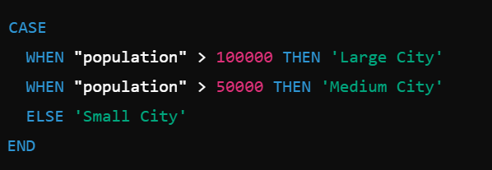

**C. String Operations**

* Manipulate text fields.
* Example 1: Combine two fields into one:

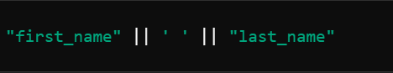

* Example 2: Extract a substring:

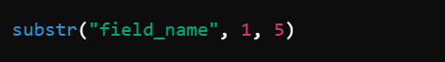

**D. Geometry-Based Calculations**

* Calculate spatial properties.
* Example 1: Perimeter of polygons:



Example 2: Distance from a point to another layer:

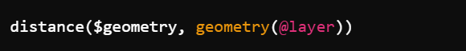

**E. Data Conversion**

* Convert data types or formats.
* Example: Convert numeric field to text:



# Creating spatial data (Layers)

* + Creating new shapefiles/layers

QGIS provides tools to create new spatial datasets, such as shapefiles or other vector layers, for points, lines, and polygons. Here’s a step-by-step guide:

**1. Creating a New Shapefile or Layer**

**Steps to Create a New Layer**

1. **Open the Layer Creation Dialog**:
   * Go to *Layer > Create Layer > New Shapefile Layer.*
2. **Configure Layer Properties**:
   * **File Name**: Click Browse to save the shapefile and name it.
   * **Geometry Type**: Select the type of layer to create:
     + **Point**: For locations like cities or landmarks.
     + **Line**: For linear features like roads or rivers.
     + **Polygon**: For areas like parcels or lakes.
   * **Coordinate Reference System (CRS)**: Choose an appropriate CRS (e.g., WGS 84 - EPSG:4326 for global data).
   * **Fields**: Add attribute fields to store data for each feature:
     + Click the **Add to Fields List** button.
     + Define the **Field Name**, **Type** (e.g., Text, Integer), and **Length**.
3. **Click OK**: A new empty shapefile layer will appear in the **Layers Panel**.

**2. Adding Features to the Layer**

Once the new layer is created, features can be added by digitizing.

**Enable Editing Mode**

* Right-click the layer > Toggle Editing.

**Add Features**

1. Select the **Add Feature** tool from the toolbar.
2. Click on the map to draw the geometry:
   * **Points**: Click once to place a point.
   * **Lines**: Click to add vertices, and right-click to finish the line.
   * **Polygons**: Click to add vertices, and right-click to close the polygon.
3. **Add Attributes**:
   * After completing the geometry, a dialog will appear to enter attribute data.
   * Fill in the fields and click OK.

**Save Edits**

* Click the **Save Layer Edits** button in the toolbar to save your work.

**3. Example: Creating Each Geometry Type**

**A. Creating a Point Layer**

1. Use **Point Geometry** during layer creation.
2. Add features by placing points at specific locations (e.g., GPS coordinates of schools).
3. Attributes might include Name, Type, or Population.

**B. Creating a Line Layer**

1. Use **Line Geometry** during layer creation.
2. Add features by digitizing linear elements (e.g., roads or rivers).
3. Attributes might include Road Name, Type (e.g., Highway, Street), or Length.

**C. Creating a Polygon Layer**

1. Use **Polygon Geometry** during layer creation.
2. Add features by digitizing areas (e.g., lakes, parks, or administrative boundaries).
3. Attributes might include Region Name, Area, or Land Use.

**4. Advanced Editing Tools**

**Snapping**

* Enable snapping to ensure new features align with existing ones:
  + Go to Settings > Snapping Options.
  + Set snapping to **Vertex** or **Edge** for precise placement.

**Modify Features**

* **Move Feature Tool**: Move an existing point, line, or polygon.
* **Vertex Tool**: Edit individual vertices of a line or polygon.

**Merge or Split Features**

* **Merge Features**: Combine multiple polygons into one.
* **Split Features**: Divide a polygon into smaller parts using the **Split Tool**.

Layer editing

Layer editing in QGIS allows you to modify the geometry and attributes of spatial features. It includes adding, deleting, and updating features, as well as refining the spatial accuracy of geometries. Here's a comprehensive guide to layer editing:

**1. Enabling Editing Mode**

Before editing a layer:

1. **Toggle Editing**:
   * Right-click the layer in the ***Layers Panel*** *> Toggle Editing*.
   * Alternatively, select the layer and click the **Toggle Editing** button in the toolbar.
2. Once editing is enabled, the layer becomes editable, and editing tools are activated.

**2. Editing Geometry**

**A. Adding Features**

1. Select the **Add Feature** tool from the toolbar.
2. Digitize the feature:
   * **Points**: Click on the map to add a point.
   * **Lines**: Click to add vertices, then right-click to finish.
   * **Polygons**: Click to add vertices, right-click to close the shape.
3. Enter attribute data in the pop-up form and click **OK**.

**B. Modifying Features**

1. Use the **Vertex Tool** to:
   * Move existing vertices.
   * Add new vertices (click on a segment).
   * Delete vertices (select and press delete).
2. Use the **Move Feature Tool** to reposition entire features.

**C. Splitting Features**

* Select the **Split Features** tool to divide polygons or lines into smaller parts.

**D. Merging Features**

* Select multiple features > Right-click > Merge Selected Features.
* Enter new attribute data for the merged feature.

**E. Deleting Features**

* Use the **Delete Selected Features** tool to remove unwanted features.

**3. Editing Attributes**

**A. Open Attribute Table**

1. Right-click the layer > Open Attribute Table.
2. Click the **Toggle Editing** button in the attribute table.

**B. Modify Attribute Values**

1. Double-click a cell to edit the value.
2. Use the **Field Calculator** for bulk updates or calculations.

**C. Add or Delete Fields**

1. Add Fields:
   * Click the **New Field** button.
   * Specify field name, type (text, integer, etc.), and length.
2. Delete Fields:
   * Select the field(s) and click the **Delete Field** button.

**4. Topological Editing**

Ensure geometric accuracy and maintain spatial relationships:

1. Enable snapping (Settings > Snapping Options).
   * Set snapping to **Vertex**, **Edge**, or both.
   * Define the snapping tolerance (e.g., pixels or map units).
2. Enable topological editing (Settings > Options > Digitizing).
   * Helps maintain shared boundaries between features during editing.

**5. Advanced Editing Tools**

**A. Reshape Features**

* Use the **Reshape Features** tool to adjust feature boundaries.
* Ideal for extending or trimming lines and polygons.

**B. Simplify Features**

* Use the **Simplify Tool** to reduce the number of vertices in complex geometries.

**C. Offset Curve**

* Create parallel curves for lines, useful for road networks or buffers.

**D. Undo and Redo**

* Use **Ctrl + Z** and **Ctrl + Y** to undo or redo edits during editing.

**6. Saving and Finalizing Edits**

1. Save edits frequently using the **Save Layer Edits** button.
2. Once editing is complete, click **Toggle Editing** to disable editing mode.
   * You’ll be prompted to save or discard changes.

# Cartography and Map Design

* + Elements of map-making (scale, legend, titles).

Effective map design combines art and science to communicate spatial information clearly and accurately. Maps are composed of essential elements that enhance usability and understanding.

**1. Core Elements of Map-Making**

**A. Scale**

* **Definition**: Represents the relationship between map distances and real-world distances.
* **Types of Scale Representations**:
  1. **Graphic Scale**: A bar that visually indicates distances.
  2. **Verbal Scale**: A textual description (e.g., "1 inch equals 1 mile").
  3. **Fractional Scale**: A ratio (e.g., 1:50,000 means 1 unit on the map equals 50,000 units in the real world).
* **Importance**:
  1. Helps users measure distances accurately.
  2. Ensures appropriate zoom levels for different applications.
* **Placement**: Positioned prominently, typically near the map's border.

**B. Legend**

* **Definition**: A key explaining the symbols, colors, and patterns used on the map.
* **Components**:
  + Symbols for points, lines, and polygons.
  + Descriptions of each symbol's meaning.
* **Design Tips**:
  + Use clear, non-ambiguous symbols.
  + Group related items logically (e.g., land use, water features).
  + Ensure the legend matches the map's symbology exactly.
* **Placement**: Usually in a corner, avoiding overlap with critical map features.

**C. Title**

* **Definition**: A concise statement describing the map's purpose or content.
* **Tips for Titles**:
  + Use descriptive and specific language (e.g., "Population Density of California in 2024").
  + Ensure readability with appropriate font size and style.
  + Avoid clutter; keep it simple and informative.
* **Placement**: Centered at the top or bottom of the map layout.

**D. North Arrow**

* **Definition**: Indicates the orientation of the map relative to geographic north.
* **Tips**:
  + Use a simple, clear design.
  + Place in a corner to avoid obstructing the map content.
* **Importance**:
  + Helps readers understand the map's orientation, especially for navigation or analysis.

**E. Map Frame (Extent)**

* **Definition**: Defines the area covered by the map.
* **Components**:
  + A border that frames the map content.
  + Insets or secondary maps to show broader context or details.
* **Importance**:
  + Ensures spatial focus and highlights the area of interest.

**F. Labels**

* **Definition**: Text or annotations identifying features on the map.
* **Design Tips**:
  + Use a readable font size and style.
  + Avoid overlapping features or other labels.
  + Prioritize important features using size, color, or boldness.

**G. Data Source and Citation**

* **Definition**: Acknowledges the source of the data used to create the map.
* **Importance**:
  + Ensures transparency and credibility.
  + Helps users verify or reuse the data.
* **Placement**: Typically in small text at the bottom of the map.

**H. Graticule or Grid**

* **Definition**: A grid of latitude and longitude lines to indicate geographic coordinates.
* **Tips**:
  + Use for maps requiring precise geographic references.
  + Make the grid subtle to avoid overwhelming the map content.

**2. Advanced Map Elements**

**A. Insets**

* **Definition**: Smaller maps showing additional information or context.
* **Use Cases**:
  + Zoom in on a congested area.
  + Show the location of the main map area within a broader region.
* **Placement**: Typically in a corner or side of the layout.

**B. Symbology**

* **Definition**: The visual representation of spatial features.
* **Design Tips**:
  + Use intuitive colors (e.g., blue for water, green for forests).
  + Ensure visual hierarchy (e.g., larger or bolder symbols for important features).

**C. Annotation**

* **Definition**: Explanatory text or graphics providing additional information about specific features.
* **Placement**: Positioned near the related feature without obstructing other elements.

Creating professional map layouts.

**Steps to Create a Professional Map Layout in QGIS**

**1. Prepare Your Map in the Main QGIS Window**

1. **Load and Style Layers**:
   * Add the necessary spatial data (e.g., shapefiles, rasters).
   * Apply appropriate symbology (e.g., color ramps, categorized styles).
2. **Set Map Extent**:
   * Zoom in/out to focus on the area of interest.
3. **Label Features**:
   * Add labels for key features using Layer Properties > Labels.
4. **Enable Graticules (Optional)**:
   * Add gridlines for geographic reference under View > Decorations > Grid.

**2. Open the Print Layout**

1. Go to Project > New Print Layout.
2. Name your layout (e.g., "Population Map") and click **OK**.

**3. Add and Customize Map Elements**

**A. Add a Map Frame**

* Use the **Add Map** tool from the toolbar.
* Drag and draw a rectangle to define the map area.
* Adjust the map's position and scale:
  + Right-click the map > Item Properties.
  + Set the **Scale** manually or adjust the **Extent** interactively.

**B. Add a Title**

* Use the **Add Label** tool.
* Click on the layout canvas and type your title (e.g., "Population Distribution in 2024").
* Customize the font, size, and style in the **Item Properties** panel.

**C. Add a Legend**

* Use the **Add Legend** tool.
* Place it in a corner of the layout.
* Customize:
  + Exclude unnecessary layers under Item Properties > Legend Items.
  + Change font sizes, colors, and spacing for clarity.

**D. Add a Scale Bar**

* Use the **Add Scale Bar** tool.
* Place it near the bottom of the map frame.
* Customize:
  + Choose units (e.g., kilometers, miles).
  + Adjust divisions and styles in the **Item Properties** panel.

**E. Add a North Arrow**

* Use the **Add Picture** tool.
* Choose a north arrow symbol from QGIS’s built-in options or load a custom image.
* Place it in an unobtrusive location, typically a corner.

**F. Add Graticules or Gridlines (Optional)**

* Select the map frame > Item Properties > Grid.
* Enable the grid and configure:
  + **Style**: Solid or dashed lines.
  + **Interval**: Define spacing (e.g., 10° latitude/longitude).
  + **Labels**: Show coordinate values along the grid.

**4. Additional Layout Enhancements**

**A. Add Insets**

* Use the **Add Map** tool to create a smaller map on the layout.
* Position it to show the location of the main map area within a larger region.
* Use Item Properties > Lock Layers and Styles to fix the inset map's content.

**B. Add Annotations**

* Use the **Add Label** tool for explanatory text, such as descriptions or notes.
* Example: "Data Source: XYZ Agency."

**C. Add Borders**

* Add borders to elements like the map frame or legend for a cleaner look:
  + Select the item > Item Properties > Frame.

**D. Use Images or Logos**

* Use the **Add Picture** tool to include organizational logos or thematic images.

**5. Layout Design Principles**

**A. Visual Balance**

* Arrange elements symmetrically for a clean, professional appearance.
* Avoid overcrowding by leaving enough whitespace.

**B. Consistent Style**

* Use uniform fonts, colors, and sizes across elements.
* Ensure symbology matches the legend exactly.

**C. Readability**

* Use large, clear fonts for titles and labels.
* Avoid overlapping text or elements.

**D. Focus**

* Highlight the map content while keeping auxiliary elements (e.g., scale bar, legend) unobtrusive.

**6. Exporting the Map**

1. Click Layout > Export as Image, Export as PDF, or Export as SVG.
2. Configure export settings:
   * **Resolution**: Set a higher DPI (e.g., 300) for professional-quality prints.
   * **File Format**: Choose based on your purpose (e.g., PDF for reports, PNG for presentations).
3. Save the file to your desired location.