LAW LLM User Manual

1. Introduction
LAW LLM is a web-based legal workspace that helps legal professionals intake facts, analyze legal issues, draft notices, and manage controlled access for users.
This manual is designed for:
- Advocates and legal researchers
- Internal legal operations users
- Admin users managing approvals and access
LAW LLM supports legal work. It does not replace professional legal judgment.

2. System Requirements
- Modern browser: Chrome, Edge, or Firefox (latest recommended)
- Stable internet connection for AI responses
- Approved LAW LLM account
- Valid role-based access (User or Admin)

3. Getting Started
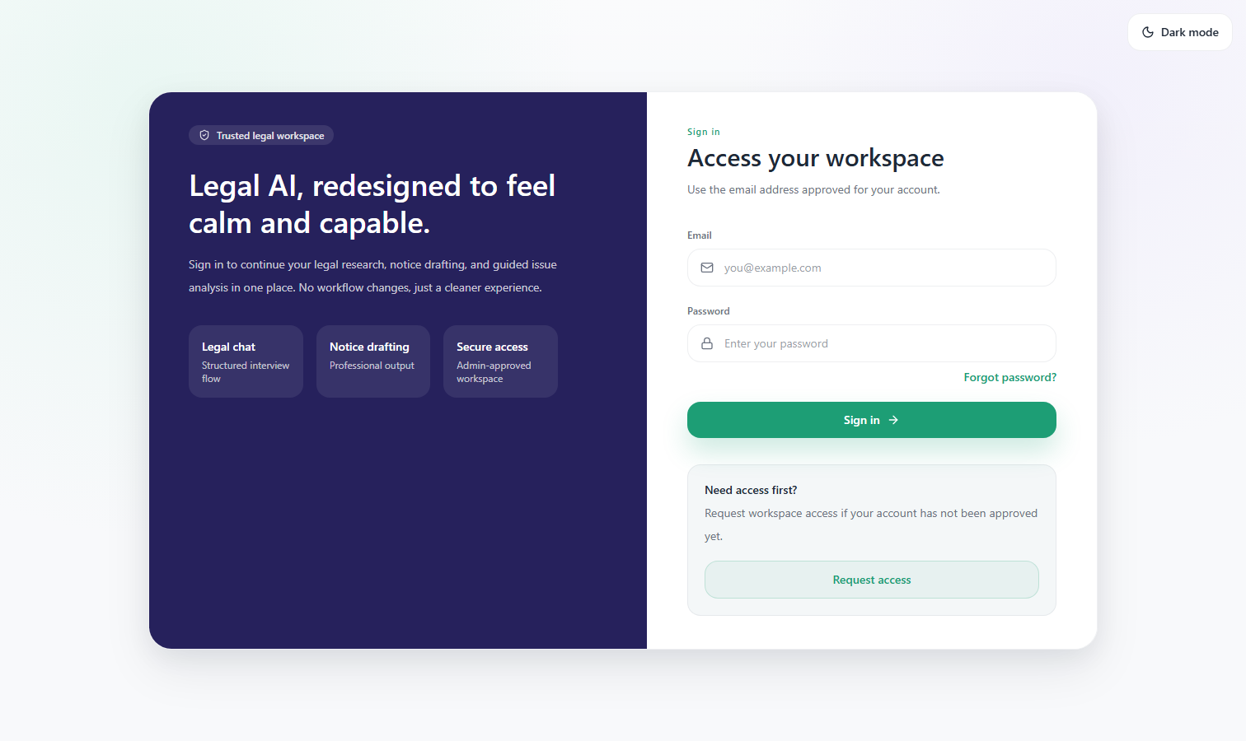

Figure: Login page (enter approved email and password)

1. Open the LAW LLM web app URL provided by your organization.
2. On the login screen, enter your approved email and password.
3. If you do not have access yet, select Request access.
4. After login, use the left navigation to open Legal Chat, Document tools, and Settings.

What you should see:
- A dashboard/workspace with navigation and module cards
- Theme and session controls in the top area

4. Account Access and Authentication

4.1 Sign In
1. Enter approved email.
2. Enter password.
3. Click Sign in.
If successful:
- You are redirected into the workspace.

4.2 Forgot Password
1. Enter your email on the login page.
2. Click Forgot password?
3. Check email for a setup/reset link.
4. Open link and set a new password.
Common mistakes to avoid:
- Entering a different email than the approved account
- Using an expired link

4.3 Request Access
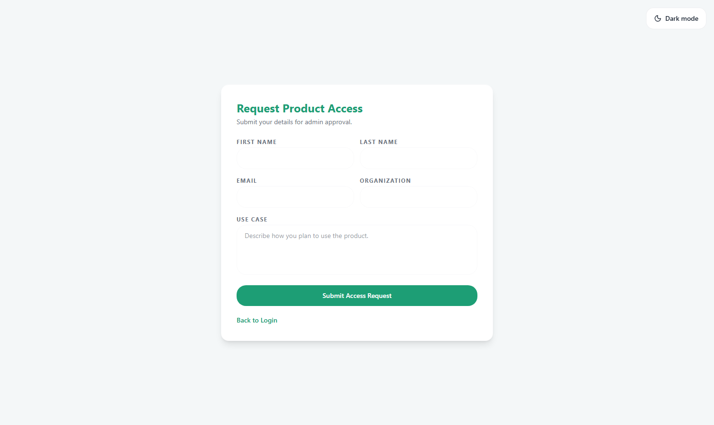

Figure: Request Access page

1. Click Request access on login.
2. Fill first name, last name, email, organization, and use case.
3. Submit request.
4. Wait for admin approval.

4.4 Set Password (First-Time Setup)
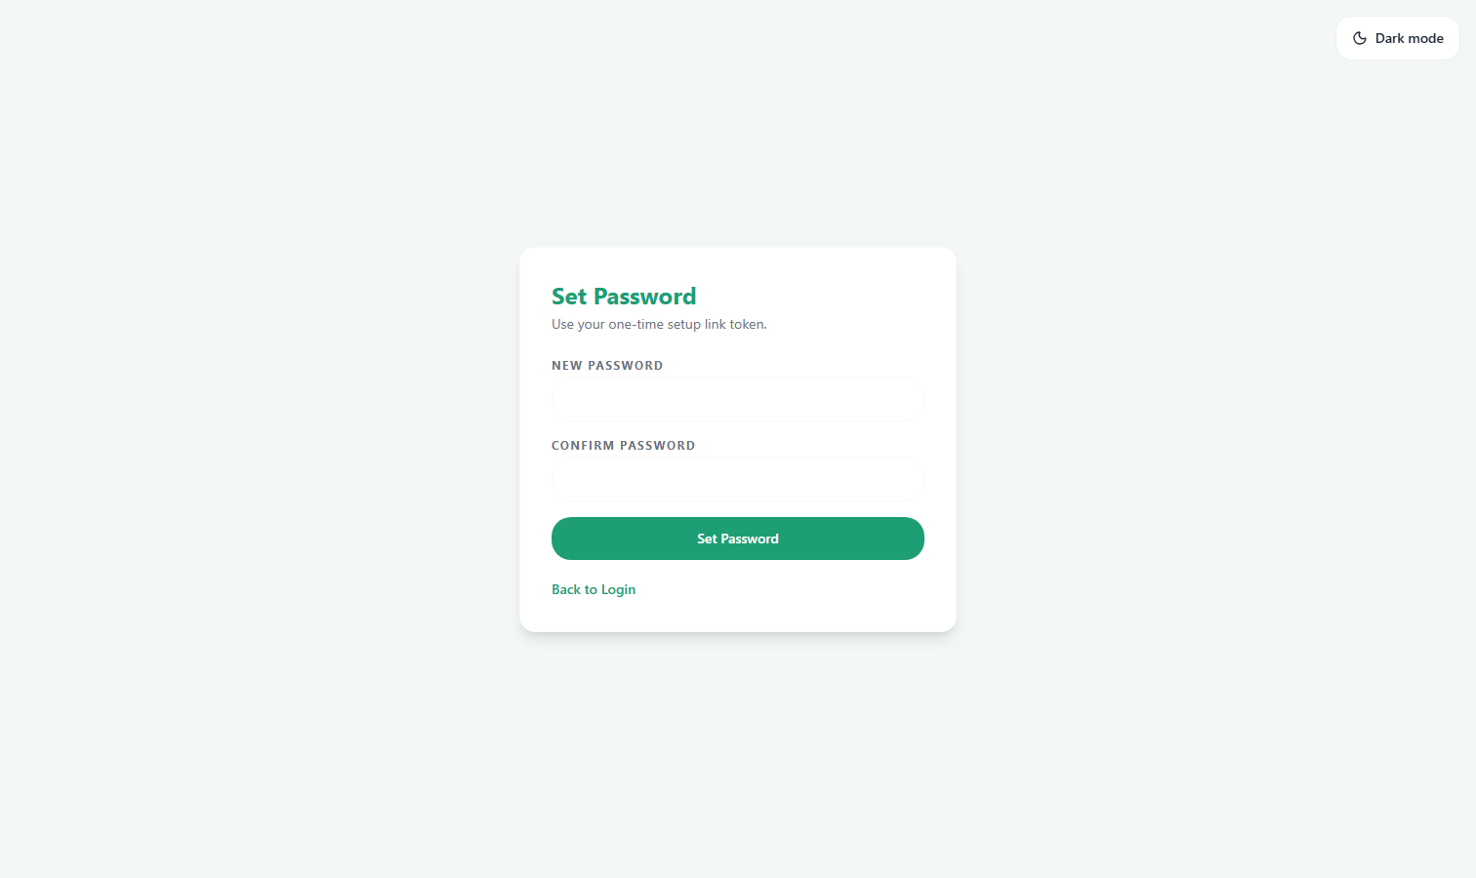

Figure: Set Password page using one-time setup token

1. Open one-time setup link from email.
2. Enter new password and confirm it.
3. Submit.
4. Return to login and sign in.

5. Navigation Overview
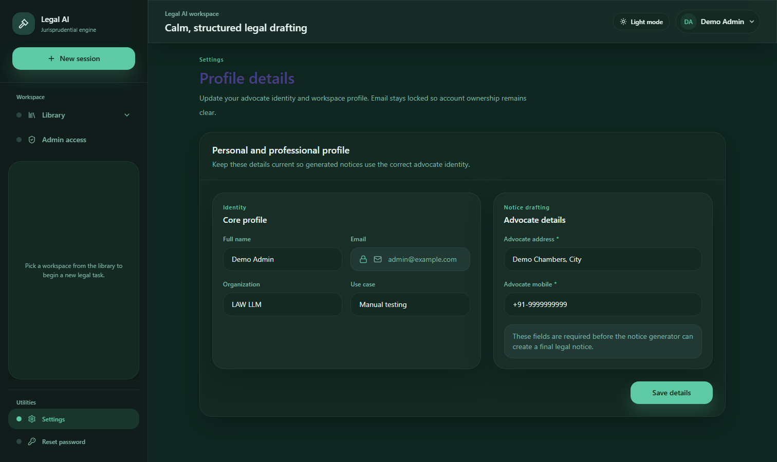

Figure: Workspace navigation example (including settings access)

The main workspace typically includes:
- Legal Chat: Structured legal intake and analysis conversation
- Document Generator: Draft legal notices/documents
- Document Analyzer: Analyze uploaded legal text/documents
- Settings: Profile and password updates
- Admin Access (admin role): User approvals, setup links, access history
What you should see:
- Active module highlighted in the sidebar/navigation
- Context panel and content area for the selected module

6. How to Use Legal Chat
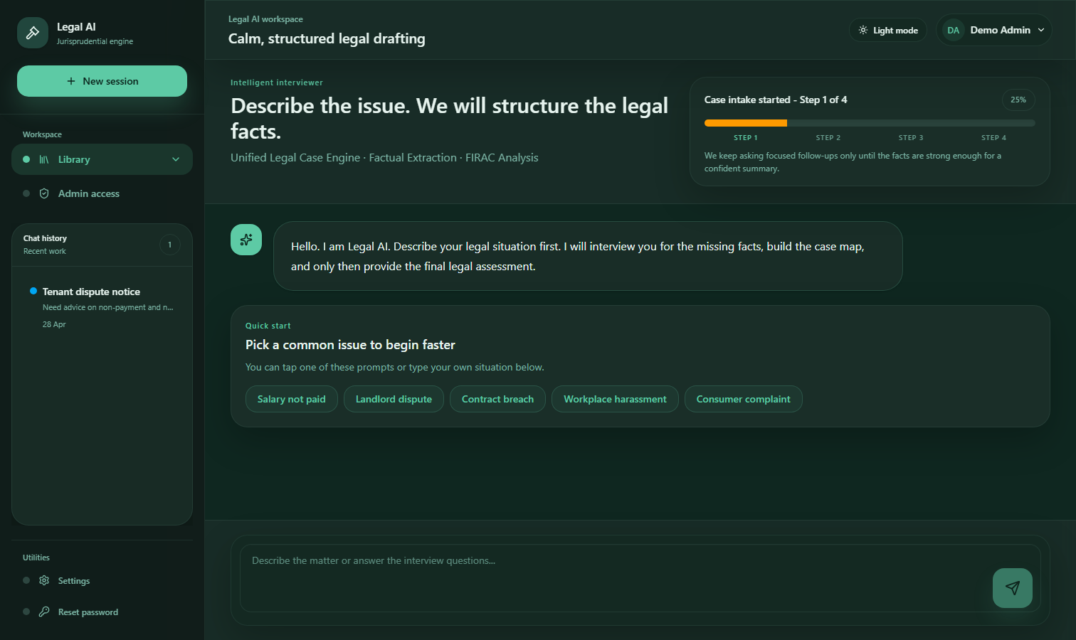

Figure: Legal Chat module

Purpose
Legal Chat helps structure facts and guide legal issue framing before drafting or deeper analysis.

Steps
- 1. Open Legal Chat.
- 2. Start with a short issue statement.
- 3. Answer follow-up questions with concrete facts, dates, parties, and documents.
- 4. Review suggested issues and AI analysis.
- 5. Continue until the issue summary becomes clear and complete.

Input quality tips
- Include parties, timeline, jurisdiction, and key evidence.
- Separate facts from assumptions.
- Mention known relief sought (for example, payment, injunction, specific performance).
What you should see:
- Progress/confidence indicators
- Follow-up question flow
- Structured outputs and issue framing

Common mistakes to avoid:
- Very short prompts without factual context
- Missing dates and jurisdiction
- Treating first output as final without verification

7. How to Generate Legal Drafts
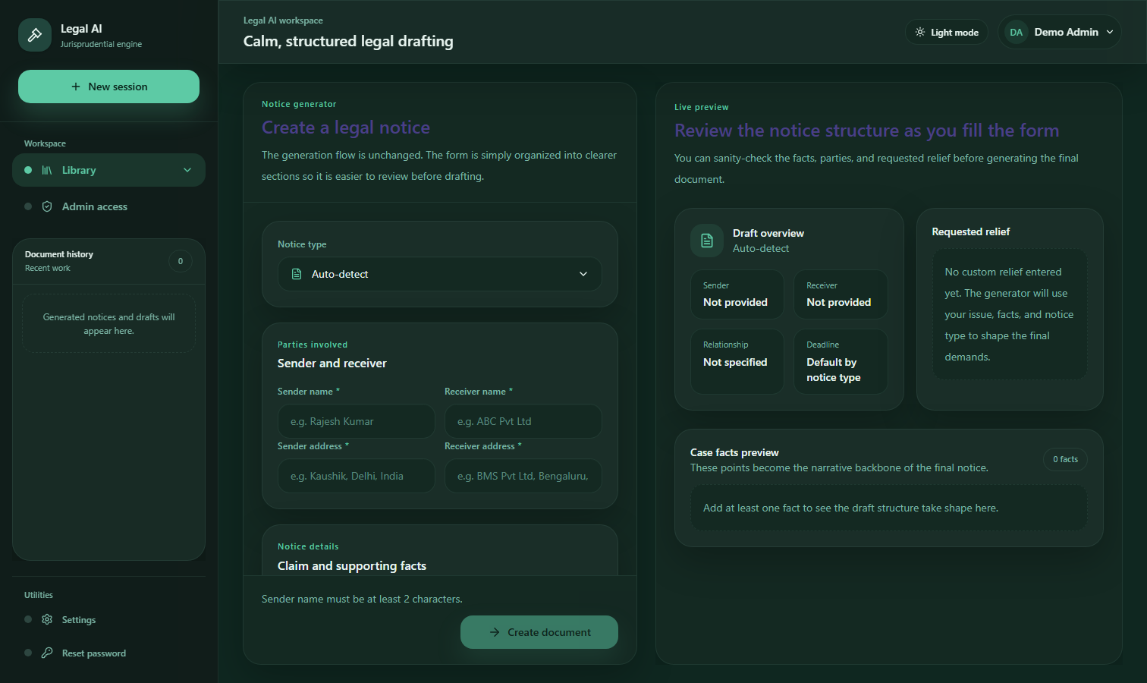

Figure: Document Generator module

Purpose
Generate structured legal drafts (for example, notices) from provided case facts.

Steps
1. Open Document Generator.
2. Fill all required fields carefully.
3. Add precise facts, chronology, and legal basis.
4. Start generation.
5. Review and edit the draft before external use.

Review checklist before use
- Names, dates, addresses, and amounts are correct
- Jurisdiction and legal references are applicable
- Tone and prayer/relief align with case strategy
- Final document is reviewed by a responsible legal professional

What you should see:
- Draft sections rendered in a structured format
- Status updates during generation

8. How to Analyze Documents
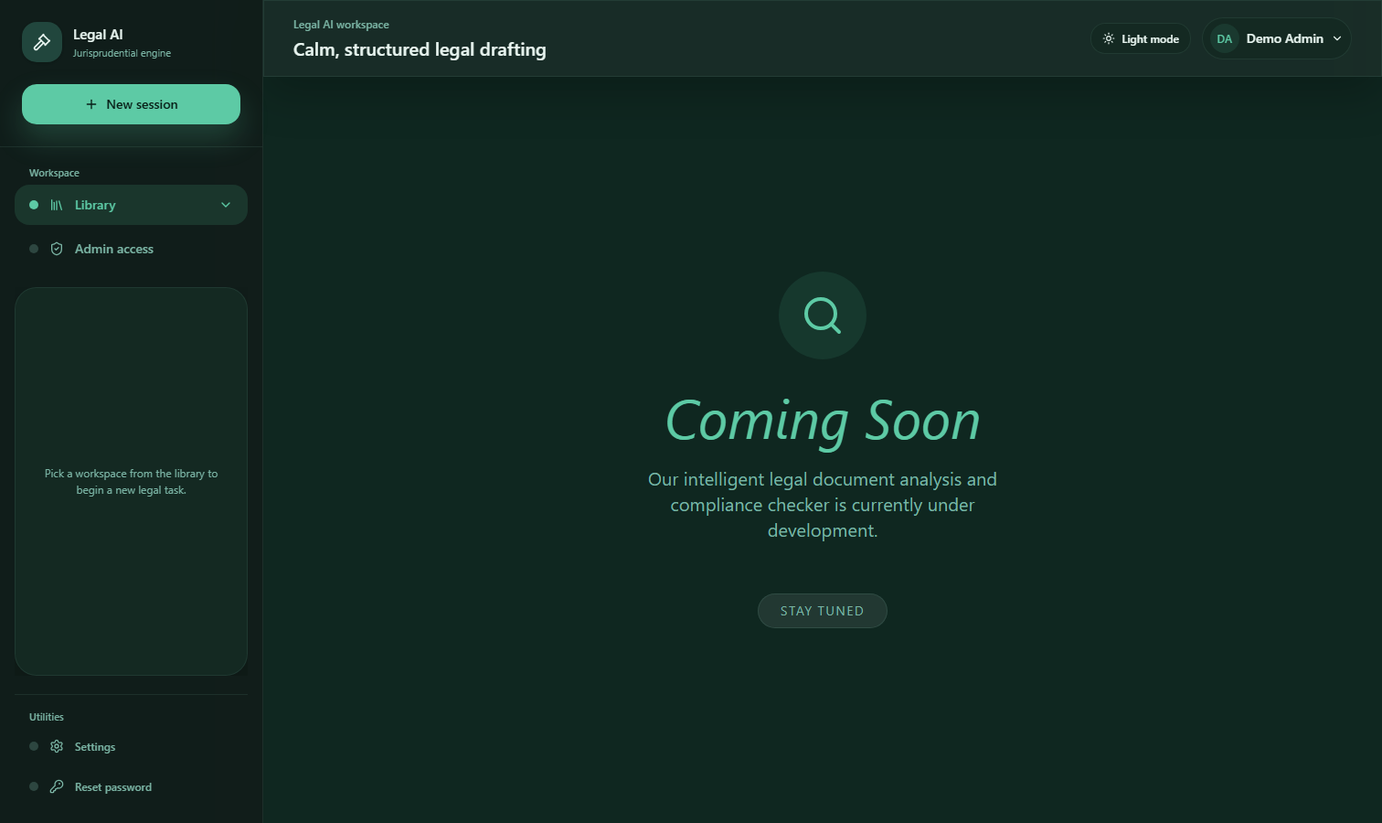

Figure: Document Analyzer module

Purpose
Extract insights from uploaded/provided legal content to support case preparation.

Steps
1. Open Document Analyzer.
2. Upload or provide the document text.
3. Trigger analysis.
4. Review extracted points, risks, or summaries.
5. Cross-check critical findings against source text.

Common mistakes to avoid:
- Uploading low-quality or incomplete files
- Relying on extracted points without verification

9. Admin Operations
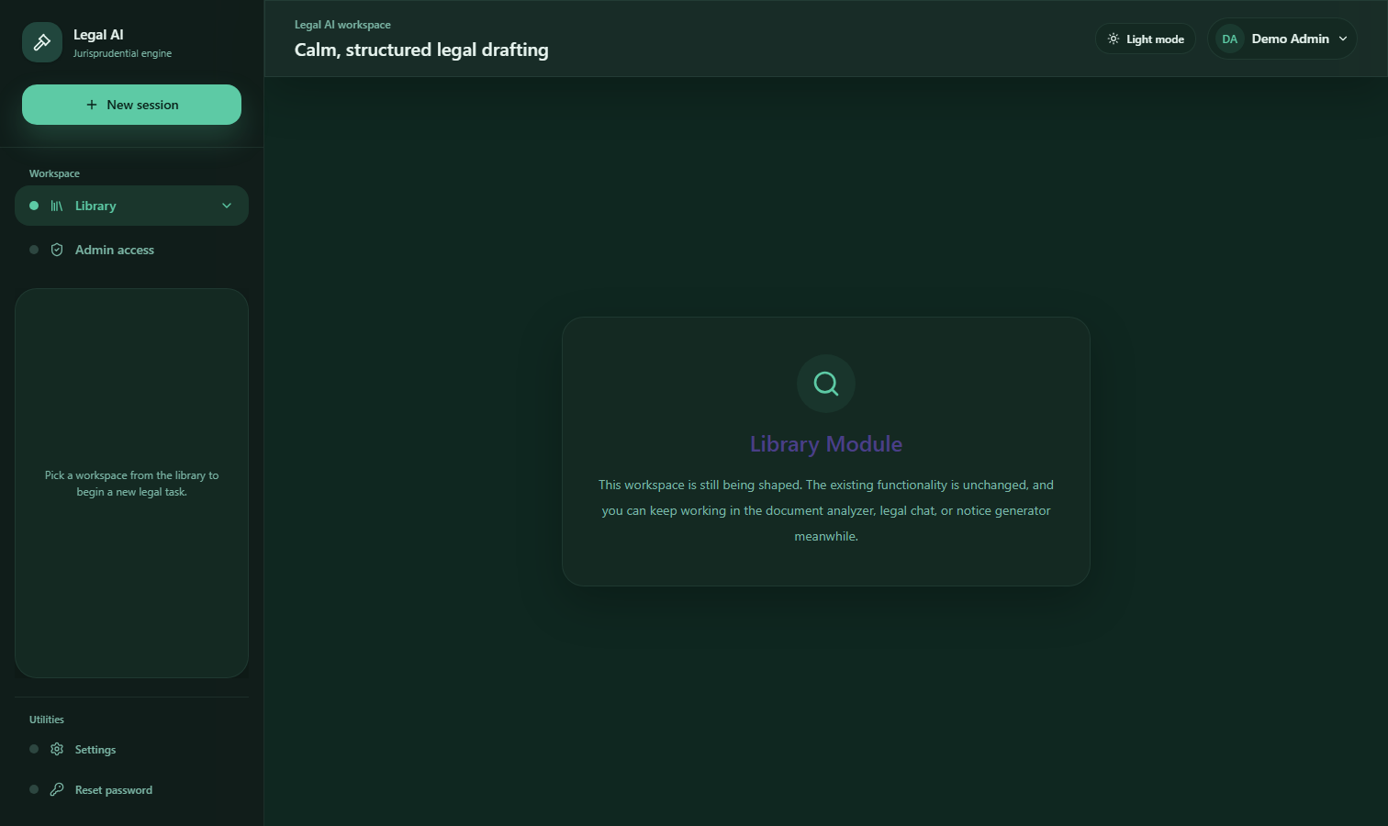

Figure: Admin Access Control module

Admin users can:
- Approve, deny, or manage access requests
- Generate/manage password setup links
- Monitor access activity and user status

Typical approval flow
1. Open Admin Access Control.
2. Review pending users and metadata.
3. Approve or deny based on policy.
4. If approved, ensure password setup process is completed.

Admin best practices
- Apply least-privilege access
- Review logs periodically
- Revoke access promptly for inactive or unauthorized users

10. Security and Privacy Best Practices
- Do not share credentials.
- Use strong, unique passwords.
- Log out from shared devices.
- Enter only necessary sensitive data.
- Follow organization data handling and retention policies.
- Restrict exports and sharing of generated outputs as per policy.

11. Troubleshooting and Error Messages

Login failed / invalid credentials
- Recheck email/password
- Confirm caps lock is off
- Use forgot password if needed

Access pending or denied
- Pending: wait for admin decision
- Denied: contact admin with use-case details

Forgot password link issues
- Ensure email matches approved account
- Check spam/junk folder
- Request a new link if expired

Slow or incomplete AI response
- Retry with clearer, smaller factual chunks
- Avoid combining too many legal issues in one prompt
- Refresh session if response stalls

Draft quality improvement tips
- Provide chronology and objective details
- Specify jurisdiction and desired outcome
- Include opposing party actions and supporting records

When to contact admin:
- Access, role, or account status problems

When to contact technical support:
- Repeated system errors, failed loads, or generation failures

12. Limitations and Responsible Use
- LAW LLM may produce incomplete or imperfect analysis.
- AI-generated legal text must be reviewed before filing or serving.
- Verify statutes, citations, deadlines, and jurisdiction applicability.
- Final legal responsibility remains with the human legal professional.

13. FAQ

Is LAW LLM a replacement for a lawyer?
No. It is an assistive legal productivity tool.

Can I use generated notices directly?
Only after legal review and necessary edits.

Why am I not able to log in?
Possible reasons: wrong credentials, no approved access, or setup incomplete.

Can admin see all users?
Admin can view and manage users relevant to the configured access system.

What should I do if output seems inaccurate?
Refine prompts, add facts, and verify results against sources and legal standards.

14. Support and Escalation
- First level: Organization admin for access and role issues
- Second level: Technical support for application errors
- Third level: Legal reviewer/senior counsel for output validation

When escalating, share:
- Timestamp of issue
- Module name
- Error message text
- Steps attempted

---

Quick Start Guide (1-Page)
1. Open LAW LLM URL.
2. Sign in with approved email/password.
3. Start in Legal Chat and enter core facts.
4. Use Document Generator for draft notices.
5. Use Document Analyzer for insight extraction.
6. Review every AI output before external use.
7. Update profile/password in Settings.

New User Checklist
- Access approved by admin
- Password set successfully
- First Legal Chat completed with full facts
- One draft generated and reviewed
- Security basics followed (unique password, no credential sharing)

Admin Checklist
- Review pending requests daily
- Approve/deny with policy consistency
- Confirm setup links are sent and completed
- Audit user status and access history
- Revoke unnecessary access promptly

Glossary
- Legal Chat: Guided issue-intake conversation interface
- Document Generator: Tool to create draft legal notices/documents
- Document Analyzer: Tool to summarize/extract legal insights from text/files
- Access Pending: User request submitted, awaiting admin decision
- Setup Link Token: One-time token used to create first password
- Jurisdiction: Legal territory whose law applies to the case

