Data Summary Eg

Cian

September 2018

## Simple Example

I have created some data and have calculated some numerical and graphical summaries.

These are the data:

data1 <- c(10, 23,14,12,34,26,28,58,61)

The mean is:

mean(data1)

## [1] 29.55556

The summary statistics are:

summary(data1)

## Min. 1st Qu. Median Mean 3rd Qu. Max.   
## 10.00 14.00 26.00 29.56 34.00 61.00

A boxplot would look like:

boxplot(data1)

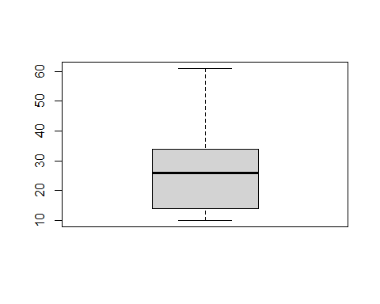

And a histogram:

hist(data1)

