**Business Requirements Document for Amazon Login page**

**Customer: Amazon**

**1.0 Display:**

* 1. Amazon company logo should display at the centre-top of login panel like so:

* 1. Clicking the need help button should display a drop-down menu containing the forgot password button and need help button.

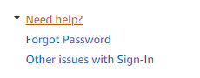

* 1. There should be a button which gives the user to option to create a new amazon account, located at the centre bottom of the forum.

1. **Functionality:**
   1. The continue button should check the inputted number or email to see if the account exists.

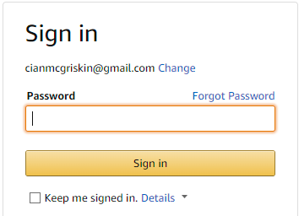

* 1. If the account does not exist, an error message should be displayed stating the account could not be found like so:

* 1. Similarly, if the user enters an incorrect mobile number a box should show like so

* 1. If the account exists, it should generate a prompt to input your password, if this user is incorrect, you should be prompted with this message:

* 1. There should also be a forgot password button that appears above the password input when pressed it should present a new page.

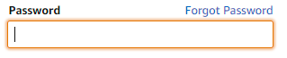

* 1. This new page should give you an option to enter your email associated with your forgot password case. Once inputted an email and the user exists, an email to reset your password should be sent to your email.

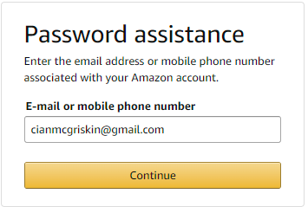

* 1. There is a checkbox that should remember your sign-in so next time when you attempt to login to the site it will automatically log you in. This will use cookie technology to do this.



* 1. When you enter an empty password, you should be greeted with an error which states the user should enter a password.

1. **Security:**
   1. If the user has 2FA set up, the site should prompt them to enter a security number sent to their phone.

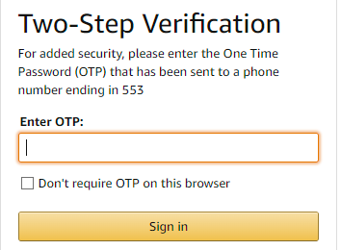

* 1. You should be able to analyse how many times a user attempted to log in and from what IP address they are attempting from.
  2. Password should be a strong password containing a capital, number and at least 8 characters.
  3. All data communicated between the client and platform should be encrypted using SSL encryption to ensure data is secure.