CCT College Dublin
Assessment Cover Page

Module Title: | Data Preparation & Visualisation  Statistical Techniques for Data Analytics  Machine Learning
Assessment Title: | Continuous Assessment
Lecturer Name: | Muhammad Iqbal  David McQuaid  Marina Soledad Iantorno
Student Full Name: | Ciara Barron
Student Number: | sba23419
Assessment Due Date: | Sunday, 07 January 2024, 11:59 PM  Extended until Friday 12 January 2024
Date of Submission:

Declaration
By submitting this assessment, I confirm that I have read the CCT policy on Academic Misconduct and understand the implications of submitting work that is not my own or does not appropriately reference material taken from a third party or other source. I declare it to be my own work and that all material from third parties has been appropriately referenced. I further confirm that this work has not previously been submitted for assessment by myself or someone else in CCT College Dublin or any other higher education institution.

Contents
Introduction 2
Data Preparation 3
Characterisation of the Data Set 3
Data Preparation and Exploratory Data Analysis (EDA) 3
Figure 1. 4
Figure 2. 5
Figure 3. 6
Figure 4. 8
Figure 5. 9
Figure 6. 10
Figure 7. 11
Encoding, Scaling and Feature Engineering 12
Figure 8. 12
Figure 9. 13
Dimensionality Reduction 13
Figure 10. 15
Statistical Techniques 16
Descriptive Statistical Analyses 16
Hypothesis Testing 16
Jupyter Notebook Results 16
Results of findings to stakeholders 16
Machine Learning 16
Conceptual Understanding and Logical Justification 16
Feature Selection and Hyperparameter Tuning 16
Training and Testing 16
Comparison of Machine Modeling Outcomes 16
Conclusion 16
Recommendations 16
Appendices 16
References 16

Introduction

Data Preparation

Characterisation of the Data Set
To begin the project, initial queries were carried out with a view to establishing the task ahead and understanding the dataset. It was established that the dataset consists of 1470 observations across 35 features. There were no duplicates but 147 observations in each feature was missing across the dataset. This amounts to 10% of the data. The data appeared to be Missing Completely at Random, Analyticsvidhya.com classifies this as ‘when the probability of missing responses is decided by the collection of observed responses rather than the exact missing values expected to be reached’. It was noted that they were intentionally removed as the data dictionary did not match the dataset. This may impact the project, as the practise of removing values from a dataset can raise ethical concerns.

Data Preparation and Exploratory Data Analysis (EDA)
Exploratory Data Analysis (EDA) was conducted to establish the method to take to deal with the missing values in the categorical data, the non-categorical data and the binary columns, Attrition and Gender.
The decision was made to drop some columns; ‘Employee Number’ was dropped as these are unique identifiers assigned to each employee, therefore not providing relevant information for the objectives of the project. ‘Over18’ was dropped as all the employees are adults and therefore this was not going to impact the analysis significantly.‘DailyRate’, Hourly Rate’ and ‘MonthlyRate’ were dropped due to these being highly correlated, and it was thought that this would simplify the analysis and reduce multicollinearity in the models.
The binary columns, ‘Attrition’ and ‘Gender’ were then investigated and for ‘Attrition’ Figure 1 below, it was decided to replace the missing values with the majority class which is ‘No’.

Figure 1.
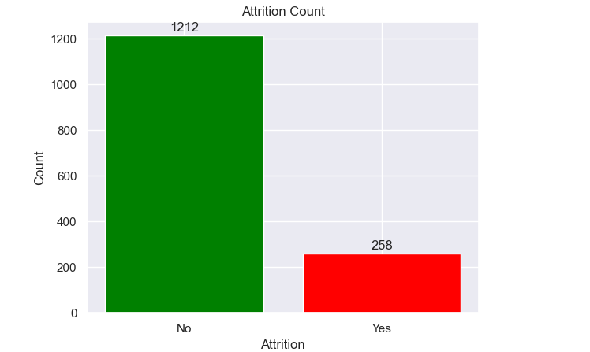
The same process was followed for ‘Gender’, The NaN value in ‘Gender’ was replaced with ‘Male’ as it is the majority class, Figure 2 below.

Figure 2.
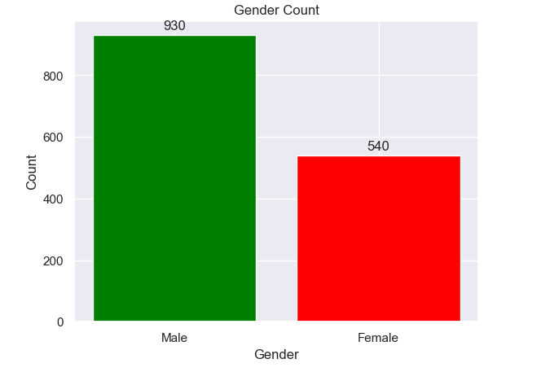

There are several options to deal with missing values in the data. These all have pros and cons. For the categorical features here, it was decided to replace the missing values with the modes. This imputes with the most common value. The pros of this method are that it works with all formats of data and the cons mean that data bias may be introduced because it ignores feature connections.
For the numerical features, Curley et al., 2017, discusses single imputation, this is a general term that describes a family of missing data replacement techniques including mean replacement.
Histograms, figure 3 below, were created to visualise whether the data was distributed in a normal fashion or if it was skewed and boxplots, figure 4, were created so that outliers were clear.

Figure 3.
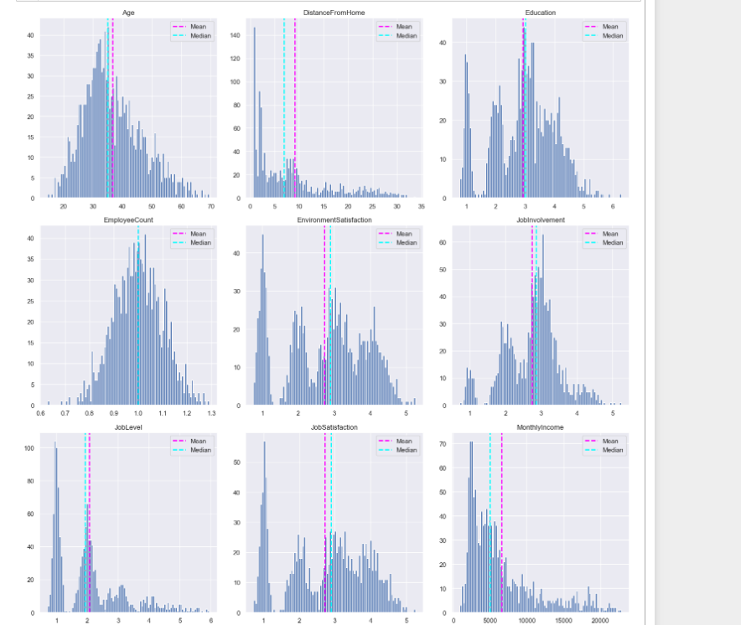
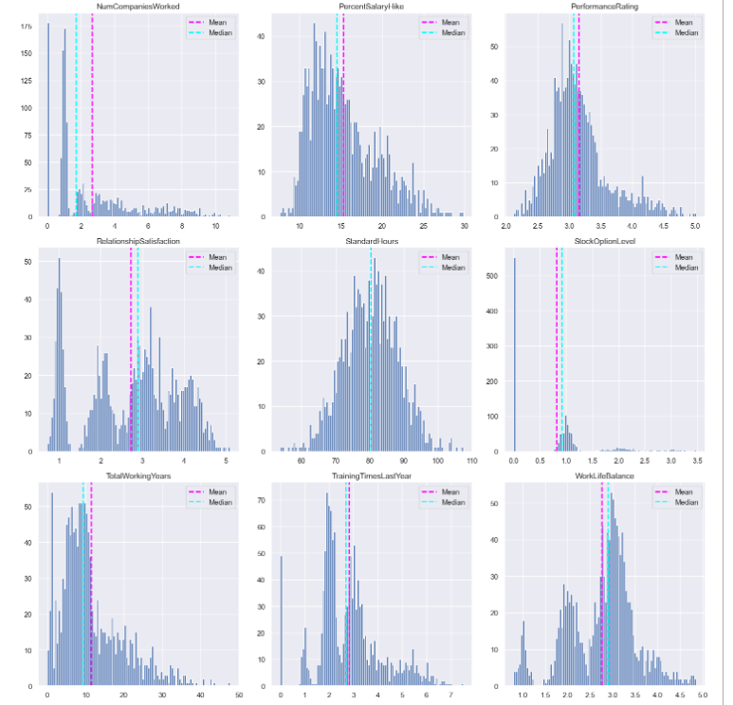
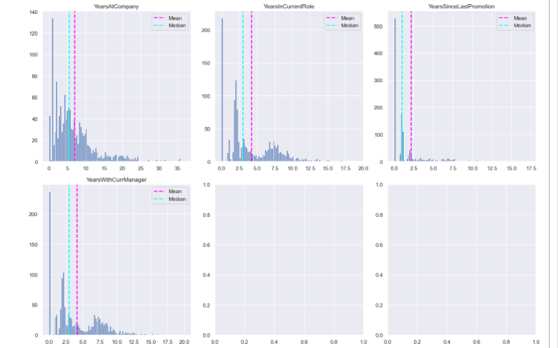

Figure 4.
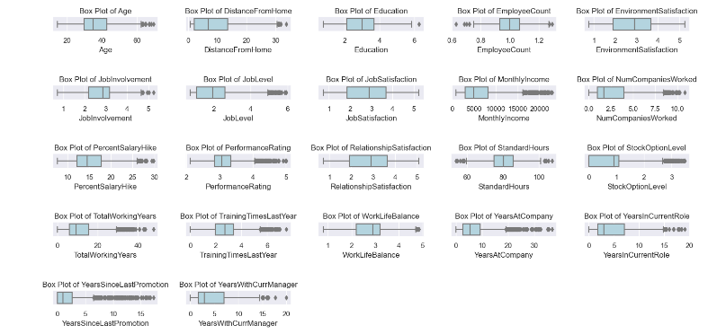
The reasons that these were visualised are that it now makes it easier to use the mean to impute missing values in numerical columns with no significant outliers and to use the median to impute missing values in numerical columns with significant outliers.
Creating the original visualisation again, Figure 5. For the initial three features demonstrates the difference in the skewedness of the data once the missing values have been imputed.

Figure 5.
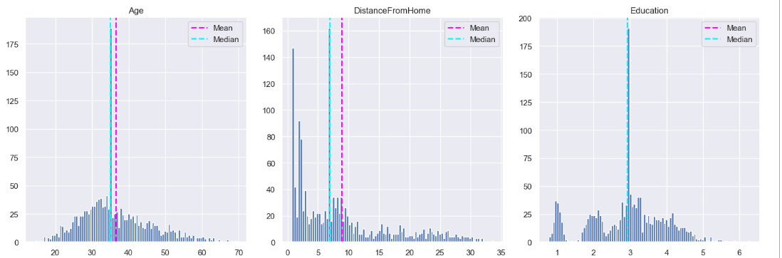
Next, a univariate analysis of the categorical data (Figure 6) was carried out, initially creating some visualisations of the features, both bar chart and a pie chart to break the features down into how they are distributed across the categories.

Figure 6.
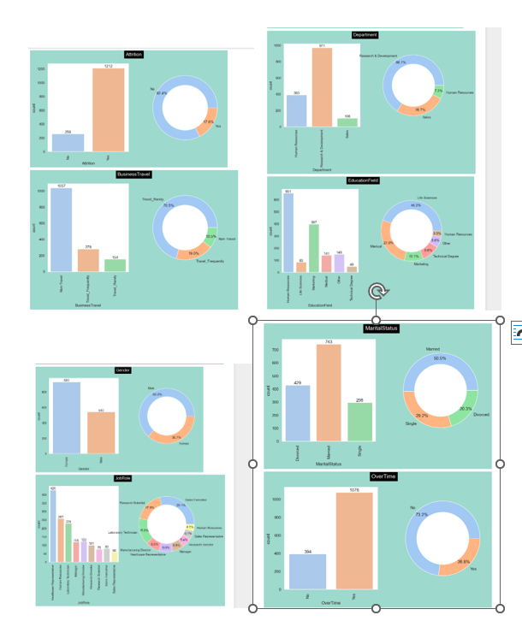

Figure 7 shows us how these variables compare against the target variable ‘Attrition’. It can be seen that the Department to have the highest rate of attirition is ‘Research & Development’ followed by ‘Sales’ and the Department to have the least rate of turnover is ‘Human Resources’. This doesn’t follow through to the ‘JobRole’ where the highest rate of attrition is with the employees who are Sales Executives. The Overtime column tells us that of those who don’t do Overtime, a very high number have stayed with the company.

Figure 7.
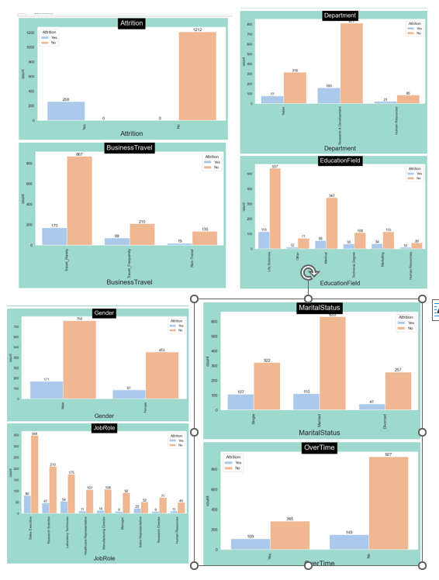
The final part of EDA was a multivariate analysis, creating a correlation matrix to visualise the connection between features. From here, some natural conclusions are made obvious, there is a high correlation between monthly income and job level as well as total working years and age. Job satisfaction has a negative correlation with Attrition which would make sense.

Encoding, Scaling and Feature Engineering
Figure 4, above, shows that there are several outliers that will be dealt with under this section. Boxplots help in understanding the spread of the data, and the outliers can be seen as points beyond the whiskers of the boxplot. Osborne, Jason W. and Overbay, Amy (2019) state that although definitions vary, an outlier is considered to be a data point that is far outside the norm for a variable or population. Outliers can heavily influence the mean and standard deviation making them less representative of the central tendency and spread of the data. They can also negatively impact the performance of machine learning models. Replacing these with the upper bound either IQR or STD, outliers will be replaced depending on which boundary they cross over. This technique was chosen as it is robust to extreme values, and provides a systematic approach to identify and handle the outliers. Figure 8 takes a visualisation of a sample of the variables and uses boxplots to demonstrate how the outliers are gone.

Figure 8.

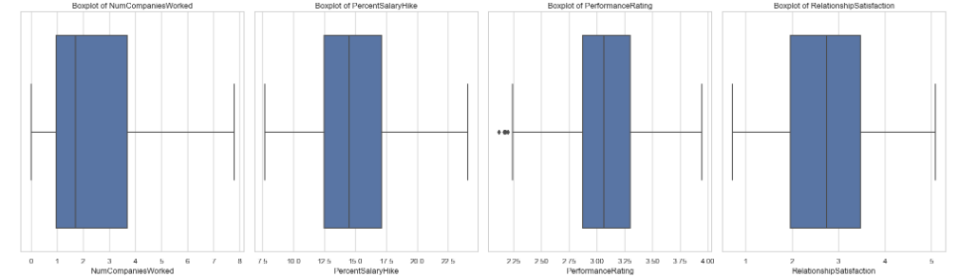
Label encoding was used to convert the three binary categorical attributes, ‘Attrition’, ‘Gender’ and ‘OverTime’. A unique numerical label is assigned to each category. This was chosen because there are two distinct categories in each attribute. One-hot vector was used to convert the categories with more than two distinct values. This was chosen as it helps to capture complex relationships in variables with more than two distinct values. It is important to be aware that these may be the wrong choices, only practise and running the machine model will tell. Other techniques may be more beneficial in getting a good result.
Figure 9 shows a bar plot to visualise the correlation between ‘Attrition’ and all the other features. A positive correlation indicates that as the feature increases, the likelihood of attrition also increases, while a negative correlation indicates the opposite. From this, the top 5 features that are correlated highly with ‘Attrition’ can be decided.

Figure 9.
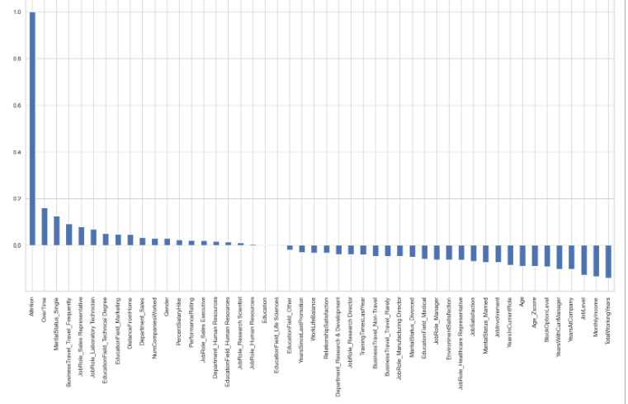
The features that rank highly are ‘OverTime’, ‘MaritalStatus_Single’, ‘Business_Travel_Travel_Frequently’, ‘JobRole_Sales Representative’ and ‘JobRole_Laboratory Technician’.

Dimensionality Reduction
It is generally recommended to apply dimensionality reduction techniques after the initial data pre-processing steps. These techniques aim to reduce the dimensionality of the feature space while preserving essential information. Once there is a more compact representation of the data, then machine learning models can be applied on the reduced feature set. For this dataset, both Linear Discriminant Analysis (LDA) and Principal Component Analysis (PCA) were applied to explore the possibility of using dimensional reduction on the dataset.
Dimensionality refers to the number of features in the dataset, the process of reducing these is known as dimensionality reduction. This is necessary because when there is a large dataset, it can become unwieldy, leading to increased computational demands, potential overfitting and diminished model interpretability. This technique, dimensionality reduction, provides a way to capture the essential information while discarding less informative features. It also helps to avoid ‘The Curse of Dimensionality’, a term introduced by Bellman to describe the problem caused by the exponential increase in volume associated with adding extra dimensions to Euclidean space (Bellman, 1957).
LDA looks at how features can separate different outcomes, so in this ‘Attrition’ dataset, it would focus on the differences between employees who stay and those who leave. It is useful for binary problems. PCA tends to look at the general trends and variations throughout the employees without considering the factors that may affect the decision, so overall patterns. The authors opinion here, is that LDA would be the best process to use for this particular problem. The outcome is a binary one, ‘Attrition’; will the employee stay or go.
LDA was the first process applied:

Table 1.
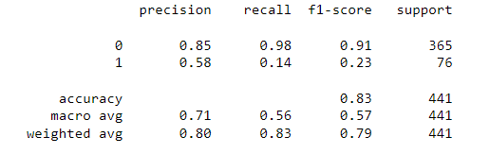
The results show that the model has a high level of accuracy (0.83), but recall in terms of class 1 (0.14) is quite low. Further investigation may be required in future to tune the model or handle class imbalance here.
PCA is then applied once ‘MinMaxScaler’ has been used, as features with the same scale are important for PCA.
Figure 10 displays a scatterplot to visualise the data, this should help to see if there is any separation or pattern in the data based on the top two principal components. The first component has the highest variance, followed by the second. There are no clear patterns or separations between classes here, this may indicate that the PCA is not effectively distinguishing the classes. Reducing the dimensionality may not have been appropriate for this dataset, and other feature engineering techniques may need to be explored. It may be useful to go back to the cleaning and preprocessing stage again. This dataset is an example of class imbalance because of the skewed distribution of the ‘Attrition’ feature so potentially PCA was not a good option for that.

Figure 10.
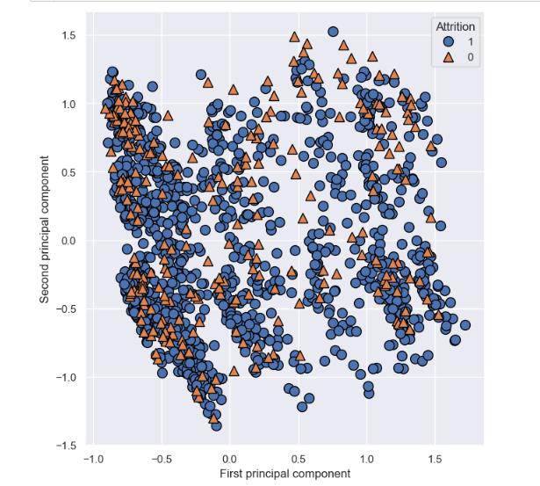

Statistical Techniques

Descriptive Statistical Analyses

For the first step in exploring the dataset using statistical techniques, it is important to investigate the central tendency of the data. To do this, a full descriptive statistical summary of the columns is found using univariate analysis. While calculating the mean would provide a measure of central tendency, a full description is valuable as it gives the Mean, median and mode of the data. It also gives the variability of the data; the range, interquartile range, and standard deviation, these will prove to be very valuable later in the analysis when it comes to looking at how balanced the data is.
Choosing several central variables within the data, some further EDA (exploratory data analysis) was carried out. To determine the best numerical variables to work with, a correlation matrix was created using a heatmap, the results of which show that a lot of the values are close to zero, suggesting a weak correlation. This doesn’t help to narrow down which factors affect attrition as most of those are negative and close to zero. It is clear that there are strong correlations between TotalWorkingYears and MonthlyIncome, and Age/TotalWorkingYears, and Age/MonthlyIncome.

Figure 11.
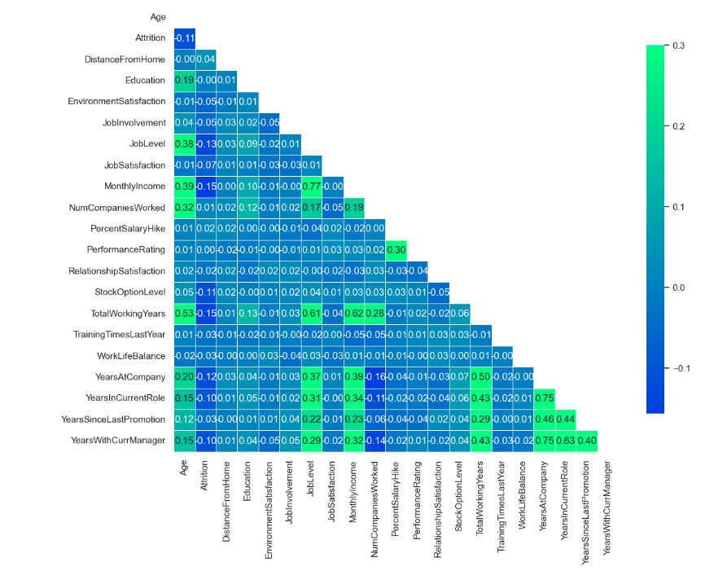
To investigate the central categorical variable ‘Attrition’, the relative frequency was calculated. This shows imbalance between the categories. It is heavily skewed towards the ‘No’ category.

Table 2.
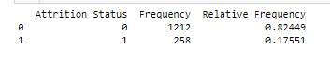

Hypothesis Testing

Next, statistical techniques were used to formulate and test hypotheses within a business context. The first hypothesis is do older workers leave at a higher rate than younger ones? Boxplots were created as a visualisation of Age by Attrition Status, and the results of the T-Tests showed that it failed to reject the null hypothesis, there is no significant difference in Age. This means that the t-test has a p-value above the significance level of 0.5.

Figure 12.

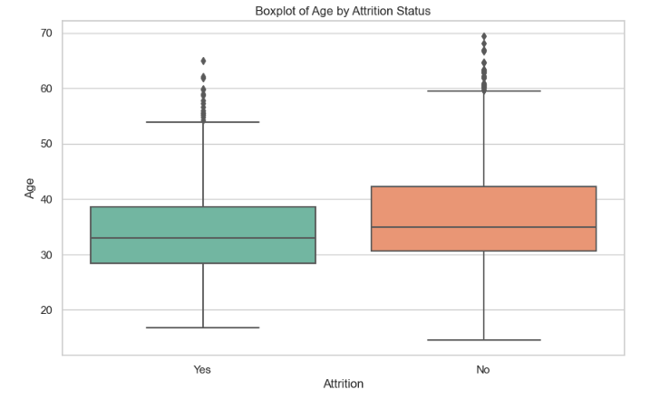

Table 3.
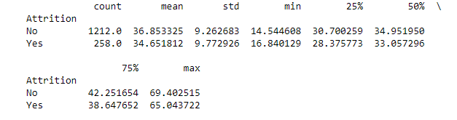
Next the same tests are carried out on the hypothesis- Does monthly Income have an impact on Attrition?

Figure 13.
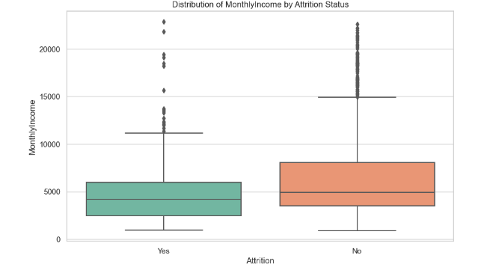

Table 4.
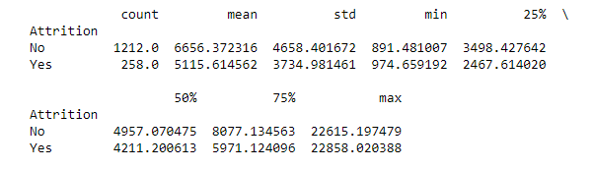
The results of this are similar to the first hypothesis. There is no significant difference in monthly income, the p-value is greater than 0.5.
A general hypothesis was put forward to investigate the overall probability of success, the overall probability of attrition was worked out to be 17.55%. This gives the average of how often attrition occurs in the dataset.
Confidence intervals are estimated on the basis of a desired confidence level (Hazra, 2017) The stated confidence level is selected by the user and is not dependent on the characteristics of the sample. It is useful for our project to find the average age where attrition is yes. Table 5 tells us that the average age is 34.65 with a 90% confidence interval of the range falling between 33.64 and 35.65.

Table 5.
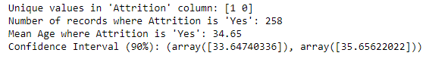
At a 95% confidence interval, the results show an array of 33.45-35.84 while at 99% confidence interval, the results are an array of 33.07-36.23. Here we are 99% confident that the true average age of all employees in the company falls into this range.
ANOVA tests were applied to compare means across groups. A one-way ANOVA was utilsed, using one independent variable. Initially the normality of the group was checked using a QQ plot. This is important because ANOVA works on the assumption of normality.
Shapiro tests are applied and the results here show that for the different departments:
Research & Development: This data comes from normal distribution as the p-value(1.52) is greater than alpha (0.05).
Sales: This data comes from normal distribution as the p-value(6.37) is greater than alpha (0.05).
Human Resources: This data does NOT come from normal distribution as the p-value(0.0004) is less than alpha(0.05).
Next the equality of the variances are tested using a Levene test. This assumes equality of the variances because the p-value (0.265) is greater than alpha (0.05)

Table 6.

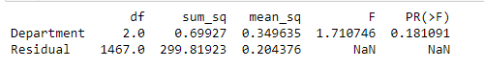
Table 6 shows the results of the ANOVA one way testing, the p-value is 0.18 which is greater than alpha (0.05). H0 is accepted (mu PerformanceRating HumanResources = mu PerformanceRating ResearchDevelopment = mu PerformanceRating Sales) and the results suggest there is no significant difference in the means of the ‘Department’ variable and insufficient evidence to reject the null hypothesis.

Jupyter Notebook Results
Use a Jupyter notebook to produce result sets from the provided dataset, such as scatter plots or
regression models. Provide a summary of your findings. (0-10 marks)

Results of findings to stakeholders
Write the results of the analysis of your findings to stakeholders using clear and concise
explanations, visualisations, and appropriate statistical terminology. (0-20 marks)

Machine Learning

Conceptual Understanding and Logical Justification

Feature Selection and Hyperparameter Tuning

Training and Testing

Comparison of Machine Modeling Outcomes

Conclusion

Recommendations

Appendices

References

