Week 1:
I implemented player movement.
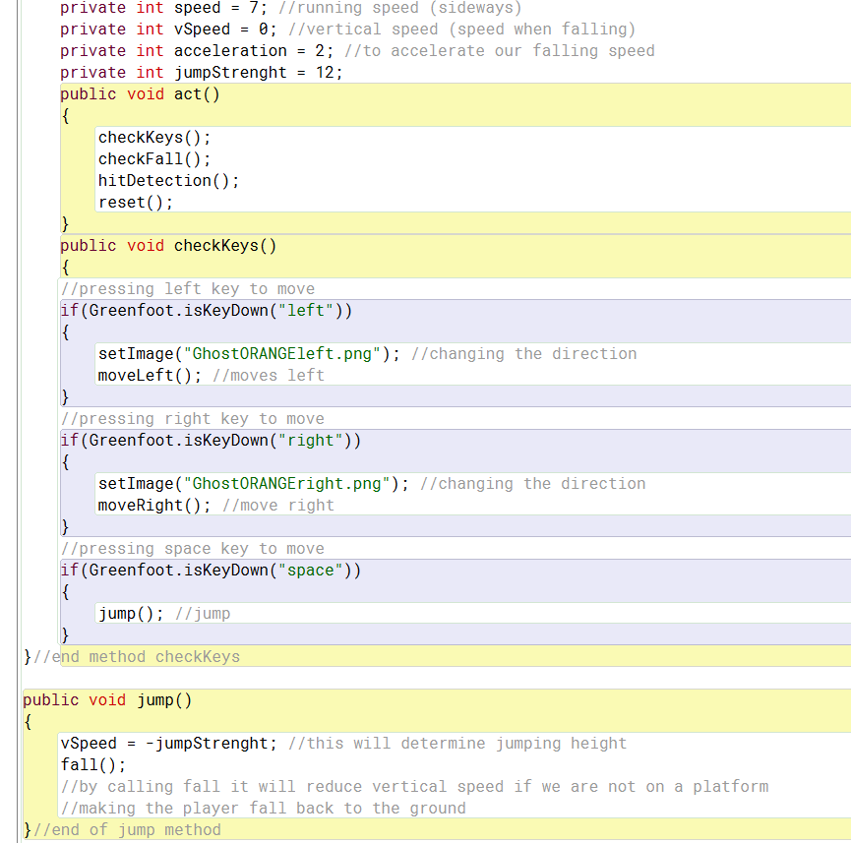
I followed a tutorial to implement platformer physics. So the player speeds up when moving and can stand on platforms and fall if they miss a platform.


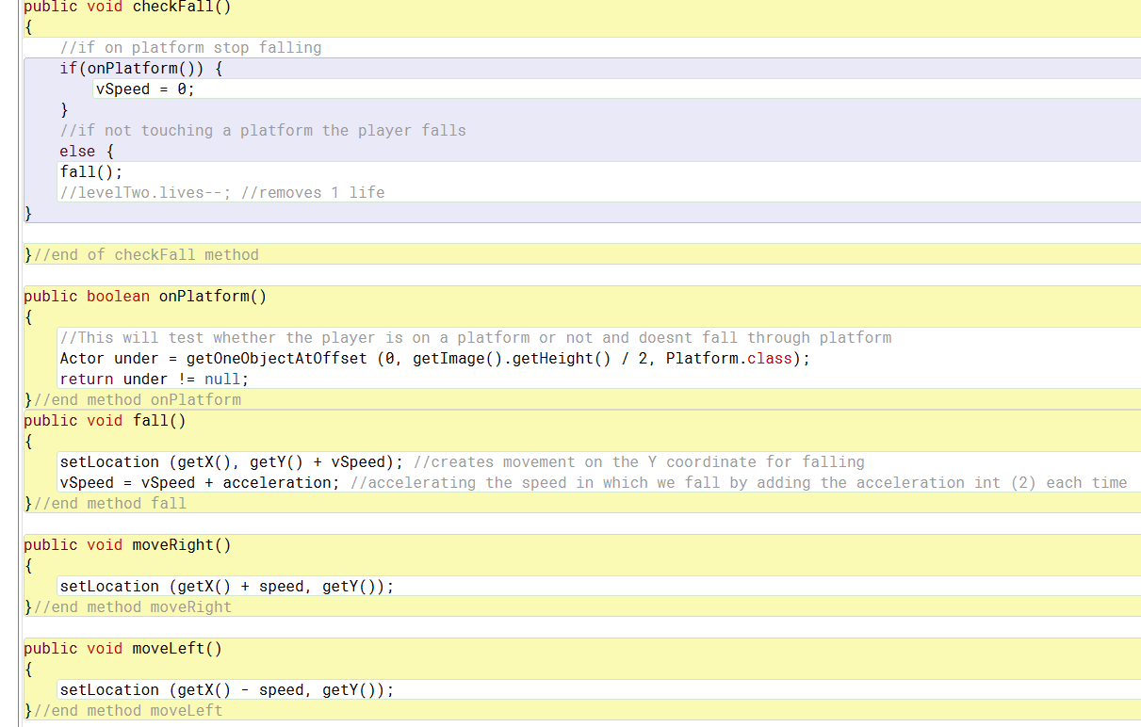

Week 2:
In my levelTwo world I implemented a score counter that increases when the player collects coins.
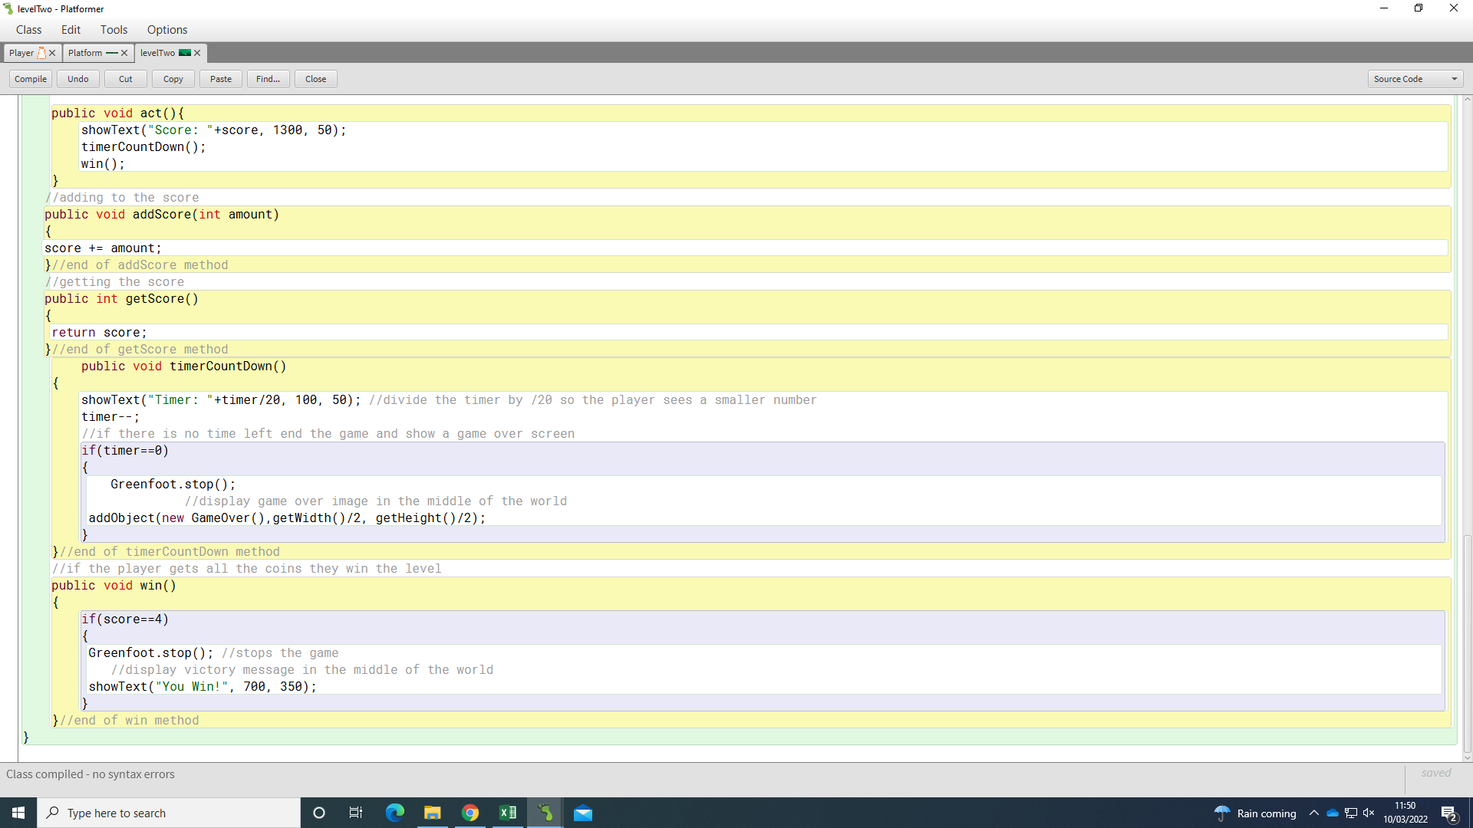


I implemented a timer that ends the game when it runs out.


Week 3:
I removed the timer countdown as we decided not to use one in the game.

I added in the feature that if the player falls off a platform the level resets instead of using lives in the game.
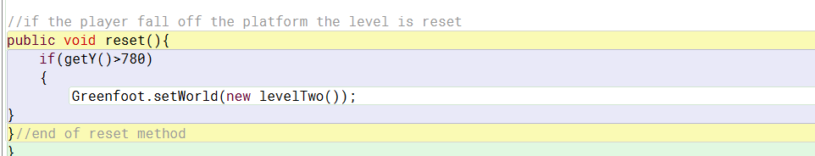

I added in a title screen and when the player presses enter it starts the game.
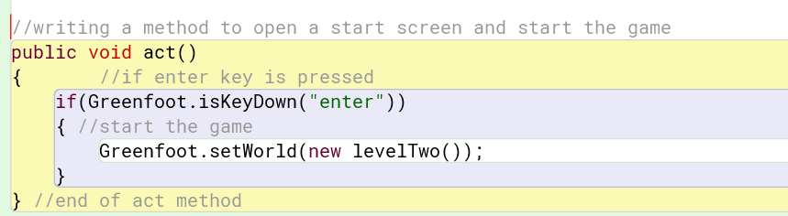
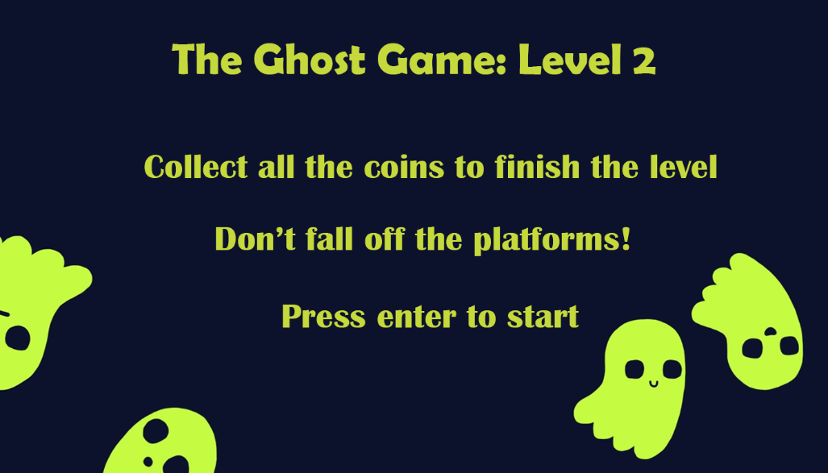
Week 4:
Our group combined our 3 levels together so that we had a full game with 3 levels.
