International Student Study Portal

Submitted 02/05/17

Lecturer – Deirdre Lawless

Ciarán O’Brien – DT282/2 – C15765215



**Table of Contents**

1. General Project Information 1

2. Group Work [only required if working as a group – individual submissions can ignore this section] 1

3. Hi-Fidelity Prototype(s) Developed 1

3.1 General UX issues 1

3.2 Internationalization 2

3.3. Localization 2

3.4 Hofstede Dimensions addressed 3

UAI - Uncertainty Avoidance 3

PDI - Power Distance Index 6

# 1. General Project Information

Student Name: Erik Stenberg

Student Number: C15495352

Student Name: Ciarán O’Brien

Student Number: C15765215

We heavily used Google drive for our group work, Slides, [Docs](https://docs.google.com/document/d/1HBMDX_PnEdM9-WUczNO4CkFHU6B9AetDvavBqfrL5JA/edit?usp=sharing). We did so for a multitude of reasons;

Allowed for the two of us to edit the same document as the same time

It wasn’t necessary for the two of us to meet up that often. A lot of communication was done through Slack within Asana.

The Docs link above is accessible to all with the link.

# 2. Group Work [only required if working as a group – individual submissions can ignore this section]

From the onset, we both looked at doing two separate UIs. This strategy was so that we could, at the end of our Low Fidelity Prototyping, merge the two ideas together. All of the best aspects of each Prototype would then be added to this new prototype.

Secondly, this strategy was also to help with our own individual submission. These prototype would then best to help build our own Hi-Fidelity Prototypes with QtDesigner.

# 3. Hi-Fidelity Prototype(s) Developed

## 3.1 General UX issues

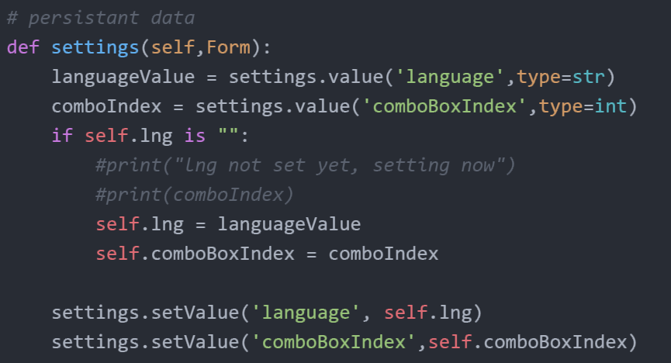

I simply used QSettings from QtCore in order to save values as persistent data. The values are retrieved in similar fashion to a hashmap, whereby the hashKey is the same of the value, as seen above, which in turn returns the desired piece of data.

## 3.2 Internationalization

Below is a example of how getText.py will be able to interpet the strings to be translated. In order to traslate the text 'Single Semester', I have to wrap it inside of the following syntax, _()

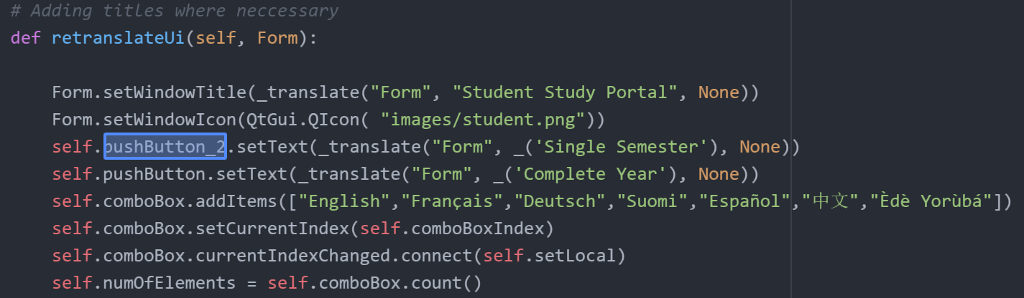

Once the above has been done with all of the strings reqruired to be tranlated. The script is ready to be passed through getText.py The restuling output is a .pot file, included in the repository.

Next, the .pot file is opened within POedit, and the relavent langauges and translations are added.

## 3.3. Localization

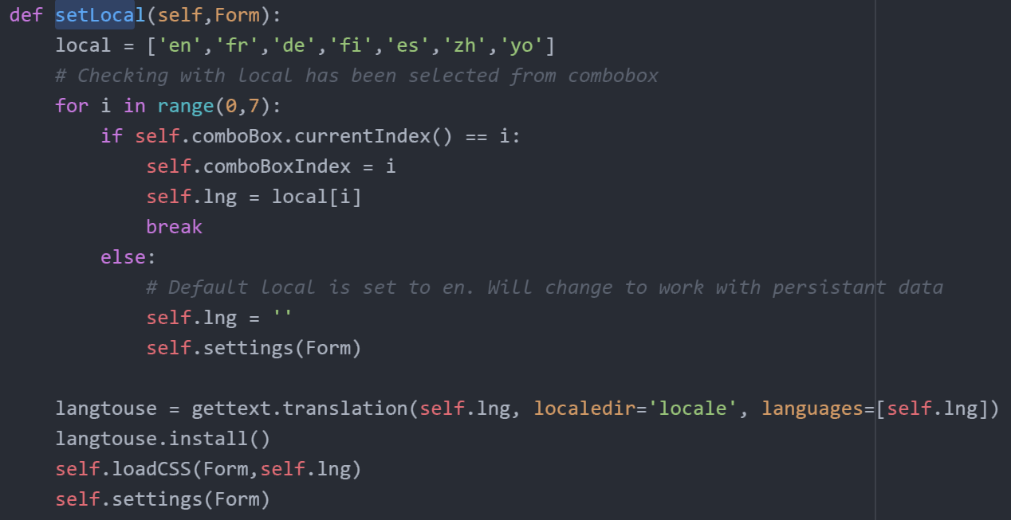

L10n – Languages

I simply used text files to load the college in a specific language, based on the locale set from the front page. These were stored in a text file, 'countries.txt', within each local folder, see above.

See below of how they were loaded, as well as a look as to how each of the button are created and object values set.

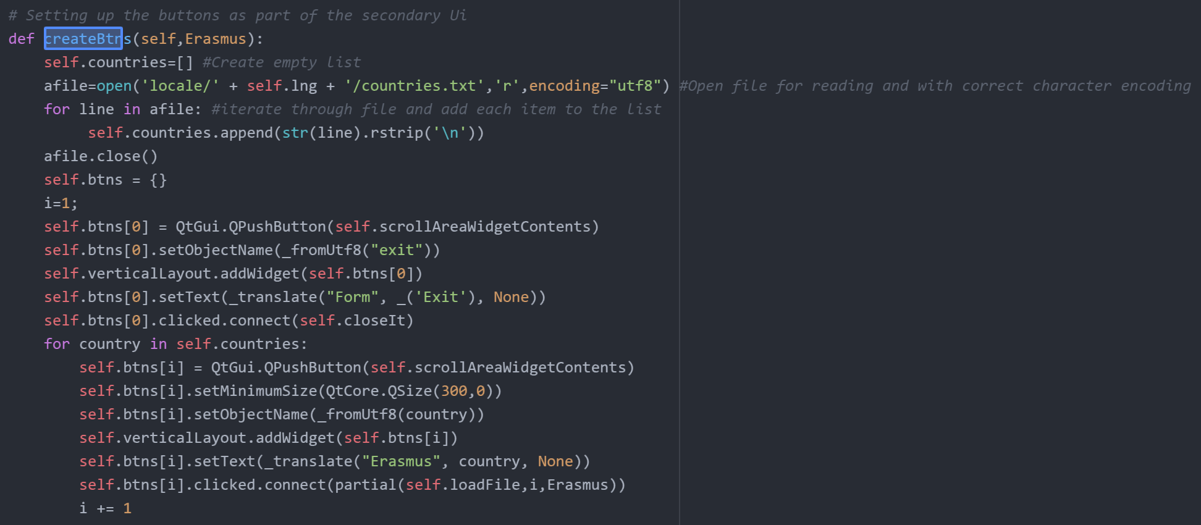

## 3.4 Hofstede Dimensions addressed

### UAI - Uncertainty Avoidance

"Extent to which people feel threatened by ambiguous situations and have created beliefs and institutions that try to avoid such situations"

**High uncertainty avoidance countries** People have high need for security, strong belief in experts and their knowledge, structured organizational activities, more written rules, less risk taking by managers

\***Low uncertainty avoidance countries** People are more willing to accept risks associated with the unknown, less structured organizational activities, fewer written rules, more risk taking by managers, higher employee turnover, more ambitious employees - Geert Hofstede

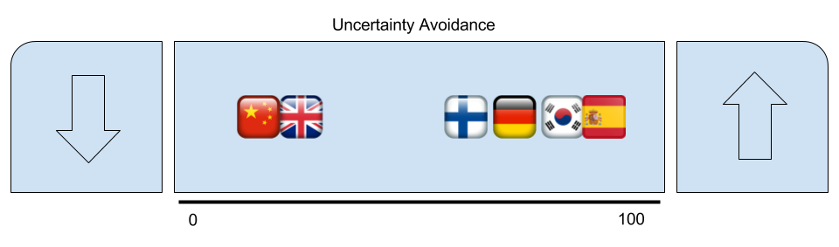

What I’ve taken from Hostede’s research above, with regards to Uncertainty Avoidance, is that there may be a few anomalies with the results seen above. Most notably the two countries scoring lower on the index. We, as Westerns, see China as being a very strict and power orientated. I discuss this below in PDI, but here, we see China scoring the lowest.

But upon further research, we can see that China fall correctly into this position. Why? China are renowned for their for-planning, their ability to plan ahead, and always having a long term plan. This is how I see Hofstede’s Dimension scoring China so low.

As for designing for the opposite end, high Uncertainty Avoidance, the need to be able to balance different options against each other is necessary in order to make a reliable decision. I achieved this through the side to side layout between the Country selection and College options. This familiar design follows throughout the whole app.

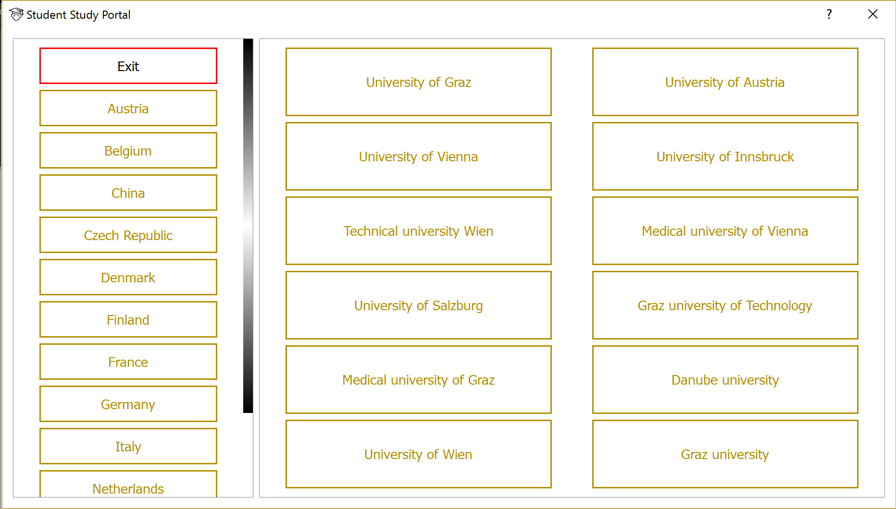

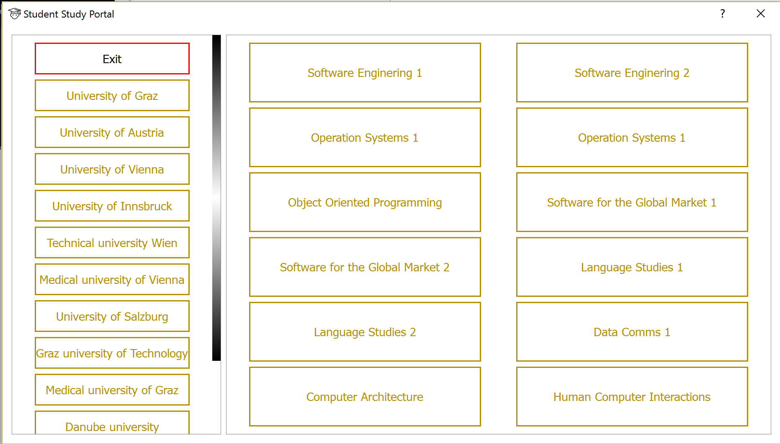

*Illustrating the familiar side-by-side layout*

### PDI - Power Distance Index

"Extent to which less powerful members of institutions and organizations accept that power is distributed unequally "

**High power distance countries** (autocratic) People more likely to simply obey the orders of their superiors without discussion, centralized and tall organization structures

**Low power distance countries** (democratic) Flatter and decentralized organization structures, smaller ratio of supervisors - Geert Hofstede

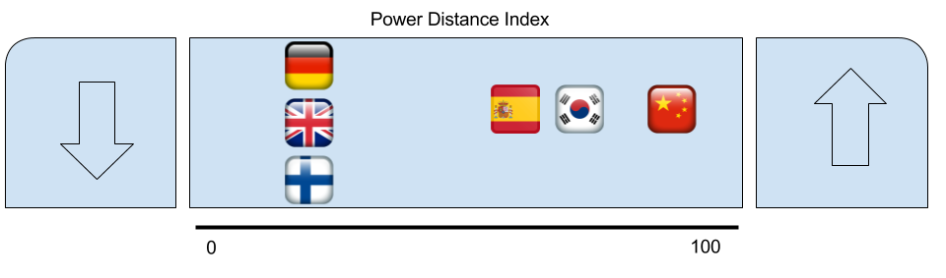

What I’ve taken from Hofstede’s research above, with regards to Power Distance Index, is that we see a striking resemblance, or opposites depending on how you look at it, to my previous insight of Uncertainty Avoidance.

On first glance, there’s a shock to see Germany so low. Why do people accept that there is power inequality that the power lies with the majority, the favoured few. But in reality, the index does show us the countries that are more than happy to accept that the police have a certain ruling, and are able/allowed to invoke this authority.

What does this mean for UI design? Well gaining trust for low scoring countries is of high importance. This is done with the simple and similar UI layout. The repetitiveness allows for recognising, rather than recall.

