**Business Requirements Document for Deli App**

1. Display Login Panel in the centre of the page

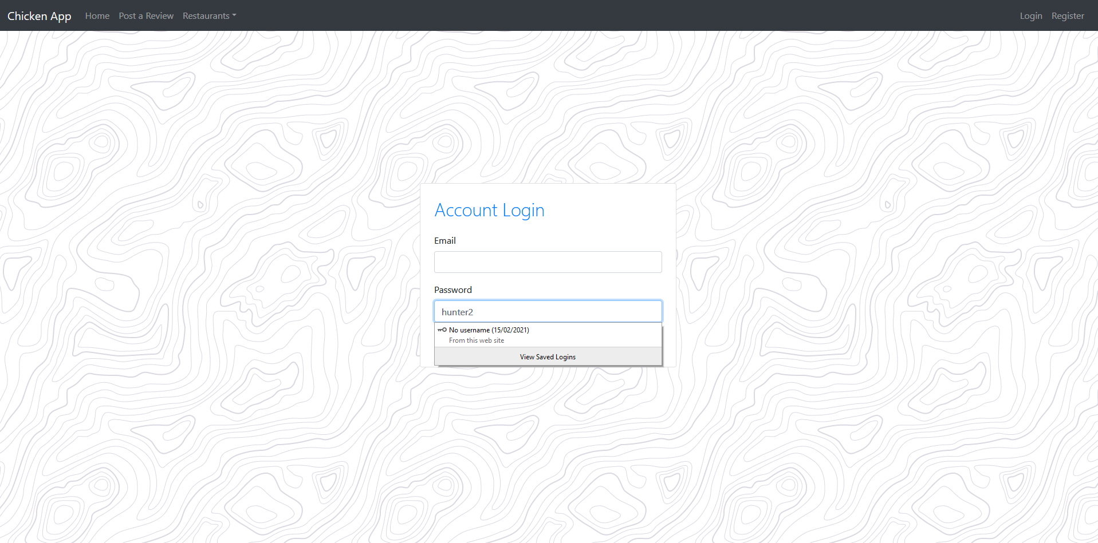

1. Navbar is present and is functional for each intended link

**

1. Registering requires a valid email, username, password, date of birth and to tick the terms and conditions box.

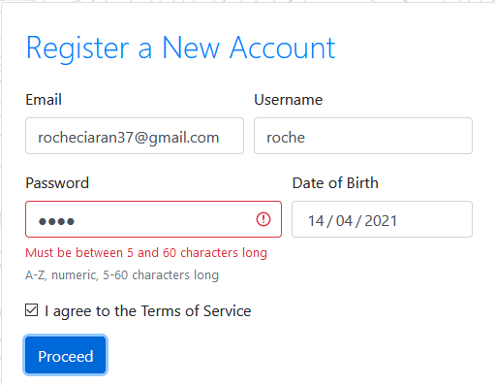

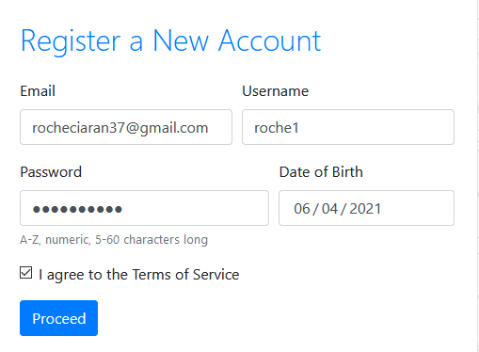

1. Login requires a valid email and password

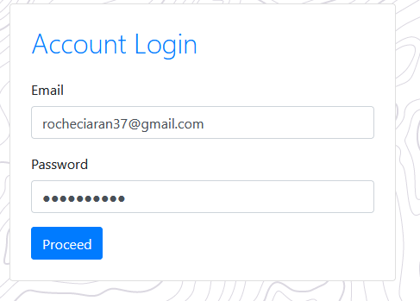

1. Home page is functional and displays the reviews
2. The user can add a chain to the database

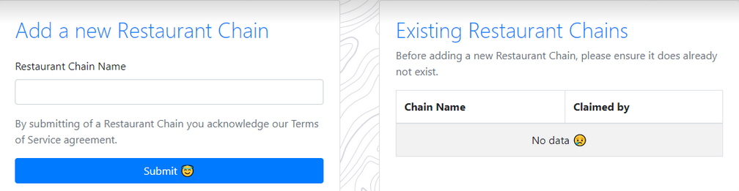

1. The user can add a restaurant to the database

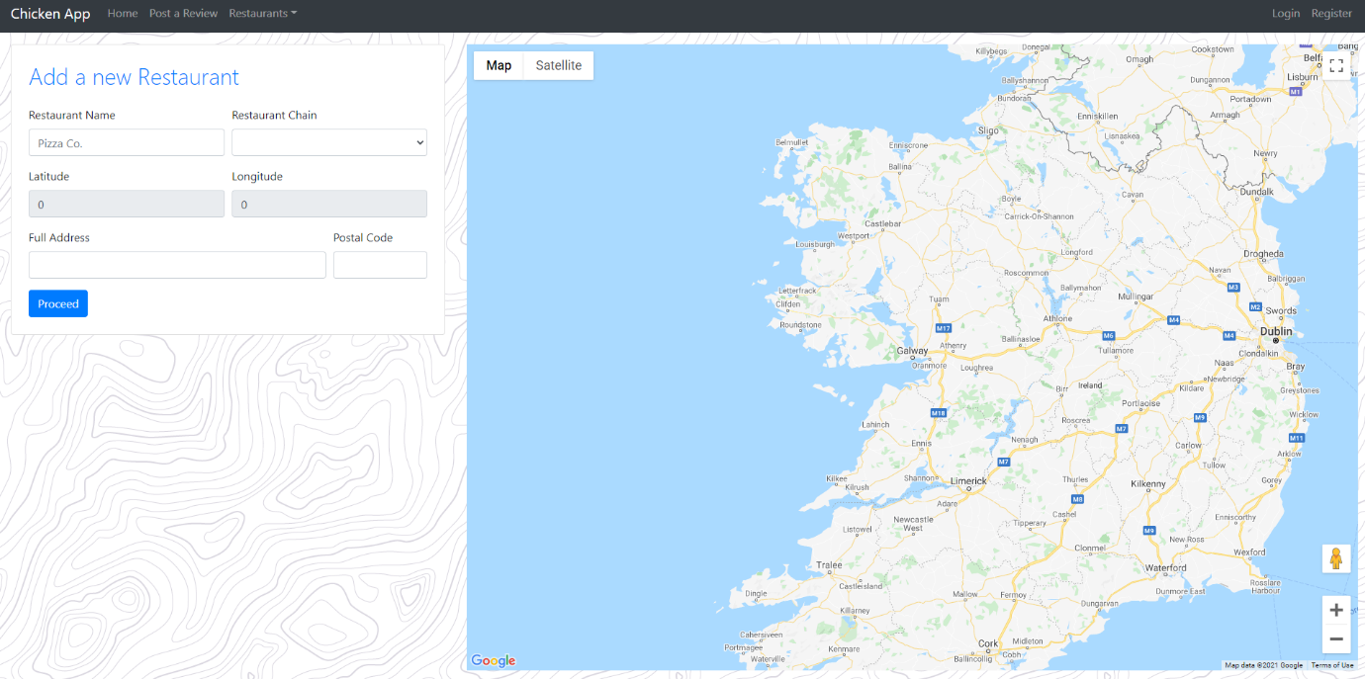

1. The user can post a review about a restaurant

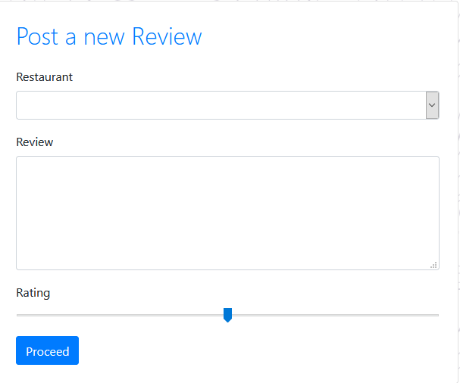

1. Get details of reviews for an individual restaurant

