Technical Report: Parameter Estimation for the ARACNE Algorithm

Introduction

ARACNE (Algorithm for the Reconstruction of Accurate Cellular Networks) is an information-theoretic algorithm for the reverse engineering of transcriptional networks from microarray data (Basso, Margolin et al. 2005; Margolin, Nemenman et al. 2006). This report documents the default choices of two parameters in the ARACNE program: kernel width and mutual information (MI) threshold. Kernel width is the most important parameter for the Gaussian kernel estimator of MI, and MI threshold is used to assess whether an MI value is statistically different from zero. We used a human B-cell dataset, which consists of 379 Microarray profiles, to study the relationship between these two parameters as a function of the sample size. Although the parameters may also depend on other characteristics of the specific dataset being analyzed, we believe that they will not be very different for other datasets with similar experimental noise and similar connectivity properties of the underlying regulatory network. The ARACNE program uses the results from the empirical study performed here to automatically extrapolate proper parameters for dataset of any size. In addition, we also make all the scripts used in this study available with the ARACNE software distribution, so that the users can fine-tune these parameters to their specific dataset if desired.

Kernel Width Extrapolation

Using the B Cell dataset, we determined the kernel width for MI estimation as a function of sample size.
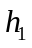

Table 1. Kernel width at different sample sizes using the B Cell dataset. h, kernel width; N, sample size.
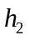 | 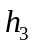 |  | N
0.17078 | 0.17119 | 0.17106 | 0.17101 | 100
0.16714 | 0.16504 | 0.16643 | 0.166203 | 120
0.15794 | 0.16148 | 0.16159 | 0.160337 | 140
0.16043 | 0.15591 | 0.15221 | 0.156183 | 160
0.15233 | 0.15045 | 0.15042 | 0.151067 | 180
0.15021 | 0.14673 | 0.14844 | 0.14846 | 200
0.14518 | 0.14558 | 0.14441 | 0.145057 | 220
0.14052 | 0.1389 | 0.14298 | 0.1408 | 240
0.13977 | 0.14228 | 0.13805 | 0.140033 | 260
0.13679 | 0.13874 | 0.13548 | 0.137003 | 280
0.13505 | 0.13195 | 0.13293 | 0.13331 | 300
0.13276 | 0.13337 | 0.12853 | 0.131553 | 320
0.12772 | 0.12809 | 0.12814 | 0.127983 | 340
0.12577 | 0.12631 | 0.12429 | 0.125457 | 360
We computed the kernel width for sample sizes ranging from 100 to 360 with an increment of 20. At each sample size, 3 random subsets were selected from the dataset, and the average kernel width was taken to avoid sampling bias (See Table 1 and Figure 1). The kernel width is determined by maximizing its posterior probability given the data, as documented in the Appendix.

It has been argued in (Hall and Hannan 1988; Aida 1999; Nemenman and Bialek 2002) that the kernel width should scale as a power-law of the sample size. Therefore we attempted to extrapolate the kernel width to any sample size by fitting the following function to our observed kernel profile

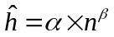

where and are two unknown constants. In practice, we perform a linear regression in the log-log space

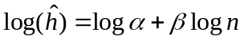

The result of the fitting is shown in Figure 2, where the best fit is

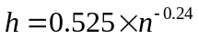
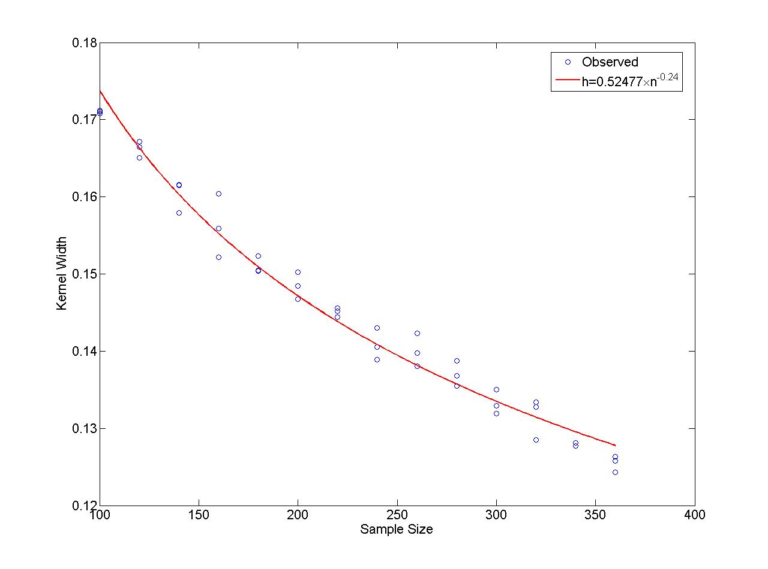
Figure 1. Kernel width vs. sample size

We believe that equation captures the general relation between the kernel width and the sample size, while the constants in the fit may be data-specific. However, we think these dataset-specific difference are small for data with similar noise properties, thanks in part to copula transformation that we performed. Therefore, ARACNE uses this result from the B Cell dataset to estimate the kernel width for any data. For example, using this extrapolation, for sample of size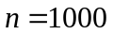, the kernel width should be 0.10. However, users are always welcome to compute the kernel width profile for their own data.

Extrapolation of MI Threshold

For a given dataset, thresholds for assessing whether a MI estimate is statistically different from zero can be obtained using the method described in (Margolin, Nemenman et al. 2006). Based on large deviation theory, the probability that a zero true mutual information results in an empirical value greater than 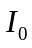is

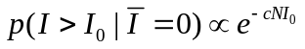

whereis the sample size and is a constant. Figure 2 shows one example of the distribution of MI under the null hypothesis of mutually independent variables. Taking the logarithm of , we have

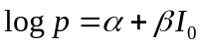

Therefore, 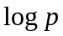 can be fitted as a linear function of, and the slope,, should be proportional to.

Based on and , we analyzed the distribution of the empirical MI estimates between statistically independent variables for samples of size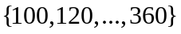. For each size, three random samples were taken and the resulting fits were averaged to avoid biased sampling (See Table 2 and Figure 3).

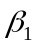 | 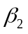 | 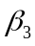 | 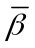 | 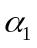 | 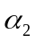 | 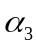 | 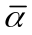
100 | -112.44 | -108.91 | -122.46 | -114.602 | 0.44065 | 0.34274 | 1.0759 | 0.6198
120 | -120.57 | -138.63 | -127.02 | -128.741 | 0.26706 | 1.3013 | 0.8032 | 0.7905
140 | -135.47 | -127.98 | -126.32 | -129.923 | 0.30818 | 0.1325 | 0.010634 | 0.1504
160 | -151.09 | -153.5 | -155.55 | -153.378 | 0.63406 | 0.85239 | 0.84187 | 0.7761
180 | -162.89 | -154.98 | -163.72 | -160.528 | 0.75236 | 0.4359 | 0.86578 | 0.6847
200 | -176.11 | -176.61 | -182.46 | -178.394 | 0.79406 | 1.0341 | 1.1235 | 0.9839
220 | -192.89 | -179.81 | -189.93 | -187.544 | 1.1513 | 0.75444 | 0.91046 | 0.9387
240 | -190.2 | -212.29 | -194.07 | -198.852 | 0.78379 | 1.4375 | 0.93918 | 1.0535
260 | -205.1 | -248.37 | -201.32 | -218.265 | 0.95712 | 2.3588 | 0.92279 | 1.4129
280 | -208.44 | -226.98 | -252 | -229.139 | 0.74691 | 1.3065 | 2.1725 | 1.4086
300 | -239.8 | -227.5 | -205.01 | -224.105 | 1.1754 | 1.1299 | 0.3717 | 0.8923
320 | -221.61 | -271.7 | -270.81 | -254.705 | 0.72786 | 2.1274 | 1.9693 | 1.6082
340 | -257.35 | -251.77 | -237.34 | -248.821 | 1.4081 | 1.2934 | 0.87284 | 1.1915
360 | -276.9 | -296.28 | -313.6 | -295.595 | 1.8566 | 2.3407 | 2.8691 | 2.3555
Table 2. Extrapolation of threshold to small p-values at each sample size.

We take the constant as the average for all sample sizes, so that 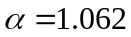. Next, we fit as a linear function of , and obtained

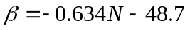

From Figure 3, we can see that can be approximated very well as a linear function of . Using these results, for any given dataset with sample size , and a desired p-value 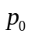, we can obtain the corresponding MI threshold as

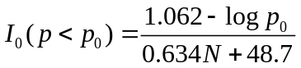

Equation can be used to compute MI thresholds for p-values smaller than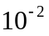. For p-values larger than, the threshold will have to be determined empirically by permutation test for each sample size. The reason for this is that the extrapolation function, i.e. equation , can be only fitted to the right tail of the null MI distribution that decays exponentially (see Figure 2). However, we believe that p-values larger than are barely useful, because the large number of variables in most network reverse engineering problem usually require heavy correction for multiple hypothesis testing (in our own application, a p-value of 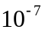 was usually chosen to control for the number of false positives in the reconstructed network).

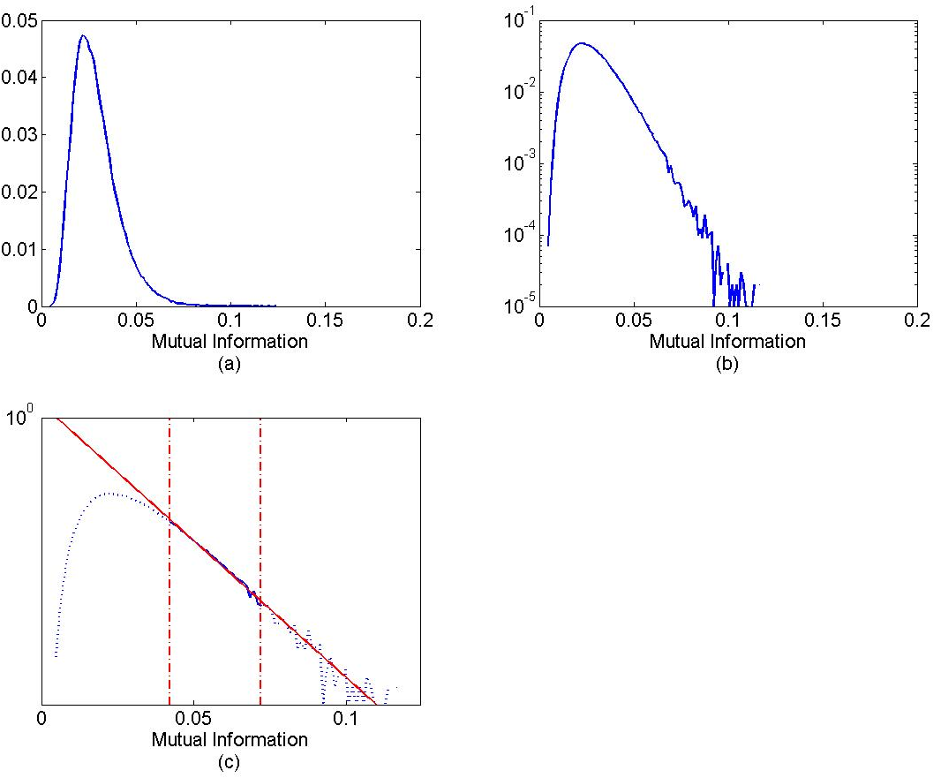
Figure 2. Threshold extrapolation for a given dataset. 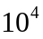 MIs were computed under the null hypothesis of mutually independent variables. (a) A histogram of these null MIs. (b) Same plot as in (a) but the Y-axis in logarithmic-scale. (c) Extrapolation of the exponential tail to arbitrarily small p-values.
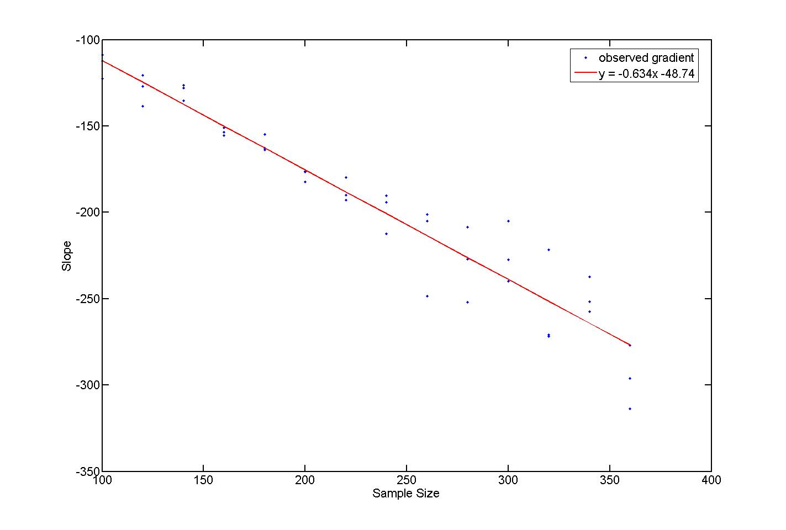
Figure 3. Slope of the MI extrapolation function at different sample sizes. For each sample size, three sets of random samples were selected, and each was fitted with Eq. . The average slope is then taken for each size and fitted with a linear function.

APPENDIX

We estimate MI using a computationally efficient Gaussian kernel estimator on copula-transformed data (Margolin, Nemenman et al. 2006). Given two variables,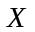 and, their marginal and joint probability densities can be estimated using Gaussian kernels:
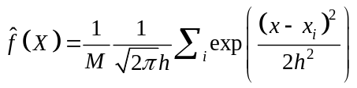

and
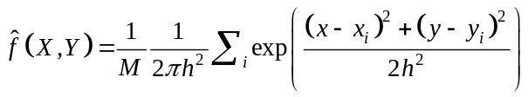

where 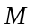is the sample size and is the kernel width. Then MI can be computed as:
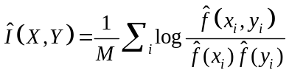

For a spatially uniform h, the Gaussian kernel MI estimator is asymptotically unbiased for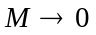, as long as 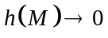 and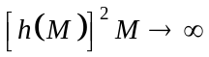. However, for finite the bias strongly depends on 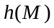 and the correct choice is not universal.

Determining the optimal kernel width for a pair of variables

There are many existing methods for determining the optimal kernel width in the density estimation literature, which falls into three broad categories: “quick and dirty” methods, plug-in methods and cross-validation methods (Turlach 1993). We choose to use a cross-validation method as it is data driven and requires no rule-of-thumb or assumption on the underlying joint distribution. We adopt the method similar to that proposed by (Duin 1976) which is to select so that the posterior probability 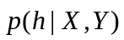 is maximized. Using Bayes theorem
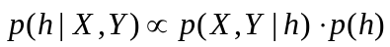

Since the likelihood 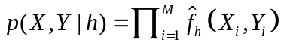 has a trivial maximum at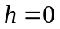, the cross-validation principle is invoked by replacing 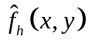 in the likelihood by the leave-one-out version 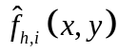, where
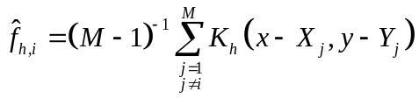

We used a weak prior on the kernel width
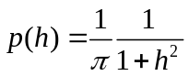
such that 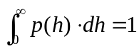. Since the data are copula-transformed between  this choice of prior has minor effect on small; for large, which implies that the true dependency can not be reliably determined given the available sample size, this prior penalizes large values of . The actual derivation of the posterior distribution is given below:

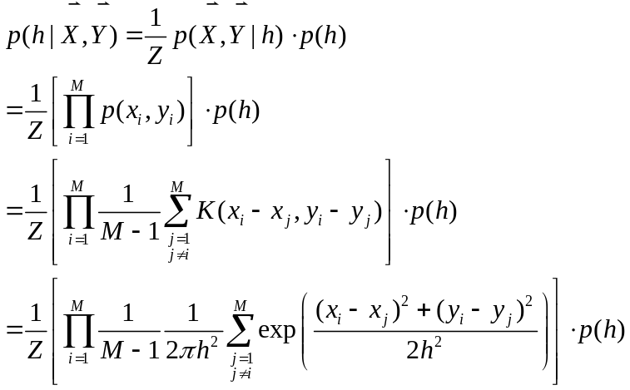

where  is the partition function. Taking logarithm of , we have

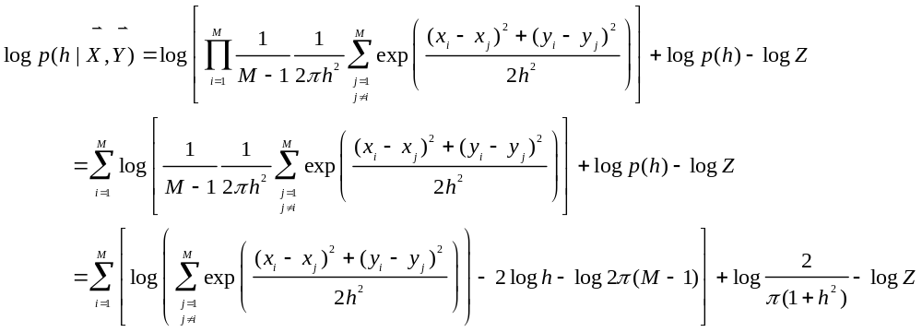

While there are many other cross-validation methods for kernel width selection, such as those which minimize Integrated Squared Error or Mean Integrated Square Error between the estimated density and the true density, it is known that the bandwidth selected by our method minimizes the Kullback-Leibler distance between and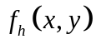 (Cao, Cuevas et al. 1994), providing some hope that other information-theoretic quantities will be similarly unbiased.

Another advantage of using this bandwidth selection method is to obtain confidence intervals on the selected kernel width. For large sample size, the posterior distribution of is approximately normal
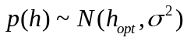
where the posterior variance may be determined by noticing that
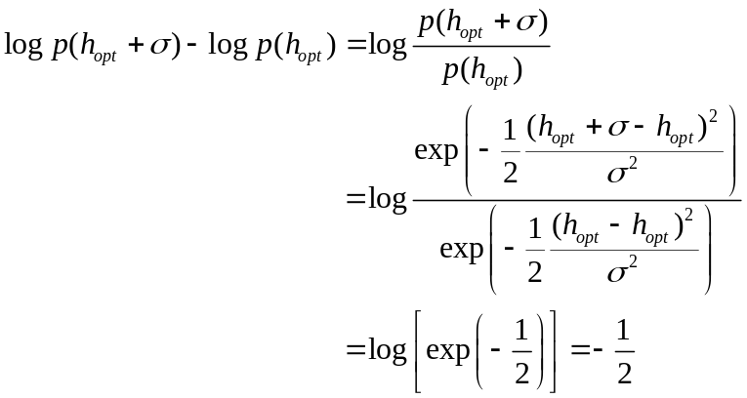
Similarly
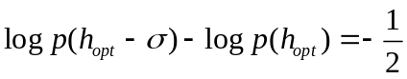
Therefore, we can find
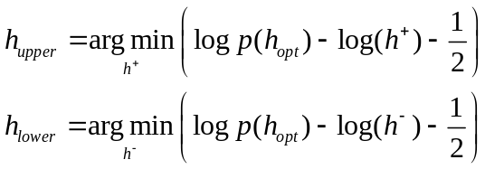

where 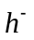and 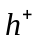represent values of smaller or larger than 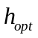. Then the interval 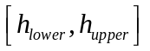 can be used as the confidence interval for that is one standard deviation away on both sides from the optimal value.

An example of the kernel width optimization method discussed here is shown in Appendix Figure 1.

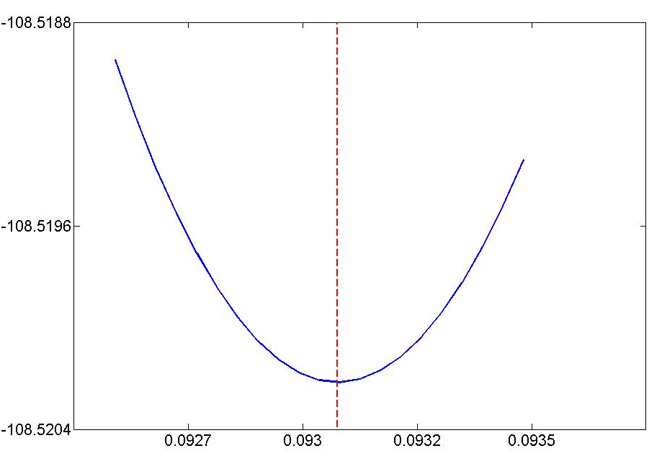
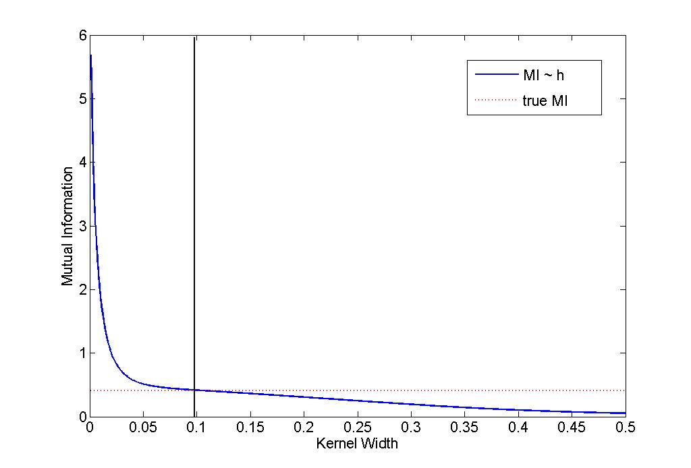
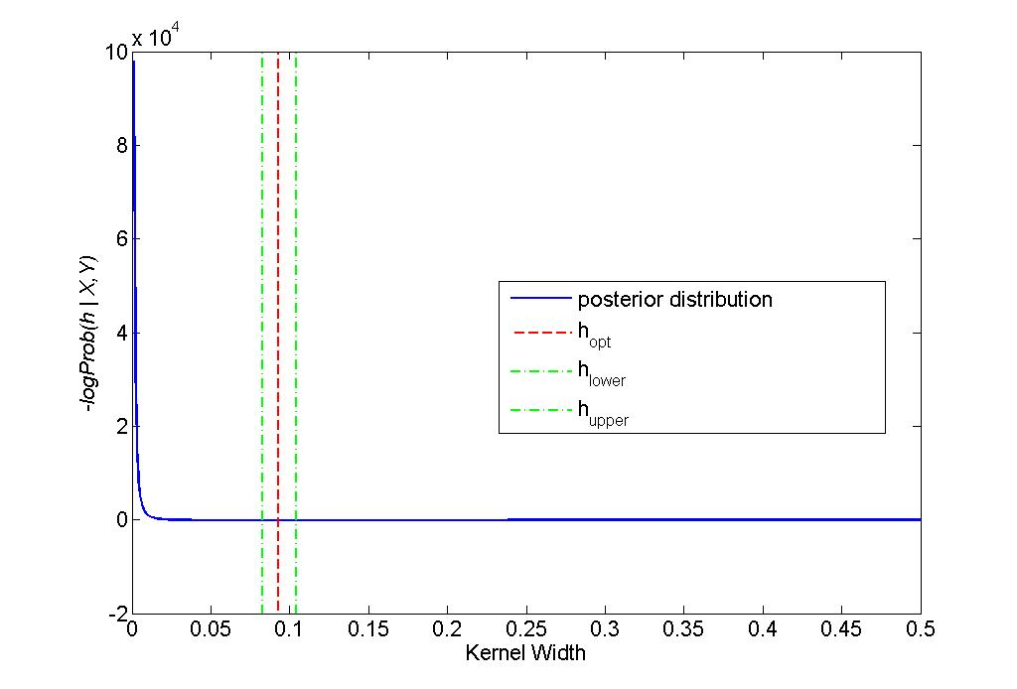
Appendix Figure 1. Kernel width optimization. 300 observations of a pair of variables X and Y were sampled from a bivariate Gaussian distribution. The top panel shows MI estimation as a function of kernel width. The dotted red line indicates the true MI which was computed analytically. The value of at the intersection of the two lines should be the optimal kernel. The bottom panel shows the kernel optimization using the method described in the text. The red dashed line is where the optimal kernel width lies (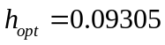), while the two green dashed lines represent the confidence interval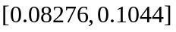. The inserts show the region where the optimality was achieved.

Estimating kernel width for the entire dataset

Ideally, we would hope to compute an optimal kernel width for all pairs of variables in a dataset; however, doing so may be computationally prohibitive especially for large datasets such as most microarray gene expression profile data which usually contain thousands of variables. In practice, the following procedures are applied as an approximation: 1) randomly select a large number of variable pairs, e.g. 5000 random pairs from the dataset and determine the optimal kernel width for each of these pairs; 2) the average of these individual optimal kernel widths will then be used as the kernel width for the entire dataset.

As a result, each individual mutual information estimate may not be computed at its optimal kernel width. However, as was discussed in detail in (Margolin, Nemenman et al. 2006), although the accuracy of individual MI estimation may depend on the choice of kernel width, the rank among the MI estimates is insensitive to a wide range of kernel width choices, which is what is most critical for ARACNE’s success.

References

Aida, T. (1999). "Field theoretical analysis of on-line learning of probability distributions." Phys. Rev. Lett 83: 3554-3557.
Basso, K., A. A. Margolin, et al. (2005). "Reverse engineering of regulatory networks in human B cells." Nat Genet 37(4): 382-390.
Cao, R., A. Cuevas, et al. (1994). "A comparative study of several smoothing methods in density estimation." Computational Statistics and Data Analysis 17(2): 153-176.
Duin, R. P. W. (1976). "On the choice of smoothing parameter for Parzen estimators of probability density functions." IEEE Trans. Comput C-25: 1175-1179.
Hall, P. and E. J. Hannan (1988). "On stochastic complexity and nonparametric density estimation." Biometrika 75(4): 705-714.
Margolin, A., I. Nemenman, et al. (2006). "ARACNE: An Algorithm for the Reconstruction of Gene Regulatory Networks in a Mammalian Cellular Context." BMC Bioinformatics 7(Suppl 1): S7.
Nemenman, I. and W. Bialek (2002). "Occam factors and model-independent Bayesian learning of continuous distributions." Phys. Rev. E 65(2): 026137.
Turlach, B. A. (1993). Bandwidth selection in kernel density estimation: A review. Louvain-la-Neuve, Belgium., Institut de Statistique.

