BSHCE4 – Cloud Computing

Cloud Application Development
Project

Smart Health App

Ciarán Byrne
13109740

Introduction

This document will outline the main functionalities, features and capabilities of the Smart Health Application developed as part of the Cloud Application Development module. It will also outline specific code and command line examples that were used to devlop this application.

The brief asked for a Smart Health Application that allowed doctors to add records for patients and keep track of these records as well adding requests as well as a number of other features that will be outline below.

Functionalities
The application allows doctors to create an account and sign in to the Smart Health App, giving them full control over their own profile. There is one Admin account that has been registered with the app ‘admin@email.ie’ with the password of ‘test123’. This administration account has been defined in the code and can be update, it gives extra functionality to the Administration user, in that they can delete and edit other profiles and already created patients. Regular users have view only access on these details.
Profiles
All logged in usrs can add new patients to the list, the form records the following details: First name, Last name, DOB, Admitted, Discharged, Hospital, Address, Phone, Injury, Infection, Cost, Observation. The ‘Hospital’ option appears on a pre-selected drop down list to prevent spelling mistakes and to ensure consistency.
Sortable columns
In the main view for all patients these columns are all sortable apart from Address and Observation as I did not feel this would be useful.
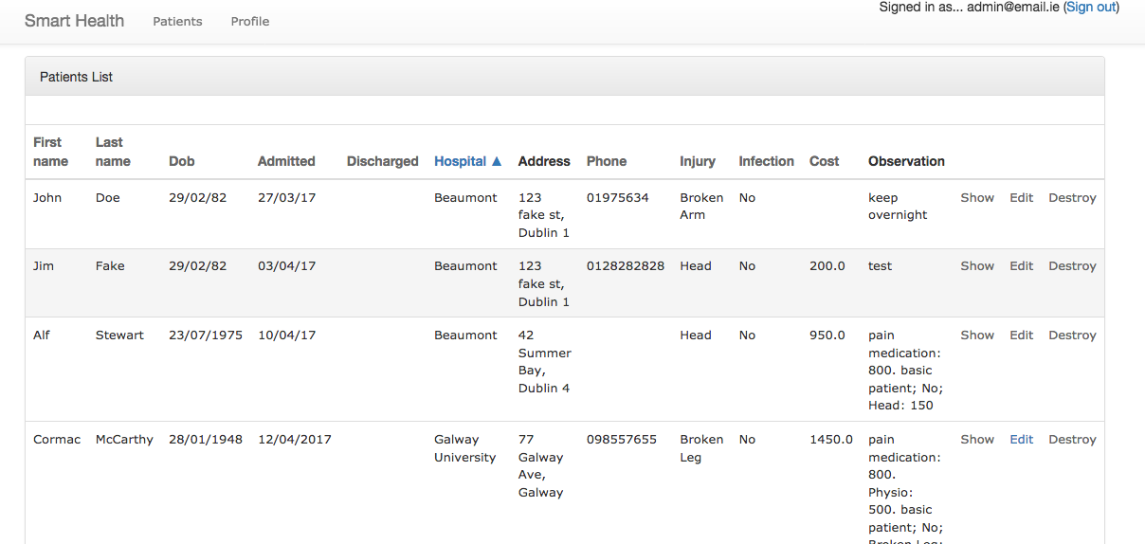
Figure 1- Sortable columns

Within the Patient details view there are check boxes for common extras that a patient may require saved on theire record, ‘Bloods’, ‘Physio’, ‘Pain Medicaiton’. When any of these are ticked they dynamically update the Cost incurred for this patient and it is recorded in the ‘Observations’ text box. The patient details can edited or deleted at any time by an administrator on the site.
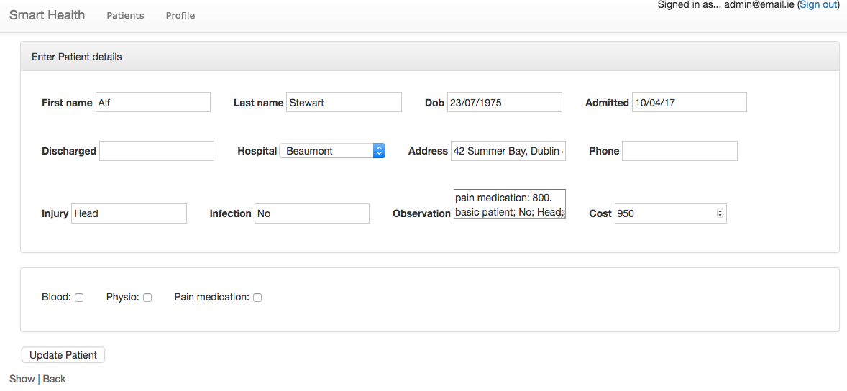
Figure 2 - Update Patient
Requests
Requests for tests be sent and recorded for Patients in the Requests section located in the Show Patient view. These tests are populated in a drop down list to ensure consistency is maintained. A Patient can have many requests at any one time, these requests include X-Ray, CAT Scan, Plaster and MRI.

Searching is fully enabled and users can be filtered on a number of fields including, ‘Last name’, ‘Hospital’, ‘Admitted between’, and ‘Injury’. This search finds records that contain any string entered into the seatch box and can be filtered with multiple queries e.g search Injury ‘head injury’ in Hospital ‘Beaumont’.

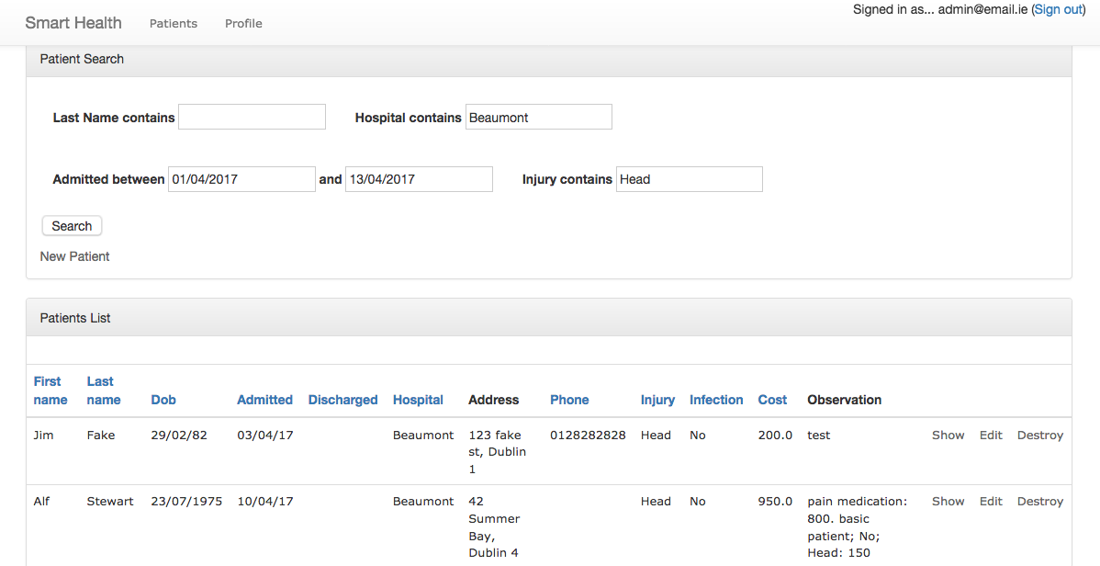
Figure 3 - Search & Report functionality
With this Search functionality a User can create Reports for a given day, week, month, year and further filter based on any of the above mention fields.

As part of the additional functionality all columns are sortable, certain fields are selected only from the dropd down as mentioned. Administrations users have more options (edit, destroy) on Profiles and Patients views than standard users. I used the Ransack Gem file to achieve this.
I have also implemented a Logfile that logs the patient name and time/ date whenever a new Patient is created.

Development Strategy
This section documents the strategy used for implementing the Rails project.

Database Design
The database used in development was a SQL Lite database but upon deployment to Heroku I had to change to Postgres SQL as it is needed in the configuration in order to successfully deploy to Heroku.
Below I will list the tables used in the development of this project and their relations.
Patient - Relationships: has many Requests.
Used to store the Patient details in the following format:
firstName:string
lastName:string
dob:date
admitted:string
discharged:string
hospital:string
address:string
phone:string
injury:string
infection:string
cost: decimal
observations:text
There was also additional checkboxes added to the Patient using the Decorator pattern:
blood
physio
pain
As the Patient was the first part of the app to be implemented I decided to use the scaffold technique in order to start the app off. The commands were as follows:
rails generate scaffold Patient first_name:string last_name:string dob:string admitted:string discharged:string hospital:string address:string phone:string injury:string infection:string observation:text
rake db:migrate

Request - Relationships: belongs to Patient
Stores data for Request details on a Patient, as it is linked directly to the Patient the only details are required are as follows:
details:string
date:string
We needed to create the model and ensure there was a link to the Patient model hance the references command. In order to generate the model I used the following
rails generate model Request details:string date:string patient:references
rails generate controller Requests index show new edit
rake db:migrate

Profile – Relationships – belongs to User
Stores profile information and was generated using the ‘Devise’ Gem, it holds details for the following:
First name:String
Last name: String
Hospital: String
User number: String

Commands:
rails generate devise user
rake db:create:all
rails g devise:views
rake db:migrate

User – Relationsships – has many Profiles
Generated in the same fashion as the Profiles with the same commands

Commands:
rails generate devise user
rake db:create:all
rails g devise:views
rake db:migrate

Implementation
In this section describe concisely the functionalities of your application, and, for each functionality list the name of the files (just the file names and not their content!) which contain the code/implementation of that functionality.
Functionality: Book an appointment – Allows all doctors to add/edit the details of the patients.
The book an appointment is implemented using an MVC approach. The functionality is implemented in the following files:
- Model: here list the name of the .rb file/files of your model/models used to implement this functionality (e.g. modelfilename1.rb)
- View: here list the name of the view/views (i.e. .html.erb files) used to implement this functionality (e.g. viewnamefilename.html.erb)
- Controller: here list the name of the controller (i.e. .rb file) used to implement this functionality (e.g. controllername_controller.rb)

Functionality: Add New Patient – Allows Doctors to add a new patient
Using an MVC approach as follows:
- Model: patient.rb
- View: new.html.erb/ _form.html.erb
- Controller: patients_controller.rb

Functionality: Edit existing Patient – Allows Doctors with Admin rights to edit an existing patient
Using an MVC approach as follows:
- Model: patient.rb
- View: edit.html.erb/ _form.html.erb
- Controller: patients_controller.rb

Functionality: Delete existing Patient – Allows Doctors with Admin rights to delete an existing patient
Using an MVC approach as follows:
- Model: patient.rb
- View: edit.html.erb
- Controller: patients_controller.rb

Functionality: Show list of Patients– Allows Doctors to view all existing patients
Using an MVC approach as follows:
- Model: patient.rb
- View: index.html.erb
- Controller: patients_controller.rb

Functionality: Show view for Patient– Allows Doctors to view specific patient details
Using an MVC approach as follows:
- Model: patient.rb
- View: show.html.erb
- Controller: patients_controller.rb

Functionality: Search/ Report for patients – Allows Doctors to search for patients using certain criteria entered by them. This can be used as a reporting View also.
Ransack Gem
Using an MVC approach as follows:
- Model: patient.rb
- View: index.html.erb
- Controller: patients_controller.rb

Functionality: Create Request for Patient– Allows Doctors to create a request for a Patient
Using an MVC approach as follows:
- Model: request.rb
- View: new.html.erb / _form.html.erb
- Controller: requests_controller.rb

Functionality: Create Request for Patient– Allows Doctors to create a request for a Patient
Using an MVC approach as follows:
- Model: request.rb
- View: new.html.erb / _form.html.erb
- Controller: requests_controller.rb

Functionality: Edit Request for Patient– Allows Doctors to edit a request for a Patient
Using an MVC approach as follows:
- Model: request.rb
- View: edit.html.erb / _form.html.erb
- Controller: requests_controller.rb

Functionality: Delete Request for Patient– Allows Doctors to delete a request for a Patient
Using an MVC approach as follows:
- Model: request.rb
- View: index.html.erb
- Controller: requests_controller.rb

Functionality: Show Request for Patient– Allows Doctors to view a request for a Patient
Using an MVC approach as follows:
- Model: request.rb
- View: show.html.erb
- Controller: requests_controller.rb

Remark: In order to create the advanced search and sorting on Patients I used a Gem called Ransack.

Design Patterns
Decorator pattern was implemented to allow a Doctor to select additional extras (Bloods, Physio, Pain medication). Each check box adds an additional sum to the costs and is updated in the observations section for reference.

Singleton pattern was implemented to allow for a logger file to be maintained everytime a new patient is created recording the patien name and time of creation. This file is saved in the main app folder for reference.

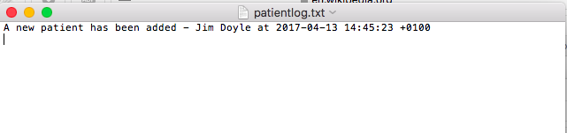

Deployment
In this section specify the Cloud Platform as a Service where you deployed your application. Also please provide the URL of your application deployed to that Cloud Platform as a Service. In addition, please include the username and password of one of the users of your application. This must be provided, in particular, if you have an admin user in your application.
Heroku was used to deploy my application, the url for which is below as well as the login credentials for an admin user.
Postgres SQL database was used for deployment purposes.
https://warm-anchorage-52275.herokuapp.com/
admin@email.ie - test123

