Portfolio Game Project Proposal

# Intro

Title: Function Fight

Genre: roguelike + fighting game

Style: simple/pixel art

Premise: Oh no! The fae have stolen your executive functioning skills! Fight through the levels to get it back! This is a dungeon-crawler game with combat similar to fighting games.

# Gameplay

## Core Gameplay

* Fighting Combo System – There will be a fighting combo system. Combination attacks will do more damage and potentially a wider area. This feature will implement the combo system from my Emoji Joy project into the combat.
* Level Progression – The player will fight through different rooms to reach the end.
* Death/Lose – Once the player dies, they lose the upgrades and items they have obtained.
* Enemy Progression – As the player progresses through the game, the enemies will get progressively more difficult to handle be it due to the amount of them or their strength.

## Win/Lose State

* The player will lose once they die and they will start back at the beginning.
* The player wins once they reach the reward at the end of the game.

## Features

* Fighting combo system
* Room progression, the player will fight through the various rooms of the game until they reach the end (kind of like a dungeon crawler)
* Death/lose
* Enemies progression, the enemies will either become more numerous or stronger or both the further into the progression the player gets
* Running score

Extra features (if there is time, this will be implemented):

* Player upgrades through a vendor (temporary and possibly permanent, meaning that they’ll carry over after death)
  + Points/currency system for this
* Switching out abilities/skills/attack combos

# Gameplay Flow charts

## Game States

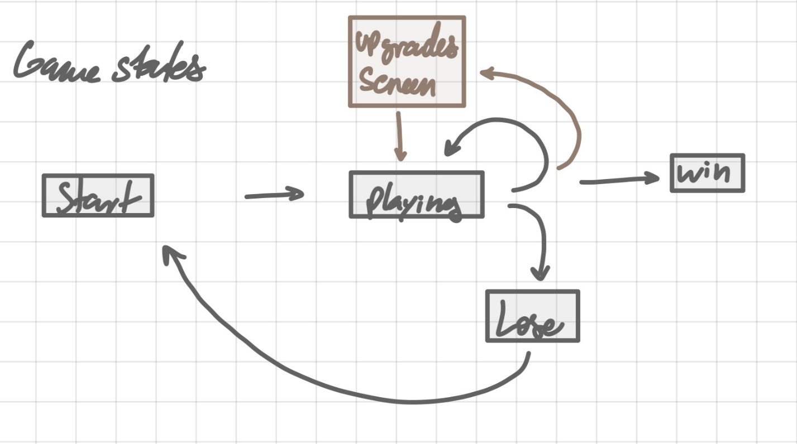

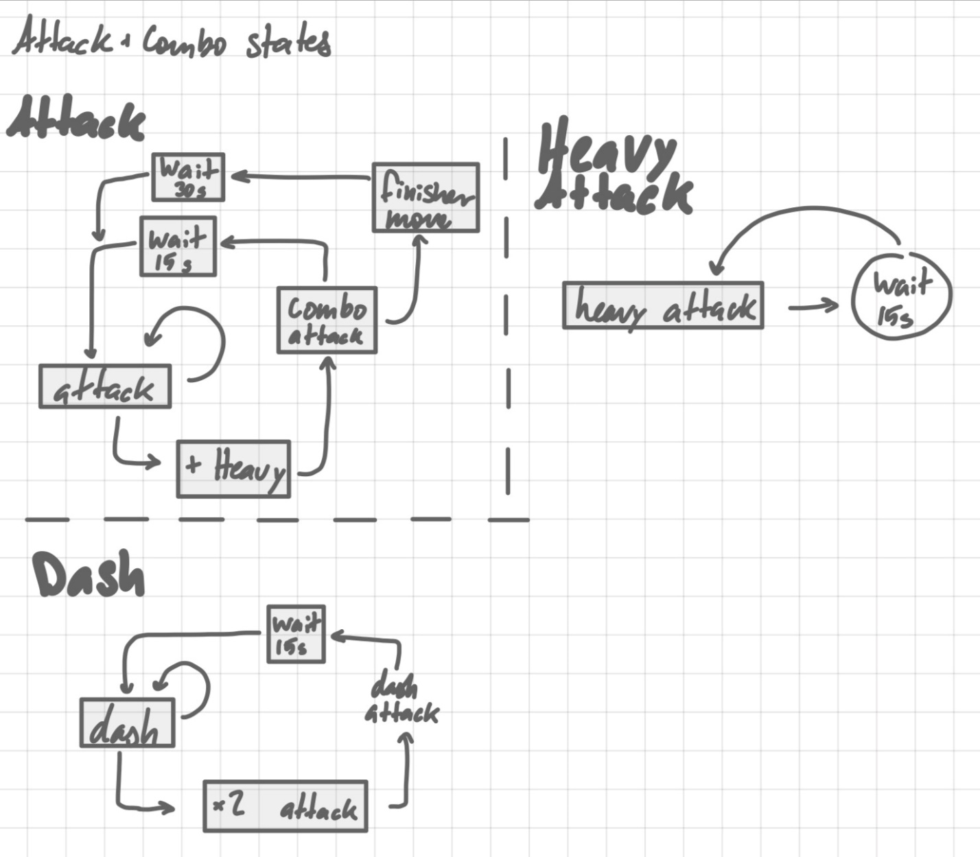

## Core Gameplay Loop

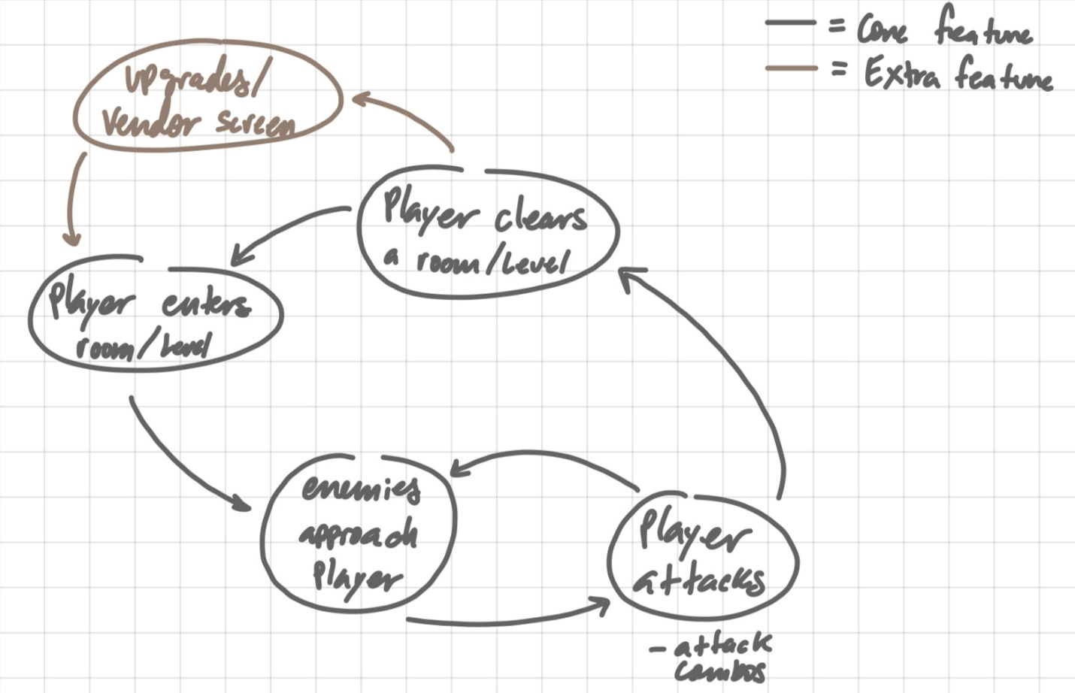

# UML

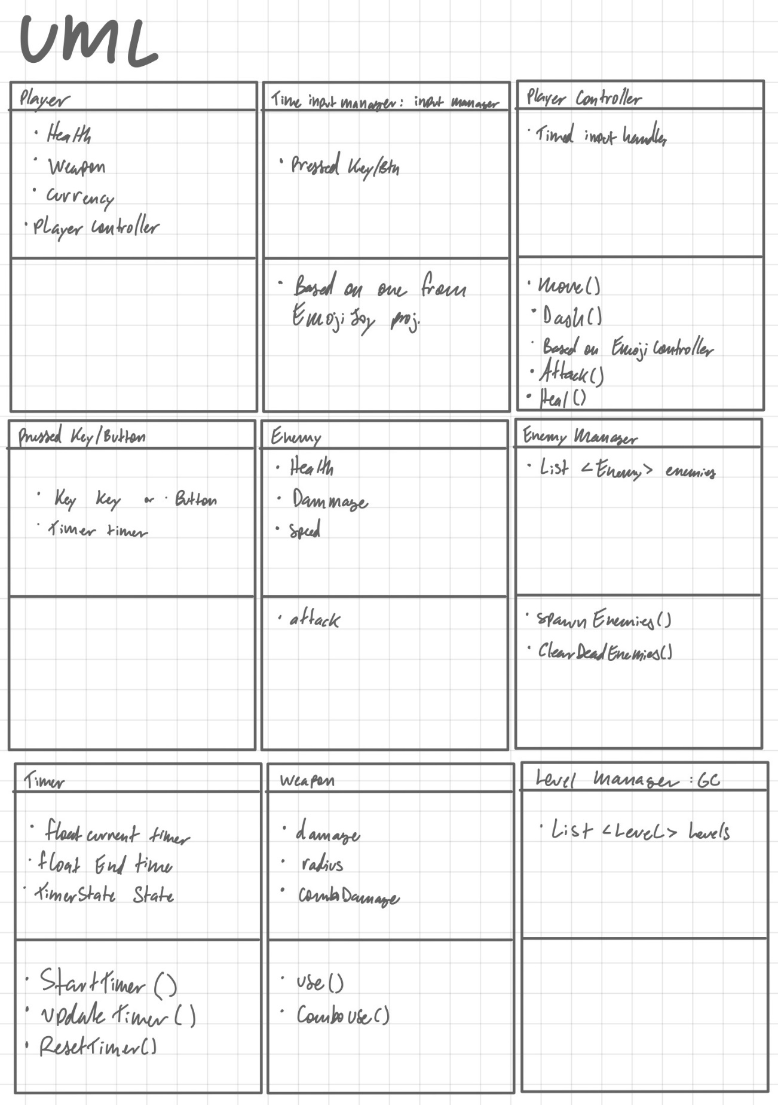

# Sample Art

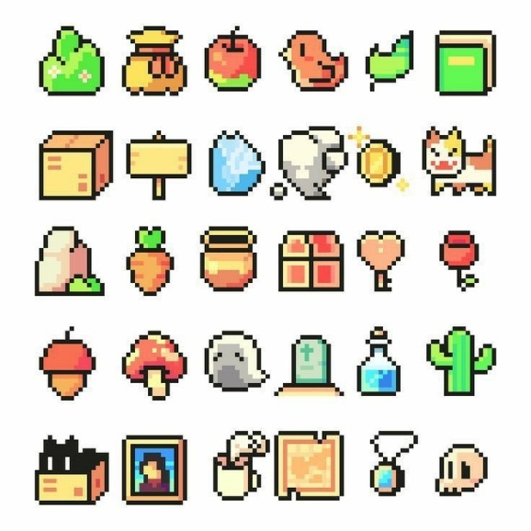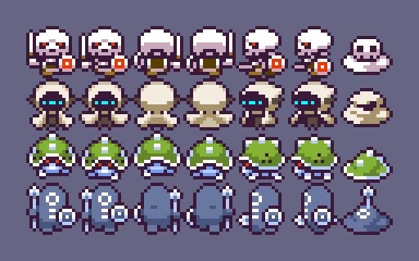

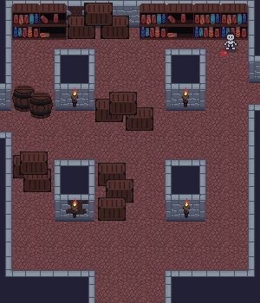

The aesthetic style for the game is this simpler pixel art aesthetic.

# Plan

## Proof of Concept – week 8

* Combat/Fighting system
* Player controller
* Enemy

## Vertical Slice – week 10

* Enemy manager
* Level/ level manager

## First Build – week 12

* Building out levels
* Score and currency
* Animations

## Final Build – Week 15

* Bug fixing and polish

## Documentation – Week 15?