Lex RAG: A Hybrid Retrieval-Augmented Legal Research Assistant for Indian Court Judgments
Cibiksha V  Department of Computer Science and Engineering  BSA Crescent Insitute of Science and Technology  cibiksha31@gmail.com | Sneha Shree S  Department of Computer Science and Engineering  BSA Crescent Insitute of Science and Technology  Snehashree158@gmail.com | Syed Ali Fathima S  Department of Computer Science and Engineering  BSA Crescent Insitute of Science and Technology  Syedfathima884@gmail.com

Abstract—Advocates in Indian courts often spend days locating relevant precedents across thousands of Supreme Court and High Court judgments, a process that is slow, incomplete and costly for small firms. General-purpose large language models (LLMs) can summarise law but are prone to fabricating authorities, which is unacceptable in legal practice. This paper presents Lex RAG, a retrieval-augmented generation (RAG) assistant for Indian legal research built entirely from free and open-source components. Lex RAG indexes a target corpus of 50,000 judgments after segmenting each into its parts (facts, issues, ratio and order), retrieves candidates with a hybrid of dense legal-domain embeddings and BM25 fused by reciprocal rank fusion, and reranks them with a cross-encoder. A locally hosted LLM then extracts the ratio decidendi of each retrieved case and drafts structured pro and contra argument outlines whose propositions are linked to retrieved sources. Advocates can upload a client case file for session-specific retrieval and export results as a Word document in an academic-legal citation format. We describe the architecture, design rationale and implementation, and outline an evaluation protocol for future work.
Index Terms—retrieval-augmented generation, legal information retrieval, Indian case law, hybrid search, large language models, open-source software.

I. Introduction
Common-law adjudication rests on precedent, so an Indian advocate preparing a matter must locate earlier Supreme Court and High Court judgments that decide the same legal question. Public repositories such as Indian Kanoon and Manupatra make judgments available online, but they are largely searched by keyword. The advocate must read many long judgments to separate the binding ratio decidendi from incidental remarks (obiter dicta), and junior researchers can miss key authorities. Senior lawyer time for such research can cost between INR 2,000 and 10,000 per hour, which makes thorough research economically out of reach for small firms.
Large language models (LLMs) appear to offer relief, but they hallucinate. Dahl et al. report that general-purpose LLMs frequently produce false statements about case law [1], and Magesh et al. found that even commercial legal research tools built on retrieval still hallucinate a non-trivial share of the time [2]. Retrieval-augmented generation (RAG) [3] reduces this risk by conditioning the model on retrieved source text, but a useful legal RAG system must address four further gaps. First, generic fixed-size chunking ignores the internal structure of a judgment. Second, pure dense retrieval can miss exact statutory sections and case names, while pure keyword retrieval misses paraphrase. Third, closed cloud APIs raise cost and confidentiality concerns for client files. Fourth, free-text answers are not in a form that advocates can use directly in a brief.
This paper presents Lex RAG, a legal research assistant for Indian courts. Our contributions are:
- A legal-structure-aware ingestion pipeline that segments judgments into facts, issues, ratio and order before indexing.
- A two-stage retrieval design that fuses dense and BM25 results with reciprocal rank fusion and refines them with a cross-encoder.
- LLM-based holding extraction (ratio decidendi and obiter dicta) and an argument drafter that produces pro and contra outlines with citation-linked evidence, plus session-specific retrieval over an uploaded case file.
- A fully open-source, locally deployable implementation that exports results to Word in an academic-legal citation format.
Section II reviews related work, Section III describes the architecture, Section IV the implementation, Section V a planned evaluation, and Section VI limitations. Section VII concludes.

II. Related Work

A. Legal NLP and Indian Case Law
LEGAL-BERT adapts BERT to legal text and improves several legal tasks over general models [4], and the CaseHOLD benchmark shows that domain pretraining helps most when the task is close to the legal domain [5]. However, LEGAL-BERT was trained mainly on English legislation, court cases and contracts from the EU, UK and US, so its transfer to Indian judgments is an empirical question. For India, ILDC provides a corpus of Supreme Court cases for judgment prediction and explanation [6], and Kalamkar et al. annotate rhetorical roles in Indian legal documents [7]. These resources motivate our decision to segment judgments by their functional parts.

B. RAG and Hybrid Retrieval
RAG couples a retriever with a generator [3], and recent surveys catalogue its variants [8]. Dense retrievers such as DPR capture semantic similarity [9], whereas BM25 remains a strong lexical baseline that handles rare terms and exact identifiers well [10]. Reciprocal rank fusion (RRF) combines ranked lists without requiring score calibration [11], and cross-encoder rerankers jointly score the query and passage for higher precision [12]. LLM-generated query expansion, as in HyDE, can improve recall for short or underspecified queries [13]. Lex RAG combines these techniques for the Indian legal setting.

C. Hallucination in Legal AI
The evidence in [1] and [2] shows that legal users need outputs that are traceable to sources. We therefore treat every generated proposition as a claim that should point to a retrieved judgment, and we keep the human advocate as the final verifier.

III. System Architecture
Lex RAG has an offline indexing pipeline and an online query pipeline (Fig. 1). The offline stage builds a searchable index of judgments. The online stage retrieves and reranks evidence for an advocate’s query and passes it to an LLM that produces holdings and argument outlines, which are then exported.
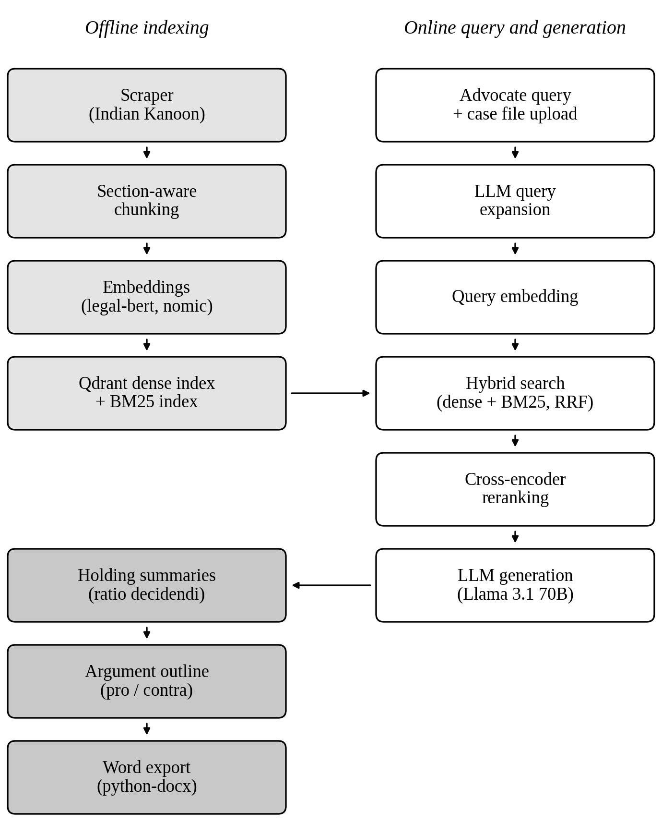
Fig. 1. Architecture of Lex RAG. Light-shaded boxes form the offline indexing pipeline, white boxes the online retrieval pipeline, and dark-shaded boxes the generated outputs.

A. Corpus Acquisition
A scraper collects a target set of 50,000 Supreme Court and High Court judgments from Indian Kanoon. PDF documents are parsed with PyMuPDF and pdfplumber, and HTML pages with BeautifulSoup. Metadata such as court, date, bench and citation is stored with each judgment so that every retrieved passage can be traced to its source.

B. Legal-Aware Chunking
Judgments are long and follow a recognisable structure. Instead of splitting text at fixed lengths, the pipeline segments each judgment by section into facts, issues, ratio and order, using structural and discourse cues in the text; a trained rhetorical-role model such as that of [7] is a natural alternative. Sections longer than the encoder limit are further split with overlap, and every chunk carries its case identifier, section label and citation. Keeping the section label allows retrieval to be filtered or weighted by the role of the passage, for example to prefer ratio sections when the advocate asks for the governing principle.

C. Indexing
Chunks are embedded with legal-bert from HuggingFace [4], a domain-tuned encoder, and optionally with nomic-embed-text served through Ollama [14]; supporting both allows a direct comparison. Because BERT-style encoders accept at most 512 tokens, chunk length is bounded accordingly. Dense vectors and their metadata are stored in Qdrant, and a BM25 index [10] is built over the same chunks so that both retrievers address identical units.

D. Query Processing and Hybrid Retrieval
An advocate’s query is first expanded by the LLM into alternative formulations that include related legal terminology [13]. The original and expanded queries are embedded for dense search and also used for BM25 search. Each retriever returns its top candidates, and the ranked lists are merged with RRF [11]:
RRF(d) = ∑_{r∈R} 1 / (k + rank_{r}(d)) (1)
where R is the set of rankers (dense and BM25), rank_r(d) is the position of chunk d in ranker r, and k is a smoothing constant, commonly set to 60 [11]. RRF is attractive here because dense and BM25 scores lie on different scales. If the advocate uploads a client case file, it is parsed and chunked with the same pipeline and held in a session-scoped collection that is searched alongside the corpus, so that the facts of the present matter can be compared with candidate precedents.

E. Cross-Encoder Reranking
The fused candidates are rescored by a cross-encoder from HuggingFace (ms-marco) that reads the query and chunk together [12]. The top-ranked chunks, with their case identifiers, form the context passed to the LLM. Since this reranker is trained on web passages, fine-tuning on Indian legal relevance judgments is a clear direction for future work.

F. Holding Summariser and Argument Drafter
For each retrieved case, the holding summariser prompts the LLM to state the ratio decidendi and to separate it from obiter dicta, using only the retrieved text. The argument drafter then takes the holdings and, when available, the facts of the uploaded case file, and produces a structured outline with a position in favour, a position against, and the supporting precedents for each point, each tied to the case identifiers in the context. Structured outputs are validated against Pydantic schemas before they are shown.

G. Interface and Export
A FastAPI backend exposes the pipeline to a Streamlit front end. Argument outlines and summaries can be exported with python-docx to a Word document in an academic-legal citation format, which lets the advocate continue editing in a familiar tool.

IV. Implementation
Every layer of Lex RAG uses free or open-source software (Table I), which keeps recurring cost low and lets the system run without sending client material to external APIs. The LLM is Llama 3.1 70B in 4-bit quantised form served by Ollama, which offers a 128k-token context window [15]. Services are packaged with Docker Compose and can run on a local machine or on an Oracle Cloud Always Free virtual machine.
TABLE I
Open-Source Technology Stack of Lex RAG
Layer | Component
Parsing | PyMuPDF, pdfplumber, BeautifulSoup
Embeddings | legal-bert (HuggingFace); nomic-embed-text (Ollama)
Vector store | Qdrant (self-hosted)
Retrieval | BM25 + dense search with RRF; cross-encoder (ms-marco, HuggingFace); LLM query expansion
LLM | Llama 3.1 70B, 4-bit quantised, via Ollama
Backend | FastAPI, Pydantic
Frontend | Streamlit
Deployment | Docker Compose (local or Oracle Cloud Always Free VM)
Export | python-docx

V. Proposed Evaluation
Lex RAG is at the design and implementation stage, and we report no quantitative results in this paper. We outline the protocol we intend to follow.
Test collection. We will build a set of legal research queries with relevance judgments from advocates or senior law students, and may supplement it with weak labels derived from citation links between judgments. Retrieval metrics. We will report Recall@k, MRR and nDCG@k and compare BM25 only, dense only (legal-bert and nomic-embed-text), hybrid without reranking, and the full pipeline. Ablations will cover fixed-size versus section-aware chunking, query expansion on or off, and reranking on or off.
Generation quality. Holding extraction will be compared with expert-annotated ratio decidendi using overlap and embedding-based metrics together with expert ratings. Faithfulness will be measured as citation precision, the share of cited authorities that exist in the retrieved set and support the stated proposition, and as the rate of unsupported claims. Usability and efficiency. A small study with practising advocates will measure time to find relevant precedents against manual search, and we will record latency and memory use.

VI. Discussion and Limitations
Grounding in retrieved text reduces but does not remove hallucination [2]. Lex RAG output is a research aid, and an advocate must verify every authority before relying on it. A simple additional safeguard is to check that each cited identifier corresponds to a retrieved chunk and to flag any that does not; we plan to include it.
Several limitations apply. The domain encoder and reranker were not trained on Indian judgments, so their effectiveness must be measured. A 4-bit 70B model needs roughly 40 GB of memory for its weights, more than the 24 GB offered by the free-tier virtual machine, so a smaller model or a larger host will be needed for that deployment. Scraping is subject to the terms of the source website, and coverage is limited to the collected judgments, which are mostly in English. Finally, local inference keeps client files on the advocate’s own infrastructure, which is a practical advantage over cloud-only tools.

VII. Conclusion and Future Work
We presented Lex RAG, an open-source retrieval-augmented assistant for Indian legal research that combines structure-aware chunking, hybrid retrieval with reranking, and LLM-based holding extraction and argument drafting with a Word export. Next steps are to complete the evaluation in Section V, fine-tune the embedding and reranking models on Indian legal data, add automatic citation verification, and extend coverage to more courts and languages.

References
[1] M. Dahl, V. Magesh, M. Suzgun, and D. E. Ho, “Large legal fictions: Profiling legal hallucinations in large language models,” J. Legal Analysis, vol. 16, no. 1, 2024.
[2] V. Magesh, F. Surani, M. Dahl, M. Suzgun, C. D. Manning, and D. E. Ho, “Hallucination-free? Assessing the reliability of leading AI legal research tools,” arXiv:2405.20362, 2024.
[3] P. Lewis et al., “Retrieval-augmented generation for knowledge-intensive NLP tasks,” in Proc. Adv. Neural Inf. Process. Syst. (NeurIPS), vol. 33, 2020, pp. 9459–9474.
[4] I. Chalkidis, M. Fergadiotis, P. Malakasiotis, N. Aletras, and I. Androutsopoulos, “LEGAL-BERT: The muppets straight out of law school,” in Findings Assoc. Comput. Linguistics: EMNLP, 2020, pp. 2898–2904.
[5] L. Zheng, N. Guha, B. R. Anderson, P. Henderson, and D. E. Ho, “When does pretraining help? Assessing self-supervised learning for law and the CaseHOLD dataset of 53,000+ legal holdings,” in Proc. 18th Int. Conf. Artif. Intell. Law (ICAIL), 2021, pp. 159–168.
[6] V. Malik et al., “ILDC for CJPE: Indian legal documents corpus for court judgment prediction and explanation,” in Proc. 59th Annu. Meeting Assoc. Comput. Linguistics (ACL-IJCNLP), 2021, pp. 4046–4062.
[7] P. Kalamkar et al., “Corpus for automatic structuring of legal documents,” in Proc. 13th Lang. Resources Eval. Conf. (LREC), 2022, pp. 4420–4429.
[8] Y. Gao et al., “Retrieval-augmented generation for large language models: A survey,” arXiv:2312.10997, 2023.
[9] V. Karpukhin et al., “Dense passage retrieval for open-domain question answering,” in Proc. Conf. Empirical Methods Natural Lang. Process. (EMNLP), 2020, pp. 6769–6781.
[10] S. Robertson and H. Zaragoza, “The probabilistic relevance framework: BM25 and beyond,” Found. Trends Inf. Retr., vol. 3, no. 4, pp. 333–389, 2009.
[11] G. V. Cormack, C. L. A. Clarke, and S. Büttcher, “Reciprocal rank fusion outperforms Condorcet and individual rank learning methods,” in Proc. 32nd Int. ACM SIGIR Conf. Res. Develop. Inf. Retrieval, 2009, pp. 758–759.
[12] R. Nogueira and K. Cho, “Passage re-ranking with BERT,” arXiv:1901.04085, 2019.
[13] L. Gao, X. Ma, J. Lin, and J. Callan, “Precise zero-shot dense retrieval without relevance labels,” in Proc. 61st Annu. Meeting Assoc. Comput. Linguistics (ACL), 2023, pp. 1762–1777.
[14] Z. Nussbaum, J. X. Morris, B. Duderstadt, and A. Mulyar, “Nomic Embed: Training a reproducible long context text embedder,” arXiv:2402.01613, 2024.
[15] A. Grattafiori et al., “The Llama 3 herd of models,” arXiv:2407.21783, 2024.

