**PyCity Schools**

**Written Report**

According to the data, district school types have a higher total school budget and per student budget than charter school types. However, charter school types have a higher average math and reading score and a higher percentage of students passing math and reading than district school types. There are more students enrolled in district school types than charter school types. Reading scores and passing percentages are higher than math.

The schools that spend less per student have a higher average math and reading score and a higher percentage of students passing math and reading than schools that spend more per student.

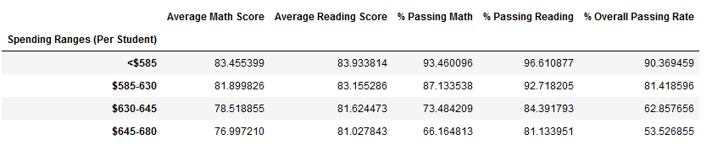

Medium schools (1000 – 2000 students) and small schools (<1000 students) have around the same average math and reading scores and the same percentages of students passing math and reading. Both are higher than the results of large schools (2000 – 5000 students).

In conclusion, charter schools that are either small or medium in size and spend less than $585 per student are the schools that produce the best results for math and reading classes. Despite the differences in school budget, size and type, more students have higher scores and passing percentages in reading than in math across all the schools.