NutriLog
UI Design Screens · Prototype v1.2
iPhone 13 Pro · MacBook Pro · High-Fidelity · March 2026
9 Screens | 2 Devices | 5 Meal Types | 2,500+ Foods

Contents
Section | Screen | Device | Page
1 | Today's Log | iPhone | 3
2 | Food Search | iPhone | 4
3 | Saved Meals | iPhone | 5
4 | History | iPhone | 6
5 | Settings | iPhone | 7
6 | PIN Screen | iPhone | 8
7 | Today's Log | Mac | 9
8 | Meals | Mac | 10
9 | History | Mac | 11
10 | Interaction Summary | All | 12

iPhone 13 Pro · 390pt viewport · Bottom tab navigation

1. Today's Log
The primary screen. Shows the date strip, daily nutrition summary, meal sections, and food log entries.

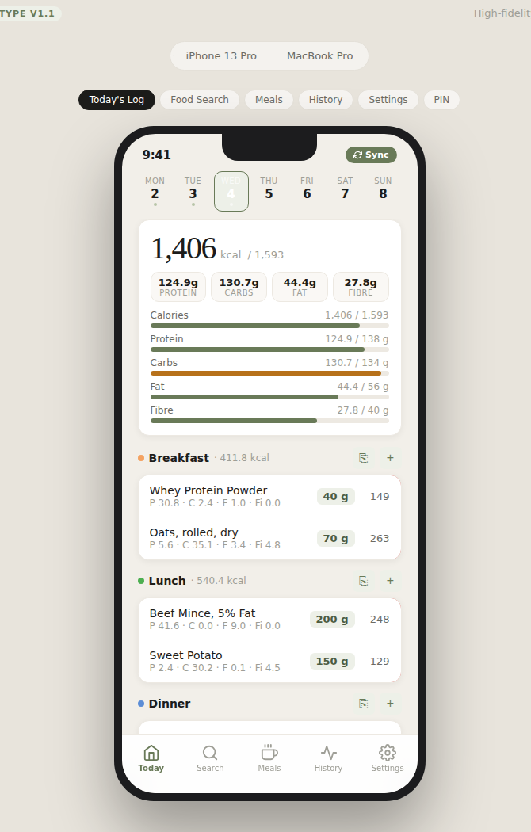
Fig 1 — iPhone: Today's Log screen

Annotations
1 | Date picker strip (top) — tap any date to view or log food for that day
2 | Sync button (top right, olive pill) — writes today's totals to DailySummary sheet in Google Sheets
3 | ⎘ Copy icon (next to each meal section) — copies all entries from the same meal type in yesterday's log
4 | Macro summary card — calories consumed vs target; progress bars for Protein, Carbs, Fat, Fibre
5 | Amount badge (e.g. '40 g') — tap to edit inline without opening a modal
6 | Left-swipe any entry to reveal the Delete button
7 | Long-press + drag an entry to move it to a different meal section
8 | Meal types: Breakfast · Lunch · Dinner · Snacks · Other

2. Food Search
Real-time search across the NutritionDB (~2,500 items) and Custom Foods. Selecting a result opens an amount + meal type picker.

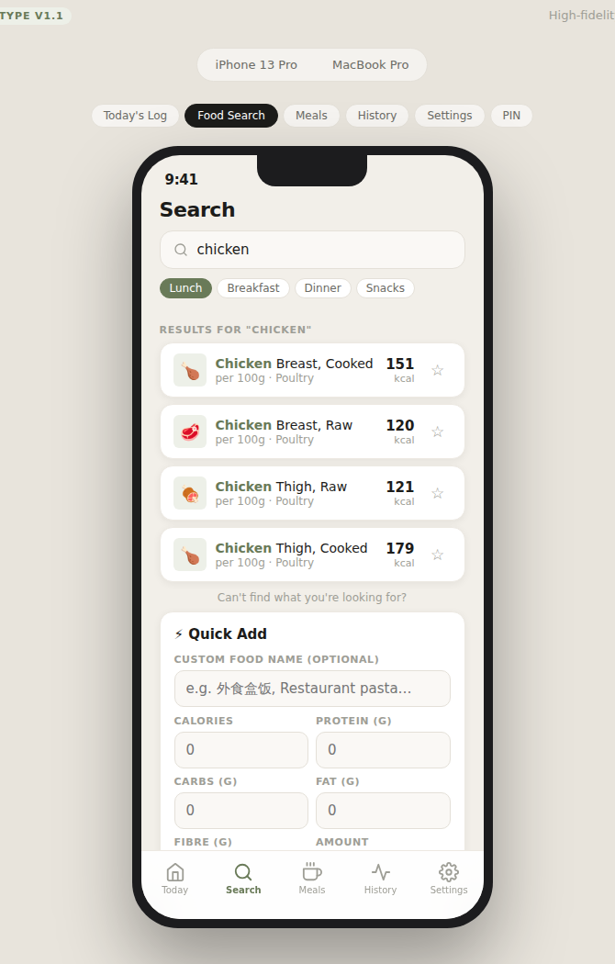
Fig 2 — iPhone: Food Search screen with 'chicken' query

Annotations
1 | Search input — results update dynamically with 200ms debounce as the user types
2 | Matched keyword highlighted in olive green in search results
3 | ★ Star button — toggle favourite; favourited foods appear at the top of results
4 | Tapping a result opens an Amount + Meal Type bottom sheet before logging
5 | Quick Add form (below results) — for restaurant meals or foods not in the database; saved to Custom Foods with IS_QUICK_ADD = TRUE
6 | Custom Food Name field replaces the old 'Meal Name' label

3. Saved Meals
Browse Composed and Manual meal templates. Tapping a meal opens a Meal Type picker before adding to the log.

\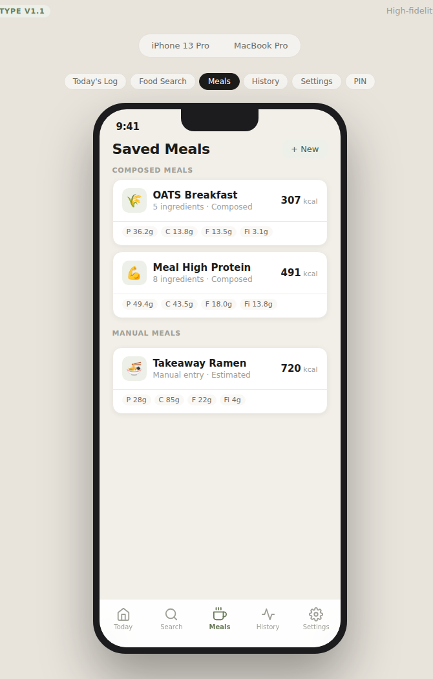
Fig 3 — iPhone: Saved Meals screen

Annotations
1 | Two meal types: Composed (assembled from individual foods) and Manual (direct nutrition entry)
2 | Each card shows: name, ingredient count, type label, calorie total, macro breakdown tags
3 | Tapping any meal card → Meal Type picker sheet (Breakfast / Lunch / Dinner / Snacks / Other)
4 | + New button (top right) — opens form to create a new Meal template

4. History
View past daily logs with a 7-day date strip and daily summary cards.

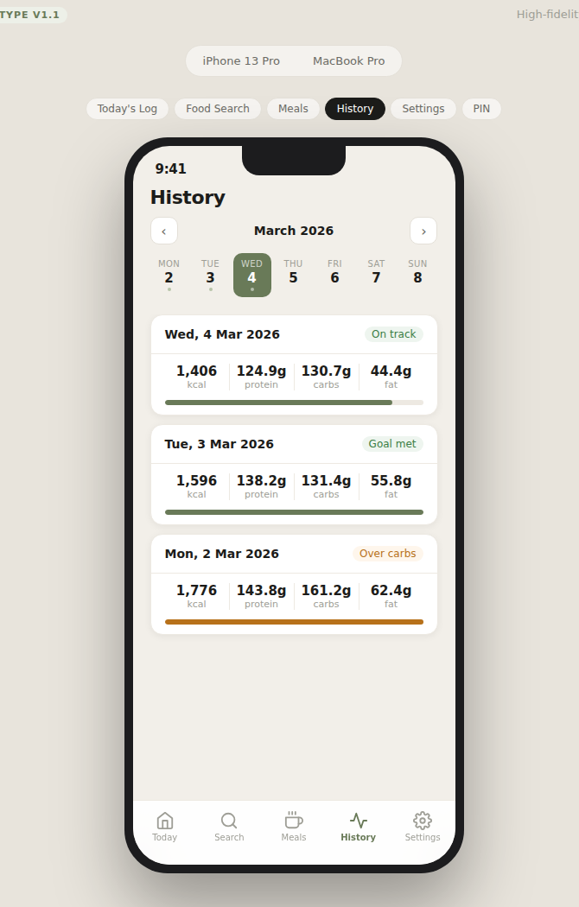
Fig 4 — iPhone: History screen

Annotations
1 | 7-day date strip — today highlighted in olive green; days with logged data show a dot indicator
2 | Each day card shows: calorie total, macro breakdown (4 nutrients), calorie progress bar
3 | Status badges — On track (green) · Goal met (green) · Over carbs (amber) · Significantly over (red)

5. Settings
Edit daily nutrition targets and manage PIN security. Targets are persisted to the Settings sheet in Google Sheets.

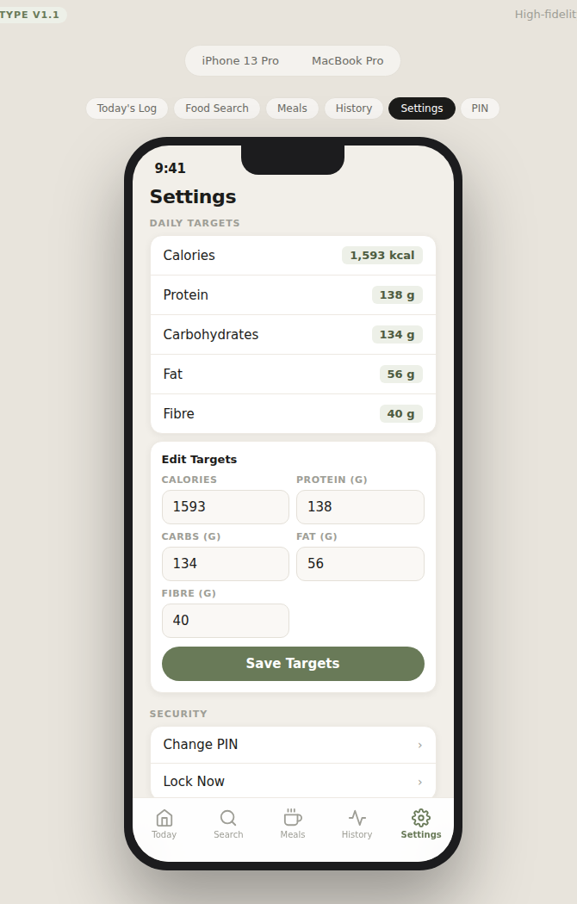
Fig 5 — iPhone: Settings screen

Annotations
1 | Daily Targets section — current values shown as olive-green badges
2 | Edit Targets form — inline grid input for Calories, Protein, Carbs, Fat, Fibre
3 | Save Targets — persists values to Settings sheet; all summary comparisons use the new values immediately
4 | Change PIN — navigates to PIN screen
5 | Sync DailySummary — manual shortcut (also available on Today's Log)
6 | Google Sheets Status — shows connection state

6. PIN Screen
Shown on first load or after session expiry. 4-digit PIN protects all data access.

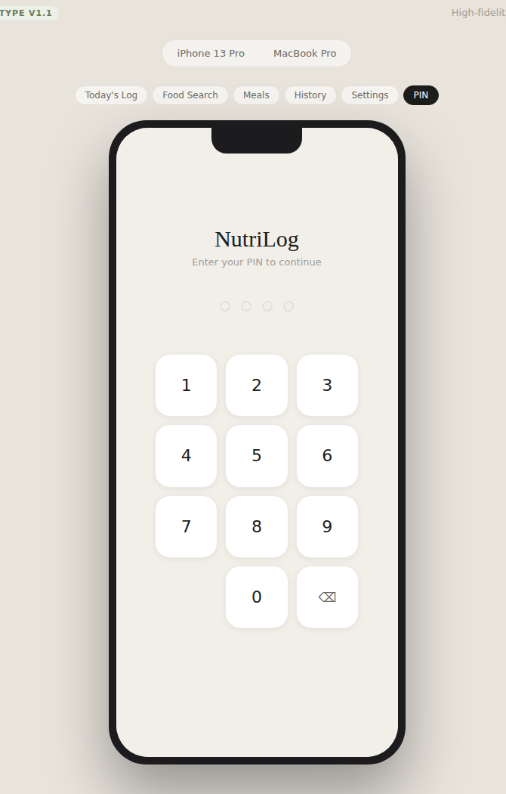
Fig 6 — iPhone: PIN screen

Annotations
1 | 4 dot indicators show input progress
2 | PIN hash (SHA-256) is stored in Google Sheets Settings sheet — the plain-text PIN is never stored or transmitted
3 | On correct PIN → session token issued, stored in sessionStorage (cleared when tab closes)
4 | On wrong PIN → error message, input resets
5 | Demo PIN for prototype: 1234

MacBook Pro · Two-column layout · Top navigation · 980pt viewport
7. Today's Log (Mac)
Two-column layout: meal log on the left, macro summary panel on the right. Central search bar for fast food entry.

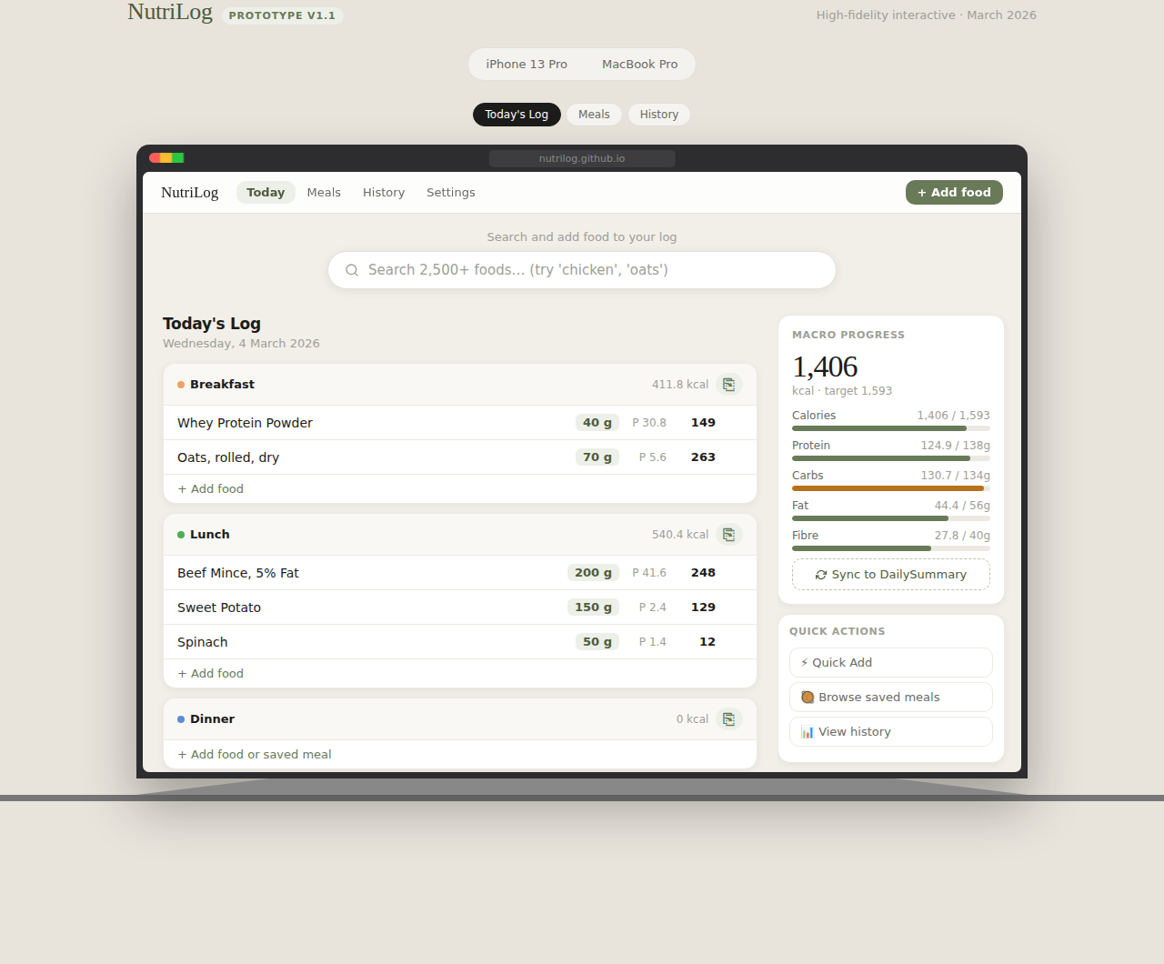
Fig 7 — Mac: Today's Log screen

Annotations
1 | Central search bar at top — search and add food to any meal type in one action; inline meal type selector in results
2 | Each meal section header has a ⎘ 'Copy yesterday' icon button (top right of each card)
3 | Hover any log entry row to reveal the × delete button
4 | Click an amount badge to edit inline
5 | Right sidebar: macro progress panel with progress bars + Sync to DailySummary button
6 | Quick Actions sidebar panel: Quick Add, Browse saved meals, View history

8. Meals (Mac)
Card grid layout showing all saved Meal templates with ingredient details. Click any card to add to today's log.

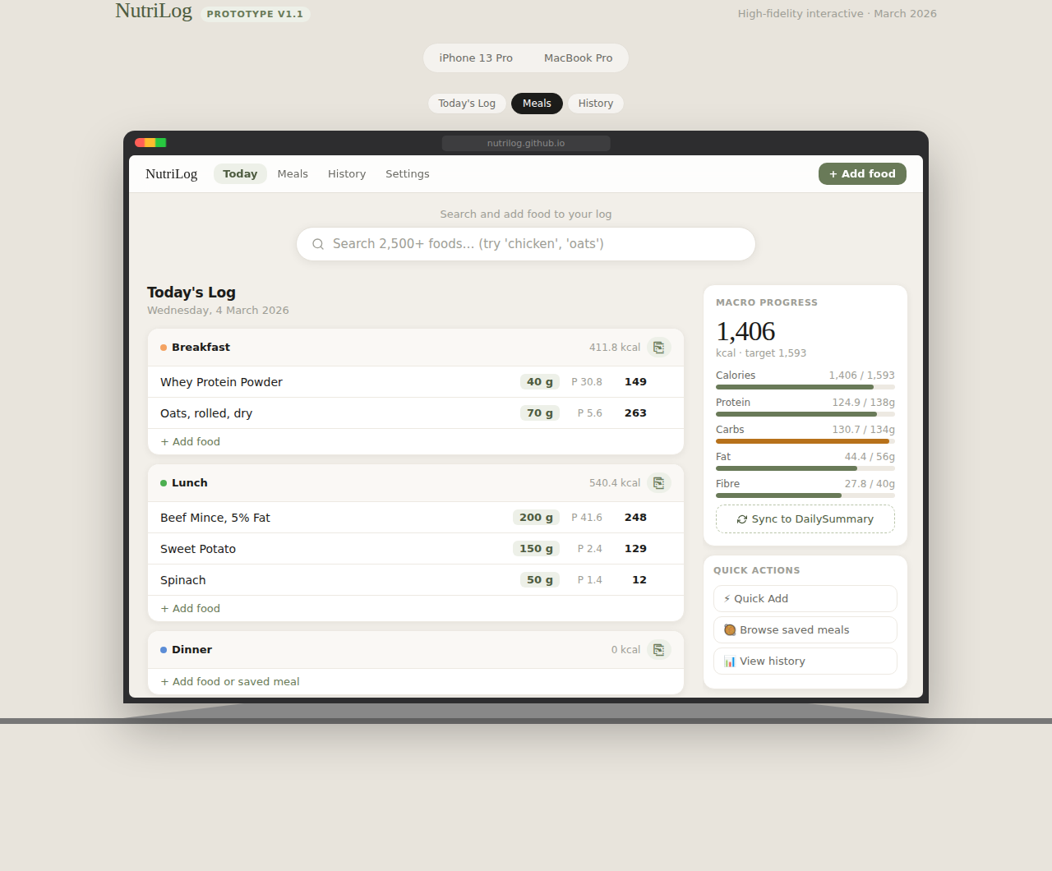
Fig 8 — Mac: Meals screen

Annotations
1 | 2-column card grid — each card shows name, type (Composed/Manual), calorie total, macro tags
2 | Composed Meals show full ingredient list below the macro tags
3 | Manual Meals show a note indicating direct nutrition entry
4 | Hover effect (green border) indicates the card is clickable
5 | Click card → Meal Type picker, then entry added to today's log
6 | Right sidebar: Quick Add form for fast manual nutrition entry
7 | Filter tabs: All / Composed / Manual

9. History (Mac)
Month-based history view with daily summary cards and a weekly average sidebar panel.

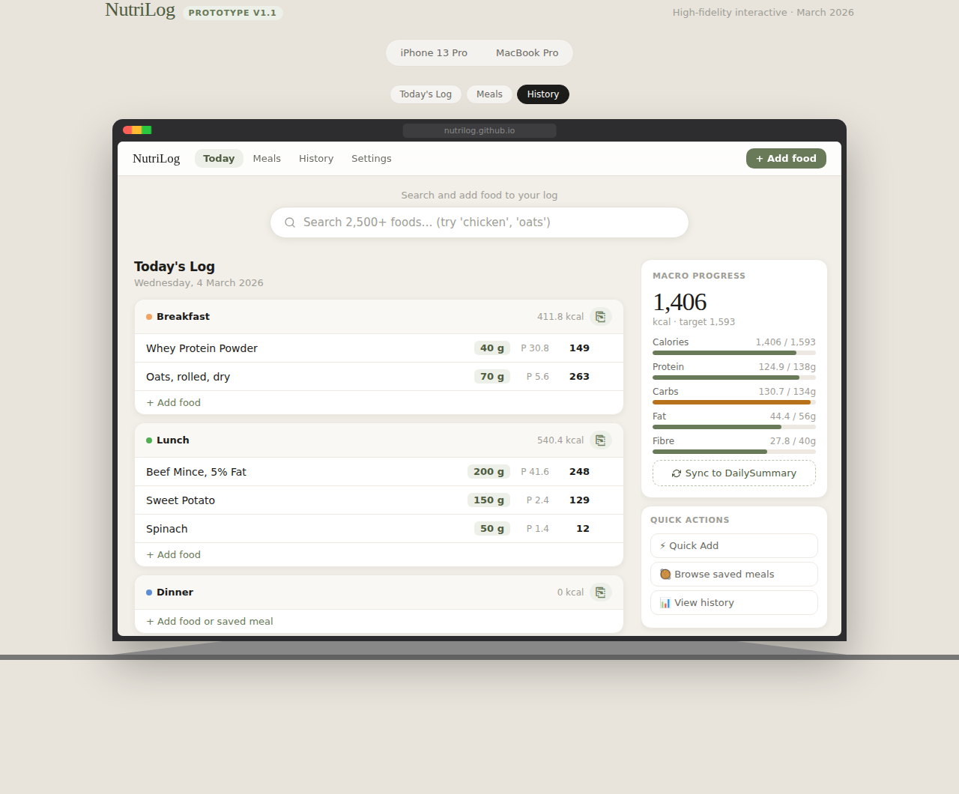
Fig 9 — Mac: History screen

Annotations
1 | Month navigation tabs (March / February / January…)
2 | Each day card shows: date, status badge, full 5-nutrient breakdown (kcal, protein, carbs, fat, fibre), calorie progress bar
3 | Right sidebar: Weekly Average panel with average kcal and macro progress bars

10. Interaction Summary
Complete list of all interactive gestures and their outcomes across both devices.

Gesture / Action | Result | Screen | Device
Tap date chip | Load log for that date | Today | iPhone
Tap Sync button | Write totals to DailySummary sheet | Today | iPhone / Mac
Tap ⎘ icon | Copy yesterday's entries for this meal type | Today | iPhone / Mac
Tap amount badge | Activate inline edit — no modal | Today | iPhone / Mac
Left-swipe entry | Reveal Delete button | Today | iPhone
Long-press + drag | Drag entry to another meal section | Today | iPhone
Type in search | Dynamic results (200ms debounce) | Search | iPhone / Mac
Tap search result | Open Amount + Meal Type picker sheet | Search | iPhone
Mac: click search result Add button | Add food to selected meal type | Search | Mac
Tap ★ star | Toggle favourite (persists to Sheets) | Search | iPhone
Tap meal card | Meal Type picker (5 options inc. Other) | Meals | iPhone / Mac
Enter PIN digits | Unlock on correct PIN; error on wrong | PIN | iPhone
Mac: hover entry row | Reveal × delete button | Today | Mac
Mac: click amount | Activate inline edit field | Today | Mac

Design Tokens
Token | Value | Usage
Background page | #F2EFE9 | Warm off-white page background
Background card | #FFFFFF | Card and surface colour
Accent (olive) | #697A58 | Buttons, progress bars, active states
Accent dark | #4E5C40 | Headings, pressed states, Sync button
Accent light | #B8C4A8 | Borders, dashed elements
Accent xlight | #EDF0E8 | Pill backgrounds, tag fills
Text primary | #1C1C1A | Body text, food names
Text secondary | #6B6B65 | Labels, metadata
Text muted | #9E9E96 | Captions, unit labels
Border | #E4E0D8 | Card borders, dividers
Status amber | #B7711A | Over-target warning (carbs near limit)
Status red | #C0392B | Significantly over target
Status green | #3A7D44 | On-track progress bars
Radius card | 14px | All card components
Radius button | 20px (pill) | Primary buttons
Font | DM Sans (sans) + DM Serif Display (headings) | Typography system

NutriLog UI Design Screens v1.2 · March 2026 · Confidential

