**Geographic patterns of living tetrapod diversity reveal the signature of global diversification dynamics**

Héctor Tejero-Cicuéndez1, Iris Menéndez2, Elizabeth M. Steell3,4, Guillermo Navalón3, Fernando Blanco2,5,6, Jiří Šmíd7,8

1Department of Biodiversity, Ecology and Evolution, Faculty of Biology, Universidad Complutense de Madrid, Madrid, Spain

2Museum für Naturkunde, Leibniz Institute for Research on Evolution and Biodiversity at the Humboldt University Berlin, 10115 Berlin, Germany

3Department of Earth Sciences, University of Cambridge, Cambridge, United Kingdom

4Department of Earth Sciences, University College London, London, United Kingdom

5Department of Biological and Environmental Sciences, University of Gothenburg, Medicinaregatan 18, 405 30 Gothenburg, Sweden

6Gothenburg Global Biodiversity Centre, Box 461, Gothenburg, Sweden

7Department of Zoology, Faculty of Science, Charles University, Prague, Czech Republic

8Department of Zoology, National Museum, Prague, Czech Republic

**Abstract**

Biodiversity is distributed unevenly among lineages and regions, and understanding the processes generating these global patterns is a central goal in evolutionary research, particularly in light of the current biodiversity crisis. Here, we integrate phylogenetic relatedness with species diversity patterns in four major clades of living tetrapods (amphibians, squamates, birds and mammals) to approach this challenge. We studied geographic patterns of richness-corrected phylogenetic diversity (residual PD), identifying regions where species are phylogenetically more closely or distantly related than expected by richness. We explored the effect of different factors in residual PD: recent speciation rates, temporal trends of lineage accumulation, and environmental variables. Specifically, we searched for evolutionary and ecological differences between regions of high and low residual PD. Our results reveal a nuanced relationship between recent speciation rates and residual PD, underscoring the role of recent speciation events in structuring current biogeographic patterns. Furthermore, we found differences between endothermic and ectothermic tetrapods in response to temperature and precipitation, highlighting the pivotal role of thermal physiology in shaping diversity dynamics. By illuminating the multifaceted factors underpinning global diversity patterns, our study represents a significant advancement towards more effective and holistic conservation approaches that are crucial to facing ongoing environmental challenges.

The study of global biodiversity patterns has occupied a prominent role in macroecological discussion since the infancy of evolutionary biology as a discipline1–3 The biodiversity levels in a given geographic area are ultimately determined by three processes: speciation, extinction, and dispersal4–6, which result in the unequal accumulation of species across regions and clades. Variations in these three processes may be influenced by biotic and abiotic factors operating at regional and local scales7–9, such as ecological interactions10, evolutionary time11,12, ecomorphological dynamics13,14, environmental conditions15,16, climatic trends17, or topography and plate tectonics18–20.

The emergence of spatial phylogenetics21,22 has advanced our understanding of macroecological dynamics by combining phylogenetic relatedness with geographic biodiversity patterns. The use of phylogeny-based metrics (e.g., Faith’s phylogenetic diversity; PD23) enables investigations into the geographic distribution of species relatedness by considering the length of the phylogenetic branches connecting the species present in a region. Namely, high PD results from distantly related species, while low PD indicates closely related species inhabiting a given area. The explicit inclusion of the phylogenetic dimension may greatly improve our ability to elucidate the synergistic effects of evolution, ecology, and the environment on diversity dynamics24,25 in addition to providing essential information for conservation purposes23,26.

Species richness and PD are in general positively correlated: regions showing high and low species richness have high and low levels of PD, respectively (e.g.,24,27). A positive linear relationship between richness and PD is expected under a null scenario of balanced phylogeny and species distributions: if all the species and clades in particular regions were subjected to homogeneous and constant diversification and dispersal rates, an increase (or decrease) in richness would be reflected in a proportional increase (or decrease) in the number of clades, such that the degree of phylogenetic relatedness would change accordingly and invariably across regions. This makes species richness a generally good proxy of PD28. However, geographic patterns of richness and PD are not necessarily congruent29. There are regions where species are more distantly (high PD) or more closely (low PD) related than would be predicted by richness (Fig. 1a). These deviations from the expected relationship of PD to species richness (residual PD30) are the result of variations in the generative processes (i.e., speciation, extinction, and dispersal) across regions and clades, and therefore studying them is essential to understand the factors underpinning global biodiversity patterns.

For example, high residual PD might represent the so-called “museums” or “sanctuaries” of biodiversity31,32 resulting from the gradual accumulation of species by immigration or by low turnover rate, but they might also arise through a different combination of processes, such as fast speciation in the past followed by reduced extinction of old lineages, or, alternatively, exceptionally high extinction rates of younger lineages. Conversely, low residual PD can indicate “cradles” of biodiversity32 resulting from high turnover rates, but it can also arise through reduced extinction of young lineages or increased extinction of older clades. The multiplicity of scenarios able to generate similar patterns of lineage and phylogenetic diversity (Fig. 1b) highlights the importance of investigating the underlying processes beyond solely focusing on elucidating whether specific regions are cradles or museums of biodiversity33.

The increasing availability of distribution and phylogenetic data from species-rich clades allows for the exploration of large-scale diversity patterns and processes. In the last decade, residual PD patterns have been addressed for the four major clades of living tetrapods: mammals24, amphibians27, birds34, and squamates35,36. This constitutes an exciting, but unrealized, opportunity for a detailed comparison of residual PD patterns across tetrapods, identifying differences and similarities in the factors underpinning global patterns. Here, we characterize geographic patterns of tetrapod richness and PD, and we test the impact of multiple factors on residual PD: recent speciation, evolutionary time, and environmental conditions. We identify key regions with extreme levels of residual PD across tetrapod clades that shed light on the processes underlying these patterns. Beyond informing our understanding of evolutionary dynamics, our study ultimately aims to help identifying priorities for conservation strategies in the face of the challenges imposed by the global environmental crisis.

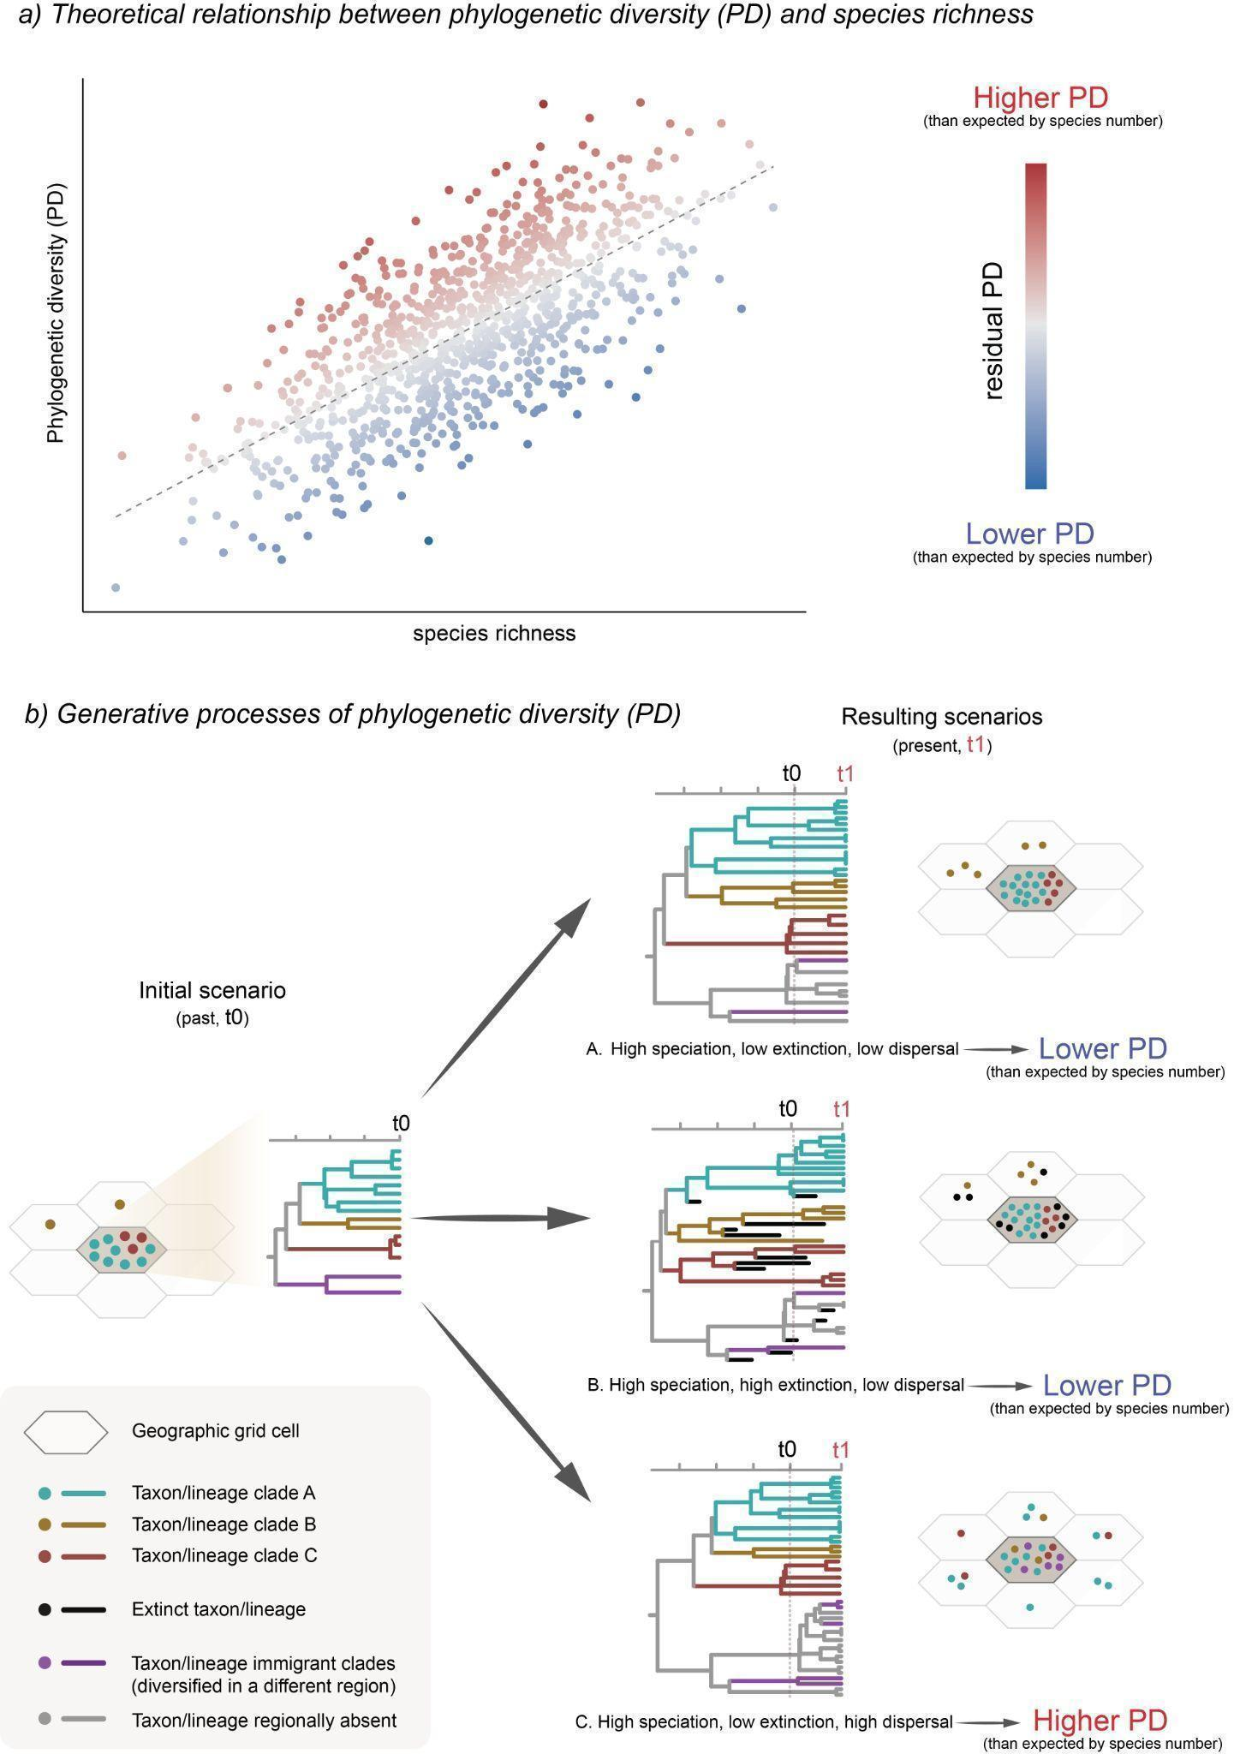

Fig. 1. a) Schematic representation of the relationship between species richness (X-axis) and phylogenetic diversity (Y-axis). Each point represents a geographic grid cell with color representing residual phylogenetic diversity: in red, the cells with more distantly related species (high PD) and in blue more closely related (low PD) than would be predicted by the number of species that these regions harbor. b) Hypothetical scenarios produced by different combinations of speciation, extinction, and dispersal.

**Materials and Methods**

**Vertebrate data**. We obtained distribution vector data for amphibians and terrestrial mammals from IUCN 37, for birds from BirdLife International (http://www.birdlife.org/) and for squamates from 38. Range maps for all groups were downloaded on 1 May 2022.

Phylogenetic data for all groups were downloaded from VertLife (<https://data.vertlife.org/>). This includes the consensus and posterior phylogenetic trees for amphibians 39, birds 40 (backbone from 41), mammals 42, and squamates 43.

After matching both distribution and phylogenetic data, the final datasets contained a total of 28,270 species: 5832 amphibians, 7995 birds, 5164 mammals, and 9279 squamates. These were the datasets used in subsequent analyses.

**Geographic grid and species richness**. For each group, we first produced a hexagonal 100-km-resolution species richness grid using the epm package v1.1.1 44 in R 4.3.0 45, with the polygon distribution data transformed into an equal-area Behrmann projection as input and the ‘centroid’ approach. The resulting grid contains the information of the species present in each hexagonal cell, and was the base cell grid for all subsequent analyses.

**Residual phylogenetic diversity**. We obtained an average phylogenetic diversity (PD) grid after calculating PD grids for 100 trees from the posterior distribution for each tetrapod group. These grids were produced with the functions addPhylo and gridMetrics in epm 44, and they represent the sum of the branch lengths of the phylogenetic tree connecting all species in each cell (Faith’s PD 23). We used the R package rlist v0.4.6.2 46 to process the ‘posterior’ grids and ultimately obtaining a grid of average PD values. With the per-cell values of species richness and PD, we performed a local regression analysis (LOESS) with a smoothing parameter α = 0.75 and obtained the residuals from it. We then mapped these residuals again onto the original hexagonal grid to visualize the geographic distribution of the deviation of PD relative to richness (residual PD). High residual values indicate high PD for a given number of species (i.e., the species within a grid cell are more distantly related to each other than expected by the species richness of the grid cell), and, conversely, low residual PD indicates that the species present in a grid cell are more closely related to each other than predicted by species richness. To identify focal regions of particularly extreme values of residual PD, we set a threshold at 10% (i.e., lowest residual PD) and 90% (i.e., highest residual PD) from the total distribution of values from each vertebrate clade. We then visually identified regions of interest with elevated density of contiguous high and low residual PD grid cells to investigate whether there are differences between them in speciation rates, lineage accumulation patterns, and environmental conditions.

**Recent speciation rates**. We estimated recent speciation rates (tip rates) calculating the average DR metric 40 across 100 trees from the posterior distribution for each vertebrate clade. Then, we calculated mean DR values for each hexagonal grid cell. We plotted these per-cell mean DR values in the map and conducted a linear regression model of per-cell mean DR against residual PD (see above). To further understand the links between speciation rates and patterns of geographic diversity, we tested for differences in DR values between species present in regions of highest and lowest residual PD. To do this, we performed linear models with randomized residual permutations with the RRPP package v1.3.1 47,48, first to globally compare grid cells of high and low residual PD and then to individually compare among the focal regions we identified (see above).

**Evolutionary time and lineage accumulation**. To explore whether there are differences in the age or the lineage accumulation patterns between regions of high and low residual PD, we calculated the number of lineages through time for extreme regions falling within the 10% lowest and 90% highest values of residual PD using the R package ape v5.7.1 49, with the aid of geiger v2.0.11 50 and phytools v1.5.1 51 for phylogenetic data handling. We then visually compared lineage-through-time (LTT) plots to determine whether our data reflect two main expectations: i) regions of high residual PD should exhibit comparatively older lineages than regions with low residual PD values, which might indicate that these regions acted as reservoirs of ancestral diversity, and ii) the pattern of lineage accumulation might be different between regions of high and low residual PD.

**Environmental variables**. One of the factors that may affect evolutionary processes and therefore shape geographic patterns of biodiversity is the environment in which species live. We tested the relationship between residual PD and different environmental variables: mean annual temperature, temperature seasonality, annual precipitation, precipitation seasonality, net primary productivity (NPP), and terrain roughness index (TRI, a variable representing the topographic complexity). Temperature and precipitation data were collected at a 10-minute spatial resolution (~18.5 km) from the summary data for the period between the years 1970 and 2000 contained in the WorldClim v2.1 dataset 52. Net primary productivity data summarized over the period between 1981 and 2015 was obtained at 5-arc-minute resolution from the NDVI3g time series 53. The current topography data were based on 54 and obtained from the ENVIREM dataset 55 at a spatial resolution of 10 arc-minutes. All the environmental variables were resampled to match the spatial resolution of the hexagonal cell grid built for species richness and phylogenetic diversity (100 km), so that we could have per-cell values for every variable in order to implement regression models. Additionally, we generated three climatic spaces: one defined by temperature and precipitation, another one defined by temperature seasonality and precipitation seasonality, and a third one defined by NPP and TRI, and mapped the grid cells with lowest and highest 10% of the residual PD onto those climatic spaces to explore for potential segregation between them. Finally, we also explored how residual PD is distributed across the latitudinal gradient, to compare residual PD patterns with species richness.

**Results**

**Geographic patterns of residual phylogenetic diversity.** We found some regions with consistent patterns of residual phylogenetic diversity (PD) across all four tetrapod clades (Supp. Fig. 1). The African continent harbors overall high residual PD (i.e., individual species more distantly related to each other than expected for the species richness of the assembly) for all the four clades, except for the Sahara Desert for mammals and the rainforest in central Africa for squamates. Conversely, large areas of South America contain low residual PD (species more closely related to each other than predicted by the species richness of the assembly) for all clades. In fact, Africa and South America constitute focal regions of highest and lowest residual PD, respectively, for all vertebrate clades (Fig. 2).

On the other hand, some geographic regions exhibit very contrasting patterns of residual PD among the four clades. Australia is a low-residual-PD region for amphibians and especially squamates, while it harbors high residual PD for birds and mammals. Residual PD in the Indomalayan region is generally high for birds and squamates but relatively low for amphibians, while for mammals it is a very heterogeneous area with high levels in India but regions of low and high levels in Southeast Asia. North America is a region of low residual PD for birds and squamates, and of relatively high residual PD for amphibians. For mammals, there is a clear segregation in residual PD patterns between eastern (high values) and western (low values) North America. Eurasia is also a heterogeneous region across vertebrates, with generally low levels of residual PD for mammals and birds, high levels for amphibians, and areas of high and low levels for squamates. The Arabian Peninsula contains exclusively high levels of residual PD for squamates, but for mammals and birds it shows relatively low levels across the interior and high levels in the mountainous regions of the south and west (Supp. Fig. 1).

**The effect of speciation rates**. We found a statistically significant negative relationship between recent speciation rates (DR rates) and residual PD for all vertebrate clades (*P* <<< 0.001; Fig. 3). In other words, lineages exhibit, on average, higher recent speciation rates in regions of low residual PD (i.e., regions where species are more related to each other than predicted by the richness of the assembly), while regions of high residual PD generally have lower speciation rates. However, this negative relationship was found to be somewhat weak—with low R2 and slope coefficient values—and variable among clades (Supp. Table 1; R2amphibians = 0.005, R2birds = 0.047, R2mammals = 0.076, R2squamates = 0.13).

When comparing only regions falling in the 10% lowest and 10% highest residuals, we found significantly lower speciation rates in the lineages present in grid cells with the lowest residual PD relative to those present in cells with the highest residual PD (*P* = 0.001 in all cases), especially for squamates, although, attending to the effect sizes (*Z*) and the overall distribution of DR values, this difference appears to be mild (Fig. 4).

Likewise, we found significant differences in species’ DR rates among focal regions of highest and lowest residual PD, with low residual PD broadly corresponding to higher speciation rates. Nonetheless, overall, these differences are not prominently apparent (Supp. Fig. 2, Supp. Table 2). Furthermore, we did not find clearly greater differences in DR effect size (*Z*) between focal regions of highest and lowest residual PD than between different regions of high residual PD and between different regions of low residual PD (*P* = 0.467; Supp. Fig. 3). This indicates that the differences in DR rates between regions of high and low residual PD, though significant, are not of large magnitude.

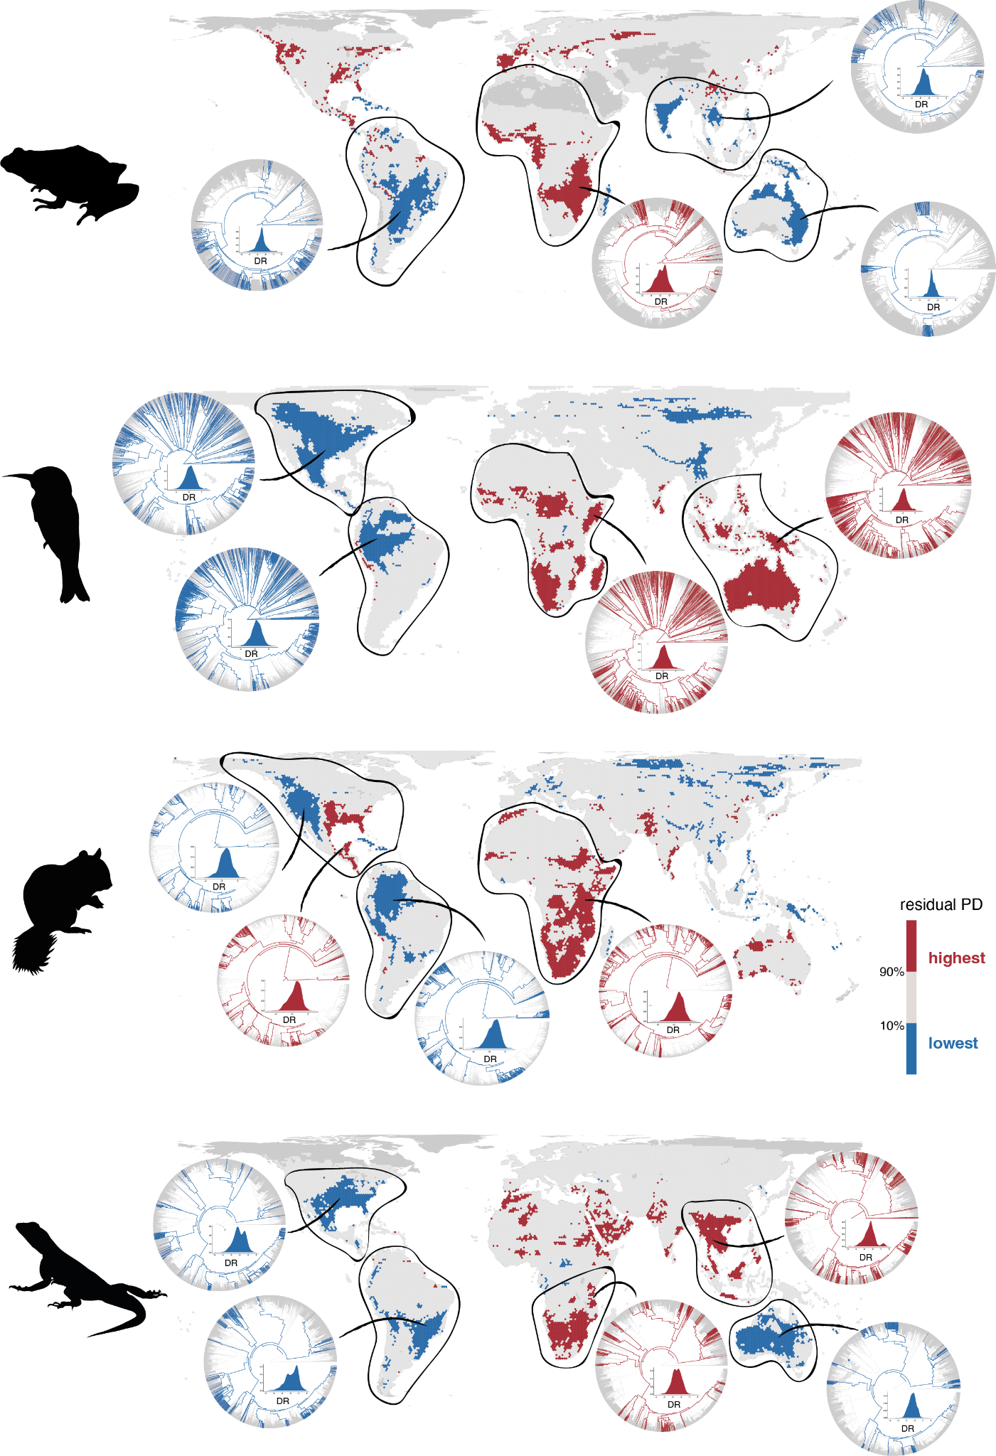

Fig. 2. Geographic distribution of areas with the 10% lowest (in blue) and highest (in red) residual PD for terrestrial vertebrates (amphibians, birds, mammals, and squamates). The phylogenetic relationships of species present in focal regions, together with the density plot of recent speciation rates (DR) of those species, are also shown to illustrate the evolutionary differences of regions with high and low residual PD. Silhouettes by Guillermo Navalón and Sergio M. Nebreda.

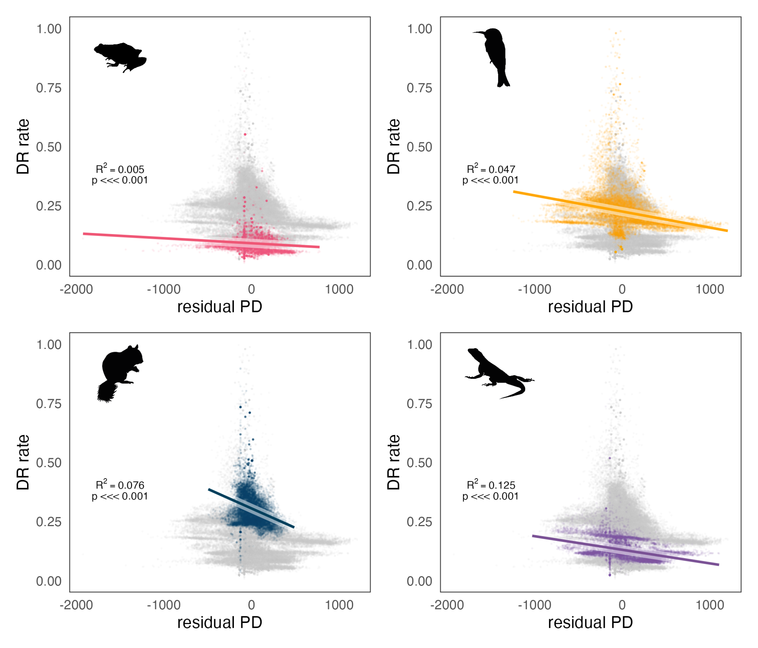

Fig. 3. Relationship between recent speciation rates (DR rates) and residual PD for all four clades of terrestrial vertebrates. The grey cloud of points in the background of each plot shows results for the four vertebrate groups combined.

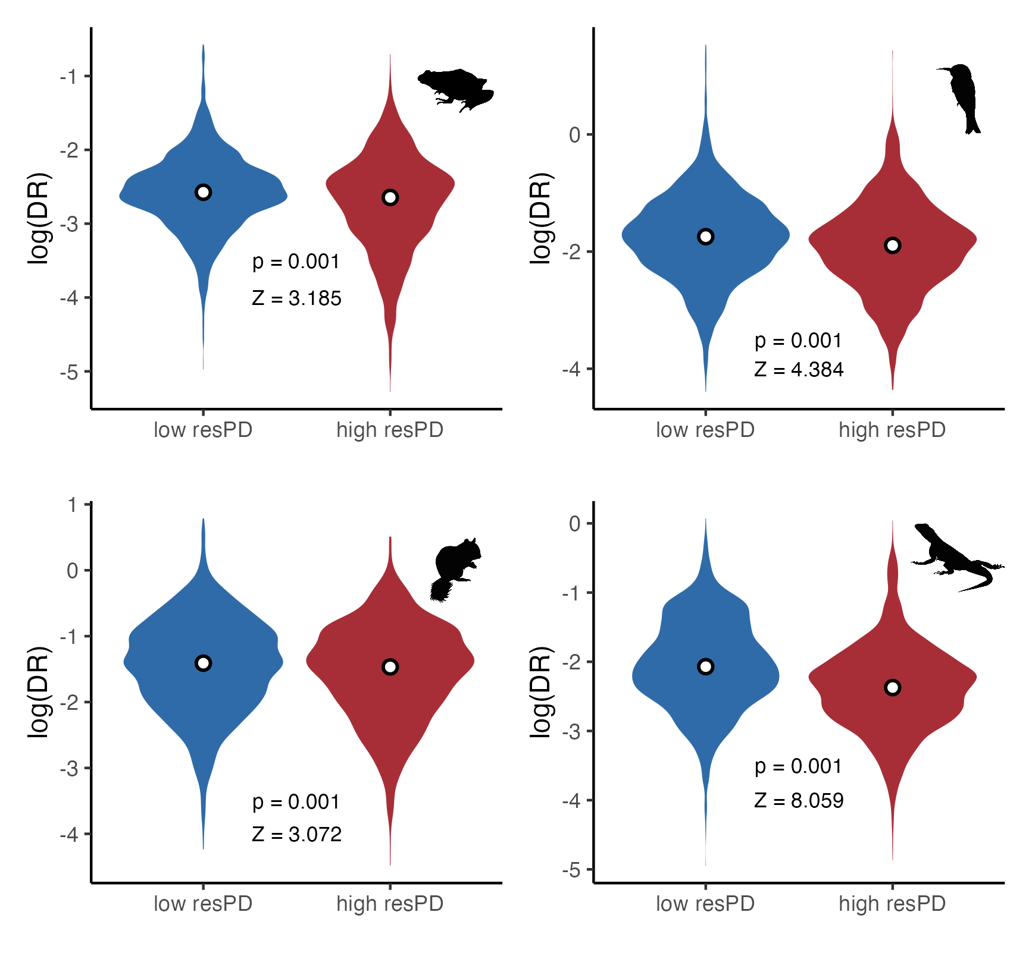

Fig. 4. Differences in recent speciation rates (DR rates) between areas of 10% lowest (in blue) and highest (in red) residual PD.

**The effect of evolutionary time and pattern of lineage accumulation**. We did not find notable differences between focal regions of high and low residual PD in the time of origin or the pattern of accumulation of the lineages they harbor (Supp. Figs. 4-7). Specifically, we did not find the lineages in regions of high residual PD to be as old as expected, and the pace of lineage accumulation is also not clearly distinguishable between regions of low and high residual PD. Even though some regions of low residual PD do harbor younger diversity than regions of high residual PD (e.g., amphibians in Oceania relative to amphibians in Africa, Supp. Fig. 4), this is the opposite in other cases (e.g., mammals in high residual PD Africa have younger ancestors than in low residual PD regions of North and South America, Supp. Fig. 6). In most cases, the age of origin of the lineages leading to present-day species and the trajectories of the accumulation curves are similar in regions of high and low residual PD.

**Environmental variables**. We found an overall low to no linear relationship between residual PD and environmental variables (Supp. Figs. 8-13). There is a very weak negative relationship between annual precipitation and residual PD for all groups (Supp. Fig. 8), while the relationship with mean annual temperature is negative for amphibians and positive for the rest of vertebrate clades (Supp. Fig. 9), with mammals showing the highest amount of residual PD variance explained in both cases (precipitation R2mammals = 0.017; temperature R2mammals = 0.138). For precipitation seasonality and temperature seasonality, amphibians show an opposite trend to that of the other clades, although the variance explained is very low overall (Supp. Figs. 10 and 11). In amphibians, the correlation of residual PD with precipitation seasonality is negative (Supp. Fig. 10), whereas it is positive with temperature seasonality (Supp. Fig. 11). For the rest of vertebrates, these correlations are positive and negative, respectively. There is an extremely low correlation of residual PD with net primary productivity (NPP) for all clades (Supp. Fig. 12). With current topographic complexity (terrain roughness index, TRI), the correlation is also very low overall, but there is a somewhat clearer negative trend in birds and mammals (Supp. Fig. 13).

However, in the environmental space defined by mean annual temperature and annual precipitation, we found some segregation between regions of low and high PD for birds and mammals, but substantial overlap for amphibians and squamates (Fig. 5). In both birds and mammals, extremely low residual PD regions are characterized by two combinations: low precipitation with low to moderate temperature (which roughly correspond to areas of tundra, cold deserts and temperate grasslands; Whittaker 1975), and high precipitation with high temperature (i.e., tropical rainforest and savannah). Most of the high residual PD regions for birds and mammals, on the other hand, are found in environments with both low to moderate precipitation and high temperature (i.e., subtropical desert and savannah). However, highest residual PD regions for birds, unlike in mammals, are also found in areas with high precipitation and temperature (i.e., tropical rainforest and savannah).

The patterns of distribution of regions with high and low residual PD across the environmental space defined by precipitation seasonality and temperature seasonality, or by NPP and TRI, do not follow clearly interpretable trends. There is no apparent segregation between high and low residual PD regions (Supp. Figures 14 and 15), except perhaps for birds in the climate seasonality space, where high residual PD regions tend to be at lower temperature seasonality than regions of low residual PD (Supp. Fig. 14).

Likewise, there is no apparent latitudinal gradient in residual PD for any vertebrate clade, in contrast to species richness (Supp. Fig. 16). Notably, regions of high richness for birds across different latitudinal bands coincide with low residual PD levels (Supp. Fig. 16), although there appears to be no clear relationship between richness and residual PD (which is expected given that richness and PD are highly correlated).

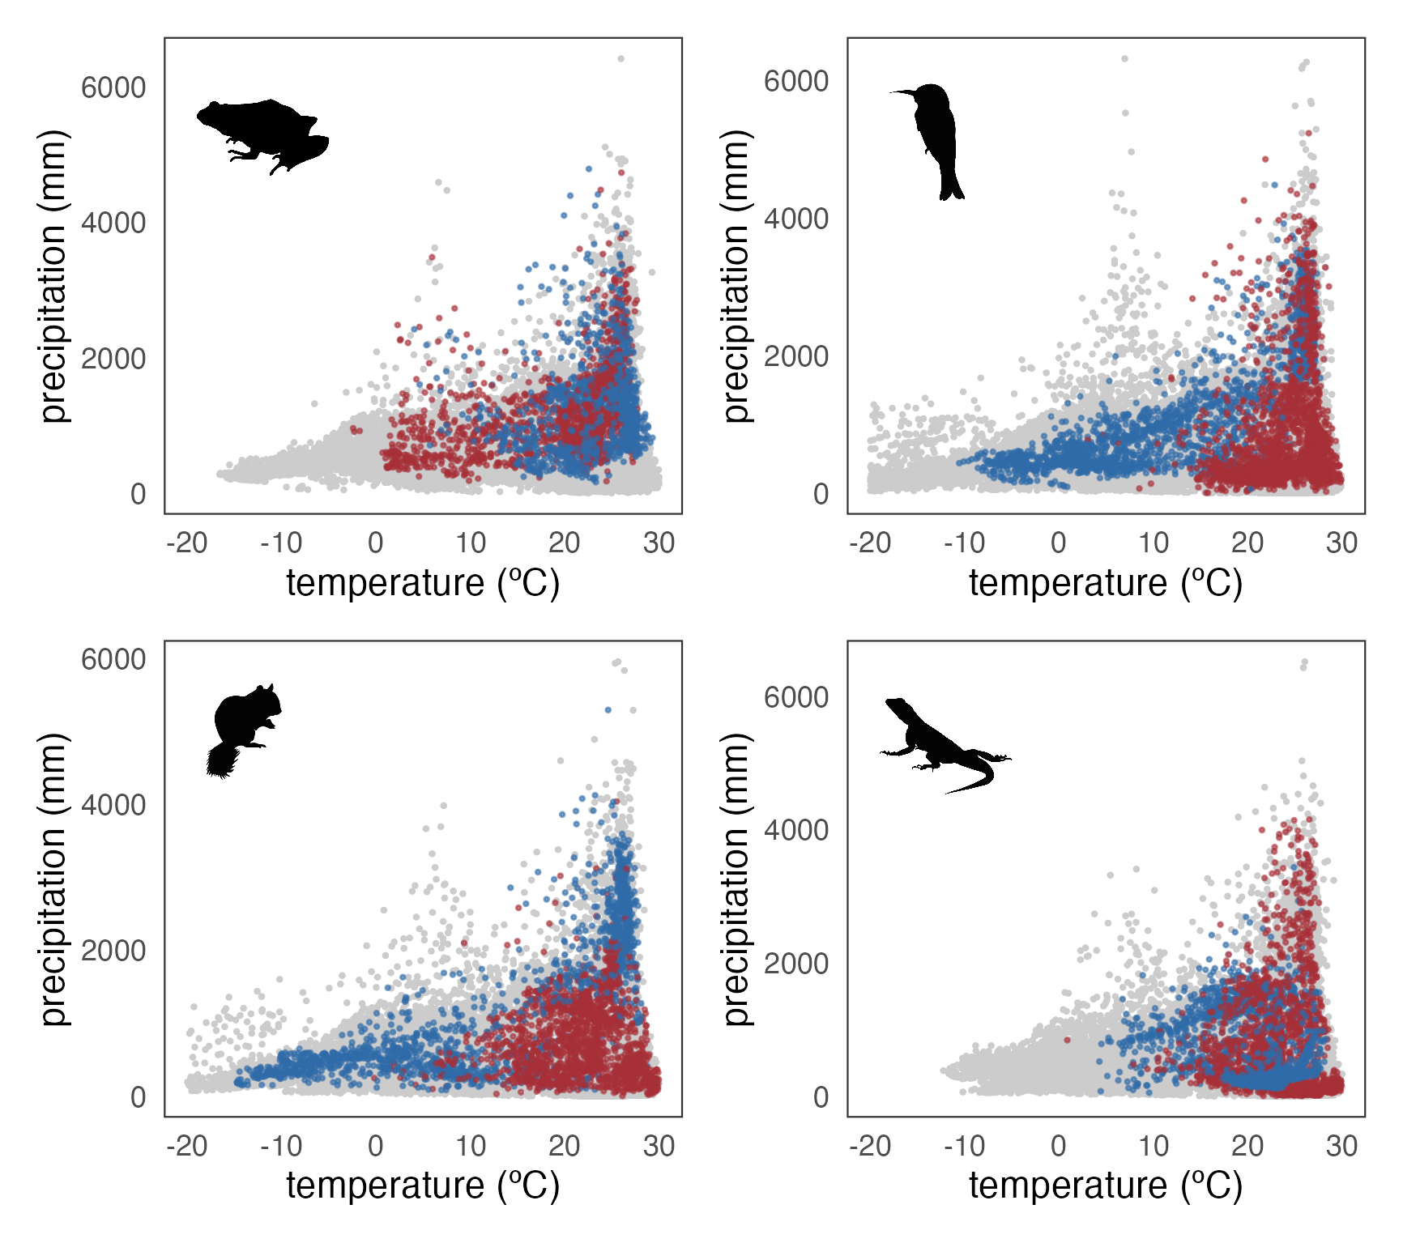

Fig. 5. Climatic space (mean annual temperature vs. annual precipitation) occupied by regions of 10% highest (in red) and lowest (in blue) residual PD for each vertebrate clade. The grey points are grid cells with residual PD values between the 10th and 90th percentiles.

**Discussion**

Our results show that the integration of phylogenetic metrics with analyses of global geographic patterns of diversity among terrestrial vertebrates facilitates a more holistic approach to exploring the evolutionary and ecological processes underlying current spatial patterns of biodiversity. Here, we addressed the global geographic distribution of richness-corrected phylogenetic diversity (residual PD) for four major vertebrate clades (amphibians, birds, mammals, and squamates).

We identified the areas of greatest concentration of high and low residual PD and found entire regions with consistently low (more closely related species than predicted by their species assemblage richness) and high (more distantly related species than predicted) levels for all four tetrapod groups (Fig. 2). Furthermore, we found a slight negative relationship of recent speciation rates with residual PD (Figs. 3 and 4), suggesting that recent speciation events helped generate present-day global biogeographic patterns. Finally, our results show that evolutionary time (i.e., clade/lineage age) as well as most climatic variables had low to no effect on the differentiation of regions with highest and lowest residual PD (Fig. 5). Nonetheless, we identified differences between endotherms (birds and mammals) and ectotherms (amphibians and squamates) when considering temperature and precipitation levels in regions with highest and lowest values of residual PD. This result indicates that thermal physiology may have influenced global diversity patterns among tetrapods.

We found that both American continents are regions of consistently low residual PD, meaning that regional assemblages are composed of species that are more closely related than expected by their richness. This applies to all the studied clades, with the exception of amphibians in North America and mammals in Eastern North America. In contrast, Africa consistently shows high levels of residual PD for all clades; in other words, it harbors species that are more distantly related than expected for all living tetrapods. Previous work on mammals 24 suggested that high residual PD found in Africa may reflect an African origin for many extant mammal clades 56. While plausible for mammals, this hypothesis does not explain this pervasive biogeographic patterning in Africa across other major terrestrial vertebrate clades that likely originated on different continents (e.g., 57,58), and instead may be indicative of other common factors related to the environmental and geological histories of the African continent. Similarly, the low residual PD for all groups observed in America, particularly in South America (Fig. 2), may have been influenced by recent diversification events in multiple extant clades, particularly following dispersal after the formation of the Isthmus of Panama, and coupled with the extinction of ancient endemic lineages 24,59–61. This is also consistent with the ubiquitous negative relationship observed between residual PD and recent speciation rates which, although weak, reflects that recent speciation is likely one of the processes governing the geographic dimension of vertebrate diversity dynamics (Fig. 3). Taken together, these results may be indicative of recent climatic or geographic events (e.g., reconfiguration of continents) as primary drivers of recent speciation rates that have consequently shaped spatial patterns of extant tetrapod diversity.

In addition to abiotic processes influencing spatial patterning of diversity, biotic factors likely drove some of these observable patterns 24. In particular, heterogeneous geographic residual PD patterns among clades (e.g., in Eurasia and Australia; Fig. 2) may indicate that intrinsic biological characteristics (i.e., physiological, ecological, or morphological) have played a role in the generation of the observed clade-specific geographic patterns. For example, the Malay Archipelago shows particularly high residual PD for birds relative to other vertebrates, whereas parts of Australia present low residual PD for amphibians and squamates but high residual PD for mammals and birds (Fig. 2). It is plausible that these differences have arisen due to ecological and functional differences among clades, which may have determined their biogeographic and evolutionary history. The high vagility of birds likely contributed to higher residual PD values in Southeast Asia and Australia due to repeated colonization of islands in these regions 62,63. In addition, the high dispersal ability of the majority of birds’ main subclades resulted in the arrival and relictual permanence of lineages with widely different phylogenetic origins 64, as opposed to isolated radiations (and, therefore, lower PD), which may be more frequent in organisms with lower dispersal abilities 65,66. High residual PD of squamates within Southeast Asia may be related to multiple waves of island colonization during intervals of low sea level and environmental change 67–70 , although this also affected mammals 71–73 and amphibians 69, which do not show comparable patterns of residual PD (perhaps due to a greater effect of environmental fluctuations promoting turnover in these taxa; e.g., 74).

In contrast, the low residual PD of squamates in arid Australia, and of amphibians in the temperate woodlands of the northern and eastern coasts of Australia, likely resulted from a few extensive radiations (see the phylogenetic trees in Fig. 2). These radiations may be facilitated by adaptation and specialization within these unique biomes, leading to community assembly driven by proportionally more closely related species 75–80. Finally, geographic patterns of residual PD may be partially generated by ancient evolutionary lineages that inhabit certain regions. This could be the case of dibamid reptiles in Southeast Asia 81, palaeognath birds in Australia 82, or marsupial and xenarthran mammals in Australia and North America, respectively 83. Additionally, passerine birds, that comprise ~60% of extant avian diversity, contribute to high residual PD in Australia due to the presence of numerous endemic lineages that are distantly related in comparison to the diverse, but generally closely related, passerine lineages inhabiting South America 84–86 (Fig. 2). These contrasting patterns are somewhat paradoxical considering that passerines are generally competent fliers, suggesting that there may be additional factors driving spatial diversity patterns among birds.

Previous work has identified that diversity dynamics are strongly influenced by both extrinsic (e.g., the paleogeographic history) and intrinsic (e.g., ecomorphological or niche-related) factors 87–92. For instance, mountainous regions (a universally recognized driver of diversity and evolutionary processes 18,93,94) serve multiple functions during biodiversity generation; mountains can promote speciation due to habitat heterogeneity across an elevational gradient (acting as a source of diversity, particularly in the tropics 95,96), or induce dispersal barriers (e.g., 97). Mountains may also generate important refugia and reserves of cold- or humid-adapted diversity during periods of climate warming and aridification 98,99. Likewise, deserts, which have been recurrently considered sinks of diversity (i.e., regions harboring distantly related species due to a lack of within-system diversification 100) may harbor low levels of residual PD, as our results show in Australia for squamates and North America for birds, mammals and squamates (Fig. 2). In many cases, this may reflect large radiations of certain clades adapted to the arid conditions (e.g., 101,102). This ecological versatility of physiographic features may be responsible for the lack of a clear relationship between environmental variables and residual PD (Supp. Figs. 8-13), although some segregation is apparent in the climate space between the regions of highest and lowest residual PD, especially in birds and mammals (Fig. 5). This may be explained by fundamental physiological differences between endotherms and ectotherms 103.

Apart from differences in trait- and environment-mediated speciation and dispersal, extinction may also be a major driver of diversity, diversification and biogeographic patterns 104,105. Specifically, extinction events are known not only to underlie current patterns of species richness 106,107, but also to substantially affect other facets of biodiversity 108–110. Extinction may both increase and decrease phylogenetic diversity, depending on the age of the lineages that are more prone to extinction 111. High residual PD regions may result from higher extinction rates of species from relatively recent radiations, mainly reducing species assemblages to taxa with more distant evolutionary relationships, whereas low residual PD may arise in regions where extinction rates are higher for relatively old diversity 33. The exploration of extinction dynamics and, critically, the inclusion of fossil data (which enables better estimates of extinction and deeper speciation events), will help to further disentangle the factors underpinning geographic patterns of vertebrate diversity. Likewise, our results show no apparent relationship between the residual PD of a region and the age of the biota within it or the pattern of lineage accumulation (Supp. Figs. 4-7), but the inclusion of fossil information would enhance our ability to investigate such a relationship.

Moving forward, our methodology to quantify spatial phylogenetic diversity may help to inform conservation policies beyond the species-richness-hotspot and endemism strategies 112. Integrating evolutionary relationships at a regional scale has been stated as a necessary step for global conservation efforts for decades 23. Assessing patterns of residual PD for focal clades would inform on which regions harbor the highest lineage diversity (highest residual PD), facilitating efforts to maximize conservation of phylogenetically distinct lineages and help to preserve larger portions of the evolutionary history of entire clades. Additionally, regions with the lowest residual PD that may be acting as sources of diversity 113 can be considered in conservation initiatives as priority areas in order to safeguard the generation of new biodiversity. Furthermore, integrating paleontological data into our method would facilitate a novel, multidisciplinary approach for utilizing deep time data for species conservation prioritization 114.

**Acknowledgments**

HT-C is supported by a "Juan de la Cierva - Formación" postdoctoral fellowship (FJC2021-046832-I) funded by MCIN/AEI/10.13039/501100011033 and by the European Union NextGenerationEU/PRTR. IM was funded by the Alexander von Humboldt Foundation through a Humboldt Postdoctoral Fellowship. GN was funded by UKRI grant MR/X015130/1. FB was funded by Gothenburg University via the Swedish Research Council (VR: 2019-04739). JŠ was supported by the Czech Science Foundation (GAČR) under grant number 22-12757S and by the Charles University Research Centre under grant number 204069.

**References**

1. Humboldt, A. von & Bonpland, A. *Essai sur la géographie des plantes*. (Schoell, 1807).

2. Darwin, C. *On the Origin of Species by Means of Natural Selection, or the Preservation of Favoured Races in the Struggle for Life*. (John Murray, 1859).

3. Wallace, A. R. *The geographical distribution of animals*. (Harper and Brothers, 1876).

4. Ricklefs, R. E. A comprehensive framework for global patterns in biodiversity. *Ecology Letters* **7**, 1–15 (2004).

5. Mittelbach, G. G. *et al.* Evolution and the latitudinal diversity gradient: Speciation, extinction and biogeography. *Ecology Letters* **10**, 315–331 (2007).

6. Wiens, J. J. The causes of species richness patterns across space, time, and clades and the role of ‘ecological limits’. *Quarterly Review of Biology* **86**, 75–96 (2011).

7. Ricklefs, R. E. Community Diversity: relative roles of local and regional processes. *Science* **235**, 167–171 (1987).

8. Ricklefs, R. E. Evolutionary diversification and the origin of the diversity-environment relationship. *Ecology* **87**, 3–13 (2006).

9. Rabosky, D. L. Ecological limits and diversification rate: alternative paradigms to explain the variation in species richness among clades and regions. *Ecology Letters* **12**, 735–743 (2009).

10. Schemske, D. W., Mittelbach, G. G., Cornell, H. V., Sobel, J. M. & Roy, K. Is There a Latitudinal Gradient in the Importance of Biotic Interactions? *Annual Review of Ecology, Evolution, and Systematics* **40**, 245–269 (2009).

11. Wallace, A. R. *Tropical nature, and other essays*. (Macmillan and Company, 1878).

12. Stephens, P. R. & Wiens, J. J. Explaining species richness from continents to communities: The time-for-speciation effect in emydid turtles. *American Naturalist* **161**, 112–128 (2003).

13. Heard, S. B. & Hauser, D. L. Key evolutionary innovations and their ecological mechanisms. *Historical Biology* **10**, 151–173 (1995).

14. Freeman, B. G., Weeks, T., Schluter, D. & Tobias, J. A. The latitudinal gradient in rates of evolution for bird beaks, a species interaction trait. *Ecology Letters* **25**, 635–646 (2022).

15. Currie, D. J. *et al.* Predictions and tests of climate-based hypotheses of broad-scale variation in taxonomic richness. *Ecology Letters* **7**, 1121–1134 (2004).

16. Allen, A. P., Gillooly, J. F., Savage, V. M. & Brown, J. H. Kinetic effects of temperature on rates of genetic divergence and speciation. *Proceedings of the National Academy of Sciences of the United States of America* **103**, 9130–9135 (2006).

17. Thompson, J. B., Davis, K. E., Dodd, H. O., Wills, M. A. & Priest, N. K. Speciation across the Earth driven by global cooling in terrestrial orchids. *Proceedings of the National Academy of Sciences* **120**, e2102408120 (2023).

18. Hoorn, C. *et al.* Amazonia Through Time: Andean Uplift, Climate Change, Landscape Evolution, and Biodiversity. *Science* **330**, 927–931 (2010).

19. Badgley, C. *et al.* Biodiversity and Topographic Complexity: Modern and Geohistorical Perspectives. *Trends in Ecology and Evolution* **32**, 211–226 (2017).

20. Tejero-Cicuéndez, H. *et al.* Reconstructing Squamate Biogeography in Afro-Arabia Reveals the Influence of a Complex and Dynamic Geologic Past. *Systematic Biology* **71**, 261–272 (2022).

21. Earl, C. *et al.* Spatial phylogenetics of butterflies in relation to environmental drivers and angiosperm diversity across North America. *iScience* **24**, 102239 (2021).

22. Mishler, B. D. Spatial phylogenetics. *Journal of Biogeography* **50**, 1454–1463 (2023).

23. Faith, D. P. Conservation evaluation and phylogenetic diversity. *Biological Conservation* **61**, 1–10 (1992).

24. Davies, T. J. & Buckley, L. B. Phylogenetic diversity as a window into the evolutionary and biogeographic histories of present-day richness gradients for mammals. *Philosophical Transactions of the Royal Society B: Biological Sciences* **366**, 2414–2425 (2011).

25. Tucker, C. M. *et al.* A guide to phylogenetic metrics for conservation, community ecology and macroecology. *Biological Reviews* **92**, 698–715 (2017).

26. Redding, D. W. & Mooers, A. O. Incorporating evolutionary measures into conservation prioritization. *Conservation Biology* **20**, 1670–1678 (2006).

27. Fritz, S. A. & Rahbek, C. Global patterns of amphibian phylogenetic diversity. *Journal of biogeography* **39**, 1373–1382 (2012).

28. Rodrigues, A. S. L., Brooks, T. M. & Gaston, K. J. Integrating phylogenetic diversity in the selection of priority areas for conservation: does it make a difference? in *Phylogeny and Conservation* (eds. Purvis, A., Gittleman, J. L. & Brooks, T.) (Cambridge University Press, 2005).

29. Tucker, C. M. & Cadotte, M. W. Unifying measures of biodiversity: understanding when richness and phylogenetic diversity should be congruent. *Diversity and Distributions* **19**, 845–854 (2013).

30. Velasco, J. A. & Pinto-Ledezma, J. N. Mapping species diversification metrics in macroecology: Prospects and challenges. *Frontiers in Ecology and Evolution* **10**, 951271 (2022).

31. Dobzhansky, T. Evolution in the tropics. *American Scientist* **38**, 209–221 (1950).

32. Stebbins, G. L. *Flowering plants: evolution above the species level*. (Harvard University Press, 1974).

33. Vasconcelos, T., O’Meara, B. C. & Beaulieu, J. M. Retiring “Cradles” and “Museums” of Biodiversity. *The American Naturalist* **199**, 195–204 (2022).

34. Voskamp, A., Baker, D. J., Stephens, P. A., Valdes, P. J. & Willis, S. G. Global patterns in the divergence between phylogenetic diversity and species richness in terrestrial birds. *Journal of Biogeography* **44**, 709–721 (2017).

35. Gumbs, R. *et al.* Global priorities for conservation of reptilian phylogenetic diversity in the face of human impacts. *Nat Commun* **11**, 2616 (2020).

36. Vásquez-Restrepo, J. D., Ochoa-Ochoa, L. M., Flores-Villela, O. & Velasco, J. A. Deconstructing the dimensions of alpha diversity in squamate reptiles (Reptilia: Squamata) across the Americas. *Global Ecology and Biogeography* **32**, 250–266 (2023).

37. IUCN. The IUCN Red List of Threatened Species. Version 2022-2. https://www.iucnredlist.org (2022).

38. Roll, U. *et al.* GARD 1.5 range shapefiles used in: Global diversity patterns are explained by diversification rates at ancient, not shallow, timescales. (2021) doi:10.5683/SP2/913A8L.

39. Jetz, W. & Pyron, R. A. The interplay of past diversification and evolutionary isolation with present imperilment across the amphibian tree of life. *Nature Ecology and Evolution* **2**, 850–858 (2018).

40. Jetz, W., Thomas, G. H., Joy, J. B., Hartmann, K. & Mooers, A. O. The global diversity of birds in space and time. *Nature* **491**, 444–448 (2012).

41. Hackett, S. J. *et al.* A Phylogenomic Study of Birds Reveals Their Evolutionary History. *Science* **320**, 1763–1768 (2008).

42. Upham, N. S., Esselstyn, J. A. & Jetz, W. Inferring the mammal tree: Species-level sets of phylogenies for questions in ecology, evolution, and conservation. *PLoS Biology* **17**, 1–44 (2019).

43. Tonini, J. F. R., Beard, K. H., Ferreira, R. B., Jetz, W. & Pyron, R. A. Fully-sampled phylogenies of squamates reveal evolutionary patterns in threat status. *Biological Conservation* **204**, 23–31 (2016).

44. Title, P. O., Swiderski, D. L. & Zelditch, M. L. EcoPhyloMapper: An r package for integrating geographical ranges, phylogeny and morphology. *Methods in Ecology and Evolution* **13**, 1912–1922 (2022).

45. R Core Team. *R: A Language and Environment for Statistical Computing*. (R Foundation for Statistical Computing, 2023).

46. Ren, K. rlist: A toolbox for non-tabular data manipulation. (2021).

47. Collyer, M. L. & Adams, D. C. RRPP: An r package for fitting linear models to high-dimensional data using residual randomization. *Methods in Ecology and Evolution* **9**, 1772–1779 (2018).

48. Collyer, M. L. & Adams, D. C. RRPP: Linear Model Evaluation with Randomized Residuals in a Permutation Procedure. (2022).

49. Paradis, E. & Schliep, K. ape 5.0: an environment for modern phylogenetics and evolutionary analyses in R. *Bioinformatics* **35**, 526–528 (2019).

50. Pennell, M. W. *et al.* Geiger v2.0: An expanded suite of methods for fitting macroevolutionary models to phylogenetic trees. *Bioinformatics* **30**, 2216–2218 (2014).

51. Revell, L. J. phytools: An R package for phylogenetic comparative biology (and other things). *Methods in Ecology and Evolution* **3**, 217–223 (2012).

52. Fick, S. E. & Hijmans, R. J. WorldClim 2: new 1-km spatial resolution climate surfaces for global land areas. *International Journal of Climatology* **37**, 4302–4315 (2017).

53. Pinzon, J. E. & Tucker, C. J. A non-stationary 1981-2012 AVHRR NDVI3g time series. *Remote Sensing* **6**, 6929–6960 (2014).

54. Wilson, M. F. J., O’Connell, B., Brown, C., Guinan, J. C. & Grehan, A. J. Multiscale Terrain Analysis of Multibeam Bathymetry Data for Habitat Mapping on the Continental Slope. *Marine Geodesy* **30**, 3–35 (2007).

55. Title, P. O. & Bemmels, J. B. ENVIREM: an expanded set of bioclimatic and topographic variables increases flexibility and improves performance of ecological niche modeling. *Ecography* **41**, 291–307 (2018).

56. Lillegraven, J. A., Thompson, S. D., McNab, B. K. & Patton, J. L. The origin of eutherian mammals. *Biological Journal of the Linnean Society* **32**, 281–336 (1987).

57. Benson, R. B. J. *et al.* Cretaceous tetrapod fossil record sampling and faunal turnover: Implications for biogeography and the rise of modern clades. *Palaeogeography, Palaeoclimatology, Palaeoecology* **372**, 88–107 (2013).

58. Claramunt, S. & Cracraft, J. A new time tree reveals Earth history’s imprint on the evolution of modern birds. *Sci. Adv.* **1**, e1501005 (2015).

59. Webb, D. S. Mammalian faunal dynamics of the great American interchange. *Paleobiology* **2**, 220–234 (1976).

60. Weir, J. T., Bermingham, E. & Schluter, D. The Great American Biotic Interchange in birds. *Proceedings of the National Academy of Sciences* **106**, 21737–21742 (2009).

61. Carrillo, J. D. *et al.* Disproportionate extinction of South American mammals drove the asymmetry of the Great American Biotic Interchange. *Proceedings of the National Academy of Sciences* 1–7 (2020) doi:10.1073/pnas.2009397117.

62. Jønsson, K. A. & Fjeldså, J. Determining biogeographical patterns of dispersal and diversification in oscine passerine birds in Australia, Southeast Asia and Africa. *Journal of Biogeography* **33**, 1155–1165 (2006).

63. Sheldon, F. H., Lim, H. C. & Moyle, R. G. Return to the Malay Archipelago: the biogeography of Sundaic rainforest birds. *J Ornithol* **156**, 91–113 (2015).

64. Jønsson, K. A., Fjeldså, J., Ericson, P. G. P. & Irestedt, M. Systematic placement of an enigmatic Southeast Asian taxon *Eupetes macrocerus* and implications for the biogeography of a main songbird radiation, the Passerida. *Biology Letters* **3**, 323–326 (2007).

65. Inger, R. F. & Voris, H. K. The biogeographical relations of the frogs and snakes of Sundaland. *Journal of Biogeography* **28**, 863–891 (2001).

66. Siler, C. D. *et al.* Did geckos ride the Palawan raft to the Philippines? *Journal of Biogeography* **39**, 1217–1234 (2012).

67. How, R. A. & Kitchener, D. J. Biogeography of Indonesian snakes. *Journal of Biogeography* **24**, 725–735 (1997).

68. Voris, H. K. Maps of Pleistocene sea levels in Southeast Asia: shorelines, river systems and time durations. *Journal of Biogeography* **27**, 1153–1167 (2000).

69. Brown, R. M. *et al.* Evolutionary Processes of Diversification in a Model Island Archipelago. *Annual Review of Ecology, Evolution, and Systematics* **44**, 411–435 (2013).

70. Husson, L., Boucher, F. C., Sarr, A.-C., Sepulchre, P. & Cahyarini, S. Y. Evidence of Sundaland’s subsidence requires revisiting its biogeography. *Journal of Biogeography* **47**, 843–853 (2020).

71. Van Den Bergh, G. D., De Vos, J. & Sondaar, P. Y. The Late Quaternary palaeogeography of mammal evolution in the Indonesian Archipelago. *Palaeogeography, Palaeoclimatology, Palaeoecology* **171**, 385–408 (2001).

72. Meijaard, E. Mammals of south-east Asian islands and their Late Pleistocene environments. *Journal of Biogeography* **30**, 1245–1257 (2003).

73. Mercer, J. M. & Roth, V. L. The Effects of Cenozoic Global Change on Squirrel Phylogeny. *Science* **299**, 1568–1572 (2003).

74. Wilting, A., Sollmann, R., Meijaard, E., Helgen, K. M. & Fickel, J. Mentawai’s endemic, relictual fauna: is it evidence for Pleistocene extinctions on Sumatra? *Journal of Biogeography* **39**, 1608–1620 (2012).

75. Pianka, E. R. Diversity and adaptive radiations of Australian desert lizards. in *Ecological biogeography of Australia* 1376–1392 (1981).

76. Rabosky, D. L., Donnellan, S. C., Talaba, A. L. & Lovette, I. J. Exceptional among-lineage variation in diversification rates during the radiation of Australia’s most diverse vertebrate clade. *Proceedings of the Royal Society B: Biological Sciences* **274**, 2915–2923 (2007).

77. Skinner, A., Hugall, A. F. & Hutchinson, M. N. Lygosomine phylogeny and the origins of Australian scincid lizards. *Journal of Biogeography* **38**, 1044–1058 (2011).

78. Vidal-García, M. & Keogh, J. S. Convergent evolution across the Australian continent: ecotype diversification drives morphological convergence in two distantly related clades of Australian frogs. *Journal of Evolutionary Biology* **28**, 2136–2151 (2015).

79. Tejero-Cicuéndez, H., Tarroso, P., Carranza, S. & Rabosky, D. L. Desert lizard diversity worldwide: Effects of environment, time, and evolutionary rate. *Global Ecology and Biogeography* **31**, 776–790 (2022).

80. Brennan, I. G. *et al.* Populating a Continent: Phylogenomics Reveal the Timing of Australian Frog Diversification. *Systematic Biology* syad048 (2023) doi:10.1093/sysbio/syad048.

81. Townsend, T. M., Leavitt, D. H. & Reeder, T. W. Intercontinental dispersal by a microendemic burrowing reptile (Dibamidae). *Proceedings of the Royal Society B: Biological Sciences* **278**, 2568–2574 (2011).

82. Yonezawa, T. *et al.* Phylogenomics and Morphology of Extinct Paleognaths Reveal the Origin and Evolution of the Ratites. *Current Biology* **27**, 68–77 (2017).

83. May-Collado, L. J., Kilpatrick, C. W. & Agnarsson, I. Mammals from ‘down under’: a multi-gene species-level phylogeny of marsupial mammals (Mammalia, Metatheria). *PeerJ* **3**, e805 (2015).

84. Moyle, R. G. *et al.* Tectonic collision and uplift of Wallacea triggered the global songbird radiation. *Nature Communications* **7**, 12709 (2016).

85. Oliveros, C. H. *et al.* Earth history and the passerine superradiation. *Proceedings of the National Academy of Sciences* (2019) doi:10.1073/pnas.1813206116.

86. Harvey, M. G. *et al.* The evolution of a tropical biodiversity hotspot. *Science* **370**, 1343–1348 (2020).

87. James, C. D. & Shine, R. Why are there so many coexisting species of lizards in Australian deserts? *Oecologia* **125**, 127–141 (2000).

88. Jetz, W. & Rahbek, C. Geographic range size and determinants of avian species richness. *Science* **297**, 1548–1551 (2002).

89. Badgley, C. Tectonics, topography, and mammalian diversity. *Ecography* **33**, 220–231 (2010).

90. Pyron, R. A. Biogeographic analysis reveals ancient continental vicariance and recent oceanic dispersal in amphibians. *Systematic Biology* **63**, 779–797 (2014).

91. Menéndez, I. *et al.* A multi-layered approach to the diversification of squirrels. *Mammal Review* **51**, 66–81 (2021).

92. Jiang, K. *et al.* Evolutionary history and global angiosperm species richness–climate relationships. *Global Ecology and Biogeography* **32**, 1059–1072 (2023).

93. Rahbek, C. *et al.* Building mountain biodiversity: Geological and evolutionary processes. *Science* **365**, 1114–1119 (2019).

94. Perrigo, A., Hoorn, C. & Antonelli, A. Why mountains matter for biodiversity. *Journal of Biogeography* 315–325 (2020) doi:10.1111/jbi.13731.

95. Cadena, C. D. *et al.* Latitude, elevational climatic zonation and speciation in New World vertebrates. *Proceedings of the Royal Society B: Biological Sciences* **279**, 194–201 (2011).

96. Šmíd, J. *et al.* Diversity patterns and evolutionary history of Arabian squamates. *Journal of Biogeography* **48**, 1183–1199 (2021).

97. Miller, M. J. *et al.* Out of Amazonia again and again: episodic crossing of the Andes promotes diversification in a lowland forest flycatcher. *Proceedings of the Royal Society B: Biological Sciences* **275**, 1133–1142 (2008).

98. Hampe, A. & Jump, A. S. Climate Relicts: Past, Present, Future. *Annual Review of Ecology, Evolution, and Systematics* **42**, 313–333 (2011).

99. Fjeldså, J., Bowie, R. C. K. & Rahbek, C. The Role of Mountain Ranges in the Diversification of Birds. *Annual Review of Ecology, Evolution, and Systematics* **43**, 249–265 (2012).

100. Crisp, M. D. *et al.* Phylogenetic biome conservatism on a global scale. *Nature* **458**, 754–756 (2009).

101. Wiens, J. J., Kozak, K. H. & Silva, N. Diversity and niche evolution along aridity gradients in North American lizards (Phrynosomatidae). *Evolution* **67**, 1715–1728 (2013).

102. Rabosky, D. L., Hutchinson, M. N., Donnellan, S. C., Talaba, A. L. & Lovette, I. J. Phylogenetic disassembly of species boundaries in a widespread group of Australian skinks (Scincidae: *Ctenotus*). *Molecular Phylogenetics and Evolution* **77**, 71–82 (2014).

103. Buckley, L. B., Hurlbert, A. H. & Jetz, W. Broad-scale ecological implications of ectothermy and endothermy in changing environments. *Global Ecology and Biogeography* **21**, 873–885 (2012).

104. Jablonski, D. Lessons from the past: Evolutionary impacts of mass extinctions. *Proceedings of the National Academy of Sciences* **98**, 5393–5398 (2001).

105. Seeholzer, G. F. & Brumfield, R. T. Speciation-by-Extinction. *Systematic Biology* syad049 (2023) doi:10.1093/sysbio/syad049.

106. Pyron, R. A. Temperate extinction in squamate reptiles and the roots of latitudinal diversity gradients. *Global Ecology and Biogeography* **23**, 1126–1134 (2014).

107. Meseguer, A. S. & Condamine, F. L. Ancient tropical extinctions at high latitudes contributed to the latitudinal diversity gradient. *Evolution* **74**, 1966–1987 (2020).

108. Erwin, D. H. Extinction as the loss of evolutionary history. *Proceedings of the National Academy of Sciences* **105**, 11520–11527 (2008).

109. Pimiento, C. *et al.* Selective extinction against redundant species buffers functional diversity. *Proceedings of the Royal Society B: Biological Sciences* **287**, 20201162 (2020).

110. Brocklehurst, N., Panciroli, E., Benevento, G. L. & Benson, R. B. J. Mammaliaform extinctions as a driver of the morphological radiation of Cenozoic mammals. *Current Biology* **31**, 2955-2963.e4 (2021).

111. Daru, B. H., Elliott, T. L., Park, D. S. & Davies, T. J. Understanding the Processes Underpinning Patterns of Phylogenetic Regionalization. *Trends in Ecology & Evolution* **32**, 845–860 (2017).

112. Myers, N., Mittermeier, R. A., Mittermeier, C. G., da Fonseca, G. A. B. & Kent, J. Biodiversity hotspots for conservation priorities. *Nature* **403**, 853–858 (2000).

113. Meseguer, A. S., Antoine, P.-O., Fouquet, A., Delsuc, F. & Condamine, F. L. The role of the Neotropics as a source of world tetrapod biodiversity. *Global Ecology and Biogeography* **29**, 1565–1578 (2020).

114. Pimiento, C. & Antonelli, A. Integrating deep-time palaeontology in conservation prioritisation. *Frontiers in Ecology and Evolution* **10**, (2022).