**The role of present-day speciation in modern dynamics of vertebrate diversity**

Alternative title: Present-day speciation rates do not generate modern terrestrial vertebrate diversity dynamics

Alternative: Is recent speciation rate the driver of modern diversity dynamics? A global assessment with terrestrial vertebrates

Alternative: Modern dynamics of vertebrate diversity: the role of present-day speciation rates in shaping cradles and museums.

Alternative: Factors generating modern patterns of phylogenetic diversity in vertebrates//Shared patterns of phylogenetic diversity among vertebrates indicate a common driver

Modern dynamics of vertebrate diversity suggest a differential role of environmental changes and life-history traits across the globe

Global geographic patterns of vertebrate diversity dynamics

Heterogeneous geographic patterns of diversity dynamics across terrestrial vertebrates

Abstract

Evolutionary and ecological dynamics differ across regions of Earth and across clades of tree of life.

Introduction

The evolutionary and ecological processes underlying global patterns of biodiversity have always been a central subject of study for evolutionary biologists (Fischer 1960; MacArthur 1964). The study of geographic patterns of species diversity has led the macroecological discussion from the very beginning of evolutionary biology as a discipline, being among the major topics in the works that paved the way for the modern evolutionary theory (Humboldt and Bonpland 1807; Darwin 1859; Wallace 1876). The biodiversity levels in a given area are ultimately determined by three fundamental processes: lineage origination (generally represented by speciation in macroevolutionary studies of extant taxa), extinction, and dispersal (REF). These processes, and therefore the differences in richness across geographic and phylogenetic contexts, might be subjected to multiple biotic and abiotic factors, such as ecological interactions (REF), evolutionary time (REF), ecomorphological dynamics (REF), environmental conditions (REF), climatic trends (REF), or topography and plate tectonics (REF).

In recent years, the emergence and development of what is known as spatial phylogenetics (Mishler 2023) has fostered the advancement of our understanding of macroecological dynamics by integrating the phylogenetic component into the study of geographic biodiversity patterns. Specifically, the use of phylogeny-based metrics of biodiversity such as phylogenetic diversity (PD) allows for the investigation of the relatedeness of biodiversity across geographic scales (high PD indicates the presence of species distantly related in the phylogeny, while low PD is the result of closely related species in a given area). This, in turn, may greatly enhance our ability to understand the evolutionary, ecological, and environmental factors that shape diversity dynamics (Davies and Buckley 2011), as well as being an essential source of information for conservation purposes (Faith 1992).

Even though richness and PD are in general positively correlated (i.e., regions of high and low richness have generally high and low PD, respectively), spatial patterns of the two are not exactly coincidental (e.g., REF). In other words, there are geographic areas that harbor higher and lower PD than expected for their richness levels – i.e., areas where species are more distantly or more closely related, respectively, than would be predicted by the number of species (Fig. 1). Identifying these deviations of PD from richness (residual PD; Velasco et al. 2022) is key to understanding the processes underlying diversity patterns and investigating evolutionary scenarios plausible with such existing patterns.

At local or regional scales, levels of residual PD might reflect the existence of biotic or abiotic filters in the community assembly. In this case, low residual PD could reflect an assembly governed by strong abiotic (e.g., habitat) filtering, leading to the coexistence of closely related species which, considering niche conservatism principles, would presumably be ecologically similar (REF). In contrast, high residual PD would primarily reflect biotic (e.g., competence) filtering, resulting in the coexistence of species with different ecological affinities and likely more distantly related phylogenetically. At broader scales, geographic differences in residual PD may arise due to the differential persistence of lineages through time, which can result in some regions having a higher proportion of older, more evolutionarily distinct lineages than others. This, in turn, can be affected by a variety of factors, such as differences in habitat stability, dispersal events, or diversification rates. More specifically, regions of high residual PD (i.e., with species more distantly related to each other than predicted by richness) might result from gradual accumulation of species, either by dispersal from other areas (immigration) or by low levels of speciation and extinction (low turnover rate), acting as a reservoir of ancient lineages. This could reflect what has been commonly known in the evolutionary biology literature as a “museum” of biodiversity (Stebbins 1974; other REFS). However, high levels of residual PD might also arise with a different combination of processes, such as high speciation rates in the past followed by low extinction of those ancient lineages, or exceptionally high extinction rates of young lineages. Conversely, regions of low residual PD (i.e., with species more closely related than expected by richness) can result from exceptionally high speciation and extinction rates maintained through time (high turnover rate), which constitute the original conceptualization of a “cradle” of biodiversity (REF). However, again, low residual PD can also be the result of other scenarios, such as reduced extinction rates of recent lineages or increased extinction of ancient clades. This multiplicity of scenarios generating patterns of lineage and phylogenetic diversity highlights the importance of investigating the underlying evolutionary processes rather than focusing the discussion on dichotomously dilucidating whether specific regions are cradles or museums of biodiversity (Vasconcelos et al. 2022).

The increasing availability of global distribution and phylogenetic data for large clades of the tree of life allows for the exploration of large-scale diversity patterns and evolutionary processes. For example, in the last decade, the geographic distribution of residual phylogenetic diversity has been addressed for the major clades of terrestrial vertebrates: mammals (Davies and Buckley 2011), amphibians (Fritz and Rahbek 2012), birds (Voskamp et al. 2017), and squamates (Gumbs et al. 2020; Vásquez-Restrepo et al. 2023). However, a comprehensive exploration including mapping residual PD and identifying similarities and differences across vertebrate clades, as well as analyzing the potential effect of different factors on such patterns, is still lacking. In this study, we characterize geographic patterns of current tetrapod diversity dynamics by inferring species and phylogenetic diversity, and test hypotheses related to the impact of multiple factors on regional levels of residual PD: recent speciation rates, evolutionary time, and environmental conditions. This allows us to identify regions in which the evolutionary history has been potentially subjected to different processes shaping the observed patterns. Ultimately, this constitutes a step forward in our understanding of evolutionary dynamics and, importantly, might provide an impactful insight into how to confront the challenges imposed by the global environmental crisis.

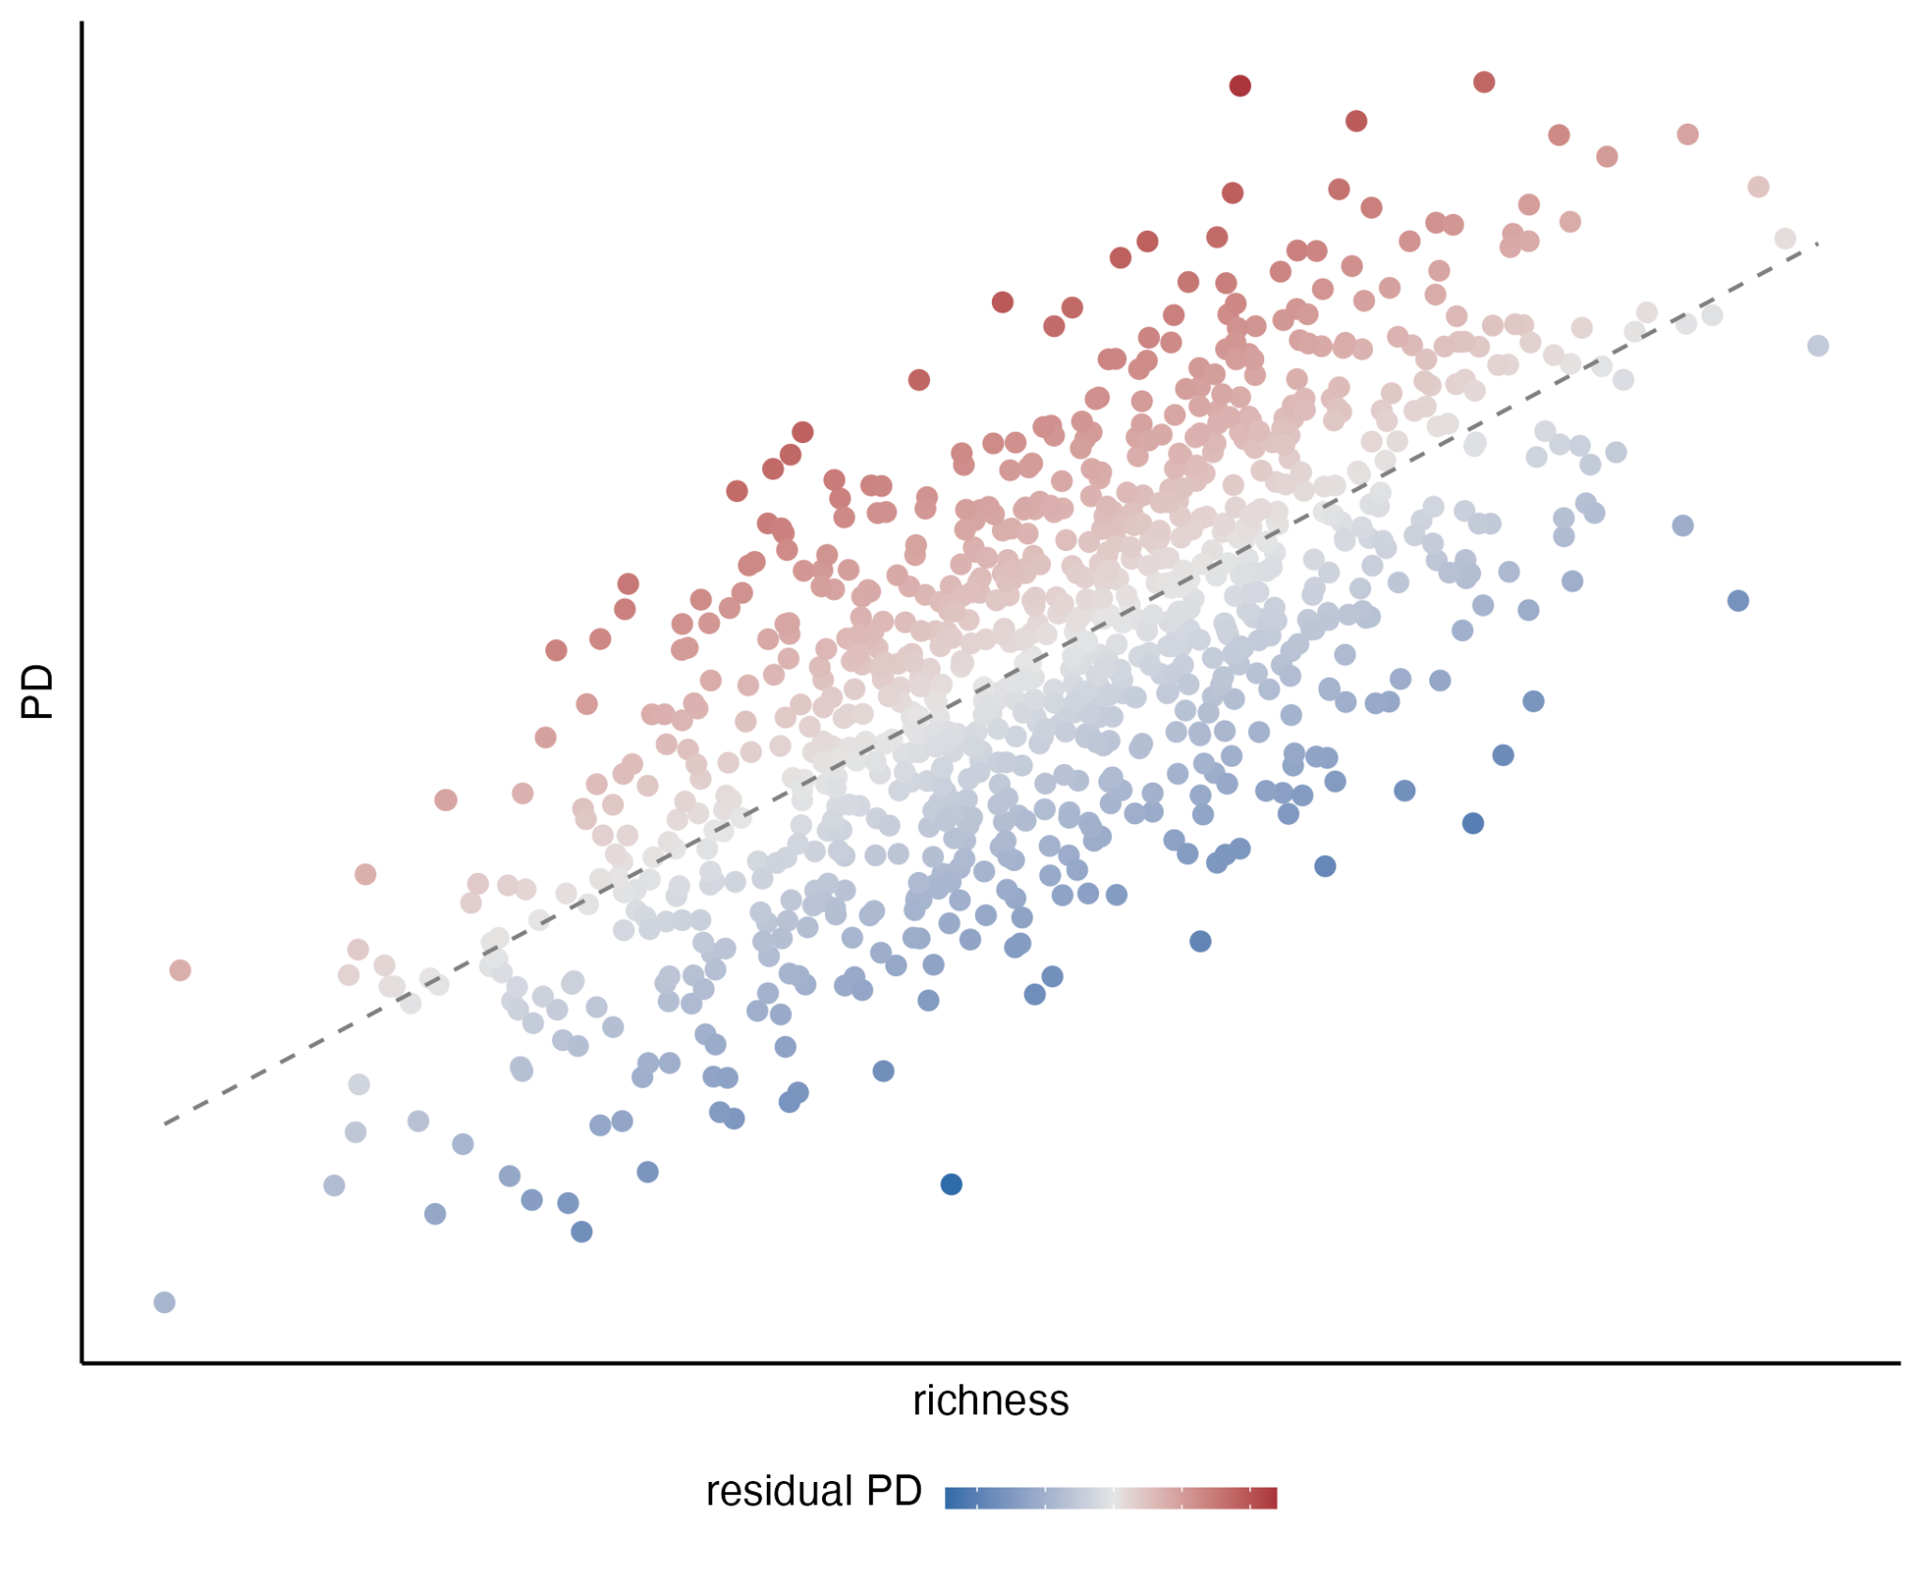

Fig. 1. Schematic representation of the relationship between species richness (X-axis) and phylogenetic diversity (Y-axis), with color representing residual phylogenetic diversity.

Materials and Methods

Data

Number of species in distribution data, in phylogeny.

Residual phylogenetic diversity

For each vertebrate group, we first produced a hexagonal 100-km-resolution species richness grid using the epm R package (REF), with the polygon distribution data transformed into a Behrmann projection as input and the ‘centroid’ approach. The resulting grid contains the information of the species present in each hexagonal cell, and was the base cell grid for subsequent analyses.

We obtained an average phylogenetic diversity (PD) grid after calculating PD grids for 100 trees from the posterior distribution. With the per-grid values of species richness and PD, we performed a local regression analysis (LOESS) and obtained the residuals from it. We then mapped these residuals onto the hexagonal grid to visualize the geographic distribution of the deviation of PD relative to richness (residual PD). High residual values indicate high PD for a given number of species (i.e., the species within a grid cell are more distantly related to each other than expected by richness), and, conversely, low residual PD indicates that the species present in a grid cell are more closely related to each other than predicted by richness.

Additionally, we set a threshold at 10% and another one at 90% of the distribution of residual PD values to visualize the grid cells with lowest and highest residual PD for each vertebrate clade. We then identified focal regions with the greatest geographic extents of contiguous high and low residual PD grid cells to investigate whether there are differences between them in speciation rates, lineage accumulation patterns, and environmental conditions.

Recent speciation rates

We estimated recent speciation rates (tip rates) calculating the average DR metric (Jetz et al. 2012) across 100 trees from the posterior distribution for each vertebrate clade. We then mapped per-cell mean DR values onto the hexagonal cell grids (see above), and implemented a linear regression model of per cell mean DR against residual PD. Additionally, we tested for differences in DR between the species present in regions of highest and lowest residual PD. To do this, we performed linear models with randomized residual permutations with the RRPP package (REF), first to globally compare grid cells of high and low residual PD and then to individually compare among the focal regions we identified (see above).

Evolutionary time and lineage accumulation

To explore whether there are differences in the age or the lineage accumulation patterns between regions of high and low residual PD, we calculated the number of lineages through time with the ape package (REF). We then visually compared lineage-through-time (LTT) plots to determine whether our data reflect two main expectations: i) regions of high residual PD might act as reservoirs of older diversity than regions of low residual PD (and therefore the ancestral origin of the lineages in high-PD regions should be older), and ii) the pattern of lineage accumulation might be different between regions of high and low residual PD.

Environmental variables

One of the factors that may affect evolutionary processes and therefore shape geographic patterns of biodiversity is the environmental conditions. We tested the relationship between residual PD and different environmental variables: mean annual temperature, temperature seasonality, annual precipitation, precipitation seasonality (Bio1, etc. from the WorldClim dataset; REF), net primary productivity (NPP, REF), and terrain roughness index (TRI, a variable representing the topographic complexity, REF). For the latter, we compared current values with estimated Holocene and Last Glacial Maximum values, and we did not find considerable differences, so we report only the analyses with the current values). Additionally, we generated three climatic spaces: one defined by temperature and precipitation, another one defined by temperature seasonality and precipitation seasonality, and a third one defined by NPP and TRI, and mapped the grid cells with lowest and highest 10% of the residual PD onto those climatic spaces to explore for potential segregation between them. Finally, we also explored how residual PD is distributed across the latitudinal gradient, to compare residual PD patterns with species richness.

Results

**Geographic patterns of residual phylogenetic diversity.** We found some regions with consistent patterns of residual PD across vertebrate clades, and some other regions of different levels of residual PD for different clades (Supp. Fig. 1). The African continent harbors overall high residual PD (i.e., species more distantly related to each other than expected for the species richness) for all vertebrates, with the exception of the Sahara desert for mammals and the rainforest in central Africa for squamates. Conversely, large parts of South America contain low residual PD (species more closely related to each other than predicted by richness) for all clades. In fact, Africa and South America constitute focal regions of highest and lowest residual PD, respectively, for all vertebrate clades (Fig. 2). Australia is a low-residual-PD region for amphibians and especially squamates, while it harbors high residual PD for birds and mammals. Residual PD in the Indomalayan region is generally high for birds and squamates and relatively low for amphibians, while for mammals it is a heterogeneous area with high levels in India and regions of low and high levels in Southeast Asia. North America is a region of low residual PD for birds and squamates, and of relatively high residual PD for amphibians. For mammals, there is a clear segregation in residual PD patterns between eastern (high values) and western (low values) North America. Eurasia is also a heterogeneous region across vertebrates, with generally low levels of residual PD for mammals and birds, high levels for amphibians, and areas of high and low levels for squamates. The Arabian Peninsula contains exclusively high levels of residual PD for squamates, but for mammals and birds it shows relatively low levels across the interior and high levels in the mountainous regions of the south and west (Supp. Fig. 1).

**The effect of speciation rates**. We found a significant negative relationship between recent speciation rates and residual PD for all vertebrate clades (*P* <<< 0.001; Fig. 3). In other words, there are in average higher recent speciation rates in regions of low residual PD (i.e., in regions where species are more related to each other than predicted by richness), while regions of high residual PD have in general lower speciation rates. However, this negative relationship was found to be somewhat weak, with low R2 and slope coefficient values (Supp. Table 1; R2amphibians = 0.005, slopeamphibians = -2.09e-5; R2birds = 0.047, R2mammals = 0.076, R2squamates = 0.12).

For all clades, we found significantly lower speciation rates in the species present in grid cells of low residual PD relative to those present in cells of high residual PD (*P* = 0.001 in all cases), although, attending to the effect sizes (Z) and the overall distribution of DR values, this difference appears to be mild (Fig. 4).

Likewise, we found significant differences in species’ DR rates among focal regions of high and low residual PD, with low residual PD broadly corresponding to higher speciation rates, but these differences are overall not prominently apparent (Supp. Fig. 2, Table post-hoc). Furthermore, we did not find clearly greater differences in DR effect size (Z) between cradles and museums than between cradles and between museums (*P* = 0.467; Supp. Fig. 3), indicating that the differences in DR rates between regions of high and low residual PD, though significant, are not of large magnitude.

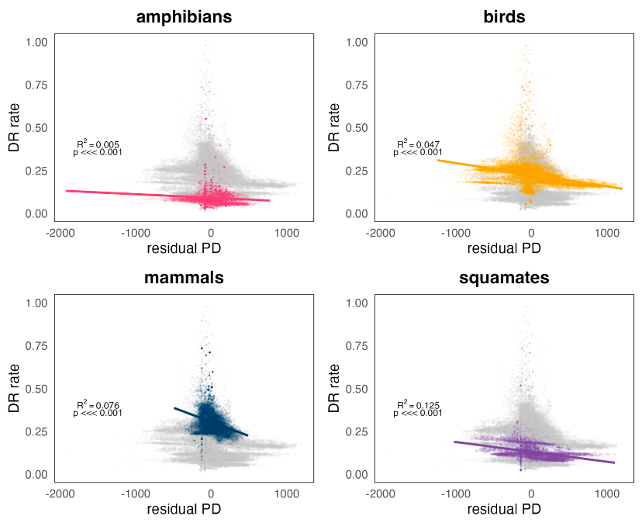

Fig. 2. Relationship between DR rates and the residuals resulting from a regression of `PD ~ Richness` for all four groups of terrestrial vertebrates.

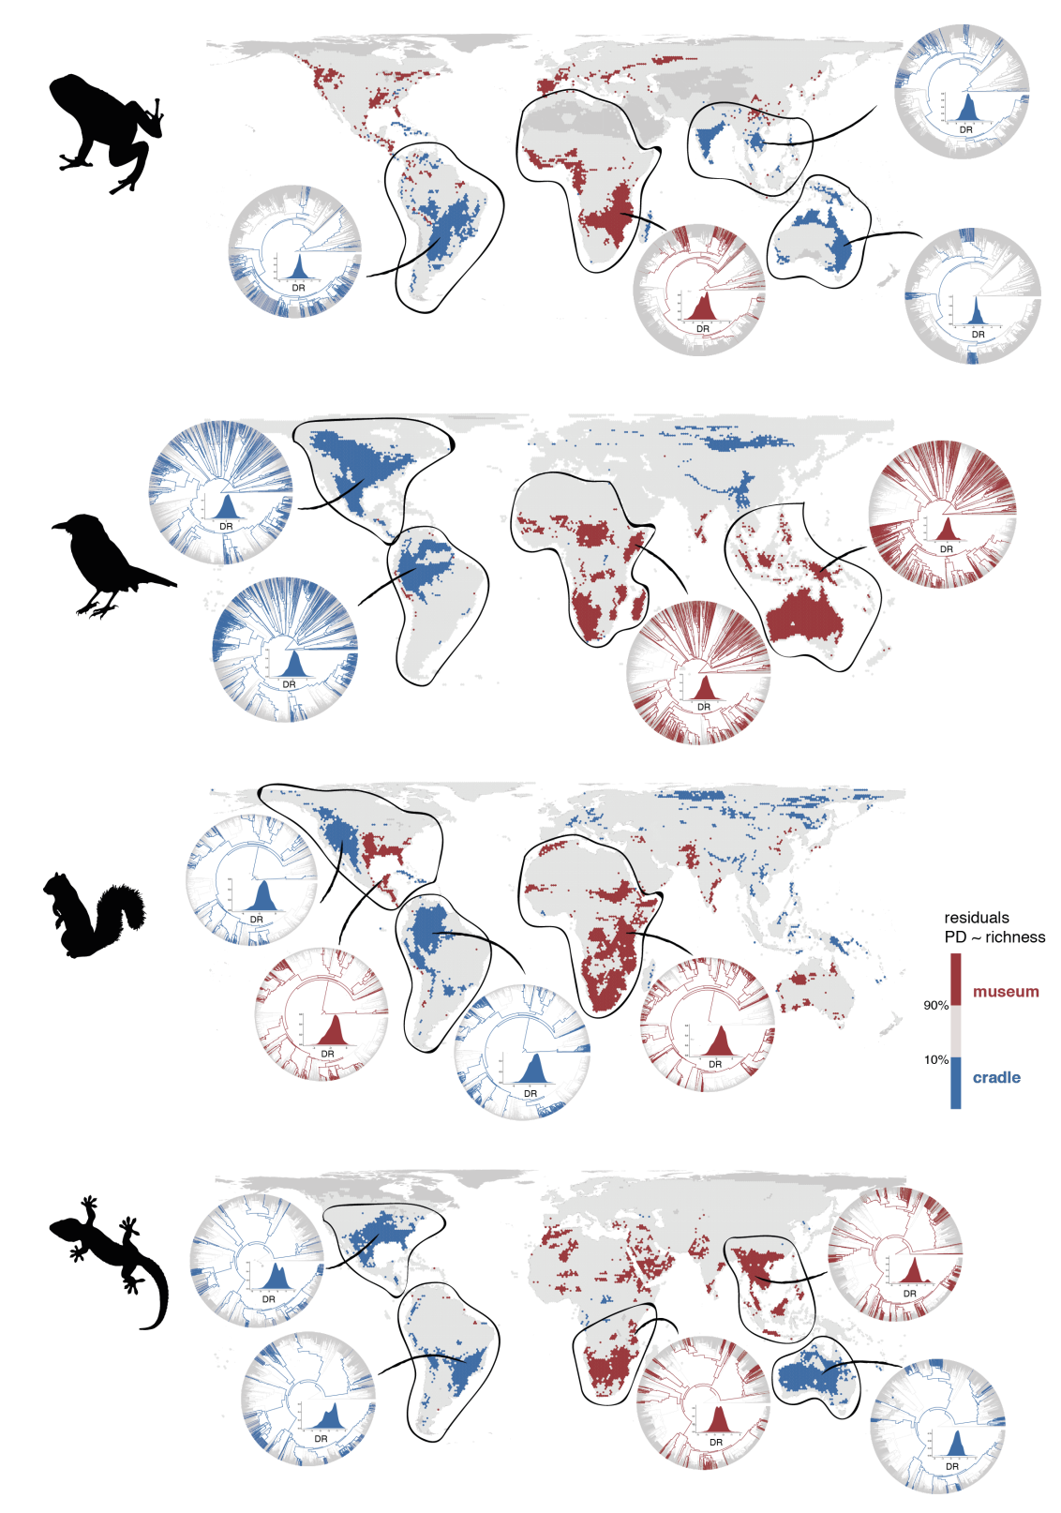

Fig. 3. Geographic distribution of areas with the 10% lowest (in blue) and highest (in red) residual PD for terrestrial vertebrates. The phylogenetic relationships of species present in focal regions are also shown to illustrate the evolutionary differences of regions with high and low residual PD. Silhouettes extracted from 'phylopic' (www.phylopic.org).

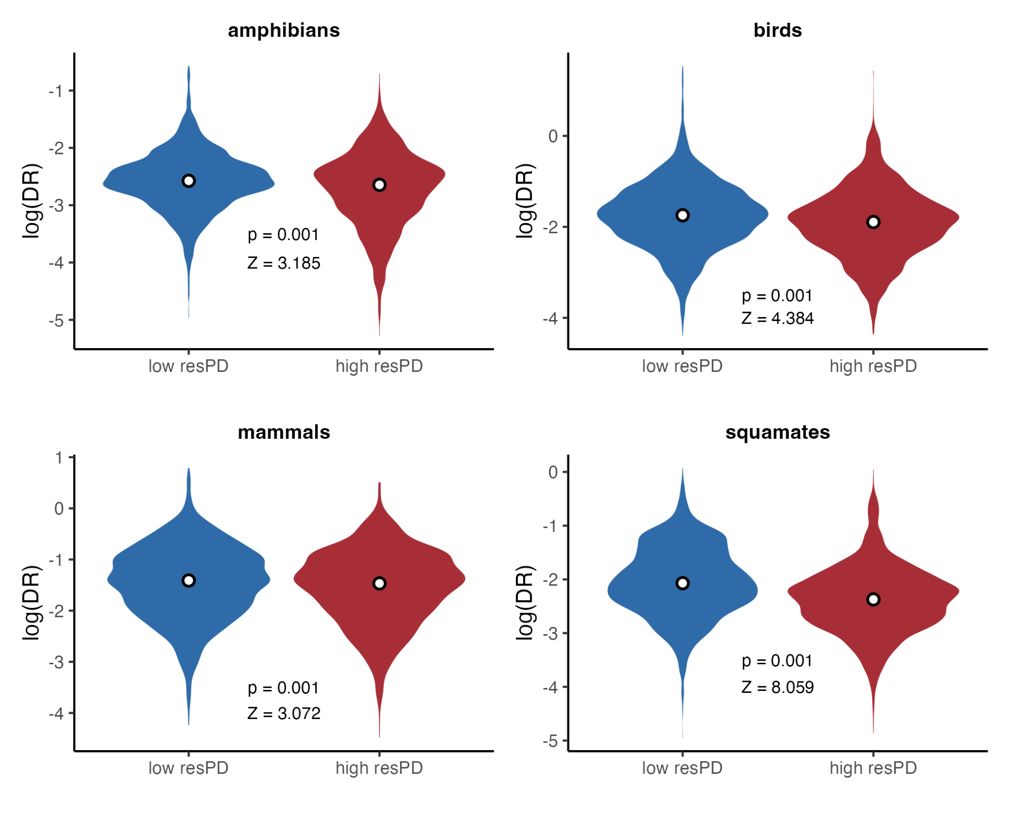

Fig. 4. Differences in DR rates between areas of low and high residual PD.

**Evolutionary time and lineage accumulation**. We did not find notable differences between focal regions of high and low residual PD in the time of origin or the pattern of accumulation of the lineages they harbor (Supp. Figs. 4-7). Specifically, we did not find the expected older age in regions of high residual PD, and the pace of lineage accumulation is also not clearly distinguishable between regions of both types. Even though some regions of low residual PD do harbor younger diversity than regions of high residual PD (e.g., amphibians in Oceania relative to amphibians in Africa, Supp. Fig. 4), this is the opposite in other cases (e.g., mammals in high residual PD Africa have actually younger ancestors than in low residual PD regions of North and South America, Supp. Fig. 6), and in most cases the age of origin of the lineages leading to the current species is similar in regions of high and low residual PD.

**Environmental variables**. We found overall low to no relationship between residual PD and environmental variables (Supp. Figs. 8-13). There is a negative and very mild relationship between annual precipitation and residual PD for all groups (Supp. Fig. 8), while the relationship with mean annual temperature is negative for amphibians and positive for the rest of vertebrate clades (Supp. Fig. 9), with mammals showing the highest amount of residual PD variance explained in both cases (precipitation R2mammals = 0.017; temperature R2mammals = 0.138). For precipitation seasonality and temperature seasonality, amphibians show an opposite trend to that of the other clades, although the variance explained is very low overall (Supp. Figs. 10 and 11). In amphibians, the correlation of residual PD with precipitation seasonality is negative (Supp. Fig. 10) and with temperature seasonality positive (Supp. Fig. 11), while for the rest of vertebrates these correlations are positive and negative, respectively. There is an extremely low correlation of residual PD with net primary productivity (NPP) for all clades (Supp. Fig. 12). With current topographic complexity (terrain roughness index, TRI), the correlation is also very low overall, but there is a somewhat more clearer negative trend in birds and mammals (Supp. Fig. 13).

In the environmental space defined by mean annual temperature and annual precipitation, we found some segregation between regions of low and high PD for birds and mammals, but not for amphibians and squamates (Fig. 5). In both birds and mammals, low residual PD regions are characterized by two combinations: low precipitation with low to moderate temperature (which roughly correspond to areas of tundra, cold deserts and temperate grasslands; Whittaker REF), and high precipitation with high temperature (i.e., tropical rainforest and savannah). Most of the high residual PD regions for birds and mammals, on the other hand, are found in environments with both low to moderate precipitation and high temperature (i.e., subtropical desert and savannah).

The patterns of distribution of regions with high and low residual PD across the environmental space defined by precipitation seasonality and precipitation seasonality, or by NPP and TRI, do not follow clearly interpretable trends, and there is not an apparent segregation of high and low residual PD regions in neither of them (Supp. Figures 14 and 15), except perhaps for birds in the climate seasonality space, where high residual PD regions tends to be at lower temperature seasonality than regions of low residual PD (Supp. Fig. 14). Likewise, there is not an apparent latitudinal gradient in residual PD for any vertebrate clade, in contrast to species richness (Supp. Fig. 16). Notably, although there appears to be no clear relationship between richness and residual PD (which is expected given that richness and PD are highly correlated), for birds regions of high richness across different latitudinal bands coincide with low residual PD levels (Supp. Fig. 16).

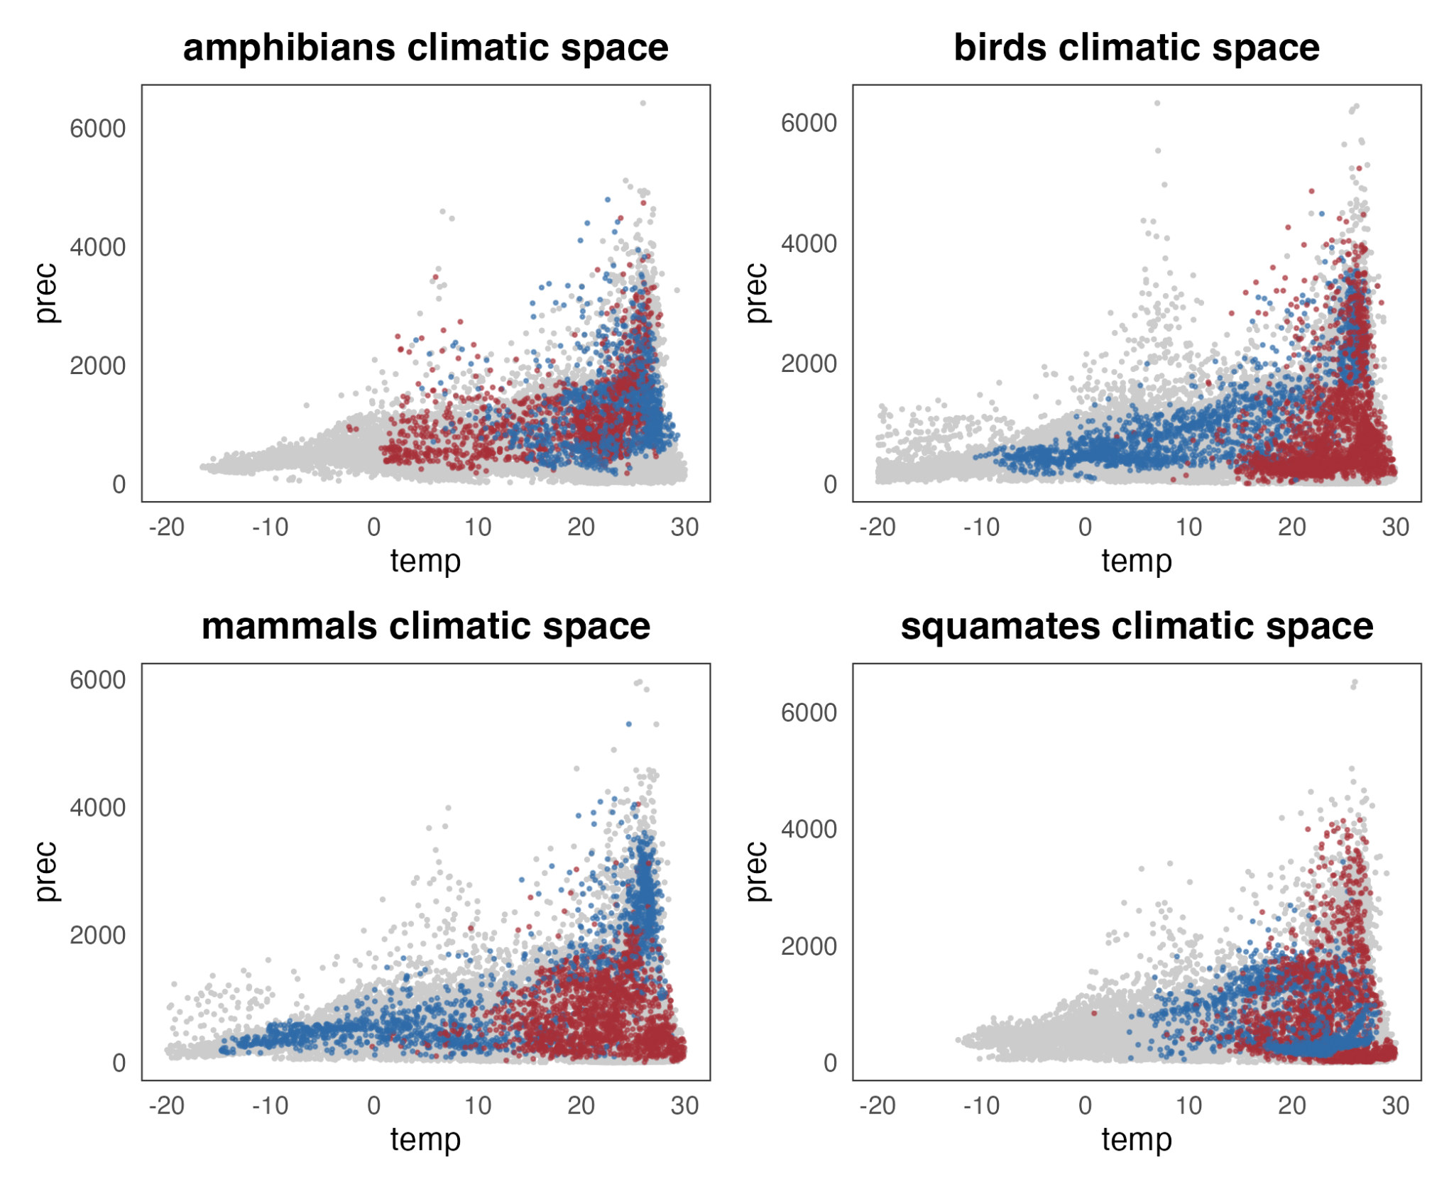

Fig. 5. Climatic space (mean annual temperature vs. annual precipitation) occupied by regions of high (in red) and low (in blue) residual PD.

Discussion

The integration of phylogenetic metrics in the analysis of diversity allows for a more informed understanding of the evolutionary and ecological processes underlying current spatial patterns of biodiversity. Here we addressed the geographic distribution of richness-corrected phylogenetic diversity (residual PD) for four major vertebrate clades (amphibians, squamates, birds, and mammals), identifying the areas of greatest concentration of high and low residual PD and finding consistently low levels (more closely related species than predicted by richness) in America and high levels (more distantly related species) in Africa for all groups (Fig. 2). Further, we found a negative but weak relationship of recent speciation rates with residual PD (Fig. 3), indicating some role, though limited, of recent speciation in generating this pattern. Finally, our results show ambiguous and low to no effect of evolutionary time and climatic variables on the differentiation of regions with highest and lowest residual PD.

There are multiple processes that can lead to certain patterns of residual PD, and therefore the specific processes underlying such patterns might vary from one region to another and among different taxonomic groups (Davies and Buckley 2011). Here we discuss some of the processes that could be generating the patterns we found, attending to historical, biogeographic, and ecological dynamics of vertebrates in different continents. We found that the American continent is consistently a region of low residual PD across vertebrate clades. Likewise, Africa consistently harbors high levels of residual PD for all groups. Previous work on mammals (Davies and Buckley 2011) suggested that the high residual PD found in Africa might reflect that many of the extant mammal clades have an African origin (Lillegraven et al. 1987). While this is a plausible explanation, we argue that the consistencies among vertebrate clades with disparate biogeographic origins might indicate that the factors generating this pattern are common for all groups, regardless of their geographic origin or historical biogeographic dynamics. Following this reasoning, attending to the environmental and geologic history of different regions that have potentially affected all vertebrates might give deeper insights into the generation of this geographic pattern. For example, the fact that America, and particularly South America, has low levels of residual PD relative to the consistently high values in Africa for all groups (Fig. 2) likely reflects the recent diversification of multiple current clades following migrations after the formation of the Isthmus of Panama coupled with the extinction of ancient lineages (Davies and Buckley 2011; Webb 1976; Webb 2006). This is consistent with the ubiquitous negative relationship observed between residual PD and recent speciation rates which, although weak, reflects that recent speciation is likely one of the processes at play in the unfolding of vertebrate diversity dynamics (Fig. 3). Taken together, these results might point at recent climatic or geographic events (e.g., reconfiguration of continents) as a primary driver of spatial patterns of diversity dynamics in some regions by affecting, at least in part, recent levels of speciation.

However, the heterogeneity in residual PD patterns among vertebrate groups in other parts of the world (e.g., Eurasia and Australia; Fig. 2) indicates that species’ intrinsic (i.e., biological, ecological, or morphological) characteristics might also have a role in the generation of these patterns. For example, the Malay Archipelago shows especially high residual PD for birds relative to the other vertebrates, while parts of Australia present low residual PD for amphibians and squamates but high residual PD for mammals and especially birds (Fig. 2). One explanation for these differences may reside in the ecological and functional differences among clades. The high vagility of birds, which enabled the repeated colonization of the islands in Southeast Asia and Australia (REF?), might be the cause of the higher values of residual PD found in the region for this clade resulting from the arrival of lineages with different phylogenetic origins, as opposed to isolated radiations which might be more frequent in organisms with lower dispersal abilities. High residual PD of squamates in this area might be related to multiple waves of island colonization during intervals of low sea levels (Inger and Voris 2001), although this also affected mammals (e.g., Mercer and Roth 2003) and amphibians (REF), which do not show comparable patterns of residual PD. On the other hand, the low residual PD of squamates in arid Australia and of amphibians in the temperate woodlands of the northern and eastern coasts of Australia is likely the result of a few massive radiations (see the phylogenetic trees in Fig. 2) facilitated by the adaptation to the environmental conditions and specialization within those biomes, which have led to a community assembly driven by proportionally more closely related species (REFS). Finally, geographic patterns of residual PD might also be partially generated by evolutionary ancient lineages that inhabit certain regions. This could be the case of dibamid reptiles in Southeast Asia, paleognath birds in Australia, or marsupial mammals in Australia and North America.

Apart from differences in trait- and environment-mediated speciation and dispersal, extinction might also be a major driver of diversity, diversification and biogeographic patterns (REF). Extinction might act generating both increasing and decreasing phylogenetic diversity, depending on the age of the lineages more prone to extinction. High residual PD regions might result from the extinction of species from relatively recent radiations, mainly reducing communities to species with a distant evolutionary relationship, while low residual PD may arise in regions where extinction rates are higher for relatively old diversity (Vasconcelos et al. 2022). The exploration of extinction dynamics and, critically, the inclusion of fossil data, might help to further disentangle the factors underlying this and other geographic patterns of vertebrate diversity.

EXTEND?: Extinction. Erwin 2008. Pyron 2014.

The variety of factors that might be generating residual PD geographic patterns is consistent with previous results indicating that the distribution of diversity is strongly subjected both to extrinsic (e.g., the paleogeographic history) and intrinsic (e.g., ecomorphological or niche-related) factors (Pyron 2014; Menéndez et al. 2021). In this sense, mountainous regions (a universally recognized driver of diversity and evolutionary processes) can have very different ecological roles depending on how the species’ ecological preferences relate to environmental features. Namely, they can act as a source of new diversity, promoting speciation due to habitat diversity across an elevational gradient (REFS), and they have also been reported as important refugia and reserves of cold-adapted diversity during periods of climate warming events (REFS). Likewise, deserts, which have been recurrently considered sinks of diversity (i.e., regions harboring distantly related species due to a lack of within-system diversification; Crisp et al. 2009) might in fact harbor low levels of residual PD, like the Australian deserts for squamates and the North American deserts for birds, mammals and squamates (Fig. 2).

This ecological versatility of physiographic features might be responsible for the lack of a clear relationship between environmental variables and residual PD (Supp. Figs. 8-13), although some segregation is apparent in the climate space between the regions of highest and lowest residual PD, especially in birds and mammals (Fig. 5). Additionally, the fact that multiple processes can lead to similar patterns of residual PD probably explain why we did not find a clear effect of evolutionary time or lineage accumulation dynamics on the differences between regions of high and low residual PD (Supp. Figs. 4-7). While time has been reported as a primary driver of diversity gradients in some systems (e.g., Miller and Román-Palacios 2021) and might be reflected in age differences among biotas in different regions, here we did not find the expected relationship between more closely related lineages (low residual PD) and younger ages. Likewise, a differential pattern of lineage accumulation between regions of high and low residual PD would be a plausible expectation. Specifically, as potential scenarios, we could expect a relatively linear or constant accumulation of species in regions of high residual PD, maybe resulting in the maintenance of ancient lineages, while in regions of low residual PD we might expect a community build-up marked by alternating periods of high diversification and stasis in lineage dynamics. However, our results show an ambiguous pattern in this respect, without a clear segregation between regions of low and high residual PD. This, together with the mild differences in recent speciation between species from low and high residual PD regions (Figs. 3 and 4), might be an indicative that the phylogenetic patterns of extant species alone cannot account for the evolutionary dynamics we found across vertebrate clades, which in turn suggests that dispersal and/or deep-time diversification might be key for understanding these results.

The study of phylogenetic diversity patterns and their underlying causes is not only important to understanding how different factors operate and shape the evolutionary history. Our results might also be especially relevant from a conservation perspective. In fact, the need of integrating the evolutionary relationships of the species at the regional scale to inform conservation policies has been stated for decades (Faith 1992), in opposition to conservation approaches that consider only levels of species richness. The geographic deviations of phylogenetic diversity from species richness (i.e., patterns of residual PD) might provide essential information to develop proper conservation strategies. Regions with high residual PD maximize the conservation of phylogenetically distinct lineages, helping to preserve larger portions of evolutionary history. However, it might not be sufficient to prioritize those areas, since regions with low residual PD, on the other hand, potentially act like sources of diversity, where new species are originating. Thus, combining the conservation of regions both with high and low residual PD might be an effective way to attend to past as well as future diversification areas. Considering additional factors, such as the stability or turnover of communities, and therefore the degree of opportunity for their permanence or demise, might prove a critical practice to integrate in the decision of where to invest conservation resources. Studying geographic patterns of diversity dynamics is the baseline to carry out these practices, which in turn might stand as the only valid approach to mitigate the effects of the undergoing global environmental change.

#####

intro

The terms 'cradles' and 'museums', referring to regions of high instability, heterogeneity and species turnover (cradles) and regions of long-lasting environmental stability and taxonomic diversity (museums) have been very popular in the macroecology literature since Stebbins [-@Stebbins1974] proposed this metaphor. Even though the dichotomous interpretation of these terms has resulted in an inappropriate simplification or directly in a wrong use [@Vasconcelos2022], it is still important to identify the geographically uneven distribution of diversity dynamics to search for their ultimate historical, ecological, and evolutionary drivers.

Meseguer et al. 2022 and others by Meseguer (GEB 2018, GEB 2020, Evolution 2020).

The modern use of the terms museum and cradle and their original meaning [@Vasconcelos2022].

Whether these particular words are used or not, there are regions that show clearly distinct diversity patterns in terms of number of species (species richness) and how closely related those species are (phylogenetic diversity), indicating the existence of differences in their evolutionary dynamics. Although the geographic patterns of species richness and phylogenetic diversity are ever more well-characterized, the role of different factors in generating such patterns is not clear in most cases. Diversification rates, and (in the light of the methodological difficulties of studying extinction at global escales) more particularly speciation rates, are one of the most frequently invoked factors when characterizing biodiversity patterns, but their effect remains ambiguous in the context of global patterns of vertebrate diversity.

Another advantage of the development of phylogenetic methods…thing that we can do with phylogenies is inferring the diversification dynamics of groups, and check if the uneven geographic patterns that we observe today are produced by differences in speciation and/or extinction rates.

The use of PD-based metrics to investigate evolutionary dynamics (spatial phylogenetics, Mishler 2023 JBI). Might reflect ecological processes of community assembly: environmental filter (low PD: closely related species coexist because there is a strong environmental filter that favors some particular ecological preferences, that the species in a clade share) vs competition (high PD: closely related species compete for resources, so only distantly related species coexist).

In this study, we use global distribution and phylogenetic data for the major clades of terrestrial vertebrates (amphibians, birds, mammals, and squamates) to characterize the geographic patterns of tetrapod diversity dynamics. Specifically, we identified areas that, based on their richness and phylogenetic diversity levels, can be considered as “cradles” (here used as regions of especially low phylogenetic diversity relative to their richness, or low residual PD) and “museums” (here used to refer to regions of high residual PD). We are aware of the ongoing debate on the use of these terms [@Vasconcelos2022], and we agree with the detrimental effect of their wrong or deficient use, as well as with the prioritization of investigating the processes driving biodiversity patterns. Therefore, our primary goal is to characterize diversity dynamics (independently from the use of specific terms) and, more importantly, to explore factors that could be generating such patterns. Particularly, we aim to determine the role of recent speciation and other factors (e.g., time, environment) in generating the present-day distribution of tetrapod diversity dynamics.

discussion

Although our results indicate that regions with high or low resPD might have a common origin, we did not find a shared pattern of lineage accumulation, or consistent climatic conditions. Each group show high and low resPD regions in different climates. ….

The indomalayan region show high resPD for birds and squamates. This is congruent with the high dispersal habilities of birds, that have repeteadly colonized the islands of the indomalayan archipielago (and Asutralia), generating more phylogenetic diversity than if they only had diversified within the islands. Squamates, although they have no high dispersal habilities, show a high resPD probably related to the repeated colonization of islands during intervals of low sea-level (Inger and Voris 2001). Although this affected too to mammals and amphibians…

Australia is a region of low resPD for squamates, specifically the desert, which is well known as a region of strikingly high richness for squamates. Australia shows also low resPD in the coast for amphibians….. for birds, Australia shows high resPD (guille + lizzy). Mammals also show high resPD regions in Australia…  
mammals in north american differences

This is congruent with the observed segregation in the climatic space (temperature vs precipitation) between high and low resPD cells, at least for some groups (especially birds and mammals). The more stable climatic conditions for each group show high resPD, while “harsh” environments show low resPD.

Negative relationship resPD ~ speciation but low effect.

Lack of effect of speciation on other diversity patterns.

We did not find the expected differential pattern of lineage accumulation between regions of high and low residual PD (i.e., museums and cradles, respectively) (LTT plots). However, the geographic patterns of residual PD might be partially derived from the richness levels of ancient lineages (i.e., species richness in the past). In mammals, for instance, this would reflect that many of the extant clades have an African origin (Lillegraven et al. 1987), making Africa a museum of diversity, while richness in South America is much younger as a result of the recent diversification of multiple current clades following migration after the formation of the Isthmus of Panama and the extinction of old lineages (Davies and Buckley 2011; GABI references: Webb 1976; Webb 2006), resulting in a cradle in this region.

It seems like there is some segregation in the climatic space (temperature vs precipitation) between museums and cradles, at least for some groups (especially birds and mammals), although the relationship between the climatic variables and residual PD is low.

Factors that may shape biodiversity dynamics.

Dispersal.

Extinction. Erwin 2008. Pyron 2014.

The interplay of environment (e.g., habitat filtering) and evolutionary time (e.g., geologically driven vicariance) drive current distribution patterns in amphibians (Pyron 2014).

The fact that the places with high speciation rates at present are not the places with more closely related diversity relative to their species richness might indicate that historical diversification trends (rather than present-day processes) are driving geographical patterns of global diversity. This, in turn, may indicate that present-day geographic patterns of speciation might be more related to future biodiversity dynamics (Schluter and Pennell 2017).

Another interesting point might be that regions of high residual PD do not consistently coincide with harsh or arid regions, which are often considered sinks of biodiversity (Crisp et al. 2009). In fact, some deserts might be sources of diversity like the mammal and bird cradles in North America, and the squamate cradles in North America and Australia (Fig. MAP). This is consistent with previous results on arid lizards in North America (Wiens et al. 2013). We do find that some hyper-arid regions harbor high levels of residual PD: the Arabian Peninsula and parts of the Sahara desert for squamates, Australia for birds, some parts of Australia for mammals, and then some areas of the Palearctic and the Nearctic for amphibians, which might be a group particularly not suited for those cold and low-humidity regions.

Something about mountains? They can act as cradles () and museums ().

Conservation. Importance of considering phylogenetic diversity, but also there is the risk of just maximizing PD: low PD might be indicative of intense diversification, or high turnover, and in some cases preserving those might be more interesting than preserving potentially more stable environments of high PD (Davies and Buckley 2011).

Effect of environmental change and habitat alteration in PD (Swan et al. 2022).

Our results can be useful for directing conservation efforts. Regions with high resPD maximize the conservation of different lineages. Regions with low resPD, on the other hand, are regions where new species are generating (sources). So combining the conservation of regions both with high and low resPD could be beneficious to past as well as future diversification.

References