**Heterogeneous geographic patterns of diversity dynamics across terrestrial vertebrates**

Héctor Tejero-Cicuéndez, Iris Menéndez, Fernando Blanco, Elizabeth M. Steell, Guillermo Navalón, Jiří Šmíd

**Affiliations (write them here and I’ll put the numbers later)**

Fer:

Lizzy: Department of Earth Sciences, University of Cambridge, Cambridge, United Kingdom; Department of Earth Sciences, University College London, London, United Kingdom.

Guille: Department of Earth Sciences, University of Cambridge, Cambridge, United Kingdom.

Jiří:

**Abstract**

Diversity is distributed unevenly among lineages and regions and understanding the underlying process generating these global patterns is a key of evolutionary research. Here we use a combined approach to this central question characterizing the global patterns of geographic diversity in four major clades of living amniotes and explicitly incorporating their phylogenetic histories….

Evolutionary and ecological dynamics differ across regions of Earth and across clades of the tree of life.

**Introduction**

Clarifying the evolutionary and ecological processes underlying present-day patterns of biodiversity remains a central goal for natural historians and evolutionary biologists (de Candolle 1859; Matthew 1915; Moore 1920; Ruthven 1920; Allee 1926; Dobzhansky 1950; Fischer 1960; MacArthur 1965; Anderson 1974; Harmon 2012; Saupe 2023). In particular, the study of global geographic patterns of species diversity (primarily, species richness) has occupied a prominent role in macroecological discussion since the infancy of evolutionary biology as a discipline (Humboldt and Bonpland 1807; Darwin 1859; Wallace 1876) to modern evolutionary theory (e.g., Futuyma 2015). The biodiversity levels in a given geographic area are ultimately determined by three fundamental processes: lineage origination (generally represented by speciation in macroevolutionary studies of extant taxa), extinction, and dispersal (Ricklefs 2004; Mittelbach et al. 2007; Wiens 2011). These three basic generative processes result in the unequal accumulation of species richness across geographic and phylogenetic contexts. This may be explained by differential biotic and abiotic factors operating at regional and local scales (Ricklefs 1987, 2006; Rabosky 2009), such as ecological interactions (Schemske et al. 2009), evolutionary time (Wallace 1878; Stephens and Wiens 2003), the relationship between organismal form and ecology (Heard and Hauser 1995; Freeman et al. 2022), environmental conditions (Currie et al. 2004; Allen et al. 2006), climatic trends (Thompson et al. 2023), or topography and plate tectonics (Hoorn et al. 2010; Badgley et al. 2017; Tejero-Cicuéndez et al. 2022a).

In recent years, the emergence and development of spatial phylogenetics (Earl et al. 2021; Mishler 2023) has advanced our understanding of macroecological dynamics by combining phylogenetic relatedness with geographic biodiversity patterns. Specifically, the use of phylogeny-based metrics of biodiversity, such as phylogenetic diversity (PD; Faith 1992), enables investigations into the geographic distribution of species relatedness. For instance, high PD values indicate the sympatric presence of distantly related species, while low PD values result from closely related species inhabiting a given geographic area. The explicit inclusion of the phylogenetic dimension may greatly improve our ability to elucidate the synergistic effects of evolution, ecology, and the environment on diversity dynamics (Davies and Buckley 2011; Tucker et al. 2017), in addition to providing an essential source of information for conservation purposes (Faith 1992; Redding and Mooers 2006).

In general, species richness and PD are expected to be positively correlated: regions showing high and low species richness are expected to have high and low levels of PD, respectively (refs and examples?). The reason for this is that, if all the species and clades present at particular regions were subjected to homogeneous and constant diversification and dispersal rates, an increase (or decrease) in the number of species would be reflected in a proportional increase (or decrease) in the number of clades, such that the degree of phylogenetic relatedness would change accordingly and invariably across regions. However, geographic patterns of richness and PD are not necessarily congruent (Tucker and Cadotte 2013). In other words, there are geographic regions where species are more distantly (high PD) or more closely (low PD) related than would be predicted by the number of species that these regions harbor (Fig. 1). Consequently, deviations from the expected relationship of PD to species richness (residual PD; Velasco and Pinto-Ledezma 2022) and their connection with biotic and abiotic factors are key research areas that will further our understanding of the processes underpinning geographic patterns of species diversity.

Therefore, at local or regional scales, deviations from the expected relationship of PD to species richness (residual PD) might indicate the existence of biotic or abiotic factors affecting the community assembly. Low residual PD could reflect a species assembly governed by strong abiotic (e.g., habitat) filtering, leading to the coexistence of a higher proportion of closely related species than expected by the number of species which, considering niche conservatism principles, would presumably be ecologically similar (Romdal et al. 2013; Pyron et al. 2015; Chazot et al. 2021). In contrast, high residual PD may reflect the primacy of biotic (e.g., competition) filtering, resulting in the coexistence of species with different ecological affinities and likely more distantly related phylogenetically (Gause 1934; Hardin 1960; Macarthur and Levins 1967; Chesson 2000; HilleRisLambers et al. 2012).

At broader spatial scales, geographic differences in residual PD may also arise due to differences in the persistence of lineages through time, which can result in some regions having a greater proportion of older, more evolutionarily distinct lineages than other regions. The survivorship of lineages in an area, in turn, can be affected by a variety of factors, such as differences in habitat stability, dispersal events, or diversification rates. More specifically, species assemblages in regions with high residual PD values (i.e., species more distantly related to each other than predicted by species richness) may result from the gradual accumulation of species, either by dispersal from other areas (immigration) or by low levels of speciation and extinction (low turnover rate), acting as a reservoir of ancient lineages. This could reflect what has been commonly known in the evolutionary biology literature as a “museum” or “sanctuary” of biodiversity (Dobzhansky 1950; Stebbins 1974). However, high values of residual PD might also arise owing to a different combination of processes, such as high speciation rates in the past followed by low extinction rates of old lineages, or alternatively, exceptionally high extinction rates of younger lineages. Conversely, regions of low residual PD (i.e., with species more closely related than expected by richness) can result from exceptionally high speciation and extinction rates maintained through time (high turnover rate), which constitute the original conceptualization of a “cradle” of biodiversity (Stebbins 1974). However, low residual PD can also be the result of other scenarios, such as reduced extinction rates of young lineages or increased extinction of older clades.

The multiplicity of scenarios able to generate similar patterns of lineage and phylogenetic diversity highlights the importance of investigating the underlying evolutionary processes beyond solely focusing on elucidating whether specific geographic regions are cradles or museums of biodiversity (Vasconcelos et al. 2022).

The increasing availability of both global distribution and phylogenetic data from species-rich clades allows for the exploration of large-scale diversity patterns and evolutionary processes. For example, in the last decade, the geographic distribution of residual PD has been addressed for the four major clades of living terrestrial vertebrates: mammals (Davies and Buckley 2011), amphibians (Fritz and Rahbek 2012), birds (Voskamp et al. 2017), and squamates (Gumbs et al. 2020; Vásquez-Restrepo et al. 2023). This wealth of data presents an exciting, but unrealized, opportunity for the detailed comparison of geographic patterns of residual PD across the four major clades of amniotes, including critically identifying differences and similarities in the biotic and abiotic factors underpinning global patterns of tetrapod biodiversity. In this study, we characterize geographic patterns of tetrapod species and phylogenetic diversity, and we test hypotheses related to the impact of multiple factors on regional levels of residual PD: recent speciation rates, evolutionary time, and environmental conditions. This enables the identification of key regions with different patterns of geographic diversity across tetrapod clades that shed light on the different processes underlying these patterns. Beyond informing our understanding of evolutionary dynamics producing global diversity patterns, our study ultimately aims to provide some insight into identifying priorities for conservation strategies in the face of the challenges imposed by the global environmental crisis.

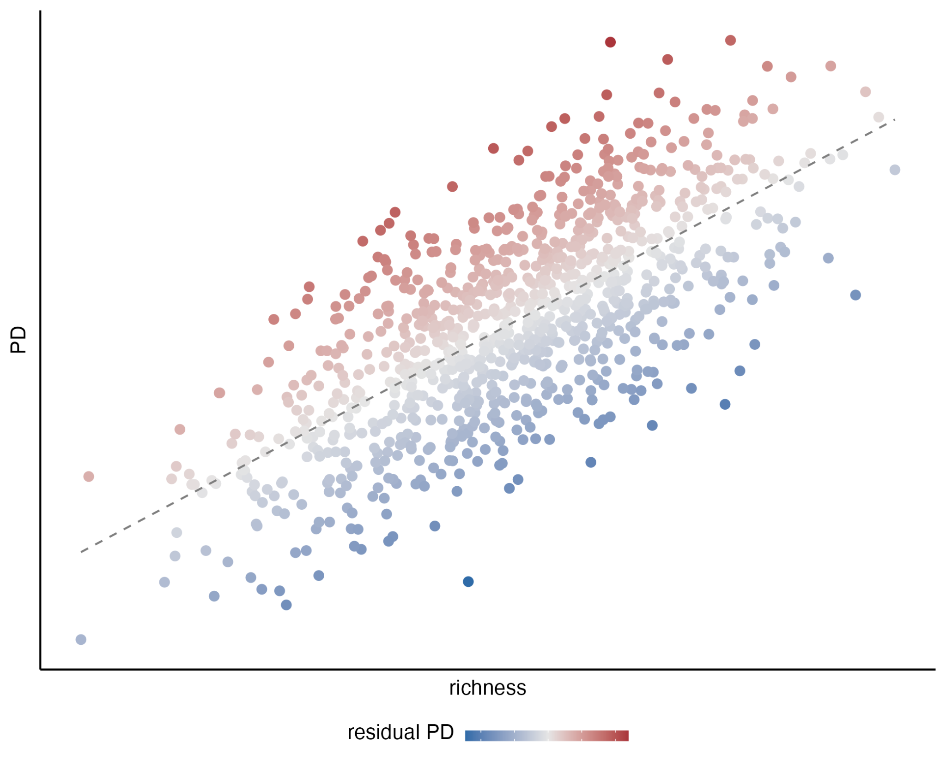

Fig. 1. Schematic representation of the relationship between species richness (X-axis) and phylogenetic diversity (Y-axis), with color representing residual phylogenetic diversity.

**Materials and Methods**

**Vertebrate data**. We obtained distribution vector data for amphibians and terrestrial mammals from IUCN (IUCN 2022), for birds from BirdLife International (http://www.birdlife.org/) and for squamates from Roll et al. (2021). Range maps for all groups were downloaded on 1 May 2022.

Phylogenetic data for all groups were downloaded from VertLife (<https://data.vertlife.org/>). This includes the consensus and posterior phylogenetic trees for amphibians (Jetz and Pyron 2018), birds (Jetz et al. 2012; we used the phylogeny built based on the backbone from Hackett et al. 2008), mammals (Upham et al. 2019), and squamates (Tonini et al. 2016).

After matching both distribution and phylogenetic data, the final datasets contained a total of 28,270 species: 5832 amphibians, 7995 birds, 5164 mammals, and 9279 squamates. These were the datasets used in subsequent analyses.

**Geographic grid and species richness**. For each amniote group, we first produced a hexagonal 100-km-resolution species richness grid using the epm package v1.1.1 (Title et al. 2022) in R 4.3.0 (R Core Team 2023), with the polygon distribution data transformed into an equal-area Behrmann projection as input and the ‘centroid’ approach. The resulting grid contains the information of the species present in each hexagonal cell, and was the base cell grid for all subsequent analyses.

**Residual phylogenetic diversity**. We obtained an average phylogenetic diversity (PD) grid after calculating PD grids for 100 trees from the posterior distribution for each amniote group. These grids were produced with the functions addPhylo and gridMetrics in epm (Title et al. 2022), and they represent the sum of the branch lengths of the phylogenetic tree connecting all species in each cell (Faith’s PD; Faith 1992). We used the R package rlist v0.4.6.2 (Ren 2021) to process the ‘posterior’ grids and ultimately obtaining a grid of average PD values. With the per-grid values of species richness and PD, we performed a local regression analysis (LOESS) and obtained the residuals from it. We then mapped these residuals again onto the original hexagonal grid to visualize the geographic distribution of the deviation of PD relative to richness (residual PD). High residual values indicate high PD for a given number of species (i.e., the species within a grid cell are more distantly related to each other than expected by the species richness of the grid cell), and, conversely, low residual PD indicates that the species present in a grid cell are more closely related to each other than predicted by species richness. To identify focal regions of particularly extreme values of residual PD, we set a threshold at 10% (i.e., lowest residual PD) and 90% (i.e., highest residual PD) from the total distribution of values from each vertebrate clade. We then visually identified regions of interest with contiguous high and low residual PD grid cells to investigate whether there are differences between them in speciation rates, lineage accumulation patterns, and environmental conditions.

**Recent speciation rates**. We estimated recent speciation rates (tip rates) calculating the average DR metric (Jetz et al. 2012) across 100 trees from the posterior distribution for each vertebrate clade. Then, we calculated mean DR values for each hexagonal grid cell. We plotted these per-cell mean DR values in the map and conducted a linear regression model of per-cell mean DR against residual PD (see above). To further understand the links between speciation rates and patterns of geographic diversity, we tested for differences in DR values between species present in regions of highest and lowest residual PD. To do this, we performed linear models with randomized residual permutations with the RRPP package v1.3.1 (Collyer and Adams 2018, 2022), first to globally compare grid cells of high and low residual PD and then to individually compare among the focal regions we identified (see above).

**Evolutionary time and lineage accumulation**. To explore whether there are differences in the age or the lineage accumulation patterns between regions of high and low residual PD, we calculated the number of lineages through time for extreme regions falling within the 10% lowest and 90% highest values of residual PD using the R package ape v5.7.1 (Paradis and Schliep 2019), with the aid of geiger v2.0.11 (Pennell et al. 2014) and phytools v1.5.1 (Revell 2012) for phylogenetic data handling. We then visually compared lineage-through-time (LTT) plots to determine whether our data reflect two main expectations: i) regions of high residual PD should exhibit comparatively older lineages than regions with low residual PD values, which might indicate that these regions acted as reservoirs of ancestral diversity, and ii) the pattern of lineage accumulation might be different between regions of high and low residual PD.

**Environmental variables**. One of the factors that may affect evolutionary processes and therefore shape geographic patterns of biodiversity is the environment in which species live. We tested the relationship between residual PD and different environmental variables: mean annual temperature, temperature seasonality, annual precipitation, precipitation seasonality, net primary productivity (NPP), and terrain roughness index (TRI, a variable representing the topographic complexity). Temperature and precipitation data were collected at a 10-minute spatial resolution (~18.5 km) from the summary data for the period between the years 1970 and 2000 contained in the WoldClim v2.1 dataset (Fick and Hijmans 2017). Net primary productivity data summarized over the period between 1981 and 2015 was obtained at 5-arc-minute resolution from the NDVI3g time series (Pinzon and Tucker 2014). The topography data were based on Wilson et al. (2007) and obtained from the ENVIREM dataset (Title and Bemmels 2018) at a spatial resolution of 10 arc-minutes. For the latter, we compared current topography values with estimated Holocene and Last Glacial Maximum values, and we did not find considerable differences, so we report only the analyses with the current values. All the environmental variables were resampled to match the spatial resolution of the hexagonal cell grid built for species richness and phylogenetic diversity (100 km), so that we could have per-cell values for every variable in order to implement regression models. Additionally, we generated three climatic spaces: one defined by temperature and precipitation, another one defined by temperature seasonality and precipitation seasonality, and a third one defined by NPP and TRI, and mapped the grid cells with lowest and highest 10% of the residual PD onto those climatic spaces to explore for potential segregation between them. Finally, we also explored how residual PD is distributed across the latitudinal gradient, to compare residual PD patterns with species richness.

**Results**

**Geographic patterns of residual phylogenetic diversity.** We found some regions with consistent patterns of residual phylogenetic diversity (PD) across all four tetrapod clades (Supp. Fig. 1). The African continent harbors overall high residual PD (i.e., individual species more distantly related to each other than expected for the species richness of the assembly) for all the four amniote clades, except for the Sahara Desert for mammals and the rainforest in central Africa for squamates. Conversely, large areas of South America contain low residual PD (species more closely related to each other than predicted by the species richness of the assembly) for all clades. In fact, Africa and South America constitute focal regions of highest and lowest residual PD, respectively, for all vertebrate clades (Fig. 2).

On the other hand, some geographic regions exhibit very contrasting patterns of residual PD among the four amniote clades. Australia is a low-residual-PD region for amphibians and especially squamates, while it harbors high residual PD for birds and mammals. Residual PD in the Indomalayan region is generally high for birds and squamates but relatively low for amphibians, while for mammals it is a very heterogeneous area with high levels in India but regions of low and high levels in Southeast Asia. North America is a region of low residual PD for birds and squamates, and of relatively high residual PD for amphibians. For mammals, there is a clear segregation in residual PD patterns between eastern (high values) and western (low values) North America. Eurasia is also a heterogeneous region across vertebrates, with generally low levels of residual PD for mammals and birds, high levels for amphibians, and areas of high and low levels for squamates. The Arabian Peninsula contains exclusively high levels of residual PD for squamates, but for mammals and birds it shows relatively low levels across the interior and high levels in the mountainous regions of the south and west (Supp. Fig. 1).

**The effect of speciation rates**. We found a statistically significant negative relationship between recent speciation rates and residual PD for all vertebrate clades (*P* <<< 0.001; Fig. 3). In other words, lineages exhibit, on average, higher recent speciation rates in regions of low residual PD (i.e., regions where species are more related to each other than predicted by the richness of the assembly), while regions of high residual PD generally have lower speciation rates. However, this negative relationship was found to be somewhat weak—with low R2 and slope coefficient values—and variable among clades (Supp. Table 1; R2amphibians = 0.005, R2birds = 0.047, R2mammals = 0.076, R2squamates = 0.13).

For all clades, we found significantly lower speciation rates in the lineages present in grid cells with the lowest residual PD relative to those present in cells with the highest residual PD (*P* = 0.001 in all cases), especially for squamates, although, attending to the effect sizes (*Z*) and the overall distribution of DR values, this difference appears to be mild (Fig. 4).

Likewise, we found significant differences in species’ DR rates among focal regions of highest and lowest residual PD, with low residual PD broadly corresponding to higher speciation rates. Nonetheless, overall, these differences are not prominently apparent (Supp. Fig. 2, Supp. Table 2). Furthermore, we did not find clearly greater differences in DR effect size (*Z*) between focal regions of highest and lowest residual PD than between different regions of high residual PD and between different regions of low residual PD (*P* = 0.467; Supp. Fig. 3). This indicates that the differences in DR rates between regions of high and low residual PD, though significant, are not of large magnitude.

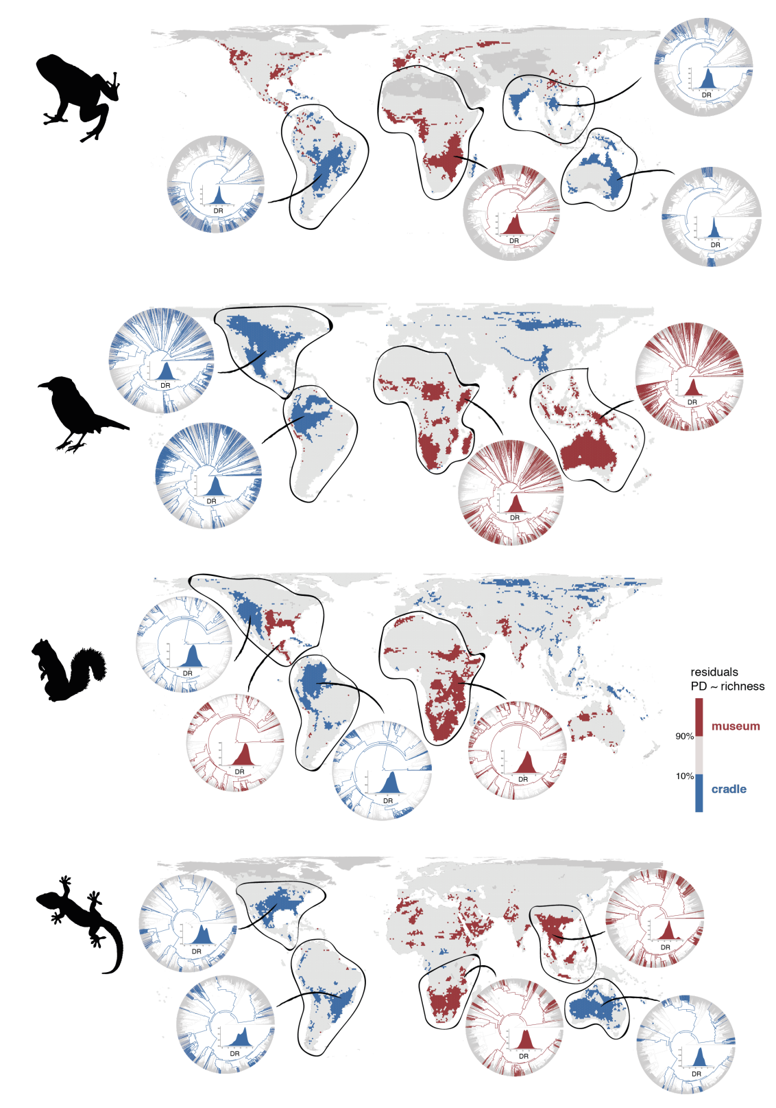

Fig. 2. Geographic distribution of areas with the 10% lowest (in blue) and highest (in red) residual PD for terrestrial vertebrates. The phylogenetic relationships of species present in focal regions are also shown to illustrate the evolutionary differences of regions with high and low residual PD. Silhouettes extracted from 'phylopic' (www.phylopic.org).

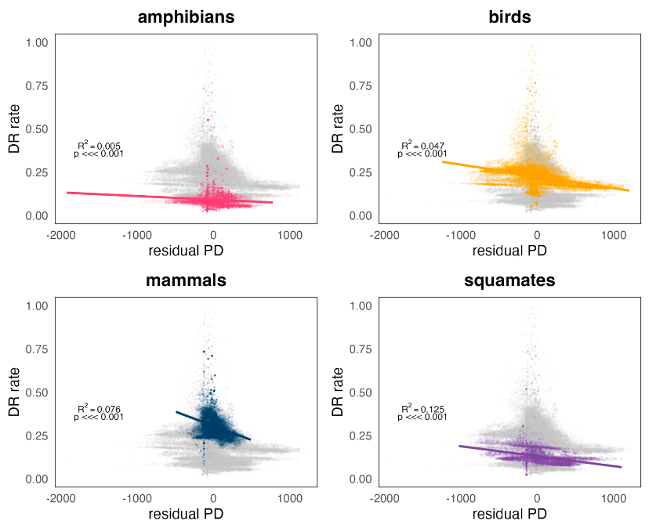

Fig. 3. Relationship between DR rates (recent speciation rates) and residual PD for all four clades of terrestrial vertebrates.

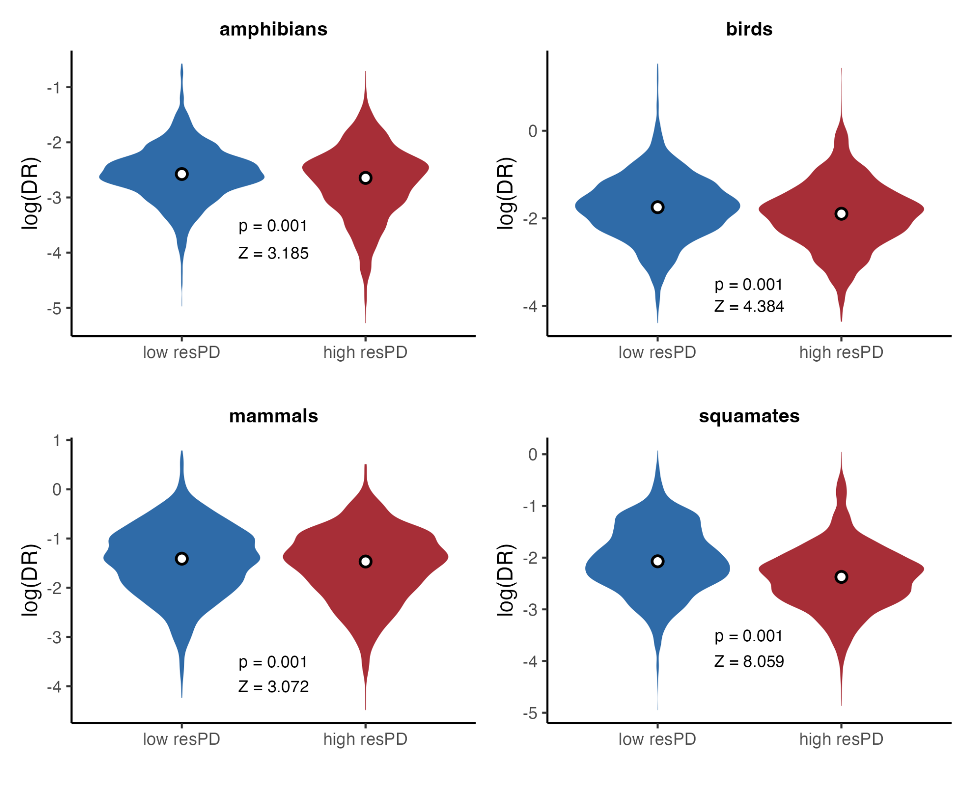

Fig. 4. Differences in DR rates (recent speciation rates) between areas of 10% lowest (in blue) and highest (in red) residual PD.

**Evolutionary time and lineage accumulation**. We did not find notable differences between focal regions of high and low residual PD in the time of origin or the pattern of accumulation of the lineages they harbor (Supp. Figs. 4-7). Specifically, we did not find the lineages in regions of high residual PD to be as old as expected, and the pace of lineage accumulation is also not clearly distinguishable between regions of low and high residual PD. Even though some regions of low residual PD do harbor younger diversity than regions of high residual PD (e.g., amphibians in Oceania relative to amphibians in Africa, Supp. Fig. 4), this is the opposite in other cases (e.g., mammals in high residual PD Africa have younger ancestors than in low residual PD regions of North and South America, Supp. Fig. 6). In most cases, the age of origin of the lineages leading to present-day species is similar in regions of high and low residual PD.

**Environmental variables**. We found an overall low to no linear relationship between residual PD and environmental variables (Supp. Figs. 8-13). There is a very weak negative relationship between annual precipitation and residual PD for all groups (Supp. Fig. 8), while the relationship with mean annual temperature is negative for amphibians and positive for the rest of vertebrate clades (Supp. Fig. 9), with mammals showing the highest amount of residual PD variance explained in both cases (precipitation R2mammals = 0.017; temperature R2mammals = 0.138). For precipitation seasonality and temperature seasonality, amphibians show an opposite trend to that of the other clades, although the variance explained is very low overall (Supp. Figs. 10 and 11). In amphibians, the correlation of residual PD with precipitation seasonality is negative (Supp. Fig. 10), whereas it is positive with temperature seasonality(Supp. Fig. 11). For the rest of vertebrates, these correlations are positive and negative, respectively. There is an extremely low correlation of residual PD with net primary productivity (NPP) for all clades (Supp. Fig. 12). With current topographic complexity (terrain roughness index, TRI), the correlation is also very low overall, but there is a somewhat clearer negative trend in birds and mammals (Supp. Fig. 13).

However, in the environmental space defined by mean annual temperature and annual precipitation, we found some segregation between regions of low and high PD for birds and mammals, but substantial overlap for amphibians and squamates (Fig. 5). In both birds and mammals, extremely low residual PD regions are characterized by two combinations: low precipitation with low to moderate temperature (which roughly correspond to areas of tundra, cold deserts and temperate grasslands; Whittaker 1975), and high precipitation with high temperature (i.e., tropical rainforest and savannah). Most of the high residual PD regions for birds and mammals, on the other hand, are found in environments with both low to moderate precipitation and high temperature (i.e., subtropical desert and savannah). However, highest residual PD regions for birds, unlike in mammals, are also found in areas with high precipitation and temperature (i.e., tropical rainforest and savannah).

The patterns of distribution of regions with high and low residual PD across the environmental space defined by precipitation seasonality and temperature seasonality, or by NPP and TRI, do not follow clearly interpretable trends. There is no apparent segregation between high and low residual PD regions (Supp. Figures 14 and 15), except perhaps for birds in the climate seasonality space, where high residual PD regions tend to be at lower temperature seasonality than regions of low residual PD (Supp. Fig. 14). Likewise, there is no apparent latitudinal gradient in residual PD for any vertebrate clade, in contrast to species richness (Supp. Fig. 16). Notably, regions of high richness for birds across different latitudinal bands coincide with low residual PD levels (Supp. Fig. 16), although there appears to be no clear relationship between richness and residual PD (which is expected given that richness and PD are highly correlated).

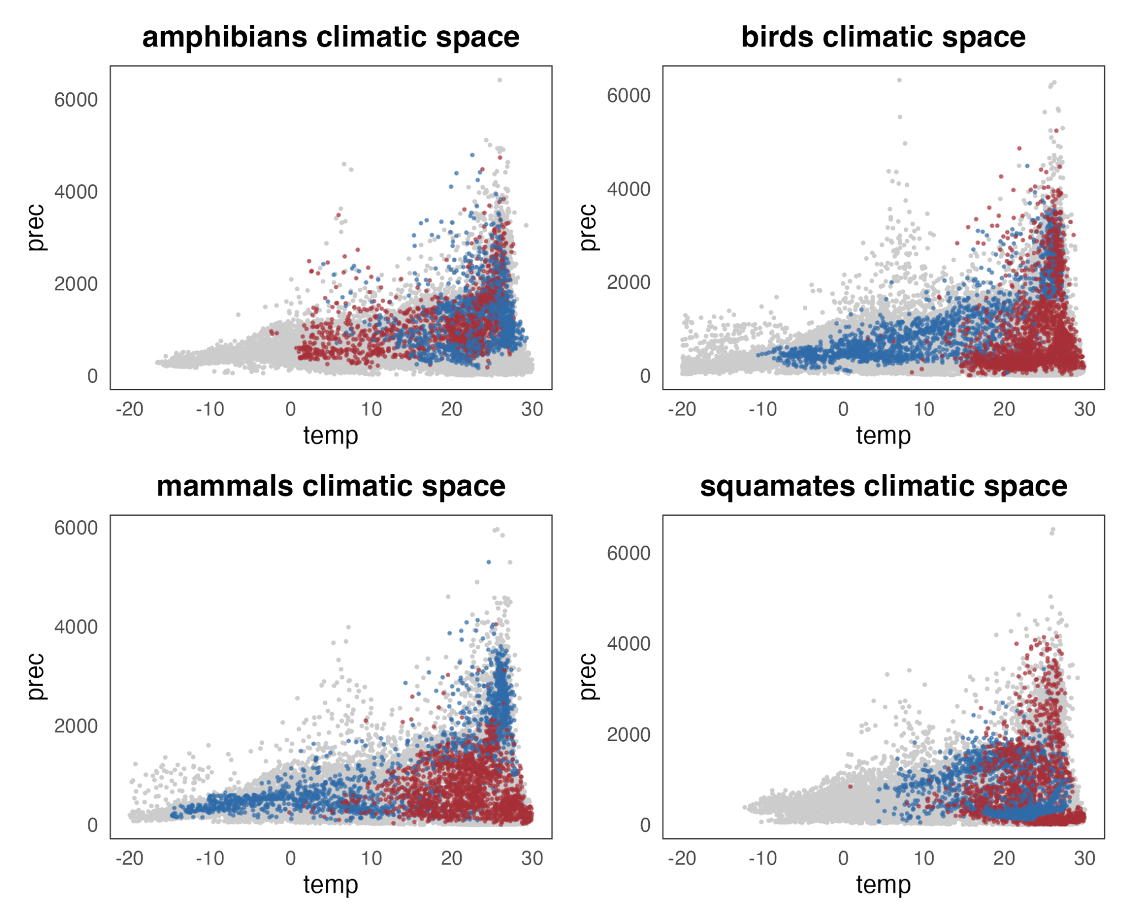

Fig. 5. Climatic space (mean annual temperature vs. annual precipitation) occupied by regions of highest (in red) and lowest (in blue) residual PD for each vertebrate clade.

**Discussion**

Our results show that the integration of phylogenetic metrics with analyses of global geographic patterns of diversity among amniotes facilitates a more holistic approach to exploring the evolutionary and ecological processes underlying current spatial patterns of biodiversity. Here, we addressed the global geographic distribution of richness-corrected phylogenetic diversity (residual PD) for four major terrestrial vertebrate clades (amphibians, birds, mammals, and squamates).

We identified the areas of greatest concentration of high and low residual PD and found entire regions with consistently low (more closely related species than predicted by their species assemblage richness) and high (more distantly related species than predicted) levels for all four tetrapod groups (Fig. 2). Furthermore, we found a slight negative relationship of recent speciation rates with residual PD (Figs. 3 and 4), indicating that recent speciation events helped generate present-day global biogeographic patterns. Finally, our results show that evolutionary time as well as most climatic variables had low to no effect on the differentiation of regions with highest and lowest residual PD (Fig. 5). Nonetheless, we identified differences between homeotherms (birds and mammals) and poikilotherms (amphibians and squamates) when considering temperature and precipitation levels in regions with highest and lowest values of residual PD. These inferences indicate that thermal physiology may have influenced global diversity patterns among amniotes.

We found that the American continent is a region of consistently low residual PD (species in regional assemblages are more closely related than expected by their richness) across vertebrate clades, and that Africa consistently harbors high levels of residual PD (species more distantly related than expected) for all groups. Previous work on mammals (Davies and Buckley 2011) suggested that high residual PD found in Africa may reflect an African origin for many extant mammal clades (Lillegraven et al. 1987). While plausible for mammals, this hypothesis does not explain this pervasive biogeographic patterning in Africa across other major terrestrial vertebrate clades that likely originated on different continents (e.g., Benson et al. 2013; Claramunt and Cracraft 2015), and instead may be indicative of other common factors related to the environmental and geological histories of the African continent. Similarly, the low residual PD observed for America, particularly South America, for all groups (Fig. 2) may have been influenced by recent diversification events in multiple extant clades, particularly following dispersal after the formation of the Isthmus of Panama, and coupled with the extinction of ancient endemic lineages (Webb 1976; Weir et al. 2009; Davies and Buckley 2011; Carrillo et al. 2020). This is also consistent with the ubiquitous negative relationship observed between residual PD and recent speciation rates which, although weak, reflects that recent speciation is likely one of the processes governing the geographic dimension of vertebrate diversity dynamics (Fig. 3). Taken together, these results may be indicative of recent climatic or geographic events (e.g., reconfiguration of continents) as primary drivers of recent speciation rates that have consequently shaped spatial patterns of extant tetrapod diversity.

In addition to abiotic processes influencing spatial patterning of diversity, biotic factors likely drove some of these observable patterns (Davies and Buckley 2011). In particular, heterogeneous geographic residual PD patterns among clades (e.g., in Eurasia and Australia; Fig. 2) may indicate that intrinsic biological characteristics (i.e., physiological, ecological, or morphological) have played a role in the generation of the observed clade-specific geographic patterns. For example, the Malay Archipelago shows particularly high residual PD for birds relative to other vertebrates, whereas parts of Australia present low residual PD for amphibians and squamates but high residual PD for mammals and birds (Fig. 2). It is plausible that these differences have arisen due to ecological and functional differences among clades, which may have determined their biogeographic and evolutionary history. The high vagility of birds likely contributed to higher residual PD values in Southeast Asia and Australia due to repeated colonization of islands in these regions (Jønsson and Fjeldså 2006; Sheldon et al. 2015). In addition, the high dispersal ability of the majority of major bird subclades resulted in the arrival and relictual permanence of lineages with widely different phylogenetic origins (Jønsson et al. 2007), as opposed to isolated radiations (and, therefore, lower PD), which may be more frequent in organisms with lower dispersal abilities (Inger and Voris 2001; Siler et al. 2012). High residual PD of squamates within Southeast Asia may be related to multiple waves of island colonization during intervals of low sea level and environmental change (How and Kitchener 1997; Voris 2000; Brown et al. 2013; Husson et al. 2020), although this also affected mammals (Van Den Bergh et al. 2001; Meijaard 2003; Mercer and Roth 2003) and amphibians (Brown et al. 2013), which do not show comparable patterns of residual PD (perhaps due to a greater effect of environmental fluctuations promoting turnover in these taxa; e.g., Wilting et al. 2012).

In contrast, the low residual PD of squamates in arid Australia, and of amphibians in the temperate woodlands of the northern and eastern coasts of Australia, likely resulted from a few extensive radiations (see the phylogenetic trees in Fig. 2). These radiations may be facilitated by adaptation and specialization within these unique biomes, leading to community assembly driven by proportionally more closely related species (Pianka 1981; Rabosky et al. 2007; Skinner et al. 2011; Vidal-García and Keogh 2015; Tejero-Cicuéndez et al. 2022b; Brennan et al. 2023). Finally, geographic patterns of residual PD may be partially generated by ancient evolutionary lineages that inhabit certain regions. This could be the case of dibamid reptiles in Southeast Asia (Townsend et al. 2011), palaeognath birds in Australia (Yonezawa et al. 2017), or marsupial mammals in Australia and North America (May-Collado et al. 2015). Additionally, passerine birds—that comprise ~60% of extant avian diversity—contribute to high residual PD in Australia due to the presence of numerous endemic lineages that are distantly related in comparison to the diverse, but generally closely-related, passerine lineages inhabiting South America (Fig. 2; Moyle et al. 2016; Oliveros et al. 2019; Harvey et al. 2020). These contrasting patterns are somewhat paradoxical considering that passerines are generally competent fliers, suggesting that there may be additional factors driving spatial diversity patterns among birds.

Previous work has identified that diversity dynamics are strongly influenced by both extrinsic (e.g., the paleogeographic history) and intrinsic (e.g., ecomorphological or niche-related) factors (James and Shine 2000; Jetz and Rahbek 2002; Badgley 2010; Pyron 2014b; Menéndez et al. 2021; Jiang et al. 2023). For instance, mountainous regions (a universally recognized driver of diversity and evolutionary processes; Hoorn et al. 2010; Rahbek et al. 2019; Perrigo et al. 2020) serve multiple functions during biodiversity generation; mountains can promote speciation due to habitat heterogeneity across an elevational gradient (acting as a source of diversity, particularly in the tropics; Cadena et al. 2011), or induce dispersal barriers (e.g., Miller et al. 2008). Mountains may also generate important refugia and reserves of cold- or humid-adapted diversity during periods of climate warming and aridification (Hampe and Jump 2011; Fjeldså et al. 2012). Likewise, deserts, which have been recurrently considered sinks of diversity (i.e., regions harboring distantly related species due to a lack of within-system diversification; Crisp et al. 2009) may harbor low levels of residual PD, as our results show in Australia for squamates and North America for birds, mammals and squamates (Fig. 2). In many cases, this may reflect large radiations of certain clades adapted to the arid conditions (e.g., Wiens et al. 2013; Rabosky et al. 2014). This ecological versatility of physiographic features may be responsible for the lack of a clear relationship between environmental variables and residual PD (Supp. Figs. 8-13), although some segregation is apparent in the climate space between the regions of highest and lowest residual PD, especially in birds and mammals (Fig. 5). This may be explained by fundamental physiological differences between homeotherms and poikilotherms (Buckley et al. 2012).

Apart from differences in trait- and environment-mediated speciation and dispersal, extinction may also be a major driver of diversity, diversification and biogeographic patterns (Jablonski 2001; Seeholzer and Brumfield 2023). Specifically, extinction events are known not only to underlie current patterns of species richness (Pyron 2014a; Meseguer and Condamine 2020), but also to substantially affect other facets of biodiversity (Erwin 2008; Pimiento et al. 2020; Brocklehurst et al. 2021). Extinction may both increase and decrease phylogenetic diversity, depending on the age of the lineages that are more prone to extinction (Daru et al. 2017). High residual PD regions may result from the higher extinction rates of species from relatively recent radiations, mainly reducing species assemblages to taxa with more distant evolutionary relationships, whereas low residual PD may arise in regions where extinction rates are higher for relatively old diversity (Vasconcelos et al. 2022). The exploration of extinction dynamics and, critically, the inclusion of fossil data (which enables better estimates of extinction and deeper speciation events), will help to further disentangle the factors underpinning geographic patterns of vertebrate diversity.

Moving forward, our methodology to quantify spatial phylogenetic diversity may help to inform conservation policies beyond the species richness hotspot and endemism strategies (Myers et al. 2000). Integrating evolutionary relationships at a regional scale has been stated as a necessary step for global conservation efforts for decades (Faith 1992). Assessing patterns of residual PD for focal clades would inform on which regions harbor the highest lineage diversity (highest residual PD), facilitating efforts to maximize conservation of phylogenetically distinct lineages and help to preserve larger portions of the evolutionary history of entire clades. Additionally, regions with the lowest residual PD that may be acting as sources of diversity (Meseguer et al. 2020) can be considered in conservation initiatives as priority areas in order to safeguard the generation of new biodiversity. Furthermore, integrating palaeontological data into our method would facilitate a novel, multidisciplinary approach for utilizing deep time data for species conservation prioritization (Pimiento and Antonelli 2022).

**References**

Allee W.C. 1926. Distribution of Animals in a Tropical Rain-Forest with Relation to Environmental Factors. Ecology. 7:445–468.

Allen A.P., Gillooly J.F., Savage V.M., Brown J.H. 2006. Kinetic effects of temperature on rates of genetic divergence and speciation. Proceedings of the National Academy of Sciences of the United States of America. 103:9130–9135.

Anderson S. 1974. Patterns of Faunal Evolution. The Quarterly Review of Biology. 49:311–332.

Badgley C. 2010. Tectonics, topography, and mammalian diversity. Ecography. 33:220–231.

Badgley C., Smiley T.M., Terry R., Davis E.B., DeSantis L.R.G., Fox D.L., Hopkins S.S.B., Jezkova T., Matocq M.D., Matzke N., McGuire J.L., Mulch A., Riddle B.R., Roth V.L., Samuels J.X., Strömberg C.A.E., Yanites B.J. 2017. Biodiversity and Topographic Complexity: Modern and Geohistorical Perspectives. Trends in Ecology and Evolution. 32:211–226.

Benson R.B.J., Mannion P.D., Butler R.J., Upchurch P., Goswami A., Evans S.E. 2013. Cretaceous tetrapod fossil record sampling and faunal turnover: Implications for biogeography and the rise of modern clades. Palaeogeography, Palaeoclimatology, Palaeoecology. 372:88–107.

Brennan I.G., Lemmon A.R., Lemmon E.M., Hoskin C.J., Donnellan S.C., Keogh J.S. 2023. Populating a Continent: Phylogenomics Reveal the Timing of Australian Frog Diversification. Systematic Biology.:syad048.

Brocklehurst N., Panciroli E., Benevento G.L., Benson R.B.J. 2021. Mammaliaform extinctions as a driver of the morphological radiation of Cenozoic mammals. Current Biology. 31:2955-2963.e4.

Brown R.M., Siler C.D., Oliveros C.H., Esselstyn J.A., Diesmos A.C., Hosner P.A., Linkem C.W., Barley A.J., Oaks J.R., Sanguila M.B., Welton L.J., Blackburn D.C., Moyle R.G., Townsend Peterson A., Alcala A.C. 2013. Evolutionary processes of diversification in a model island archipelago. Annual Review of Ecology, Evolution, and Systematics. 44:411–435.

Buckley L.B., Hurlbert A.H., Jetz W. 2012. Broad-scale ecological implications of ectothermy and endothermy in changing environments. Global Ecology and Biogeography. 21:873–885.

Cadena C.D., Kozak K.H., Gómez J.P., Parra J.L., McCain C.M., Bowie R.C.K., Carnaval A.C., Moritz C., Rahbek C., Roberts T.E., Sanders N.J., Schneider C.J., VanDerWal J., Zamudio K.R., Graham C.H. 2011. Latitude, elevational climatic zonation and speciation in New World vertebrates. Proceedings of the Royal Society B: Biological Sciences. 279:194–201.

de Candolle A.L.P.P. 1859. On the Causes which Limit Vegetable Species Towards the North, in Europe and Similar Regions. Annual Report of the Board of Regents of the Smithsonian Institution for the Year 1858.:237–245.

Carrillo J.D., Faurby S., Silvestro D., Jaramillo C., Bacon C.D., Antonelli A. 2020. Disproportionate extinction of South American mammals drove the asymmetry of the Great American Biotic Interchange. Proceedings of the National Academy of Sciences.:1–7.

Chazot N., Condamine F.L., Dudas G., Peña C., Matos-Maraví P., Freitas A.V.L., Willmott K.R., Elias M., Warren A., Aduse-Poku K., Lohman D.J., Penz C.M., DeVries P., Kodandaramaiah U., Fric Z.F., Nylin S., Müller C., Wheat C., Kawahara A.Y., Silva-Brandão K.L., Lamas G., Zubek A., Ortiz-Acevedo E., Vila R., Vane-Wright R.I., Mullen S.P., Jiggins C.D., Slamova I., Wahlberg N. 2021. Conserved ancestral tropical niche but different continental histories explain the latitudinal diversity gradient in brush-footed butterflies. Nature Communications. 12:5717.

Chesson P. 2000. Mechanisms of Maintenance of Species Diversity. Annual Review of Ecology and Systematics. 31:343–366.

Claramunt S., Cracraft J. 2015. A new time tree reveals Earth history’s imprint on the evolution of modern birds. Sci. Adv. 1:e1501005.

Collyer M.L., Adams D.C. 2018. RRPP: An r package for fitting linear models to high-dimensional data using residual randomization. Methods in Ecology and Evolution. 9:1772–1779.

Collyer M.L., Adams D.C. 2022. RRPP: Linear Model Evaluation with Randomized Residuals in a Permutation Procedure. .

Crisp M.D., Arroyo M.T.K., Cook L.G., Gandolfo M.A., Jordan G.J., McGlone M.S., Weston P.H., Westoby M., Wilf P., Linder H.P. 2009. Phylogenetic biome conservatism on a global scale. Nature. 458:754–756.

Currie D.J., Mittelbach G.G., Cornell H.V., Field R., Guégan J.-F., Hawkins B.A., Kaufman D.M., Kerr J.T., Oberdorff T., O’Brien E., Turner J.R.G. 2004. Predictions and tests of climate-based hypotheses of broad-scale variation in taxonomic richness. Ecology Letters. 7:1121–1134.

Daru B.H., Elliott T.L., Park D.S., Davies T.J. 2017. Understanding the Processes Underpinning Patterns of Phylogenetic Regionalization. Trends in Ecology & Evolution. 32:845–860.

Darwin C. 1859. On the Origin of Species by Means of Natural Selection, or the Preservation of Favoured Races in the Struggle for Life. London, UK: John Murray.

Davies T.J., Buckley L.B. 2011. Phylogenetic diversity as a window into the evolutionary and biogeographic histories of present-day richness gradients for mammals. Philosophical Transactions of the Royal Society B: Biological Sciences. 366:2414–2425.

Dobzhansky T. 1950. Evolution in the tropics. American Scientist. 38:209–221.

Earl C., Belitz M.W., Laffan S.W., Barve V., Barve N., Soltis D.E., Allen J.M., Soltis P.S., Mishler B.D., Kawahara A.Y., Guralnick R. 2021. Spatial phylogenetics of butterflies in relation to environmental drivers and angiosperm diversity across North America. iScience. 24:102239.

Erwin D.H. 2008. Extinction as the loss of evolutionary history. Proceedings of the National Academy of Sciences. 105:11520–11527.

Faith D.P. 1992. Conservation evaluation and phylogenetic diversity. Biological Conservation. 61:1–10.

Fick S.E., Hijmans R.J. 2017. WorldClim 2: new 1-km spatial resolution climate surfaces for global land areas. International Journal of Climatology. 37:4302–4315.

Fischer A.G. 1960. Latitudinal variations in organic diversity. Evolution. 14:64–81.

Fjeldså J., Bowie R.C.K., Rahbek C. 2012. The Role of Mountain Ranges in the Diversification of Birds. Annual Review of Ecology, Evolution, and Systematics. 43:249–265.

Freeman B.G., Weeks T., Schluter D., Tobias J.A. 2022. The latitudinal gradient in rates of evolution for bird beaks, a species interaction trait. Ecology Letters. 25:635–646.

Fritz S.A., Rahbek C. 2012. Global patterns of amphibian phylogenetic diversity. Journal of biogeography. 39:1373–1382.

Futuyma D.J. 2015. Can Modern Evolutionary Theory Explain Macroevolution? In: Serrelli E., Gontier N., editors. Macroevolution: Explanation, Interpretation and Evidence. Switzerland: Springer International Publishing.

Gause G.F. 1934. The struggle for existence. Baltimore, Maryland: Williams and Wilkins.

Gumbs R., Gray C.L., Böhm M., Hoffmann M., Grenyer R., Jetz W., Meiri S., Roll U., Owen N.R., Rosindell J. 2020. Global priorities for conservation of reptilian phylogenetic diversity in the face of human impacts. Nat Commun. 11:2616.

Hackett S.J., Kimball R.T., Reddy S., Bowie R.C.K., Braun E.L., Braun M.J., Chojnowski J.L., Cox W.A., Han K.-L., Harshman J., Huddleston C.J., Marks B.D., Miglia K.J., Moore W.S., Sheldon F.H., Steadman D.W., Witt C.C., Yuri T. 2008. A Phylogenomic Study of Birds Reveals Their Evolutionary History. Science. 320:1763–1768.

Hampe A., Jump A.S. 2011. Climate Relicts: Past, Present, Future. Annual Review of Ecology, Evolution, and Systematics. 42:313–333.

Hardin G. 1960. The Competitive Exclusion Principle: An idea that took a century to be born has implications in ecology, economics, and genetics. Science. 131:1292–1297.

Harmon L.J. 2012. An Inordinate Fondness for Eukaryotic Diversity. PLoS Biology. 10:8–11.

Harvey MG, Bravo GA, Claramunt S, Cuervo AM, Derryberry GE, Battilana J, Seeholzer GF, McKay JS, O’Meara BC, Faircloth BC, Edwards SV. 2020. The evolution of a tropical biodiversity hotspot. Science. 370(6522):1343-8.

Heard S.B., Hauser D.L. 1995. Key evolutionary innovations and their ecological mechanisms. Historical Biology. 10:151–173.

HilleRisLambers J., Adler P.B., Harpole W.S., Levine J.M., Mayfield M.M. 2012. Rethinking Community Assembly through the Lens of Coexistence Theory. Annual Review of Ecology, Evolution, and Systematics. 43:227–248.

Hoorn C., Wesselingh F.P., ter Steege H., Bermudez M.A., Mora A., Sevink J., Sanmartín I., Sanchez-Meseguer A., Anderson C.L., Figueiredo J.P., Jaramillo C., Riff D., Negri F.R., Hooghiemstra H., Lundberg J., Stadler T., Särkinen T., Antonelli A. 2010. Amazonia Through Time: Andean Uplift, Climate Change, Landscape Evolution, and Biodiversity. Science. 330:927–931.

How R.A., Kitchener D.J. 1997. Biogeography of Indonesian snakes. Journal of Biogeography. 24:725–735.

Humboldt A. von, Bonpland A. 1807. Essai sur la géographie des plantes. Paris, France: Schoell.

Husson L., Boucher F.C., Sarr A.-C., Sepulchre P., Cahyarini S.Y. 2020. Evidence of Sundaland’s subsidence requires revisiting its biogeography. Journal of Biogeography. 47:843–853.

Inger R.F., Voris H.K. 2001. The biogeographical relations of the frogs and snakes of Sundaland. Journal of Biogeography. 28:863–891.

IUCN. 2022. The IUCN Red List of Threatened Species. Version 2022-2. Available from https://www.iucnredlist.org.

Jablonski D. 2001. Lessons from the past: Evolutionary impacts of mass extinctions. Proceedings of the National Academy of Sciences. 98:5393–5398.

James C.D., Shine R. 2000. Why are there so many coexisting species of lizards in Australian deserts? Oecologia. 125:127–141.

Jetz W., Pyron R.A. 2018. The interplay of past diversification and evolutionary isolation with present imperilment across the amphibian tree of life. Nature Ecology and Evolution. 2:850–858.

Jetz W., Rahbek C. 2002. Geographic range size and determinants of avian species richness. Science. 297:1548–1551.

Jetz W., Thomas G.H., Joy J.B., Hartmann K., Mooers A.O. 2012. The global diversity of birds in space and time (Sup). Nature. 491:444–448.

Jiang K., Wang Q., Dimitrov D., Luo A., Xu X., Su X., Liu Y., Li Y., Li Y., Wang Z. 2023. Evolutionary history and global angiosperm species richness–climate relationships. Global Ecology and Biogeography. 32:1059–1072.

Jønsson K.A., Fjeldså J. 2006. Determining biogeographical patterns of dispersal and diversification in oscine passerine birds in Australia, Southeast Asia and Africa. Journal of Biogeography. 33:1155–1165.

Jønsson K.A., Fjeldså J., Ericson P.G.P., Irestedt M. 2007. Systematic placement of an enigmatic Southeast Asian taxon *Eupetes macrocerus* and implications for the biogeography of a main songbird radiation, the Passerida. Biology Letters. 3:323–326.

Lillegraven J.A., Thompson S.D., McNab B.K., Patton J.L. 1987. The origin of eutherian mammals. Biological Journal of the Linnean Society. 32:281–336.

Macarthur R., Levins R. 1967. The Limiting Similarity, Convergence, and Divergence of Coexisting Species. The American Naturalist. 101:377–385.

MacArthur R.H. 1965. Patterns of Species Diversity. Biological Reviews. 40:510–533.

Matthew W.D. 1915. Climate and evolution. Annals of the New York Academy of Sciences. 24:171–318.

May-Collado L.J., Kilpatrick C.W., Agnarsson I. 2015. Mammals from ‘down under’: a multi-gene species-level phylogeny of marsupial mammals (Mammalia, Metatheria). PeerJ. 3:e805.

Meijaard E. 2003. Mammals of south-east Asian islands and their Late Pleistocene environments. Journal of Biogeography. 30:1245–1257.

Menéndez I., Gómez Cano A.R., Cantalapiedra J.L., Peláez-Campomanes P., Álvarez-Sierra M.Á., Hernández Fernández M. 2021. A multi-layered approach to the diversification of squirrels. Mammal Review. 51:66–81.

Mercer J.M., Roth V.L. 2003. The Effects of Cenozoic Global Change on Squirrel Phylogeny. Science. 299:1568–1572.

Meseguer A.S., Antoine P.-O., Fouquet A., Delsuc F., Condamine F.L. 2020. The role of the Neotropics as a source of world tetrapod biodiversity. Global Ecology and Biogeography. 29:1565–1578.

Meseguer A.S., Condamine F.L. 2020. Ancient tropical extinctions at high latitudes contributed to the latitudinal diversity gradient. Evolution. 74:1966–1987.

Miller E.C., Román-Palacios C. 2021. Evolutionary time best explains the latitudinal diversity gradient of living freshwater fish diversity. Global Ecology and Biogeography. 30:749–763.

Miller M.J., Bermingham E., Klicka J., Escalante P., do Amaral F.S.R., Weir J.T., Winker K. 2008. Out of Amazonia again and again: episodic crossing of the Andes promotes diversification in a lowland forest flycatcher. Proceedings of the Royal Society B: Biological Sciences. 275:1133–1142.

Mishler B.D. 2023. Spatial phylogenetics. Journal of Biogeography. n/a.

Mittelbach G.G., Schemske D.W., Cornell H.V., Allen A.P., Brown J.M., Bush M.B., Harrison S.P., Hurlbert A.H., Knowlton N., Lessios H.A., McCain C.M., McCune A.R., McDade L.A., McPeek M.A., Near T.J., Price T.D., Ricklefs R.E., Roy K., Sax D.F., Schluter D., Sobel J.M., Turelli M. 2007. Evolution and the latitudinal diversity gradient: Speciation, extinction and biogeography. Ecology Letters. 10:315–331.

Moyle RG, Oliveros CH, Andersen MJ, Hosner PA, Benz BW, Manthey JD, Travers SL, Brown RM, Faircloth BC. 2016. Tectonic collision and uplift of Wallacea triggered the global songbird radiation. Nature Communications. 7(1):12709.

Moore B. 1920. The Ecological Society and Its Opportunity. Science. 51:67–68.

Myers N., Mittermeier R.A., Mittermeier C.G., da Fonseca G.A.B., Kent J. 2000. Biodiversity hotspots for conservation priorities. Nature. 403:853–858.

Oliveros CH, Field DJ, Ksepka DT, Barker FK, Aleixo A, Andersen MJ, Alström P, Benz BW, Braun EL, Braun MJ, Bravo GA. 2019. Earth history and the passerine superradiation. Proceedings of the National Academy of Sciences. 116(16):7916-25.

Paradis E., Schliep K. 2019. ape 5.0: an environment for modern phylogenetics and evolutionary analyses in R. Bioinformatics. 35:526–528.

Pennell M.W., Eastman J.M., Slater G.J., Brown J.W., Uyeda J.C., Fitzjohn R.G., Alfaro M.E., Harmon L.J. 2014. Geiger v2.0: An expanded suite of methods for fitting macroevolutionary models to phylogenetic trees. Bioinformatics. 30:2216–2218.

Perrigo A., Hoorn C., Antonelli A. 2020. Why mountains matter for biodiversity. Journal of Biogeography.:315–325.

Pianka E.R. 1981. Diversity and adaptive radiations of Australian desert lizards. Ecological biogeography of Australia. p. 1376–1392.

Pimiento, C. and Antonelli, A., 2022. Integrating deep-time palaeontology in conservation prioritisation. Frontiers in Ecology and Evolution, 10, p.959364.

Pimiento C., Bacon C.D., Silvestro D., Hendy A., Jaramillo C., Zizka A., Meyer X., Antonelli A., Bacon C.D. 2020. Selective extinction against redundant species buffers functional diversity. Proceedings of the Royal Society B: Biological Sciences. 287:20201162.

Pinzon J.E., Tucker C.J. 2014. A non-stationary 1981-2012 AVHRR NDVI3g time series. Remote Sensing. 6:6929–6960.

Pyron R.A. 2014a. Temperate extinction in squamate reptiles and the roots of latitudinal diversity gradients. Global Ecology and Biogeography. 23:1126–1134.

Pyron R.A. 2014b. Biogeographic analysis reveals ancient continental vicariance and recent oceanic dispersal in amphibians. Systematic Biology. 63:779–797.

Pyron R.A., Costa G.C., Patten M.A., Burbrink F.T. 2015. Phylogenetic niche conservatism and the evolutionary basis of ecological speciation. Biological Reviews. 90:1248–1262.

R Core Team. 2023. R: A Language and Environment for Statistical Computing. Vienna, Austria: R Foundation for Statistical Computing.

Rabosky D.L. 2009. Ecological limits and diversification rate: Alternative paradigms to explain the variation in species richness among clades and regions. Ecology Letters. 12:735–743.

Rabosky D.L., Donnellan S.C., Talaba A.L., Lovette I.J. 2007. Exceptional among-lineage variation in diversification rates during the radiation of Australia’s most diverse vertebrate clade. Proceedings of the Royal Society B: Biological Sciences. 274:2915–2923.

Rabosky D.L., Hutchinson M.N., Donnellan S.C., Talaba A.L., Lovette I.J. 2014. Phylogenetic disassembly of species boundaries in a widespread group of Australian skinks (Scincidae: *Ctenotus*). Molecular Phylogenetics and Evolution. 77:71–82.

Rahbek C., Borregaard M.K., Antonelli A., Colwell R.K., Holt B.G., Nogues-Bravo D., Rasmussen C.M.Ø., Richardson K., Rosing M.T., Whittaker R.J., Fjeldså J. 2019. Building mountain biodiversity: Geological and evolutionary processes. Science (New York, N.Y.). 365:1114–1119.

Redding D.W., Mooers A.O. 2006. Incorporating evolutionary measures into conservation prioritization. Conservation Biology. 20:1670–1678.

Ren K. 2021. rlist: A toolbox for non-tabular data manipulation. .

Revell L.J. 2012. phytools: An R package for phylogenetic comparative biology (and other things). Methods in Ecology and Evolution. 3:217–223.

Ricklefs R.E. 1987. Community Diversity: relative roles of local and regional processes. Science. 235:167–171.

Ricklefs R.E. 2004. A comprehensive framework for global patterns in biodiversity. Ecology Letters. 7:1–15.

Ricklefs R.E. 2006. Evolutionary diversification and the origin of the diversity-environment relationship. Ecology. 87:3–13.

Roll U., Meiri S., Farrell M., Davies J., Gittleman J., Wiens J., Stephens P. 2021. GARD 1.5 range shapefiles used in: Global diversity patterns are explained by diversification rates at ancient, not shallow, timescales. .

Romdal T.S., Araújo M.B., Rahbek C. 2013. Life on a tropical planet: niche conservatism and the global diversity gradient. Global Ecology and Biogeography. 22:344–350.

Ruthven A.G. 1920. The Environmental Factors in the Distribution of Animals. Geographical Review. 10:241–248.

Saupe E.E. 2023. Explanations for latitudinal diversity gradients must invoke rate variation. Proceedings of the National Academy of Sciences. 120:e2306220120.

Schemske D.W., Mittelbach G.G., Cornell H.V., Sobel J.M., Roy K. 2009. Is There a Latitudinal Gradient in the Importance of Biotic Interactions? Annual Review of Ecology, Evolution, and Systematics. 40:245–269.

Seeholzer G.F., Brumfield R.T. 2023. Speciation-by-Extinction. Systematic Biology.:syad049.

Sheldon F.H., Lim H.C., Moyle R.G. 2015. Return to the Malay Archipelago: the biogeography of Sundaic rainforest birds. J Ornithol. 156:91–113.

Siler C.D., Oaks J.R., Welton L.J., Linkem C.W., Swab J.C., Diesmos A.C., Brown R.M. 2012. Did geckos ride the Palawan raft to the Philippines? Journal of Biogeography. 39:1217–1234.

Skinner A., Hugall A.F., Hutchinson M.N. 2011. Lygosomine phylogeny and the origins of Australian scincid lizards. Journal of Biogeography. 38:1044–1058.

Stebbins G.L. 1974. Flowering plants: evolution above the species level. Harvard University Press.

Stephens P.R., Wiens J.J. 2003. Explaining species richness from continents to communities: The time-for-speciation effect in emydid turtles. American Naturalist. 161:112–128.

Tejero-Cicuéndez H., Patton A.H., Caetano D.S., Šmíd J., Harmon L.J., Carranza S. 2022a. Reconstructing Squamate Biogeography in Afro-Arabia Reveals the Influence of a Complex and Dynamic Geologic Past. Systematic Biology. 71:261–272.

Tejero-Cicuéndez H., Tarroso P., Carranza S., Rabosky D.L. 2022b. Desert lizard diversity worldwide: Effects of environment, time, and evolutionary rate. Global Ecology and Biogeography. 31:776–790.

Thompson J.B., Davis K.E., Dodd H.O., Wills M.A., Priest N.K. 2023. Speciation across the Earth driven by global cooling in terrestrial orchids. Proceedings of the National Academy of Sciences. 120:e2102408120.

Title P.O., Bemmels J.B. 2018. ENVIREM: an expanded set of bioclimatic and topographic variables increases flexibility and improves performance of ecological niche modeling. Ecography. 41:291–307.

Title P.O., Swiderski D.L., Zelditch M.L. 2022. EcoPhyloMapper: An r package for integrating geographical ranges, phylogeny and morphology. Methods in Ecology and Evolution. 13:1912–1922.

Tonini J.F.R., Beard K.H., Ferreira R.B., Jetz W., Pyron R.A. 2016. Fully-sampled phylogenies of squamates reveal evolutionary patterns in threat status. Biological Conservation. 204:23–31.

Townsend T.M., Leavitt D.H., Reeder T.W. 2011. Intercontinental dispersal by a microendemic burrowing reptile (Dibamidae). Proceedings of the Royal Society B: Biological Sciences. 278:2568–2574.

Tucker C.M., Cadotte M.W. 2013. Unifying measures of biodiversity: understanding when richness and phylogenetic diversity should be congruent. Diversity and Distributions. 19:845–854.

Tucker C.M., Cadotte M.W., Carvalho S.B., Davies T.J., Ferrier S., Fritz S.A., Grenyer R., Helmus M.R., Jin L.S., Mooers A.O., Pavoine S., Purschke O., Redding D.W., Rosauer D.F., Winter M., Mazel F. 2017. A guide to phylogenetic metrics for conservation, community ecology and macroecology. Biological Reviews. 92:698–715.

Upham N.S., Esselstyn J.A., Jetz W. 2019. Inferring the mammal tree: Species-level sets of phylogenies for questions in ecology, evolution, and conservation. PLoS Biology. 17:1–44.

Van Den Bergh G.D., De Vos J., Sondaar P.Y. 2001. The Late Quaternary palaeogeography of mammal evolution in the Indonesian Archipelago. Palaeogeography, Palaeoclimatology, Palaeoecology. 171:385–408.

Vasconcelos T., O’Meara B.C., Beaulieu J.M. 2022. Retiring “Cradles” and “Museums” of Biodiversity. The American Naturalist. 199:195–204.

Vásquez-Restrepo J.D., Ochoa-Ochoa L.M., Flores-Villela O., Velasco J.A. 2023. Deconstructing the dimensions of alpha diversity in squamate reptiles (Reptilia: Squamata) across the Americas. Global Ecology and Biogeography. 32:250–266.

Velasco J.A., Pinto-Ledezma J.N. 2022. Mapping species diversification metrics in macroecology: Prospects and challenges. Frontiers in Ecology and Evolution. 10.

Vidal-García M., Keogh J.S. 2015. Convergent evolution across the Australian continent: ecotype diversification drives morphological convergence in two distantly related clades of Australian frogs. Journal of Evolutionary Biology. 28:2136–2151.

Voris H.K. 2000. Maps of Pleistocene sea levels in Southeast Asia: shorelines, river systems and time durations. Journal of Biogeography. 27:1153–1167.

Voskamp A., Baker D.J., Stephens P.A., Valdes P.J., Willis S.G. 2017. Global patterns in the divergence between phylogenetic diversity and species richness in terrestrial birds. Journal of Biogeography. 44:709–721.

Wallace A.R. 1876. The geographical distribution of animals. New York, USA: Harper and Brothers.

Wallace A.R. 1878. Tropical nature, and other essays. Macmillan and Company.

Webb D.S. 1976. Mammalian faunal dynamics of the great American interchange. Paleobiology. 2:220–234.

Weir J.T., Bermingham E., Schluter D. 2009. The Great American Biotic Interchange in birds. Proceedings of the National Academy of Sciences. 106:21737–21742.

Whittaker R.H. 1975. Communities and ecosystems. Macmillan Publishing.

Wiens J.J. 2011. The causes of species richness patterns across space, time, and clades and the role of “ecological limits.” Quarterly Review of Biology. 86:75–96.

Wiens J.J., Kozak K.H., Silva N. 2013. Diversity and niche evolution along aridity gradients in North American lizards (Phrynosomatidae). Evolution. 67:1715–1728.

Wilson M.F.J., O’Connell B., Brown C., Guinan J.C., Grehan A.J. 2007. Multiscale Terrain Analysis of Multibeam Bathymetry Data for Habitat Mapping on the Continental Slope. Marine Geodesy. 30:3–35.

Wilting A., Sollmann R., Meijaard E., Helgen K.M., Fickel J. 2012. Mentawai’s endemic, relictual fauna: is it evidence for Pleistocene extinctions on Sumatra? Journal of Biogeography. 39:1608–1620.

Yonezawa T., Segawa T., Mori H., Campos P.F., Hongoh Y., Endo H., Akiyoshi A., Kohno N., Nishida S., Wu J., Jin H., Adachi J., Kishino H., Kurokawa K., Nogi Y., Tanabe H., Mukoyama H., Yoshida K., Rasoamiaramanana A., Yamagishi S., Hayashi Y., Yoshida A., Koike H., Akishinonomiya F., Willerslev E., Hasegawa M. 2017. Phylogenomics and Morphology of Extinct Paleognaths Reveal the Origin and Evolution of the Ratites. Current Biology. 27:68–77.