Animation (Ken Lin)
I used Three.js to make the cookies appear one by one instead of showing everything at once. Each cookie jumps from below the plate and goes upward into its final position. I added a bounce effect to make it a little more fun.
I also gave each cookie a little delay. The plate is just there, and different cookies show up one by one. After the cookies reach their final positions, they move slightly up and down to keep the scene from looking completely still… kind of like a minecraft item on the ground.
The entire scene also slowly rotates so users can see it from different angles. Users can also use the mouse to rotate/pan the camera and zoom in or out.
Simplified part of the code:
function animate() {
requestAnimationFrame(animate);

const t = clock.getElapsedTime();

scene.rotation.y =
Math.sin(t * 0.15) * 0.15 + t * 0.05;

meshes.forEach(function(m) {
const d = m.userData;

if (t >= d.delay) {
m.visible = true;

const progress =
Math.min((t - d.delay) * d.speed, 1);

m.position.y =
d.startY +
(d.targetY - d.startY) *
easeOutBounce(progress);
}
});

controls.update();
renderer.render(scene, camera);
}
The final result is a short entrance animation where the Chinese New Year cookies bounce onto the plate one at a time. This makes the scene more dynamic and gives the project a hint of some personality.
Figure: Final animated Three.js scene
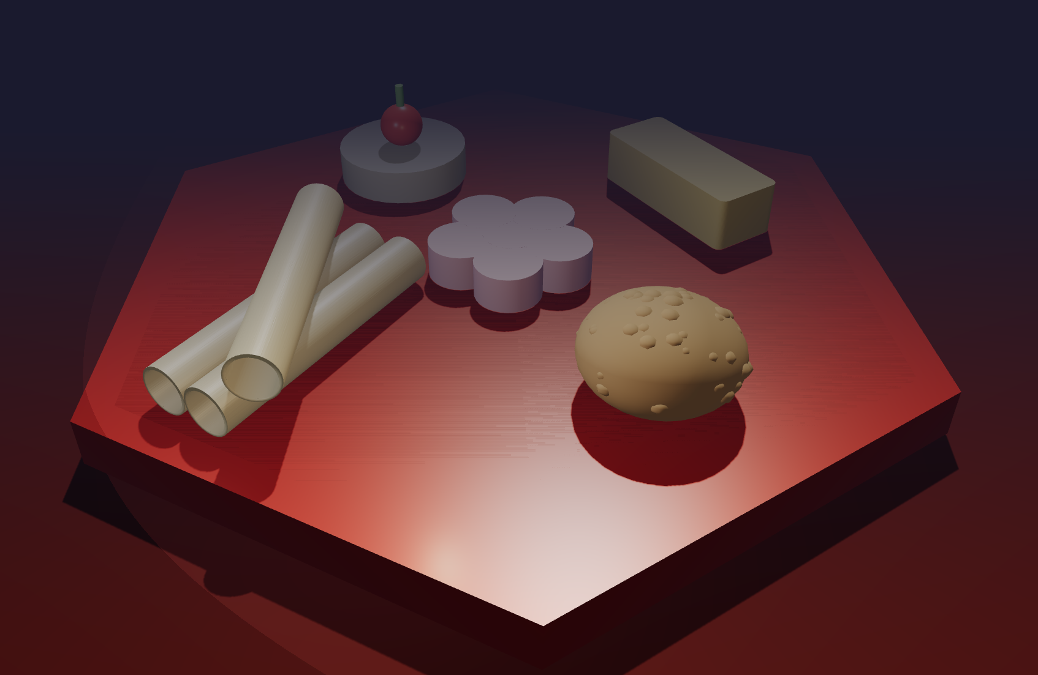
（It's an image not a video so just imagine them moving.)

Modeling (Ray Zhao)
In the modeling part, I used AI to help make the cookies. Firstly, I wrote a detailed pormpt, giving AI an identity, an expert in modeling with Openscad. Then I gave following requests:
Project Requirements
- Use procedural modeling in OpenSCAD (CSG: Constructive Solid Geometry)
- Each cookie must be an independent module
- Use Boolean operations: union / difference / intersection
- Use transformations: translate / rotate / scale
- Use color() for different parts, with RGB arrays
- Final output exported as .stl files for THREE.js animation rendering
Models Required: 4–5 Cookie Types + 1 Container
1. Pineapple Tart
- Square or round cookie body, approximately 30×30×12 mm
- Criss-cross grid pattern on top surface (carved with difference as shallow grooves)
- Golden-yellow body with slightly rounded edges
2. Peanut Cookie
- Slightly flattened sphere, diameter ~25 mm, height ~15 mm
- Surface has peanut crumb texture (use multiple randomly positioned small spheres or scale deformation)
- Light brown color
3. Love Letter (Kuih Kapit)
- Thin-walled hollow cylinder, outer diameter ~20 mm, wall thickness ~2 mm, length ~60 mm
- Can be placed at a slight tilt
- Pale golden-yellow with subtle baking texture bumps
4. Butter Cookie with Cherry
- Round cookie base (flat cylinder), diameter ~30 mm, height ~8 mm
- Cherry on top center: small hemisphere (red) + thin cylindrical stem (green)
- Base: light yellow; cherry: red
5. Flower Cookie (Bonus)
- Use a for loop to arrange 5 circular petals around a center
- Overall diameter ~35 mm, thickness ~8 mm
- Pink color scheme
Container: Chinese New Year Gift Box or Hexagonal Plate
- A Chinese hexagonal or round plate / gift box to hold all cookies
- Plate diameter ~120 mm, inner recess depth ~5 mm
- Deep red or traditional Chinese pattern color scheme
OpenSCAD Coding Standards
- Use $fn=50 or higher to ensure smooth curved surfaces
- Each cookie encapsulated in module cookie_name()
- Add comments explaining modeling logic
- Parameterize key dimensions (define variables at the top)
- Finally, use union to combine all modules, arranged on the plate
- Use translate to adjust each cookie's final placement position
Output Format
Please output the complete .scad code directly, containing:
- Top parameter section (dimensions, color variables)
- Each cookie's module definition
- Container / plate module
- Final assembly layout (all cookies placed on the plate)
- Comments in English or Chinese are both acceptable
Code style: clean, readable, modular, suitable for team members to modify and extend later.

This was the rough model AI first generated: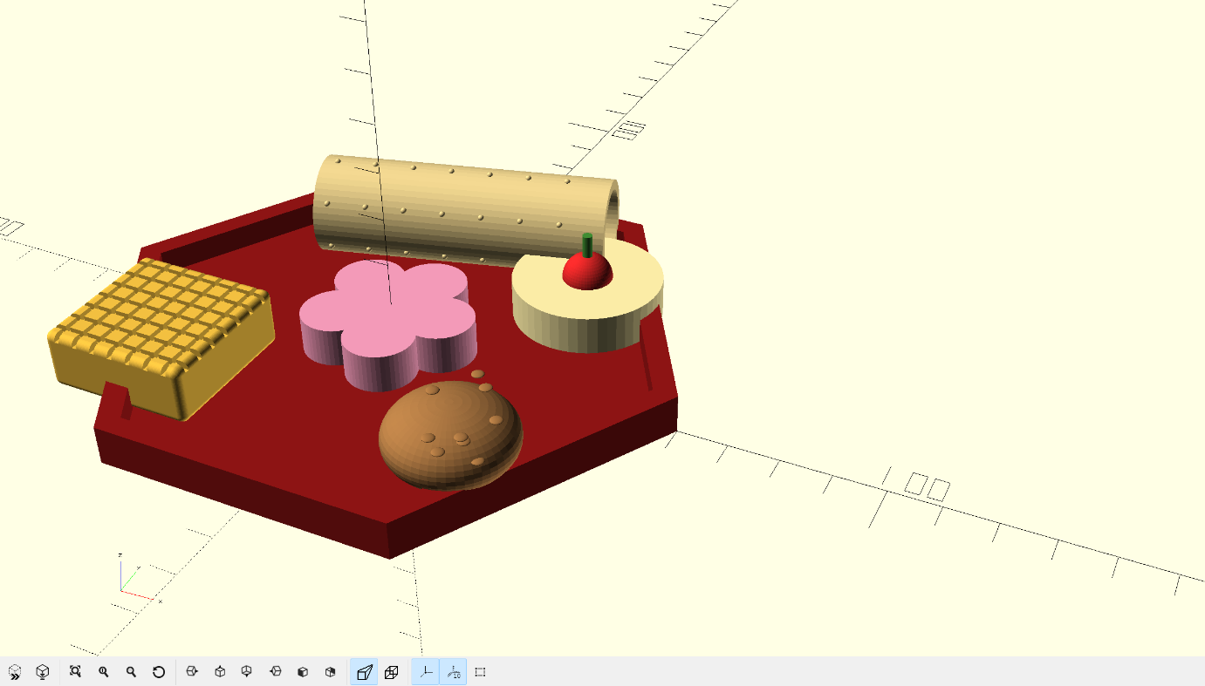

The rough model had many problems. I asked AI to enlarge the plate to make models less crowded.
Then transformed Pineapple Tart into flat and smooth rectangular prism. For the Love Letter, I found a picture and let AI generate following the picture. At last, I asked AI to reduce the height of peanuts to make them stick to Peanut Cookie. After doing these things, I got the final model:
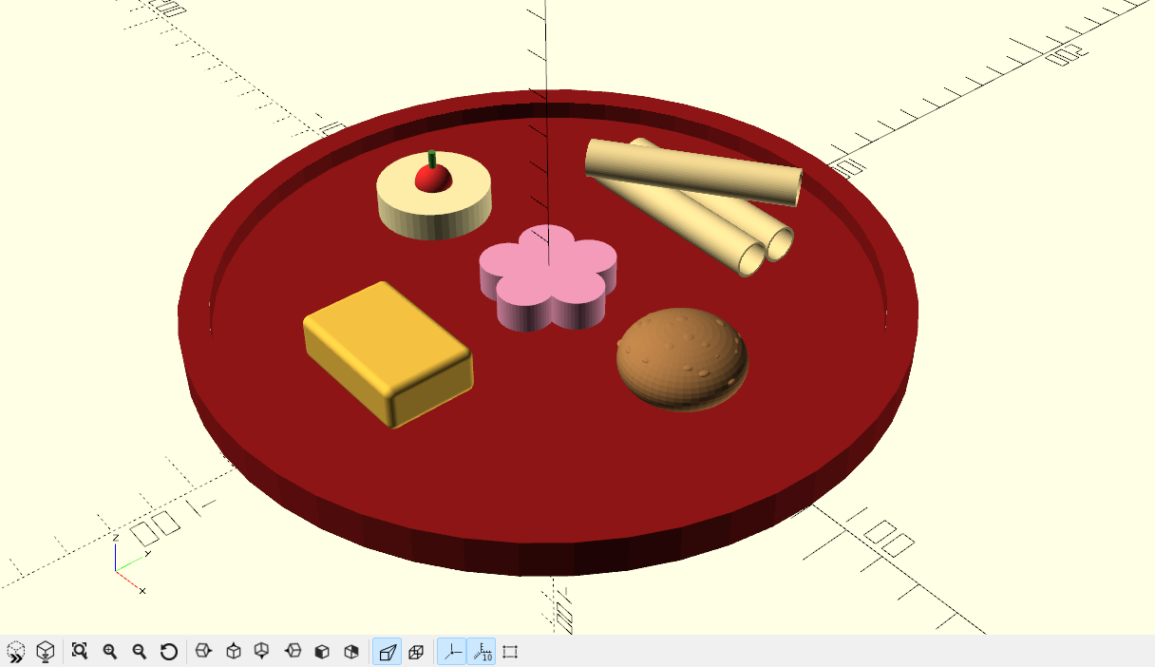
I also created the animation. I separated six models from the whole model and F6 rendered each model to export .stl document. Then I let AI to help generate animation with the model. Then I got this:
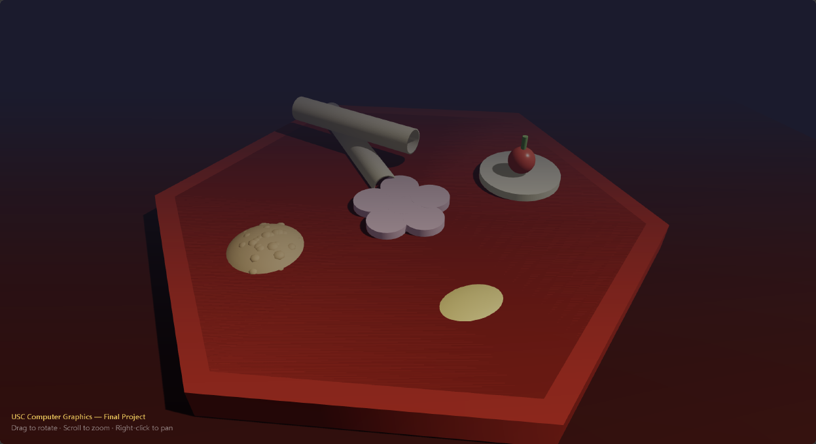
To make the models on the plate, I firstly just let AI put the cookies on the plate. However, AI looked like having difficulties understanding my orders and couldn’t achieve the result I wanted. So after trying many times, I used a stupid way, requiring AI to modify the height of cookies to make them on plate. For the Love Letter, I used more specific instructions, words like tangency, form a 30-degree angle and so on. Finally, I got this:
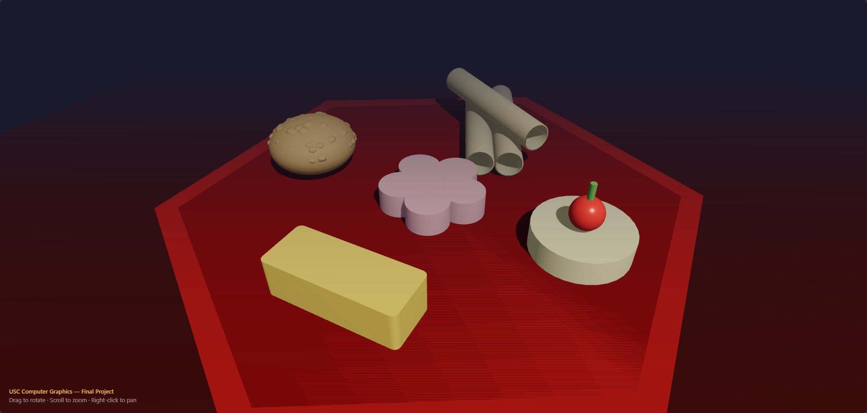

Materials, Textures, Shaders and Lighting (Shuxiao Guo)
My part mainly focused on the materials, procedural textures, GLSL shaders, and lighting in Three.js. After the cookie models were exported from OpenSCAD as separate STL files, I assigned different materials to the plate and each cookie. I mainly used MeshStandardMaterial because it works well with the lights and shadows already in Three.js. I adjusted the base color, roughness, and metalness for different objects so the cookies would not all look like the same plastic material.
One problem with STL files is that they do not give us useful UV coordinates for normal image textures. Because of this, I used the position of the model itself to generate surface details in the shader. This let me make texture effects without using a JPG or PNG image.
Pineapple Tart Procedural Shader
For the pineapple tart, I added a custom GLSL fragment shader on top of the standard Three.js material. The shader uses object-space position and value noise to make the yellow surface less uniform. It also makes some areas near the edges darker, so the tart looks slightly baked instead of having one flat yellow color. I kept the effect simple because very dark spots made the cookie look burned.
Simplified part of the shader code:
float coarseNoise = valueNoise(vObjectPosition * 0.22);
float fineNoise = valueNoise(vObjectPosition * 0.85);
float bakedSpots = smoothstep(0.56, 0.84,
coarseNoise * 0.72 + fineNoise * 0.28);
float edgeBake = max(edgeX, edgeZ);
float browning = clamp(
bakedSpots * 0.52 + edgeBake * 0.28 + topBake * 0.08,
0.0, 0.72);
diffuseColor.rgb = mix(
diffuseColor.rgb, toastedColor, browning);
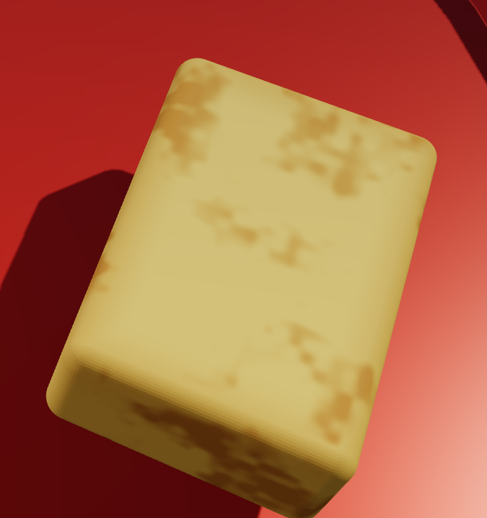
Figure: Pineapple tart with procedural baking shader
Flower Cookie Texture and Vertex Shader
I also made a procedural texture for the pink flower cookie. I used the distance from the center and the five-petal direction to change the color. The center is a little brighter, the outside of the petals is darker, and small noise values create some light surface specks. I also changed the roughness slightly in different areas, so the surface is not completely even.
For the flower cookie I also used a vertex shader. I added a time value called uTime and used a sine wave to move the outside vertices of the petals slightly up and down. The movement is intentionally small because I did not want the cookie to look like jelly. This gives us a real vertex shader deformation instead of only changing the pixel color.
Simplified vertex shader code:
float flowerRadius = length(position.xz);
float flowerAngle = atan(position.z, position.x);
float flowerEdgeMask = smoothstep(7.0, 16.5, flowerRadius);
float flowerWave = sin(
uTime * 2.0 + flowerAngle * 5.0 + flowerRadius * 0.16);
transformed.y += flowerWave * flowerEdgeMask * 0.18;
Lighting
I redesigned the lighting instead of keeping the original lights. I used a simple key, fill, and rim light setup. The key light is a warm directional light from the front-right and is the main source of shadows. The fill light is weaker and slightly cool, coming from the opposite side to make the dark parts easier to see. The rim light is a warm spotlight from behind the cookies, which helps separate their outlines from the dark blue background. I also kept a weak warm ambient light so the shadow areas would not become completely black.
Simplified lighting setup:
const ambientLight = new THREE.AmbientLight(0xfff1df, 0.18);
const keyLight = new THREE.DirectionalLight(0xffd4a8, 1.25);
keyLight.position.set(55, 85, 45);
keyLight.castShadow = true;
keyLight.shadow.mapSize.set(2048, 2048);

const fillLight = new THREE.DirectionalLight(0xb8c8ff, 0.34);
fillLight.position.set(-70, 38, 35);

const rimLight = new THREE.SpotLight(0xff7a4d, 0.8);
rimLight.position.set(-15, 68, -90);
I also lowered the tone-mapping exposure from 1.1 to 1.0 because the new key light was brighter. This helped keep the yellow and pink cookies from becoming too white under the light. The main key light uses a 2048 by 2048 shadow map so the shadows on the plate are clearer.
Problems and Final Result
While changing the project from direct Three.js modeling to STL loading, I also found that the cookies were floating above the plate. The STL geometry had already been normalized to start from the bottom, but the old animation code still added an extra height lift. I removed the old lift and used the final STL position directly so the cookies could sit on the plate correctly.
The final result uses different PBR materials, procedural GLSL textures for the pineapple tart and flower cookie, a small vertex shader animation on the flower cookie, and a new lighting setup. The procedural effects are generated from model coordinates, so they do not depend on UV maps. This was useful for the STL workflow and also gave me more control over how the cookie surfaces looked.

