**Team Cider’s UML Class Diagram for Recipe Helper**

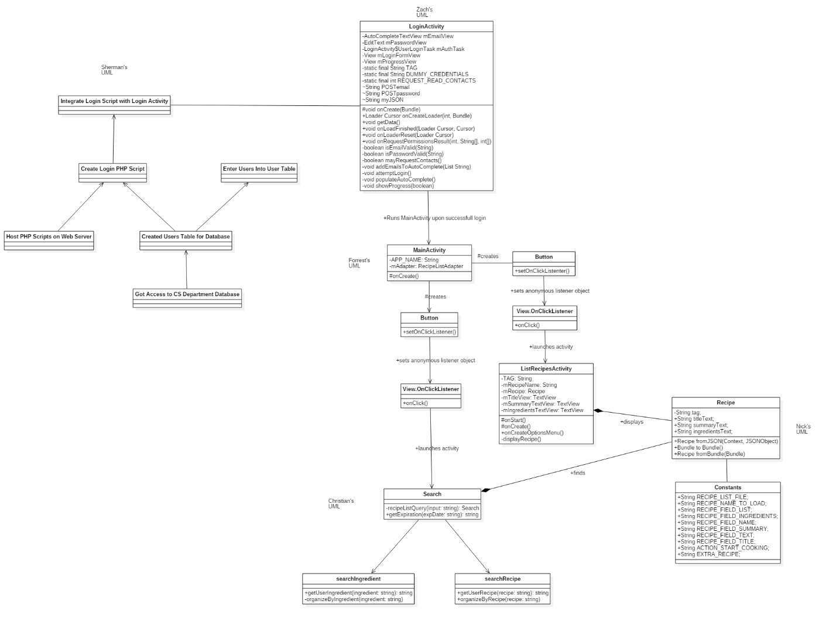

Forrest Short – My section of the UML class diagram is in the middle of whole thing and consists of MainActivity, Button, View.OnClickListener, and ListRecipesActivity.

Christian Sylvester – My portion of the diagram is the search classes located near the bottom and consists of Search, searchIngredient and searchRecipe.

Sherman Thompson – My UML section has no attributes for the class since I did not create any. Instead I listed some of the database issues I worked on and how they link with each other, and the main project.