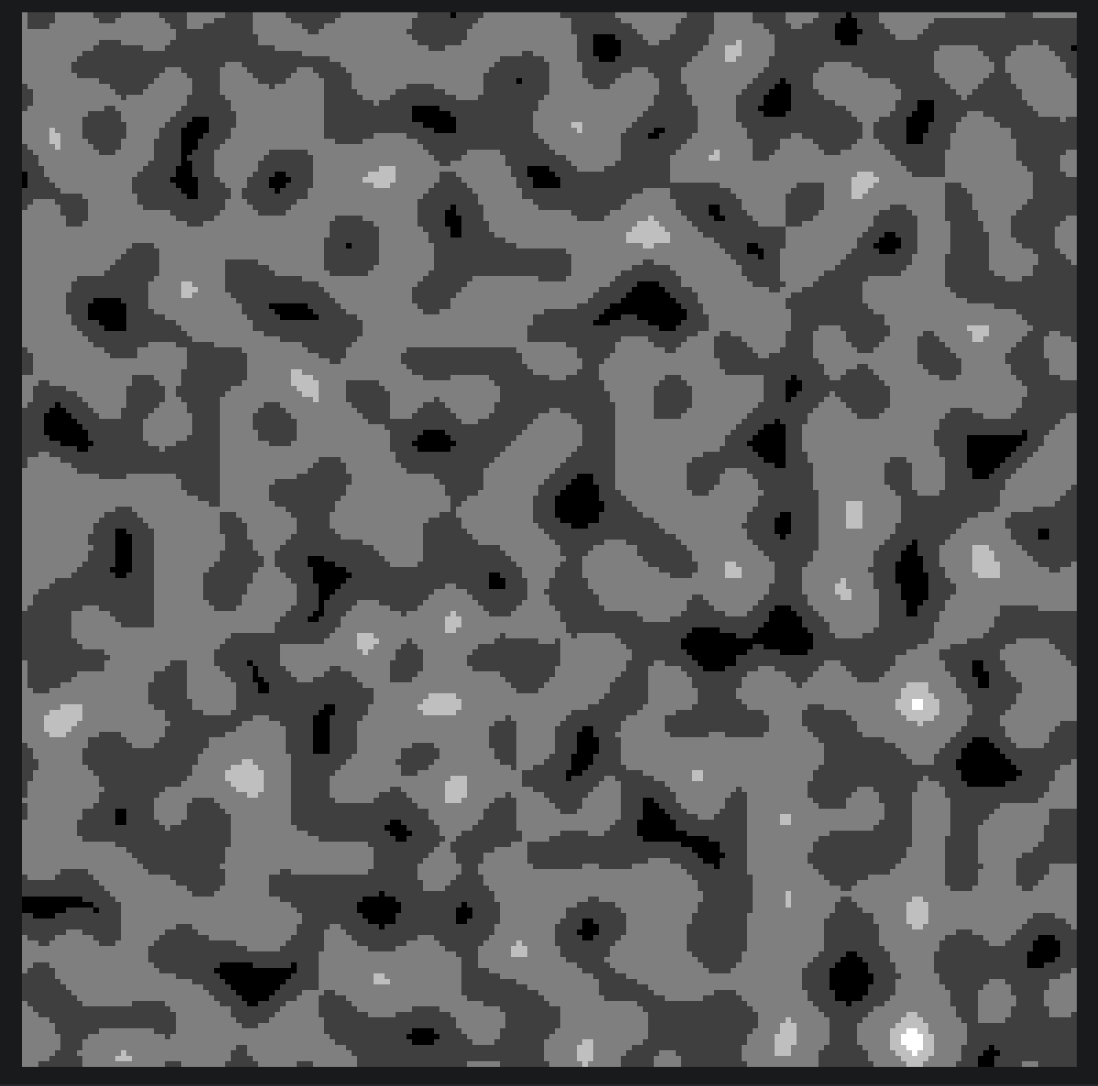
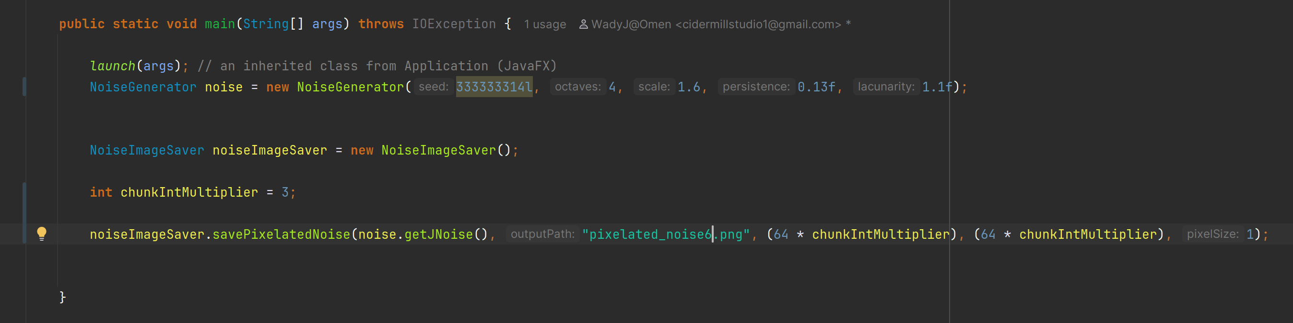
Of note, the Noise Generator was using LINEAR interpolation, not cosine.
Imagine the GRAY being floor-tiles, the light gray being points of interest, the white being RARE points of interest, the dark gray being stone walls (+/- ores and gems randomly placed), and the black being ‘bedrock’ which contains rarer ore but you need to have the right pickaxe or smth.

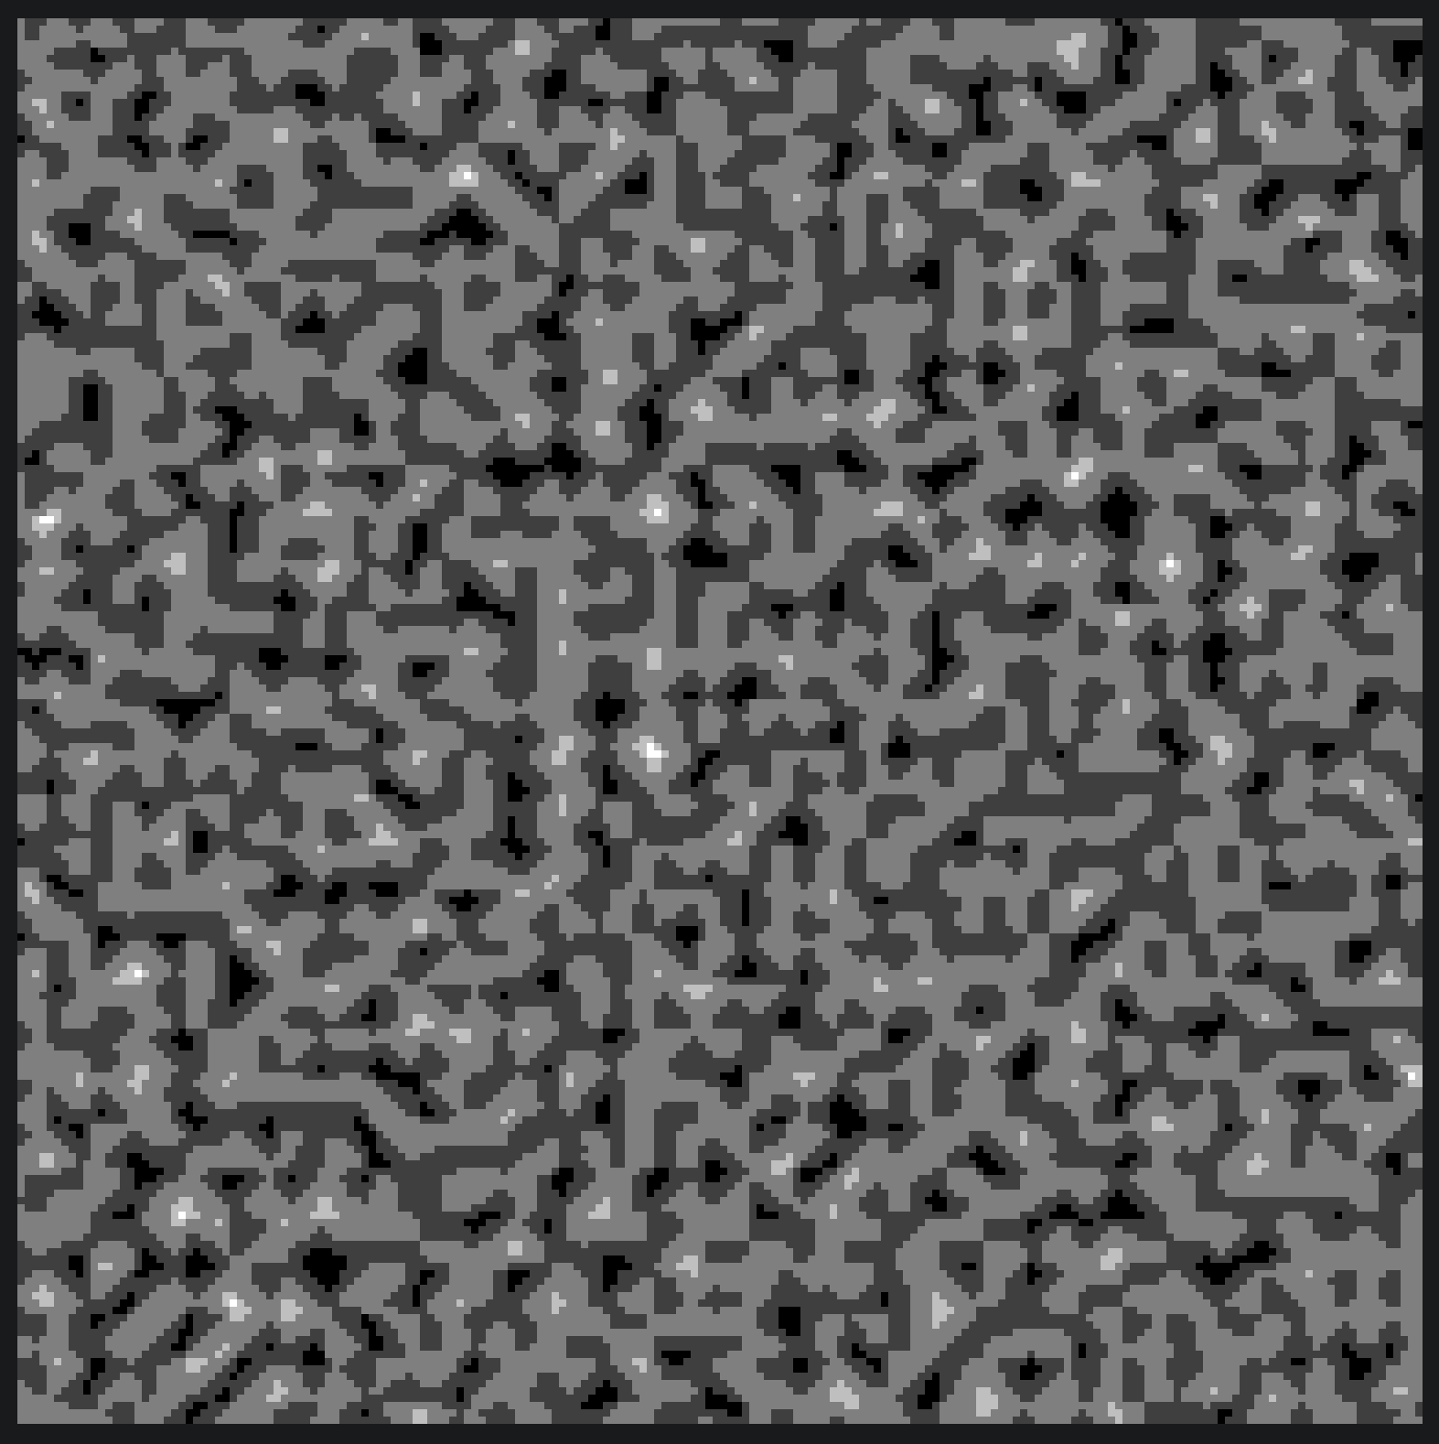
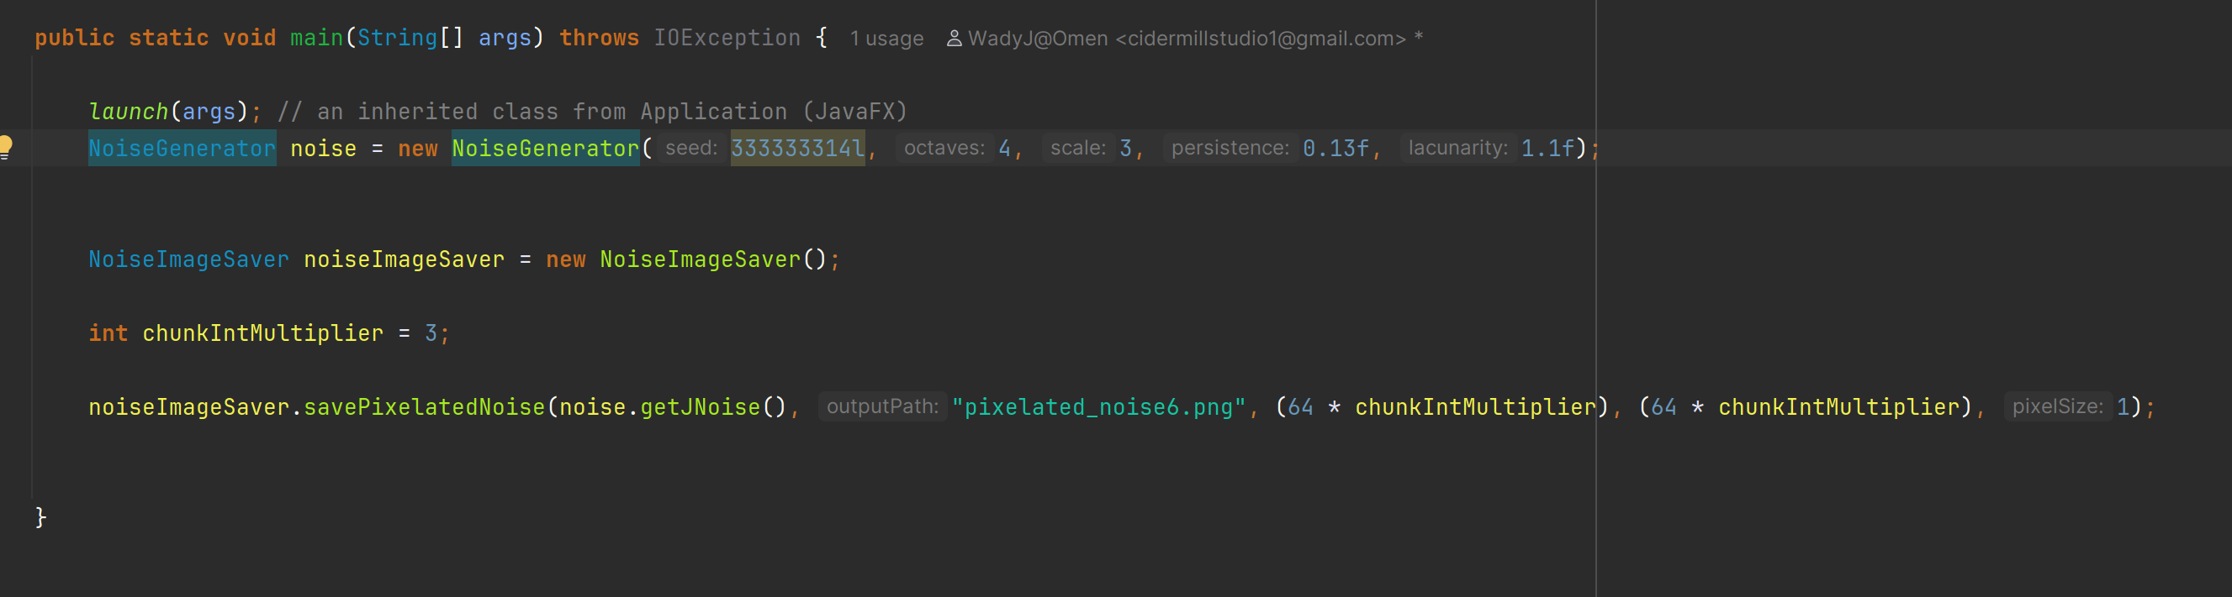
This Noise is using Interpolation.COSINE and has a larger scale value compared to the previous image.

