ECE-6143 Intro to ML

Homework1:

Haotian Yi

Net ID: hy1651

Q1:

Suppose µ is what we wish.

Prove:

$let original aim function= h\left( μ_{ }\right)= \sum_{j=1}^{n}{ }\sum_{i=1}^{d}{ }{\left(x_{ji}-μ_{i}\right)}^{2}$

$=\sum_{i=1}^{d}{ }h\left({ μ}_{i} \right)$

for each attribute $x_{ji}$,it has distribution of $\left\{x_{1i} ,x_{2i} ,...,x_{ni} \right\}$

because $E\left[{\left(x_{i}-μ_{i}\right)}^{2}\right] = \frac{\overset{n}{\underset{j=1}{\sum^{ }{ }}}{\left(x_{ji}-μ_{i}\right)}^{2}}{n}$

for each $μ_{i}$:

$h\left({ μ}_{i} \right)= \sum_{j=1}^{n}{ }{\left(x_{ji}-μ_{i}\right)}^{2}=n E[{\left(x_{ji}-μ_{i}\right)}^{2}]$

$=n E[{x_{i}}^{2} + {μ_{i}}^{2} - 2 μ_{i} x_{i}]$

$=n \{ E\left[{x_{i}}^{2}\right]+ {μ_{i}}^{2} - 2 μ_{i} E\left[x_{i}\right] \}$

to get minimum $h\left({ μ}_{i} \right)$:

$\frac{∂h(μ_{i})}{∂μ_{i}}=n \{ E\left[2 {μ_{i}}^{ }- 2E\left[ x_{i}\right] \right\}=0$

so, ${ μ}_{i}=E[ { x}_{i} ]$

thus, we can conclude that ${ μ}_{ }=E[ { x}_{ } ]$

Q2(a):

1)For ${\left\|x\right\|}_{2}$ and ${\left\|x\right\|}_{1}$:

because : < ⬄ <

(do square of both side)

and: ${\left(\sum_{i=1}^{d}{ }\left|x_{i}\right|\right)}^{2}$ = $\sum_{i=1}^{d}{ }{|x_{i}|}^{2}$ + $∑c_{j} α$,

$∑c_{j} α$ represents cross terms of ${\left(\sum_{i=1}^{d}{ }\left|x_{i}\right|\right)}^{2}$

and $∑c_{j} α$ > 0 (when $x_{i}$ are not all equal to 0)

so, $\sum_{i=1}^{d}{ }{x_{i}}^{2}$ < ${\left(\sum_{i=1}^{d}{ }\left|x_{i}\right|\right)}^{2}$

so, $\sum_{i=1}^{d}{ }{x_{i}}^{2}$ ≤ ${\left(\sum_{i=1}^{d}{ }\left|x_{i}\right|\right)}^{2}$

(equal when d = 1 or $x_{i}$ are all equal to 0 )

Thus, ${\left\|x\right\|}_{2}$ ≤ ${\left\|x\right\|}_{1}$

2)For ${\left\|x\right\|}_{1}$ and ${\sqrt{d}\left\|x\right\|}_{2}$:

Inequation above is equal when d = 1 or $x_{i}$ are all 0

when d $≥2$ and $x_{i}$ are not all 0:

+ (d-1) $\sum_{i=1}^{d}{ }{x_{i}}^{2}$ ≥ $\sum_{i=1}^{d}{ }{x_{i}}^{2}$ + 3 $\sum_{i=1}^{d}{ }{x_{i}}^{2}$

${\left({\left\|x\right\|}_{1}\right)}^{2}=\sum_{i=1}^{d}{ }{{|x}_{i}|}^{2} + ∑c_{j} α$

$∑c_{j} α$ represents cross terms of ${\left({\left\|x\right\|}_{1}\right)}^{2}$

for d =2, cross terms of ${\left(|x_{1}|+{|x}_{2}|\right)}^{2}$ is $2\left|x_{1}\right|{|x}_{2}|$ and ${{(2-1)(|x}_{1}|}^{2}$

$+{|x_{2}|}^{2})>2{|x}_{1}|{|x}_{2}|$,

for d =3, cross terms of ${\left(\left|x_{1}\right|+{|x}_{2}\left|+{|x}_{3}\right|\right)}^{2}$ is $2\left|x_{1}\right||x_{2}| + 2{|x}_{1}||x_{3}|$

$+2\left|x_{2}\right|\left|x_{3}\right|$ and ${{(3-1)(|x}_{1}|}^{2}+{{|x}_{2}|}^{2}+{\left|x_{3}\right|}^{2})>2{|x}_{1}|\left|x_{2}\right|+2{|x}_{1}||x_{3}|$

$+2|x_{2}||x_{3}|$, according to two instances above, we can infer that:

$(d-1) \sum_{i=1}^{d}{ }{x_{i}}^{2}> ∑c_{j} α$ (when d $≥2$ and $x_{i}$ are not all 0),

so ${\left\|x\right\|}_{1}$ < ${\sqrt{d}\left\|x\right\|}_{2}$ and then ≤

3) Thus: ≤

Q2(b):

1) For and :

+ +

(maxi is the subscript of the $max\left|x_{i}\right|$)

thus ${\left\|x\right\|}_{∞}$ ≤ ${\left\|x\right\|}_{2}$ (equal when d = 1 or all 0 except )

2) For and :

+ +

(maxi is the subscript of the $max\left|x_{i}\right|$)

It is obvious: $({d-1)\left(\underset{i}{max\left|x_{i}\right|}\right)}^{2}$ ≥ $\sum_{i=1}^{maxi-1}{ }{x_{i}}^{2}$ + $\sum_{i=maxi+1}^{d}{ }{x_{i}}^{2}$

thus ${\left\|x\right\|}_{2}$ ≤ $\sqrt{d}{\left\|x\right\|}_{∞}$:

3)Thus: ≤

Q2(c):

1) For and ${\left\|x\right\|}_{1}$:

${{\left\|x\right\|}_{1}}^{ }=\sum_{i=1}^{d}{ }{\left|x_{i}\right|}^{ }=\sum_{i=1}^{maxi-1}{ }\left|x_{i}\right|$ + $\underset{i}{max\left|x_{i}\right|}+\sum_{i=maxi+1}^{d}{ }\left|x_{i}\right|$

≥ $\underset{i}{max\left|x_{i}\right|}$ = ${\left\|x\right\|}_{∞}$

(maxi is the subscript of the $max\left|x_{i}\right|$)

(equal when d = 1 or all 0 except a )

2) For and $d{\left\|x\right\|}_{∞}$:

${{\left\|x\right\|}_{1}}^{ }=\sum_{i=1}^{d}{ }{\left|x_{i}\right|}^{ }=\sum_{i=1}^{maxi-1}{ }\left|x_{i}\right|$ + $\underset{i}{max\left|x_{i}\right|}+\sum_{i=maxi+1}^{d}{ }\left|x_{i}\right|$

$d{\left\|x\right\|}_{∞}=$ ($d-1) \underset{i}{max\left|x_{i}\right|}$ + $\underset{i}{max\left|x_{i}\right|}$ and it is obviously ≥ ${\left\|x\right\|}_{1}$

(equal when d = 1 or all attributes are equal)

3)Thus: ${\left\|x\right\|}_{∞}{ ≤\left\|x\right\|}_{1}$ ≤ $d{\left\|x\right\|}_{∞}$

For question 3 and question 4, there are more comments and interpretation in details in .ipynb files.

Q3:

a. Fix d = 3 and generate 10,000 random samples from the standard multi-variate Gaussian distribution defined in Rd.

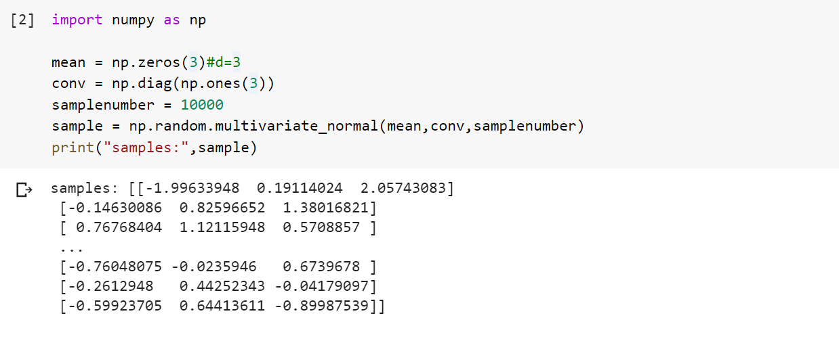

b. Compute and plot the histogram of Euclidean norms of your samples. Also calculate the average and standard deviation of the norms.

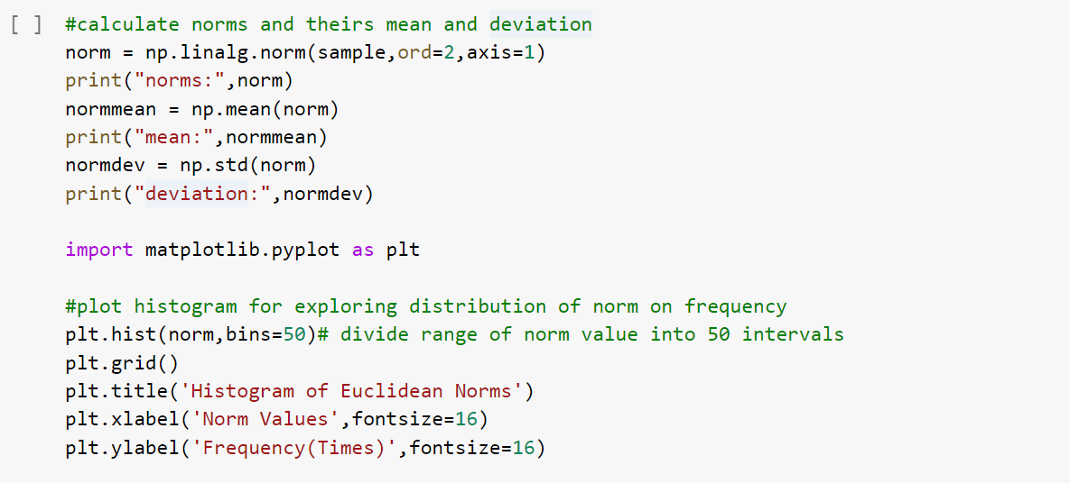

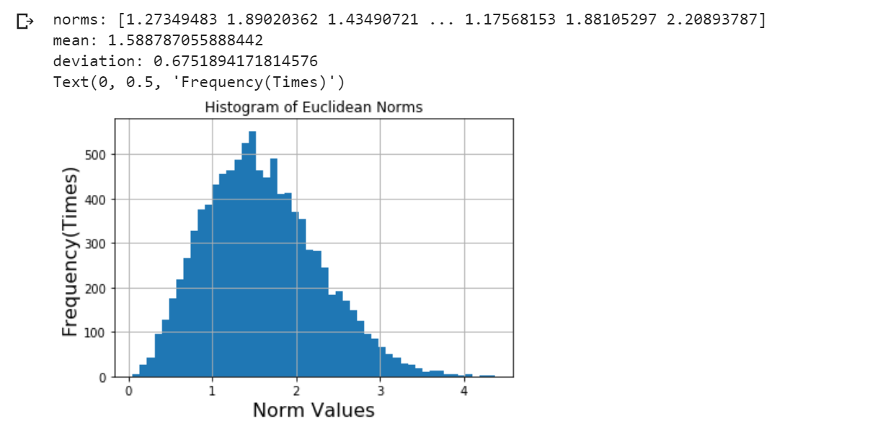

c. Increase d on a coarsely spaced log scale all the way up to d = 1000 (say d =

50; 100; 200; 500; 1000), and repeat parts (a) and (b). Plot the variation of the average and the standard deviation of Euclidean norm of the samples with increasing d.

Write a for loop, achieve goals according to the method of part a and b, here are results below:

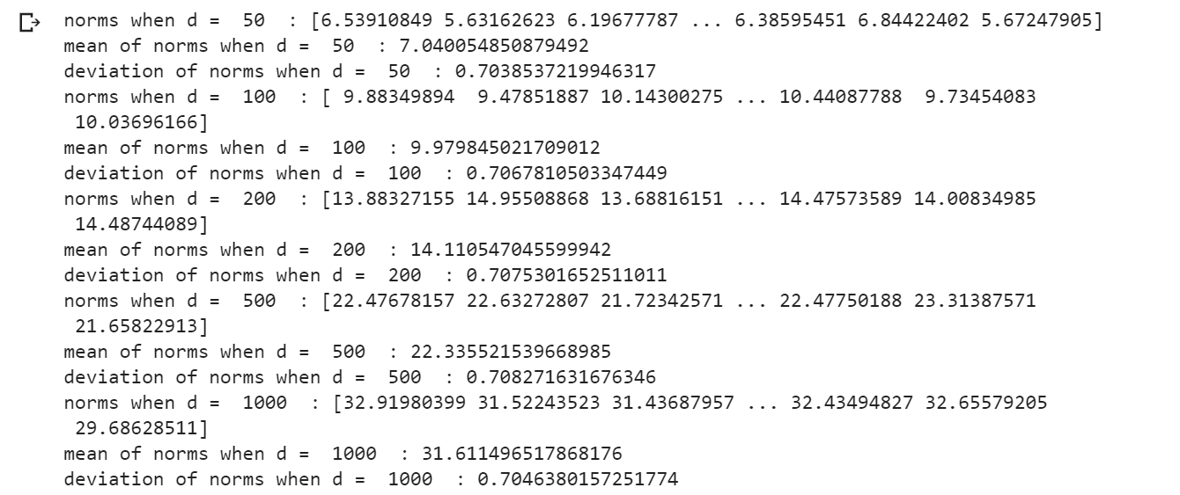

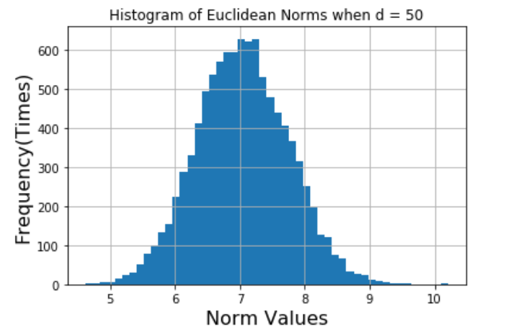

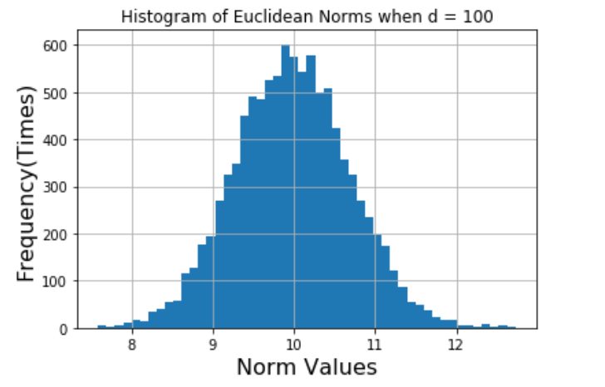

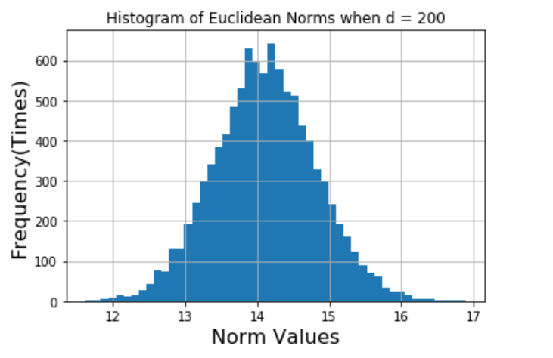

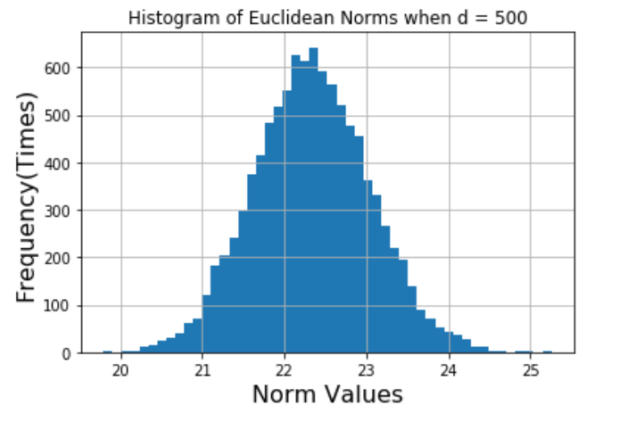

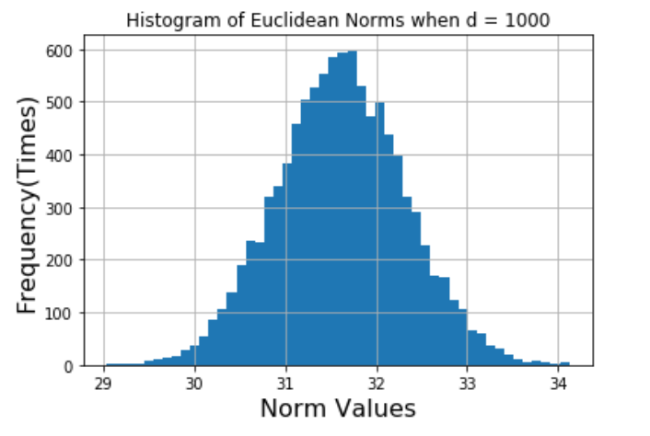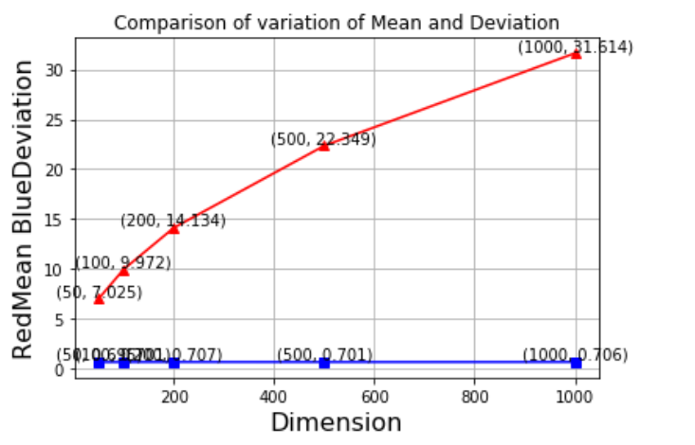

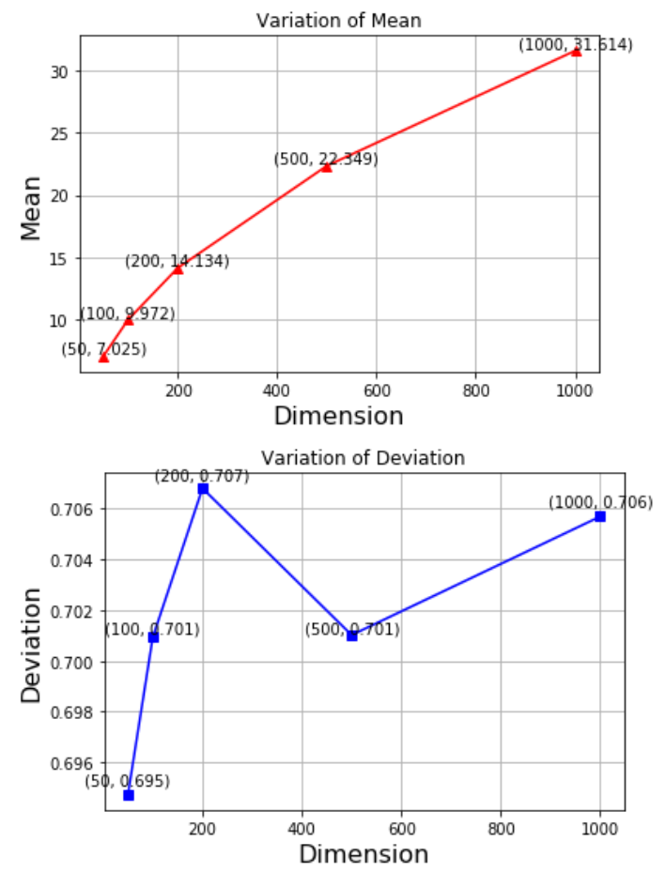

d. What can you conclude from your plot from part (c)?

According to diagram above, I discover that:

1.in high dimension, most of mass is concentrated near the mean of Euclidean norms,

2.mean of norms increase with dimension,

3.deviation is approximately not changed with dimension.

Q4:

a. Write a small parser to read each document and convert it into a vector of words.

define an function to read each document and convert it into a vector of words and obtain appearance time of each word, tf of each word and a list of all kinds of word in each .txt document saving as dictionaries

b. Compute tf-idf values for each word in every document as well as the query.

b1. write a function to obtain result of function "preprocess" on each document from paths provided in a list and put appearance counter of words, tf of words in every document and a collection of all kinds of words appear in all documents respectively into three lists : counter, tfdic, all_words

b2.write a function to unify the format of counter and tfdic to make every dictionary have same attributes and dimension, put them respectively into two lists: counters, tfdics

b3. write a function to obtain idf of each words in every document and put them together into one list: idfdics , actually they are all the same but I save them as the same format and container as tf

b4. write a function to obtain tf-idf of each words in every document and put them together into one list: tfidfdics

c. Compute the cosine similarity between tf-idf vectors of each document and the query.

define a function that can calculate cosine similarity between two dictionaries of tf-idf

d. Report the document with the maximum similarity value.

define a recognition function that can use function defined above to compare cosine similarity among documents and return sequence number of result document and maximum value of similarity

results:

d 4 is the document with maximum cosine similarity value of 0.19616295821215432

Q5: approximately 21 hours for whole homework