**Assignment 2 – Deploy a High-Availability Web App using CloudFormation**

**Prefix:**

For this Udagram Application, I applied industry knowledge in automated infrastructure deployment through the use of YAML scripts.

These YAML scripts are:

* Network-config.yml
* Infrastructure-config.yml

Files included in this upload are:

* This word document for documentation purposes
* network-config.yml
* network.json
* infrastructure-config.yml
* infrastructure.json
* create.sh - run to automate creation of yaml files
* update.sh - run to automate updating yaml files
* destroy.sh - run to automate deletion of yaml files
* Udacity.zip file – the app we are deploying

Server specs

You'll need to create a Launch Configuration for your application servers in order to deploy four servers, two located in each of your private subnets. The launch configuration will be used by an auto-scaling group. ✔️

You'll need two vCPUs and at least 4GB of RAM. The Operating System to be used is Ubuntu 18. So, choose an Instance size and Machine Image (AMI) that best fits this spec. ✔️

Be sure to allocate at least 10GB of disk space so that you don't run into issues. ✔️

**Diagram:**

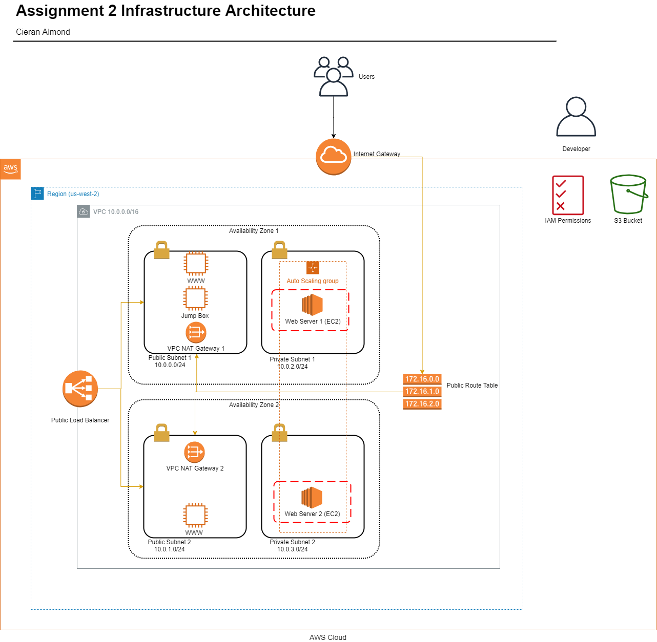

**Script:**

**The Basics:**

**Parameters: The more the better, but an exaggerated number of parameters can be messy (say, 10 or more). 1 or 0 is lacking.**

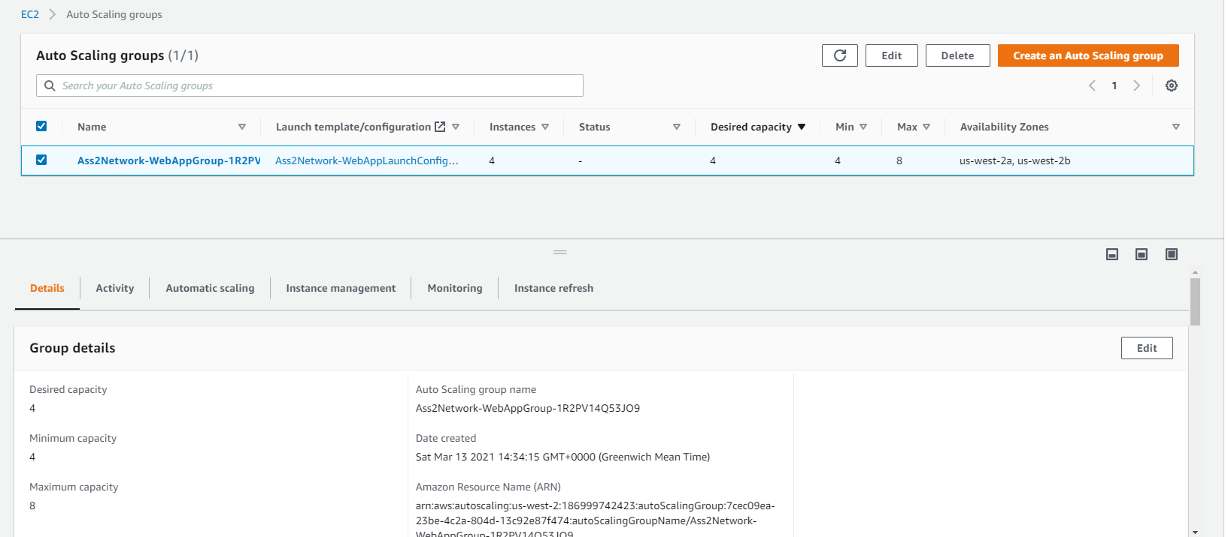

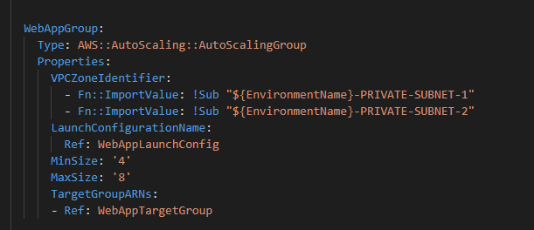

Autoscaling group has 4 to 8 parameters.

**Resources: This is the mandatory part of the script, we are looking for a Loadbalancer, Launch Config, AutoScaling Group, a health check, security groups and a listener + target group.**

**Loadbalancer with Listener:**

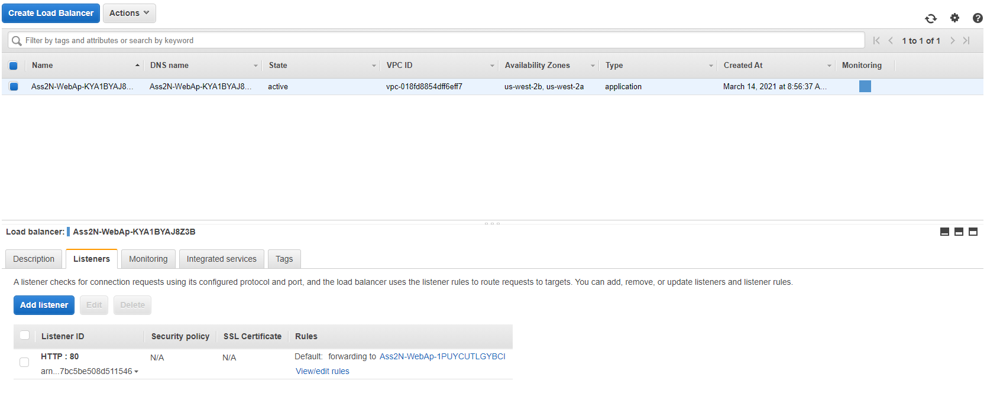

**Launch Config:**

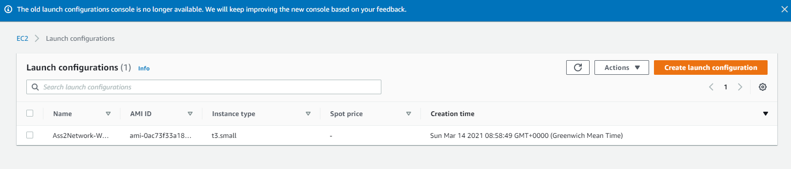

**Autoscaling Group:**

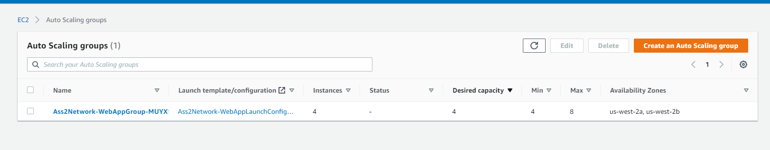

**Health Check:**

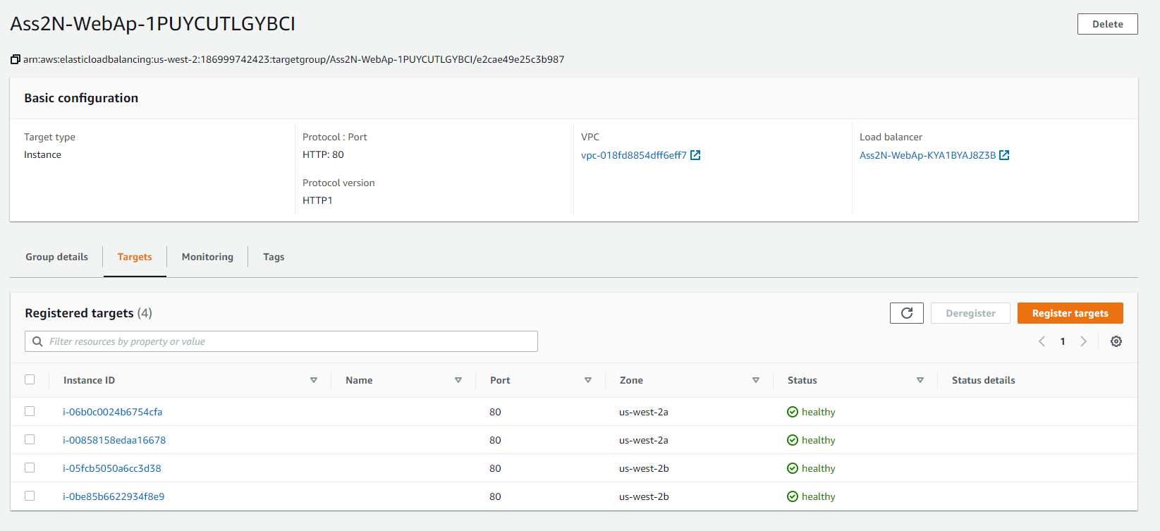

**Security Groups:**

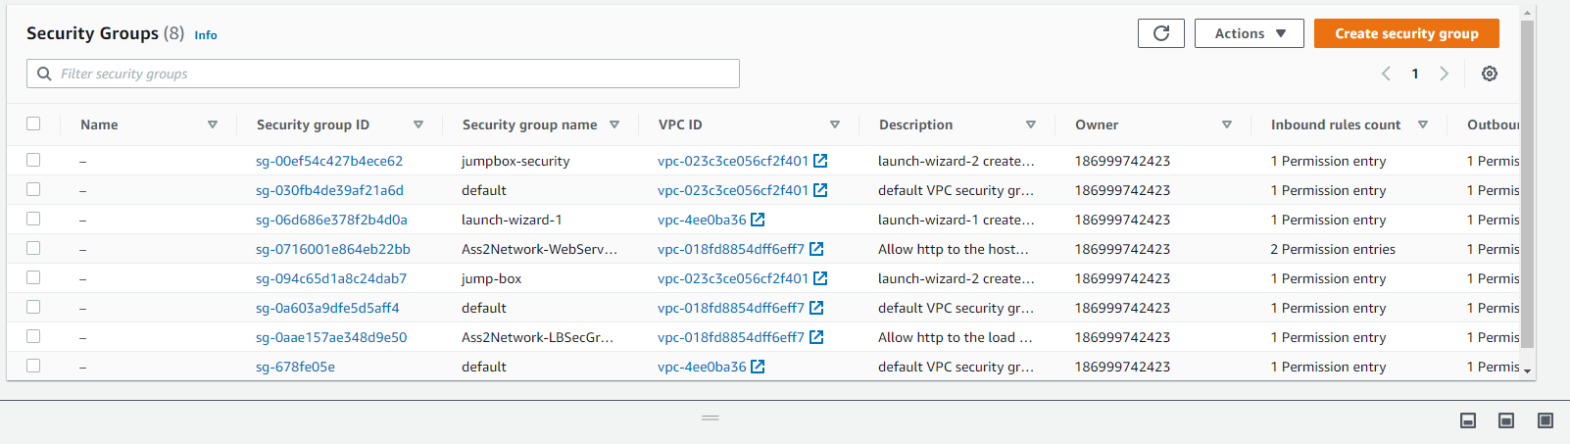

(Note only Ass2Network.. are relevant, as well as the Jumpbox for testing purposes)

**Listener + Target Group:**

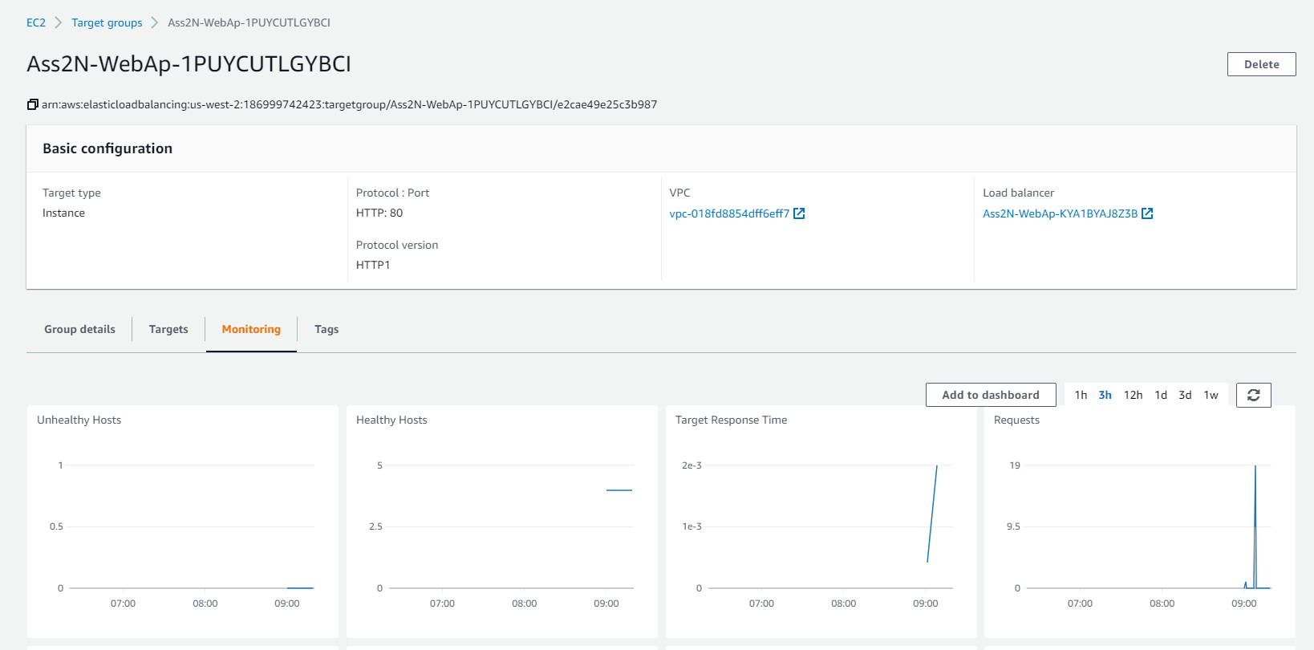

**Outputs: This is optional, but it would be nice to have a URL here with the Load Balancer DNS Name and “http” in front of it .**

Did not attempt ☹

**Working Test: If the student provides a URL to verify his work is running properly, it will be a page that says “it works! Udagram, Udacity”**

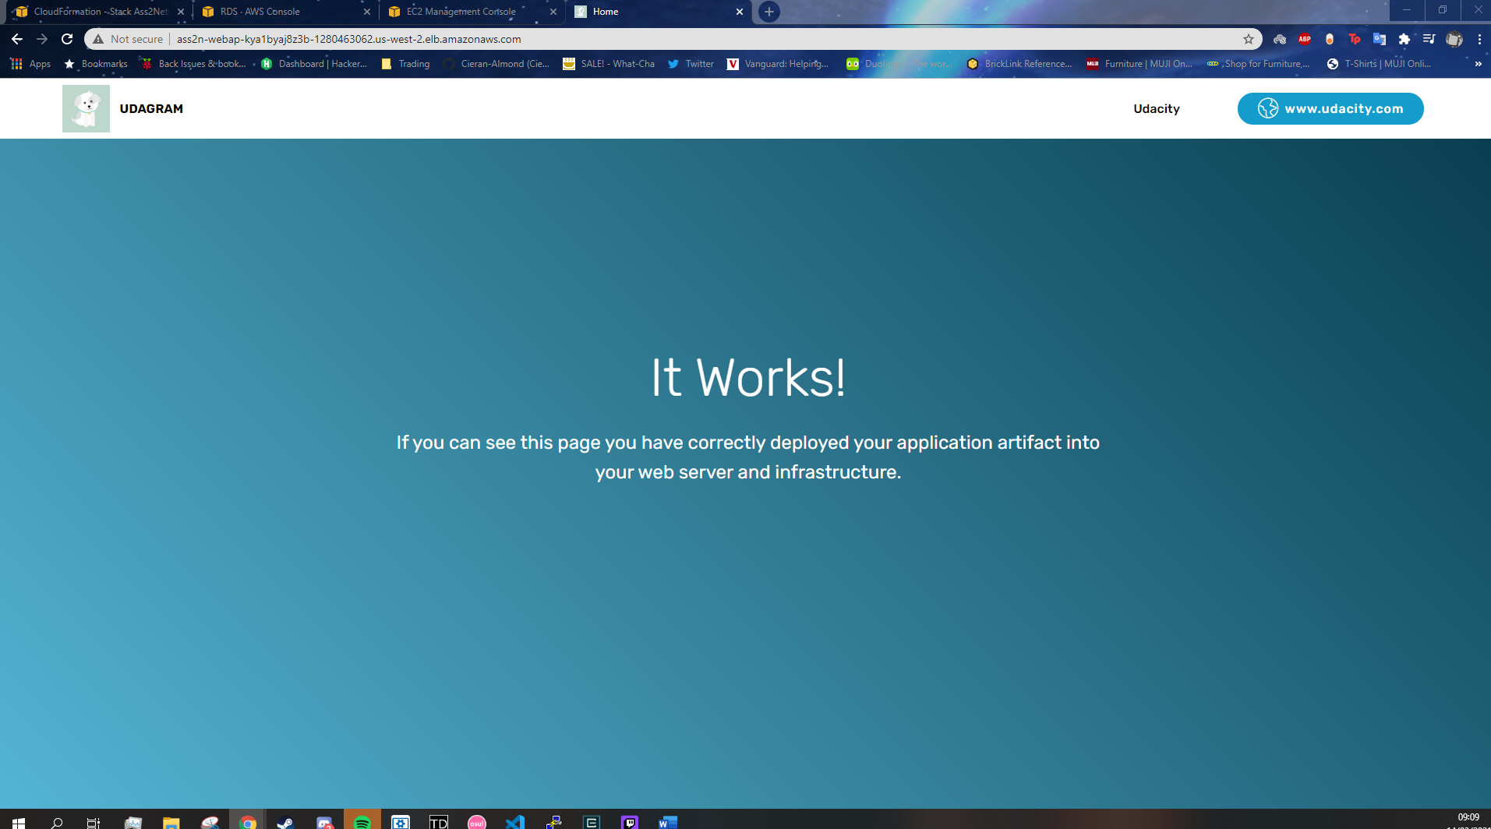

Page successfully loads from Loadbalancer url:

Ass2N-WebAp-KYA1BYAJ8Z3B-1280463062.us-west-2.elb.amazonaws.com