Remote name: ass3 or ass4

git push -u ass3 master

Prometheus
Open cmder
C:\Users\My Computer
λ ssh -i prometheus.pem ubuntu@ec2-35-162-60-29.us-west-2.compute.amazonaws.com
cd into promethus file
ls
cd prometheus-2.19.0.linux-amd64
…/
Start Prometheus
./prometheus --config.file=./prometheus.yml

cat prometheus.yml
https://codewizardly.com/prometheus-on-aws-ec2-part1/

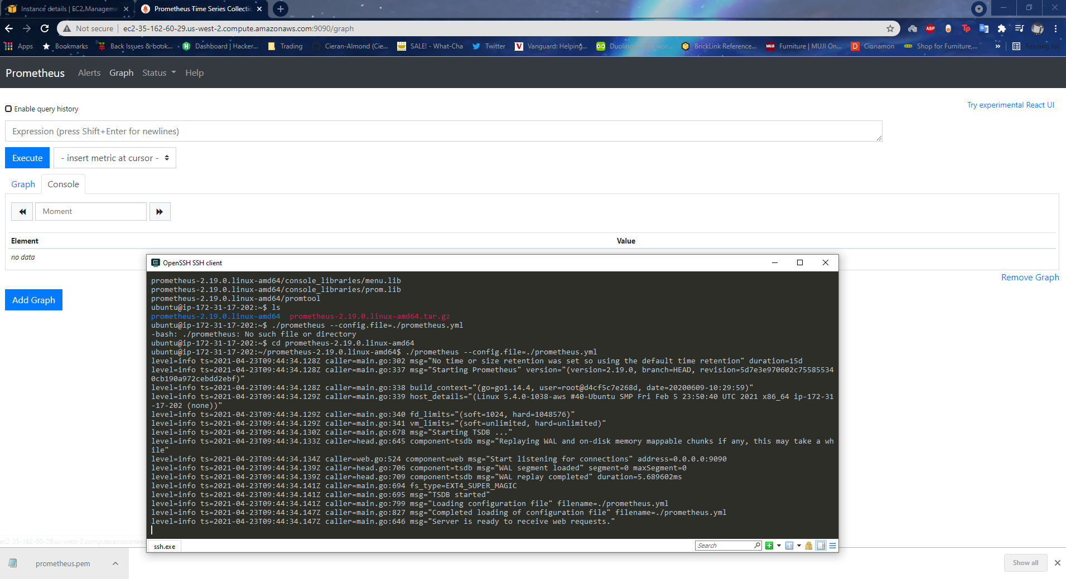

https://codewizardly.com/prometheus-on-aws-ec2-part2/

ssh -i prometheus.pem ubuntu@ec2-34-218-230-72.us-west-2.compute.amazonaws.com

https://codewizardly.com/prometheus-on-aws-ec2-part2/

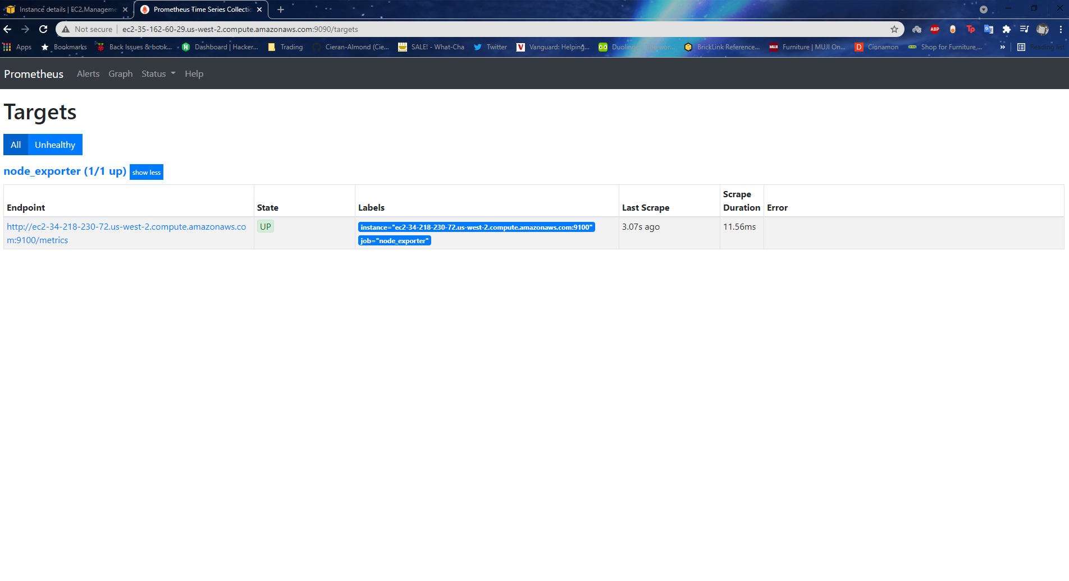

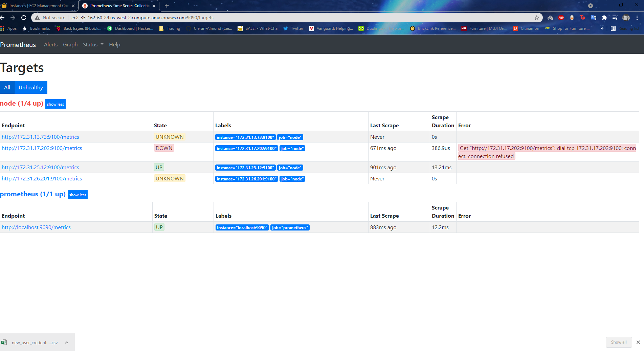
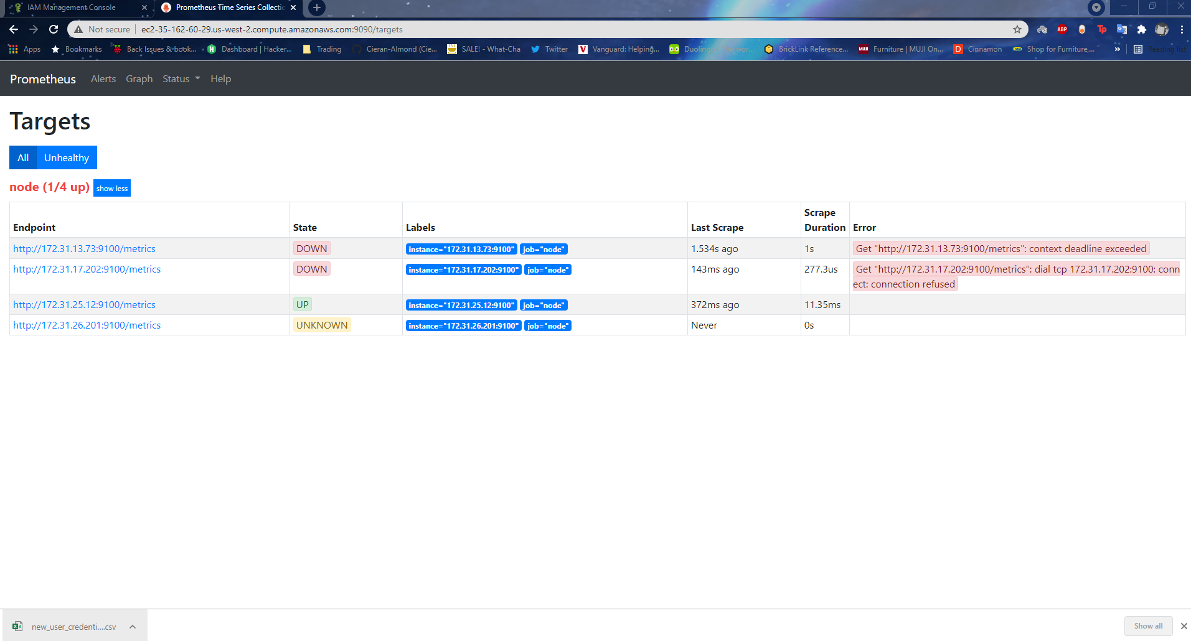

global:
scrape_interval: 15s
external_labels:
monitor: 'prometheus'

scrape_configs:

- job_name: 'node_exporter'

static_configs:

- targets: ['ec2-34-218-230-72.us-west-2.compute.amazonaws.com:9100']

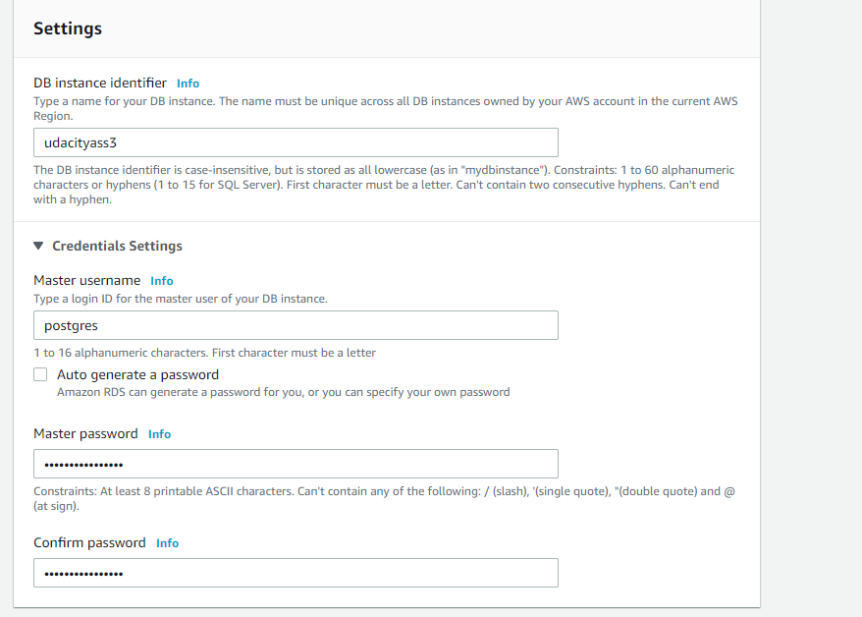
5432
Password: Mycatissobad123!

arn:aws:s3:::udapeople-ausidb12580nad9
ssh key fingerprint
a0:47:0e:0b:c9:fe:e3:93:74:eb:e0:76:84:aa:26:06

