Screenshots
Your screenshots in JPG or PNG format, named using the screenshot number listed in the instructions. These screenshots should be included in your code repository in the root folder.
- Job failed because of compile errors. [SCREENSHOT01]

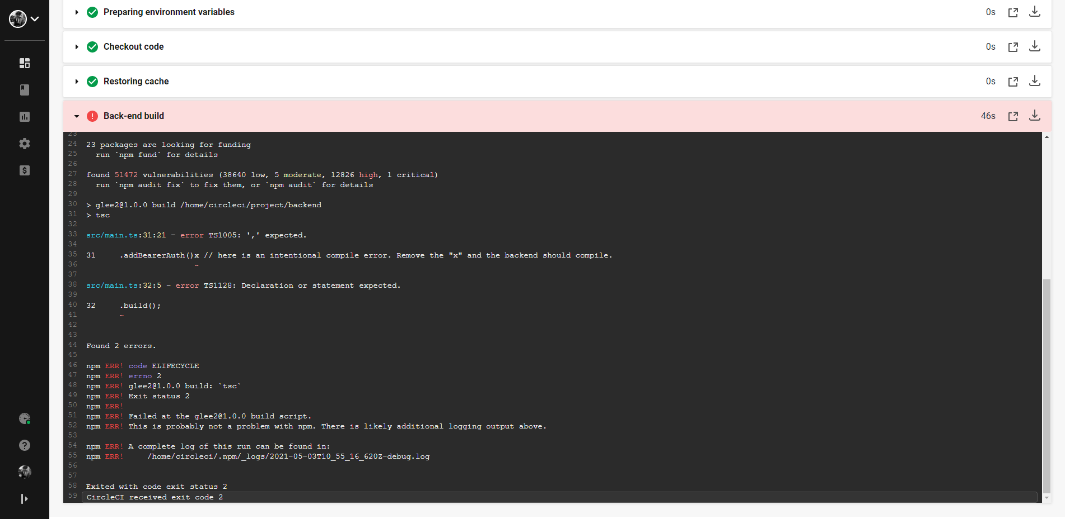
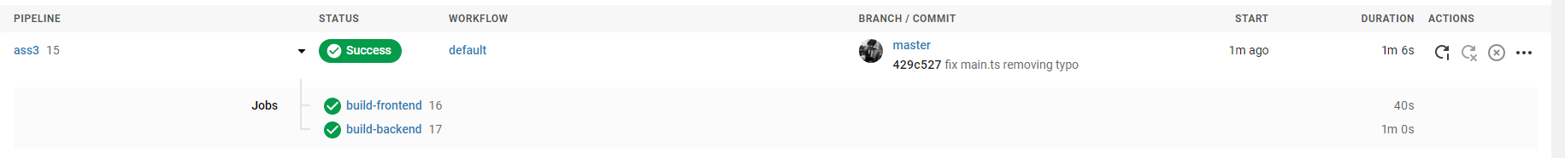

- Job failed because of unit tests. [SCREENSHOT02]

- Job that failed because of vulnerable packages. [SCREENSHOT03]

- An alert from one of your failed builds. [SCREENSHOT04]

- Appropriate job failure for infrastructure creation. [SCREENSHOT05]

- Appropriate job failure for the smoke test job. [SCREENSHOT06]

- Successful rollback after a failed smoke test. [SCREENSHOT07]

- Successful promotion job. [SCREENSHOT08]

- Successful cleanup job. [SCREENSHOT09]

- Only deploy on pushed to master branch. [SCREENSHOT10]

- Provide a screenshot of a graph of your EC2 instance including available memory, available disk space, and CPU usage. [SCREENSHOT11]

- Provide a screenshot of an alert that was sent by Prometheus. [SCREENSHOT12]

