Energy Conservation

Lab Report

Cieran Wong

Lab Partner: Bennett Jackson

Course: PHYS 141

TA: Wyatt Wallis

Due: October 13, 2022, at 8AM

**Energy Conservation**

**Abstract**

The overall goal of the lab was to apply the conservation of energy to understand the relationship between the height of the track, the speed of the car, and the time needed to get from Point A to B, and as to why the fastest path between two points is not always a straight line. From the data and the equations we derived, we were able to determine that mass had no effect on the velocity of the car, the minimum height and velocity needed to complete a loop, and the velocity changing throughout the track is what ensures that the nonlinear track is the faster one. We found the minimum height needed to release the car to be 31.25 cm (calculated) or 31 cm (measured using a meter rule), and the minimum velocity to be 1.11m/s (calculated) or 1.095m/s (recorded, averaged out).

**Introduction**

The goals for this lab are to determine the relationship between height and speed of the roller coaster, determine the minimum height for a roller coaster to complete a loop, and determine the fastest path between two points. These three goals will help us to understand the connection between potential energy and kinetic energy, represented by the conservation of energy as: E = K + U. Where E is total energy, K is kinetic energy, and U is gravitational potential energy.

**Procedure**

For the experiment, we will need the following pieces of equipment: roller coaster, car, mass set, photogates, sparklink, and the software provided.

To determine the relationship between the height and speed of the roller coaster, we will set up the roller coaster according to the following image:

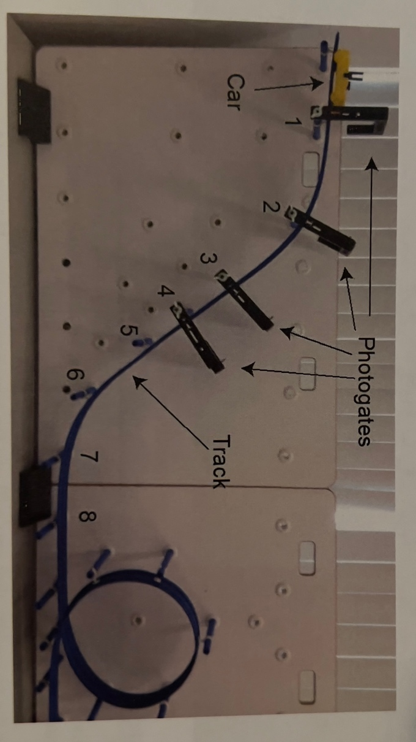

The four photogates, each setup at four different respective points, will allow us to measure the speed of the car at each point. Release the car right before the first photogate, giving it no initial push so that it essentially starts from rest. Pushing the car will result in discrepancies in the data as it will affect how much initial kinetic and potential energy is present. Therefore, set the car in a position where it will free fall. This will take a few trials, so before collecting any data, ensure that a position is determined through some test runs. To collect data, perform five trials with just the car. Then add on a mass to the car, the mass provided weighs 49.2 grams. Perform five more trials with the added weight, again starting from the predetermined position where the car can free fall. The third set of five trials will be performed with a second weight being added onto the first. The total mass of the car and weights would be 140 grams. These fifteen trials will provide the data to determine the speed of the roller coaster as a function of its height.

For the second part of the lab, we will be determining the minimum height for the roller coaster to complete a loop. Keeping the set up the same as in the first part of the lab and adding on a photogate at the top of the loop, we will use the data from part I to determine the minimum height that the roller coaster needs to start at to be able to complete a loop. This can be done by calculating the minimum velocity of the car needed to complete a loop. The math is shown in the Theory section and the numbers we found are substituted in the Sample Calculations section. After obtaining the minimum velocity, we then substitute that number into an equation to find the minimum initial height needed. Again, the math is shown in the Theory section, and numbers are substituted in the Sample Calculations section. Now that we have minimum height, we can begin testing. Set the car at the minimum height, using a meter rule to measure whereabout on the track would the minimum height be at. Perform five trials, starting the car at the determined height on the track, and measuring the velocity of the car at the top of the loop. It is worth noting that the minimum height is the height from the bottom of the track to the determined height, not from the table to the determined height. Using the latter will result in bad data and the car will not be able to complete the loop. The reference image for Part II can be found below:

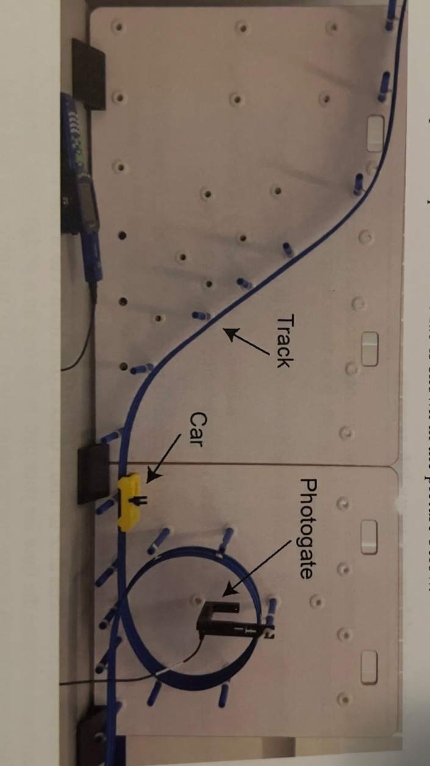

For the third part of the lab, we will be determining the fastest path between two points. First set up the track according to the following picture:

Perform and record five trials, measuring the time at each photogate. This will give us the time needed for the car to get from Point A to Point B. We will then rearrange the track to look like the following image:

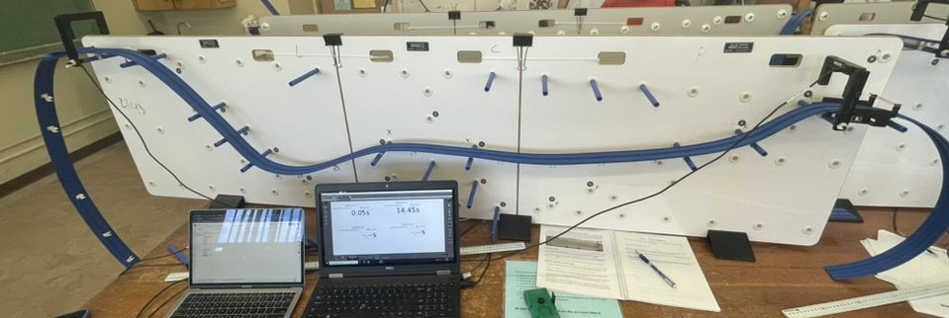

Once the track has been set up, perform five trials, again recording the time at Point A and Point B. From the data, it will be possible to determine which of the two variations of the track produced the fastest time or the least amount of time needed to go from Point A to Point B.

**Theory**

For the Theory section of the lab, we will be using the conservation of energy to help us find the relationship between speed and height and then eventually using that formula to find the minimum height needed for the car to complete a loop. The conservation of energy is as follows:

$$E=K+U...\left(1\right)$$

From the conservation of energy, we can expand into the following:

$$E_{Total Initial}=E_{Total Final}$$

$$K_{i}+U_{i}=K_{f}+U_{f}$$

$$\frac{1}{2}mv_{i}^{2}+mgh_{i}=\frac{1}{2}mv_{f}^{2}+mgh_{f}$$

Because initial kinetic energy is zero due to the car starting from rest, we are left with the following:

$${mgh}_{i}=\frac{1}{2}{mv}_{f}^{2}+{mgh}_{f}$$

Solving for initial height, we get the following equation:

$$h_{i}=\frac{v_{f}^{2}}{2g}+h_{f}...(2)$$

As we can see from (2), the masses (m) cancel out, indicating that mass is not relevant in determining the initial height.

We know what the final height is as it is the height of the top of the loop, where the car needs to pass through in order to be able to follow through and complete the entire loop. This can be found by measuring the radius of the loop, from the bottom of the track to the top using a meter rule. This is shown by the following:

$$h_{f}=2r…\left(3\right)$$

To find the minimum velocity of the car needed to complete the loop, we use the following formula:

$$\sum{F_{y}=ma=N+mg=m\frac{v^{2}}{r}}$$

Therefore, since N = 0:

$$mg=m\frac{v^{2}}{r}…\left(4\right)$$

Solving for velocity:

$$v=\sqrt{gr}…\left(5\right)$$

(5) is our minimum velocity needed to pass through the loop. Again, the masses cancel out, therefore we are able to plausibly conclude that mass plays no role in the minimum velocity of the car needed to pass through and complete a loop. We can then substitute velocity in (2) to get the following which will help us find the minimum height needed to pass through and complete the loop:

$$h_{i}=\frac{gr}{2g}+h_{f}=\frac{r}{2}+h_{f}…\left(6\right)$$

For part three of the lab, determining the fastest path between Point A and Point B, we could use the following equation, considering we know the time taken, we can then find the average velocity between the two points:

$$Average Velocity=\frac{\int_{t_{1}}^{t_{2}}{V\left(t\right)dt}}{t_{2}-t_{1}}…\left(7\right)$$

**Sample Calculations and Results**

Using the equations found in the Theory section, we can then substitute in the values found through measuring using the meter rule or from the data collected. We begin by calculating the top of the loop, which is the final height and the point the car needs to pass in order to be able to complete the loop.

$$h_{f}=2r = 0.25m, r=0.125m$$

Substituting the value of the radius and the final height into equation (6), we can then determine the minimum height needed:

$$h_{i}=\frac{0.125m}{2}+0.25m=0.3125m=31.25cm$$

The minimum velocity needed is given by the following:

$$v=\sqrt{gr}=\sqrt{9.8×0.125}=1.11m/s$$

The following tables are the result of Part I of the lab, determining the relationship between the speed and height of the car.

Table 1:

|  |  |  |  |  |  |
| --- | --- | --- | --- | --- | --- |
| **Trial** | **1** | **2** | **3** | **4** | **5** |
| Photogate | Time (s) | Time (s) | Time (s) | Time (s) | Time (s) |
| 1 | 0.38 | 0.41 | 0.42 | 0.42 | 0.42 |
| 2 | 1.19 | 1.2 | 1.21 | 1.21 | 1.21 |
| 3 | 1.9 | 1.89 | 1.89 | 1.9 | 1.89 |
| 4 | 2.31 | 2.29 | 2.24 | 2.29 | 2.29 |
| Mas = 42.5 grams (just car) | |  |  |  |  |
|  |  |  |  |  |  |
| Table 2: |  |  |  |  |  |
| **Trial** | **1** | **2** | **3** | **4** | **5** |
| Photogate | Time (s) | Time (s) | Time (s) | Time (s) | Time (s) |
| 1 | 0.42 | 0.42 | 0.42 | 0.43 | 0.42 |
| 2 | 1.21 | 1.2 | 1.2 | 1.21 | 1.2 |
| 3 | 1.94 | 1.94 | 1.95 | 1.92 | 1.95 |
| 4 | 2.22 | 2.22 | 2.16 | 2.28 | 2.19 |
| Mass = 91.7 grams (car = 42.5g, Mass1 = 49.2g | | |  |  |  |
|  |  |  |  |  |  |
| Table 3: |  |  |  |  |  |
| **Trial** | **1** | **2** | **3** | **4** | **5** |
| Photogate | Time (s) | Time (s) | Time (s) | Time (s) | Time (s) |
| 1 | 0.39 | 0.39 | 0.38 | 0.4 | 0.39 |
| 2 | 1.18 | 1.18 | 1.18 | 1.18 | 1.18 |
| 3 | 1.93 | 1.93 | 1.91 | 1.91 | 1.91 |
| 4 | 2.17 | 2.18 | 2.21 | 2.13 | 2.23 |
| Mass = 140 grams (car = 42.5g, Mass1 = 49.2g, Mass2 = 48.3g) | | | |  |  |

Table 4 given below is the data for Part II of the experiment, where we were supposed to find the minimum height of the track needed for the car to complete a loop.

|  |  |
| --- | --- |
| **Trial** | **Velocity** |
| 1 | 1.09 |
| 2 | 1.08 |
| 3 | 1.1 |
| 4 | 1.1 |
| 5 | 1.08 |

Table 5 and 6 are from Part III, where we are changing the shape of the track to measure the time it takes for the car to get from Point A to Point B.

Table 5, straight track:

|  |  |
| --- | --- |
| **Trial** | **Time Point A to B** |
| 1 | 2.09 |
| 2 | 2.11 |
| 3 | 2.13 |
| 4 | 2.2 |
| 5 | 2.1 |
|  |  |
| Average Time | 2.126 |

Table 6, wiggly track with ups and downs:

|  |  |
| --- | --- |
| **Trial** | **Time Point A to B** |
| 1 | 1.76 |
| 2 | 1.75 |
| 3 | 1.65 |
| 4 | 1.66 |
| 5 | 1.77 |
|  |  |
| Average Time | 1.718 |

**Discussion and Conclusion**

From equations (2) and (5), we can see that the masses cancel out, resulting in the mass of the car and the added masses having no effect on the velocity of the car at any point. This is shown from the data in Table 1, 2, and 3. The changes in the velocity could be due to where we were releasing the car, we did try to be as consistent as possible, however, it was slightly difficult to accurately drop the car from the same spot every single time for fifteen trials.

We do not use Newton’s law to find the velocity as there are forces acting in all directions. The conservation of energy considers the total energy of the system, and from there we are able to calculate the velocity while acknowledging all the different forces that are acting on the car. Newton’s law of F=ma also considers the mass of the car, which from the data we have obtained, has no effect on the velocity of the car at any given point. Newton’s law also does not consider forces changing, it only considers forces at a single point in time, or when the car is at rest. The equation (2) and (5) will be able to tell us the velocity and height at any point in time.

Our calculated velocity is 1.11m/s, and from the data we found, our calculated velocity was off by about 0.02 m/s on average. This could be due to the position that we were releasing the car from, we used a photogate as a benchmark, however, the point of release may have differed by about 0.5-1 cm, and this could have thrown off the data by a bit.

For the minimum height needed to complete the loop, our calculated value was 31.25 cm. Our measured value was about 31 cm. This could be due to the point that we were measuring at not being exactly accurate as we were using a meter rule and our eyes to try and get the most accurate reading.

In Part III, the reason why our second track, the track with the ups and downs, was faster that the straight track is due to the velocity of the car changing constantly. In the first track, the straight one, the velocity was constant throughout from Point A to Point B. In the second track, the up and down one, the velocity is changing, it is increasing and decreasing. Increasing when the track drops and decreasing when the track goes up. This change in velocity affect the time needed to get from Point A to Point B as it is faster throughout the track even though the initial and final velocities are the same at the start and at the end. It is the middle part that changes, and this affects the time needed, explaining why the nonlinear path is the quickest.

From all the data and calculations that we have obtained, it is clear to conclude that mass has no effect on the velocity of the car, the fastest path between two points is not necessarily a straight line for a roller coaster, and the minimum height needed to make a complete loop is 31.25 cm, and the minimum velocity for the same application is 1.11m/s.

**Additional Graphs and Tables**

Table : For Part I, heights of the photogates.

|  |  |
| --- | --- |
| **Photogate** | **Height** |
| 1 | 57.5 cm |
| 2 | 54 cm |
| 3 | 41 cm |
| 4 | 32.5 cm |

Table : For Part I, measuring the standard deviation of the velocity for each respective photogate.

|  |  |
| --- | --- |
| **Photogate** | **Standard Deviation** |
| 1 | 0.017099151 |
| 2 | 0.012983506 |
| 3 | 0.479784674 |
| 4 | 0.559395135 |