Font: Beba Neue – food name, price, and description.

MENU:

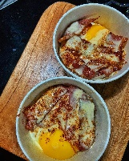

BACSILOG – 65

Bacsilog? Them Bacon? Mmm…wakey wakey eggs ‘N bakey

No mistakey. There is that delicious fatty and crispy part.

Not a care not a worry

Time has come to get some and oh boy what a meal.

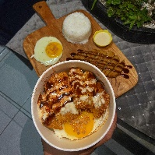

TONKATSILOG – 70

Damn there’s a TON of crispiness on the outside that’s KAT to be juicy on the inside coz I SUuuu really like that.

Saang sauce yang Tonkatsu ba kamo? Sa Ate Carla’s Bacsgilog lang yan! Kain kain lang dito! Get that haponese vibes.

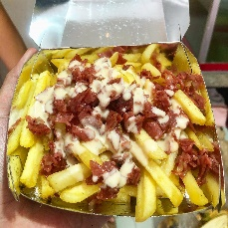

CHEESY FRIES W/ BACON BITS – 60

Eyes on the fries. Bacon and fries can go together.

Parang kayo lang, bihira lang nakita at kasama. Mapapasulit ka pa sa mga magagandang pinagsamahan niyo lalo na pag kumain kayo nito sa Ate Carla’s Bacsilog 😉

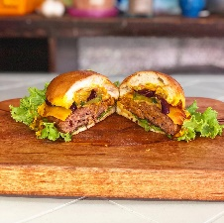

CHEESY ANGUS BEEF BURGER – 85

Meet your meat! Yung angas ba hinahanap mo? Heto sayo! Cheesy Angus Beef Burger! O ano? May beef pa kami? Malaman gusto mo ng gantong kaaway harap-harapan. The meat is on! Mapapamura ka talaga dito! Lettuce get eating!

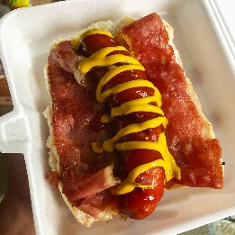

CHEESY HUNGARIAN W/ BACON STRIP – 90

Tired of being cheesy? Ako rin eh. Hungry lang yan.

O eto Cheesy Hungarian w/ Bacon strip. Tama lang sa mood natin may kasama pang bacon—it is like meat candy. Drained no more. Tuloy lang good vibes.

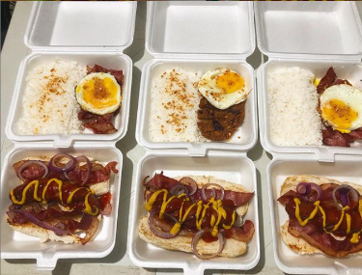

HUNGSILOG – 90

A hungarian hot dog for a hungry customer. Ate Carla never hung up on your call. Meet more meats here! Hindi ka mabibitin! Mahuhunghang ka na lang sa sarap

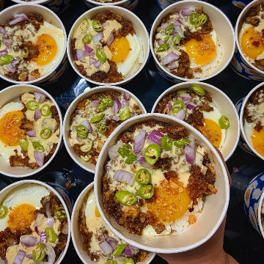

CHEESYSIGSILOG – 70

Kaya talaga number one pulutan ito sa menu nila Ate Carla eh. AYYEE CHEESYSIGSILOG!! Haba nun noh? Talagang sulit at pinapabusog ka pa lalo ni Ate Carla.

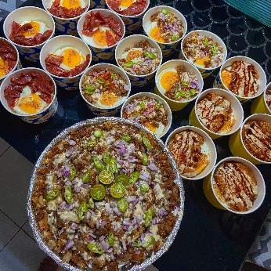

SISIG IN TUB – 160

Talagang SISIGi ka nito… Sisig in a Tub? Huwat? Are Ü for Realz?? Malaman So Lit sa Party!

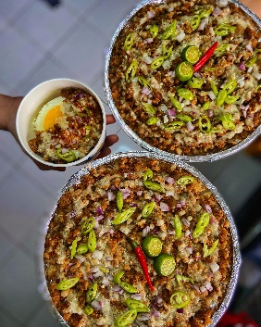

SISIG BILAO – 300

Pagdating sa sisig talaga mmh! Mapapabilao ka talaga nito eh! Mapapahigh blodd ka talaga dami pagpipilian.

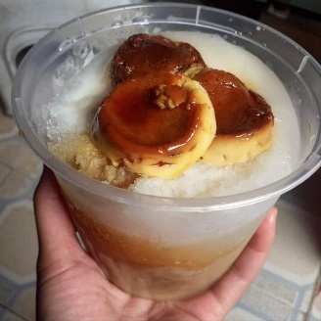

SAGING CON YELO – 50

Init sa pinas init din ng menu

Saging con yelo lang yan siyempre may palamig din si Ate Carla

Mapaprefresh ka pa bigla oha!