Location, Planning and Zoning By-Laws

For the construction of DKAL to move ahead a suitable location will be needed to accommodate the Hydroponic/Aquaponic and Energy System divisions of the business. The property will have to be an on an estimated 40-acre plot of land that with the proper landscape to build the ponds to hold all the fish species. The Recreation and Cafeteria buildings will be constructed on this same land away from the farms. Thunder Bay has official Zoning By-Laws which Dkal will have to abide by, which will be discussed in details later on in this document. Building permits will also be needed before construction begins.

Location

Choosing the right location will need to be discussed prior to applying for any official documents. The city offers an interactive zoning map which can be found at <http://thunderbay.maps.arcgis.com/apps/webappviewer/index.html?id=fe1c1cbffb7d43f482d006579a53c6a4>. Shown in the image below is all the districts in the Thunder Bay region.

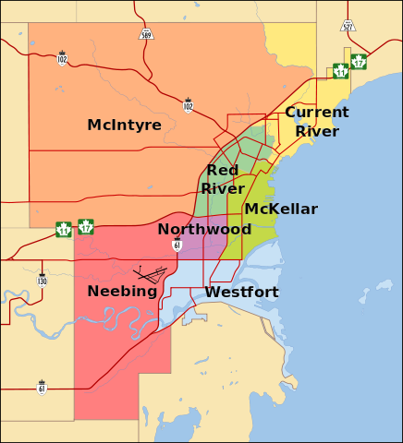

Planning

According to official documents from the City of Thunder Bay the Planning Services Division develops and maintain the Official Plan and Zoning By-Laws. The Official Plan is the City’s main land use policy document. It describes what kind of community they want to become in the future. It sets goals, objectives, and policies which guide land use planning decisions. The Zoning By-law aims to implement these goals and objectives on a day-to-day basis.

Planning Services reviews development proposals, making sure new developments comply with the Zoning By-law. All properties within the City must comply. Before purchasing a property or applying for a building permit, Planning Services can help you determine if your proposal complies with zoning regulations and if a planning application is necessary.

By-Laws

For Dkal to deal with all the By-Laws, consulting with Planning Service Staff will be required. According to the City of Thunder Bay the Zoning By-law sets strict rules about what you can and cannot do with land. On the other hand, the Official Plan provides somewhat flexible guidance. There are only a few strict policies in the Official Plan. Mostly, it describes Thunder Bays vision for the city and the ways they might reach this vision. The Zoning By-law is one of many tools used to implement this vision.

The Zoning By-law divides the City into zones. Each zone has a list of permitted uses and rules about how properties under that zone may develop. For example, in the "R2" - Residential Zone Two you may build a duplex, but you may not build an office. There are other rules regarding lot size, setbacks, and parking which must also be followed.

References

<https://www.thunderbay.ca/en/business/planning-applications.aspx>

<https://www.thunderbay.ca/en/business/zoning.aspx?_mid_=1006>

<http://thunderbay.maps.arcgis.com/apps/webappviewer/index.html?id=fe1c1cbffb7d43f482d006579a53c6a4>

<https://en.wikipedia.org/wiki/Thunder_Bay_District>