# Terminal kodları

## npm init

## npm install express

Serverin çalışması için

npm run start

Serveri kapatmadan değişiklikleri görmek için (D development aşaması anlamında)

npm install -D nodemon

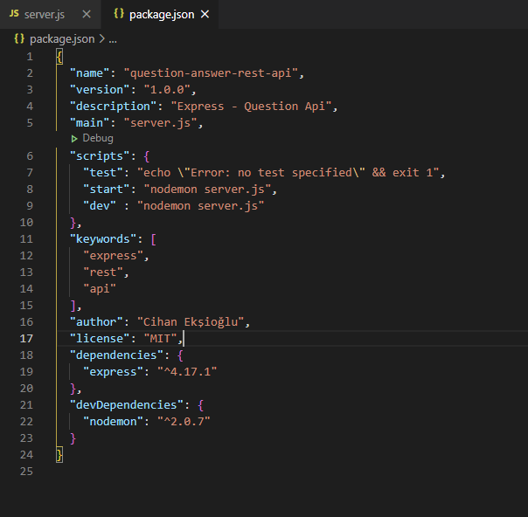

  "scripts": {

    "test": "echo \"Error: no test specified\" && exit 1",

    "start": "nodemon server.js",

    "dev" : "nodemon server.js"

  },

npm run dev

# Server.js

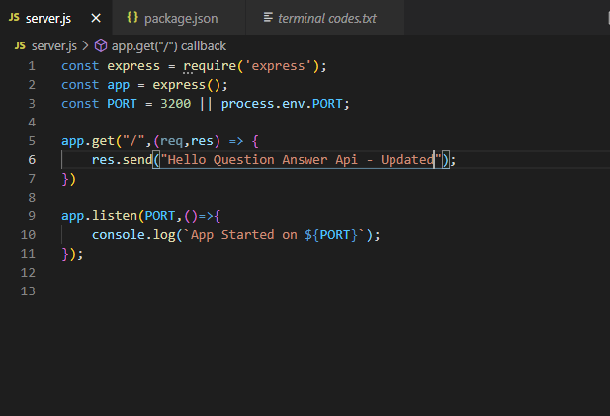

const express = require('express');

const app = express();

const PORT = 3200 || process.env.PORT;

app.get("/",(req,res) => {

    res.send("Hello Question Answer Api - Updated");

})

app.listen(PORT,()=>{

    console.log(`App Started on ${PORT}`);

});

# Config.env

npm install dotenv

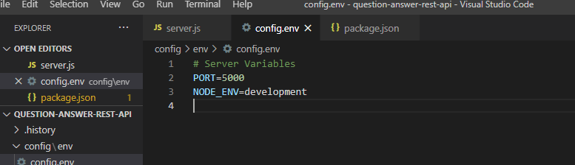

# Server Variables

PORT=5000

NODE_ENV=development

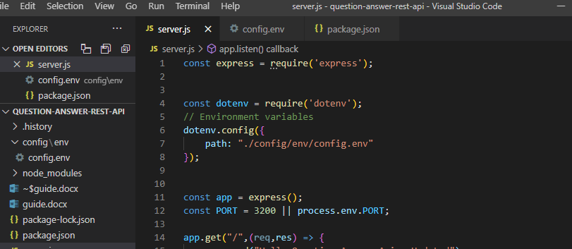

const dotenv = require('dotenv');

// Environment variables

dotenv.config({

    path: "./config/env/config.env"

});

# Routers



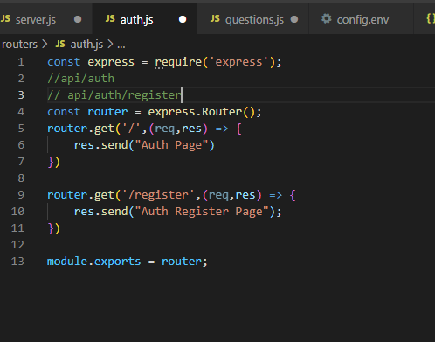

const express = require('express');

//api/auth

// api/auth/register

const router = express.Router();

router.get('/',(req,res) => {

    res.send("Auth Page")

})

router.get('/register',(req,res) => {

    res.send("Auth Register Page");

})

module.exports = router;

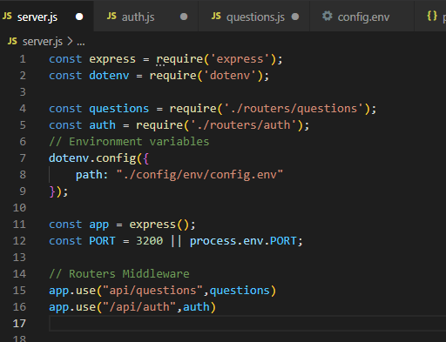

const questions = require('./routers/questions');

const auth = require('./routers/auth');

// Routers Middleware

app.use("api/questions",questions)

app.use("/api/auth",auth)

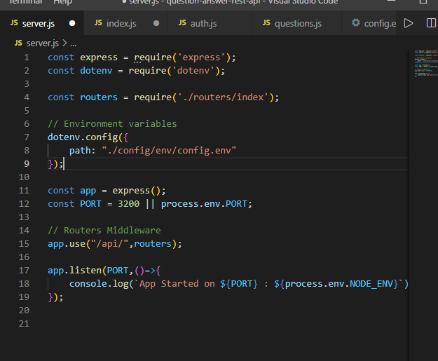

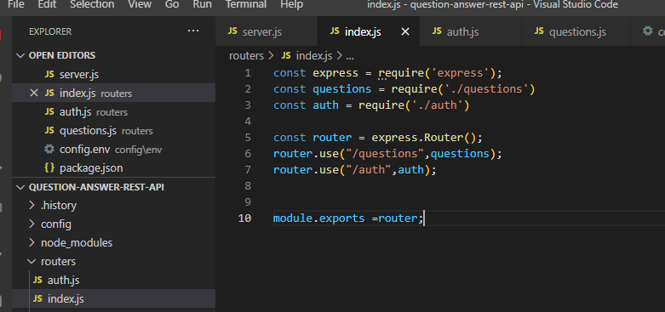

const express = require('express');

const questions = require('./questions')

const auth = require('./auth')

const router = express.Router();

router.use("/questions",questions);

router.use("/auth",auth);

module.exports =router;

# Serverden JSON döndürmek

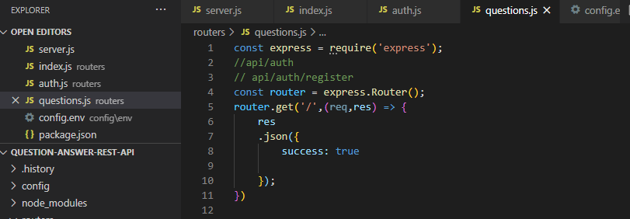

router.get('/',(req,res) => {

    res

    .json({

        success: true

    });

})